**NETWORKING & SYSTEM ADMINISTRATION LAB**

**Experiment No.: 3**

**Aim**

Familiarization of the linux commands.



**Name:**

**UPAS NATH**

**Roll No:**

**47**

**Batch:**

**B**

**Date:**

**31**

**/03/2022**

**Procedure**

# cut -d

This command is used to cut and display the content based on the delimiter given.

Syntax :- $ cut –d delimiter –fieldnumber filename

Output :-

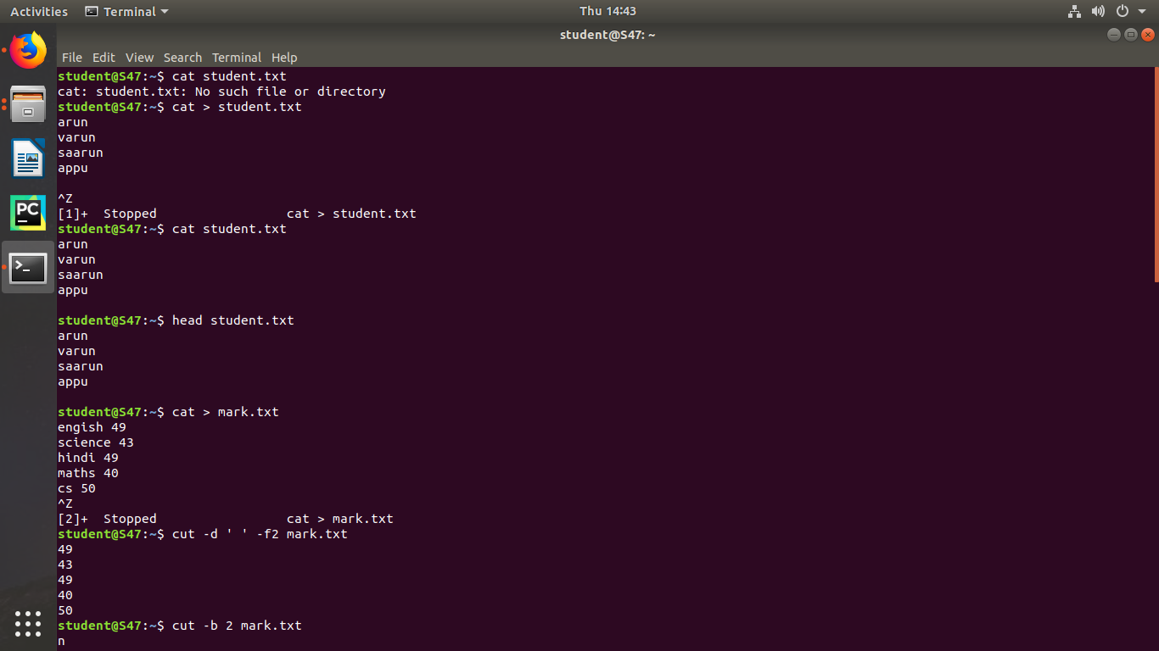

# cut -b

This command is used to cut and display the content based on the specified byte number.

Syntax :- $ cut –b bytenumber filename

Output :-

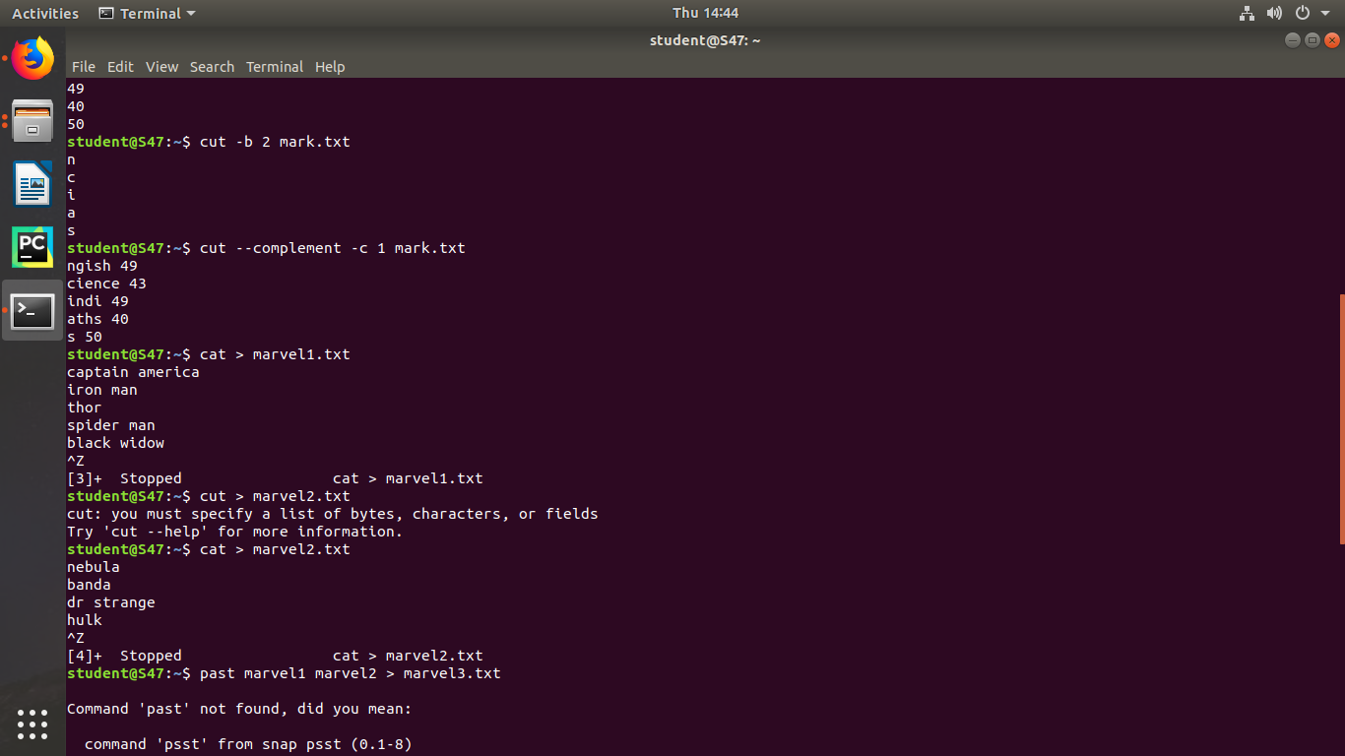

# cut --complement -c

This command is used to erase the specified character and display the remaining content of the file.

Syntax :- $ cut --complement –c characternumber filename.txt Output :-



# paste

This command is used to paste the contents from the specified file.

Syntax :- $ paste filename

Output :-



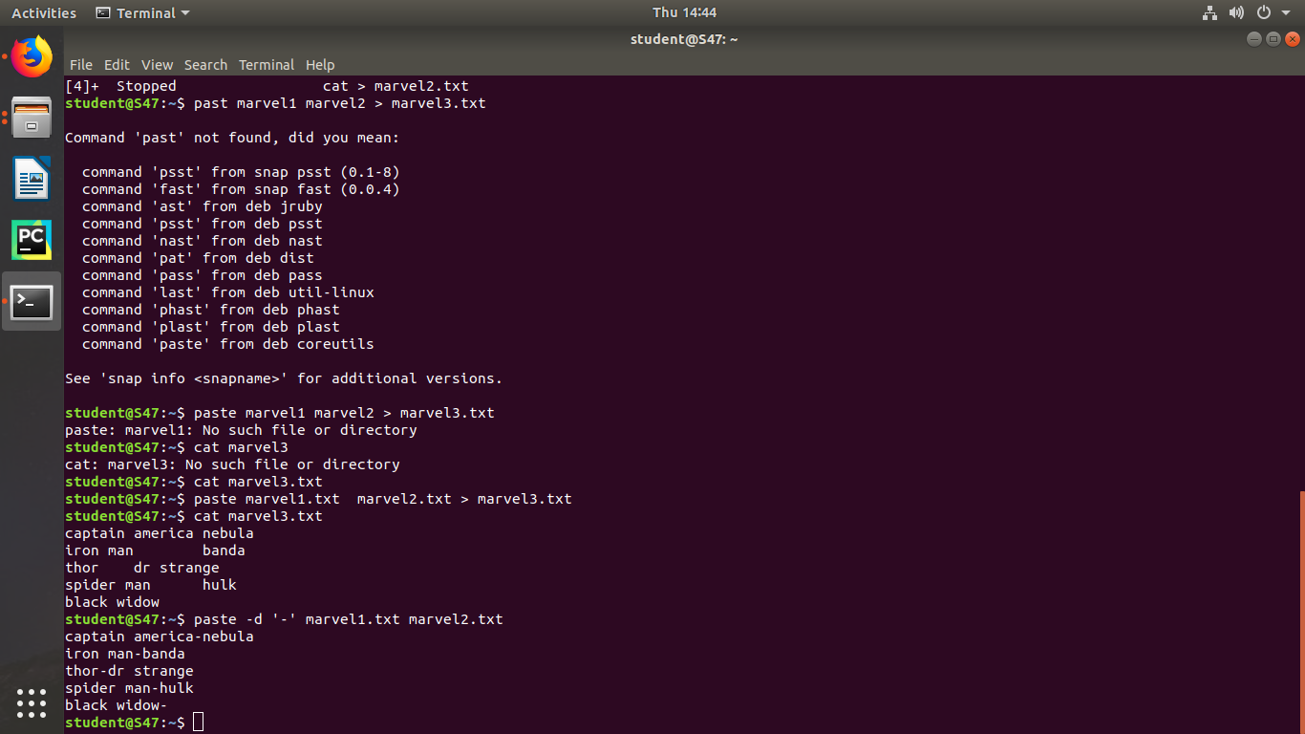

# paste file1 file2 > file3

This command is used to paste the contents from the specified files to another file. Syntax :- $ paste file1 file2 > file3

Output:-



# paste -s

This command is used to paste the contents sequentially. It reads all the lines from the file and merges all these lines into a single line with each line separated by tab.

Syntax :- paste –s file1 file2 Output :-

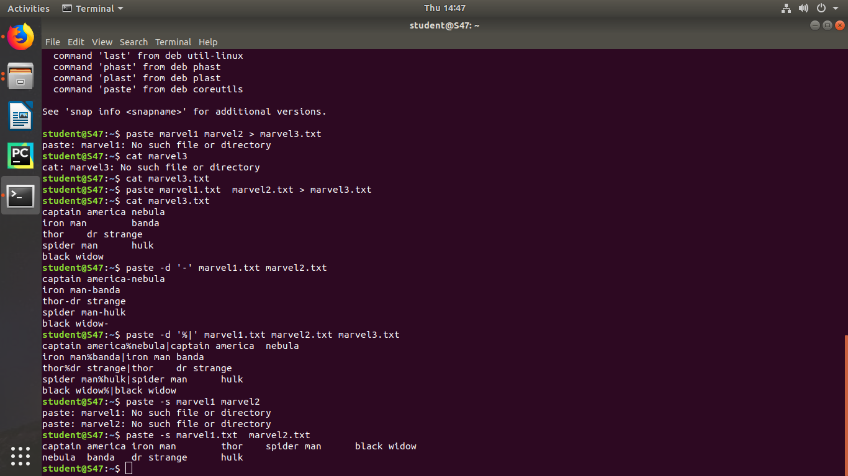

# paste -d

This command is used to paste the contents from the given files with the delimiter given.

Syntax :- $ paste –d delimiter file1 file2 Output :-



# more

This command is used to view the text files in the command prompt, displaying one screen at a time in case the file is large.

Syntax :- $ more filename

Output :-

# more -number

This command is used to display display the lines to the specified number from head.

Syntax :- $ more -number

Output :-

# more +number

This command use the line number from where we want to displaying the text content.

Syntax :- $ more +number

Output :-