**Name: UPAS NATH**

**Roll No: 47**

**Batch: B**

**Date: 24/03/2022**

**NETWORKING & SYSTEM ADMINISTRATION LAB**

**Experiment No.: 3**

**Aim**

Familiarization of the linux commands.

**Procedure**

**1. pwd**

This command is used to display the location of the current working directory.

Syntax :- $ pwd

Output :-

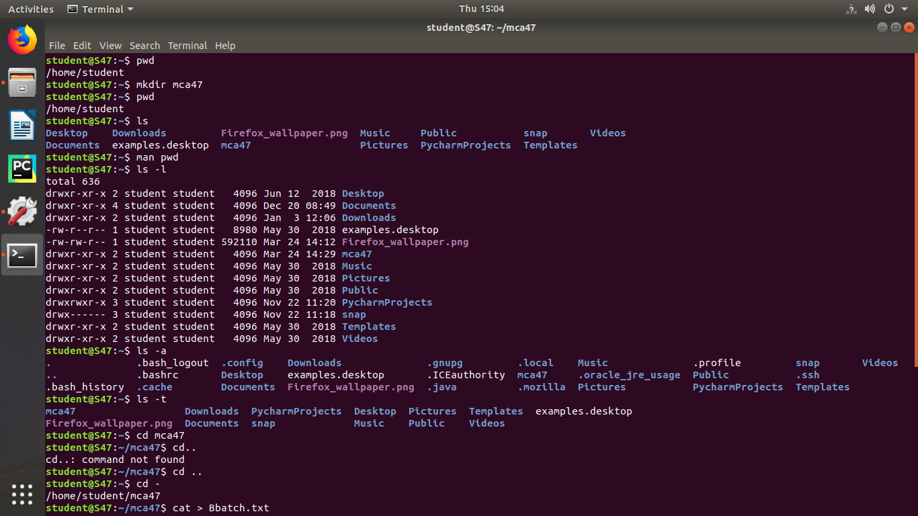

**2. mkdir**

This command is used to create a new directory under any directory.

Syntax :- $ mkdir <directory name>

Output :-



**3. ls**

This command is used to display a list of content of directory.

Syntax :- $ ls

Output :-



**4. man**

This command is used to display the user manual of any command that we can run on the terminal.

Syntax :- $ man <command name>

Output :-



**5. ls –l**

This command is used to shows file or directory, size, modified date and time, file or folder name and owner of the file, and its permission.

Syntax :- $ ls –l

Output:-



**6. ls –r**

This command is used to display files and directories in reverse order.

Syntax :- $ls –r

Output :-

**7. ls –a**

This command is used to list all files including hidden files.

Syntax :- $ls –a

Output :-

**8. ls –al**

This command is used to

Syntax :- $ ls -al

Output :-

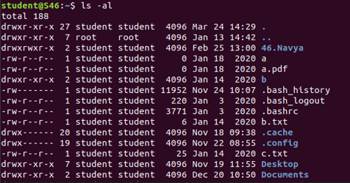

**9. ls –t**

This command is used to display files in the last modified order.

Syntax :- $ ls –t

Output :-



**10. cd**

This command is used to change the current directory.

Syntax :- $ cd <directory name>

Output :-



**11. cd ..**

This command is used to move to the parent directory of current directory, or the directory one level up from the current directory.

Syntax :- $ cd ..

Output :-

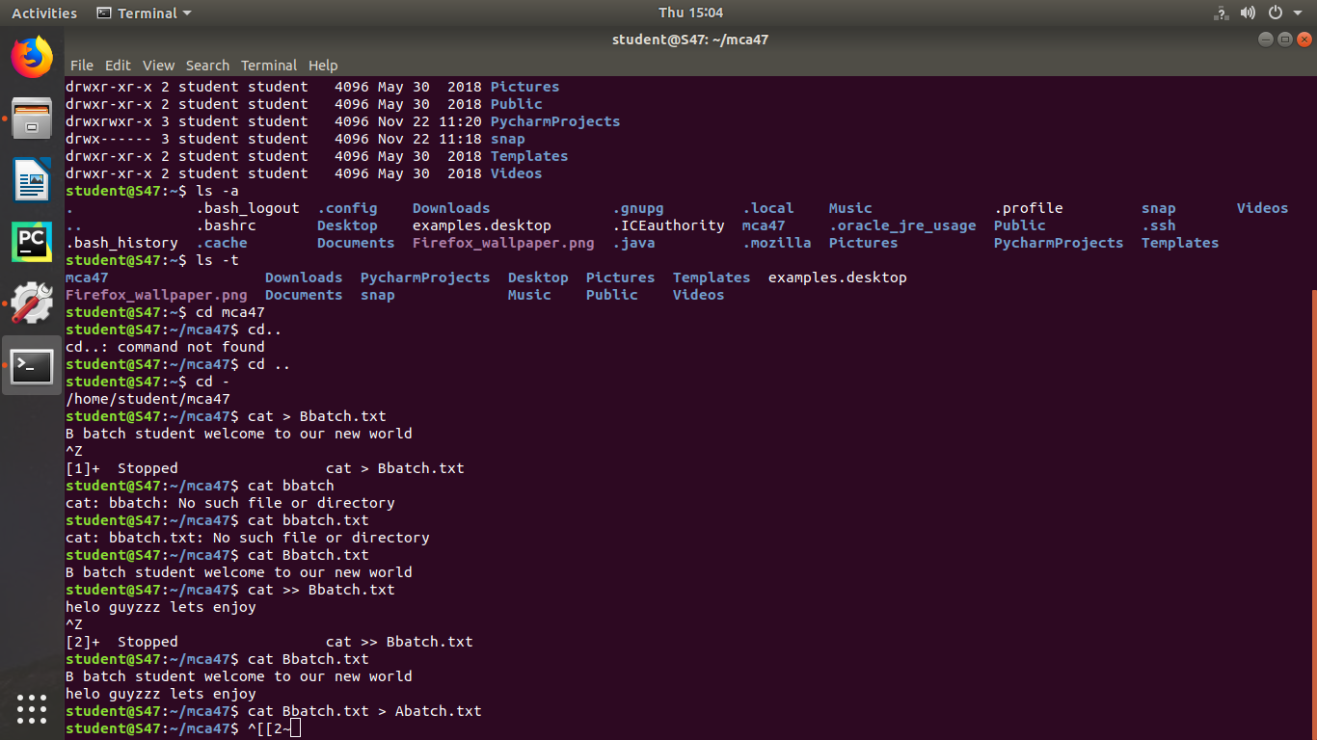

**12. cd –**

This command is used to switch back to previous directory we were working earlier.

Syntax :- $ cd –

Output :-



**13. cat > filename**

This command is used to create a file and add contents to that file.

Syntax :- $ cat > filename.txt

Output :-



**14. cat>>filename**

This command is used to add contents to an existing file.

Syntax :- $ cat >> filename.txt

Output :-



**15. cat filename**

This command is used to view the contents in the file.

Syntax :- $ cat filename.txt

Output :-



**16. cat filename1 > filename2**

This command is used to copy the content from one file to another file.

Syntax :- $ cat filename1 > filename2

Output :-

