T E C H N I C A L S P E C I F I C A T I O N
Upcheck Product
Architecture &
User Experience
Shrimp Farm Management Platform — Technical Specification v1.0
Stack: Expo React Native SDK 51 | Supabase | NestJS
Target: Shrimp Farms in India
Version: 1.0 — June 2026

Confidential June 2026

Table of Contents

Right-click the Table of Contents and select “Update Field” to refresh page numbers after opening.

1. Executive Summary
This document is the authoritative technical specification for the Upcheck shrimp farm management platform. It replaces the original product vision draft with implementation-ready architecture, data models, permission systems, user flows, and API contracts. Every design decision in this document resolves a specific gap or ambiguity identified in the earlier draft, ensuring that a development team can build the product without requiring additional clarification.
The original draft articulated a compelling vision but left critical questions unanswered: How does the app handle a user who is an Owner of one farm and a Worker of another? What exactly can a Manager do? Does the app work without internet? Which Indian languages are supported? These questions are no longer deferred — they are answered with specificity below.
Key architectural decisions resolved in this document: (1) Offline-first architecture using WatermelonDB for local SQLite storage with background sync; (2) Farm-context-based role resolution that determines home screen and feature access per-farm rather than globally; (3) A complete permission matrix with every action enumerated for Owner, Manager, Worker, and Viewer roles; (4) OTP-based mobile authentication via Supabase Auth and MSG91; (5) A five-language localization strategy phased across releases; (6) A task model supporting recurrence, time windows, data attachments, and verification workflows; (7) A crop cycle data model that includes FCR, DOC, mortality records, disease treatments, and survival rate — metrics that the original draft omitted entirely.
The technology stack is Expo React Native SDK 51 for the mobile client, NestJS for the backend API, and Supabase for authentication, PostgreSQL with Row Level Security, storage, and real-time subscriptions. This combination was chosen specifically for the Indian shrimp farming context: low-end Android devices, intermittent connectivity, and multilingual users who need simplicity over feature density.
The document also includes a phased MVP roadmap that acknowledges a fundamental tension in the original draft: the desire to be an “operating system” for shrimp farms cannot coexist with a commitment to simplicity in version one. This roadmap resolves that tension by starting as a digital record book (V1), adding operations and team coordination (V2), then insights and analytics (V3), and finally external integrations (V4). Each phase ships a complete, usable product.

2. Product Vision & Core Principles

2.1 The Resolved Vision
The original draft stated that Upcheck should become “the operating system of a shrimp farm.” This is the correct long-term ambition, but it is not a V1 product description. An operating system implies infrastructure — something other things depend on. Upcheck earns that status by becoming the single source of truth for farm data first, then layering coordination, then intelligence, then integration on top.
V1 Identity: Upcheck V1 is a digital record book for shrimp farm operations. It replaces notebooks, WhatsApp messages, and spreadsheets as the place where feed records, water quality readings, sampling data, and crop cycle information live. If a farmer cannot record and retrieve their farm data in Upcheck, nothing else matters.
V2 Identity: Upcheck V2 adds team coordination. Tasks can be assigned, tracked, and verified. Workers see their daily assignments. Managers oversee execution. The record book becomes a coordination tool.
V3+ Identity: Upcheck V3 and beyond add intelligence, integration, and marketplace features. The coordination tool becomes a decision-support system and eventually an operating system.

2.2 What Upcheck IS (in V1)
- A mobile-first digital record book for shrimp farm operations
- A tool that works offline in rural coastal areas with poor connectivity
- A platform that speaks the farmer’s language (Telugu and English at launch)
- A system that organizes data by Farm → Pond → Crop Cycle hierarchy
- An app that a farm owner can use alone without needing to invite anyone

2.3 What Upcheck IS NOT (in V1)
- An IoT dashboard (sensors come in V4)
- A marketplace for buying feed or seed (ecommerce comes in V4)
- A real-time monitoring system (real-time sensor data is V4)
- A financial accounting tool (cost management comes in V3)
- A WhatsApp replacement (WhatsApp integration for notifications comes in V2)

2.4 Design Principles
These principles are ordered by priority. When principles conflict, the earlier one wins.
Priority | Principle | Implication
1 | Works Offline | Every critical action must function without internet. Sync when connected.
2 | Speaks the User’s Language | Support Telugu and English at V1 launch. Regional languages phased in.
3 | Zero Training Required | A farm worker should complete their first task within 60 seconds of opening the app.
4 | Low-End Device Friendly | Target 2GB RAM Android devices. No heavy dashboards on worker screens.
5 | Progressive Complexity | Show only what the current role needs. Features appear when they become relevant.
6 | Data Over Features | Accurate, complete data recording matters more than feature count.
7 | Context-Adaptive UI | The same app shows different content based on farm membership role.

3. System Architecture Overview
The Upcheck platform follows a three-tier architecture: a mobile client tier (Expo React Native), an API tier (NestJS), and a data tier (Supabase). The mobile client is designed as offline-first, meaning all read and write operations target a local SQLite database first, with background synchronization to the server when connectivity is available. This architecture is not an afterthought — it is the foundational technical decision that enables the app to function in the rural coastal areas of Andhra Pradesh, Tamil Nadu, and other shrimp farming regions where 4G connectivity is intermittent and Wi-Fi is nonexistent.
The NestJS backend serves as the API gateway and business logic layer. It does not directly access the database — instead, it uses the Supabase client library which respects Row Level Security policies defined in PostgreSQL. This means that every data access is automatically scoped to the user’s farm memberships, and no additional application-level filtering is needed for basic authorization. The backend handles complex operations that cannot be expressed as simple RLS rules: invitation flows, ownership transfers, report generation, and notification dispatching.
Supabase provides four core services: PostgreSQL with RLS for data storage, Supabase Auth for OTP-based authentication, Supabase Storage for file uploads (photos, documents), and Supabase Realtime for live updates when the client is online. The Realtime layer is used selectively — only for alert notifications and task assignment updates, not for bulk data synchronization which uses a pull-based sync mechanism.
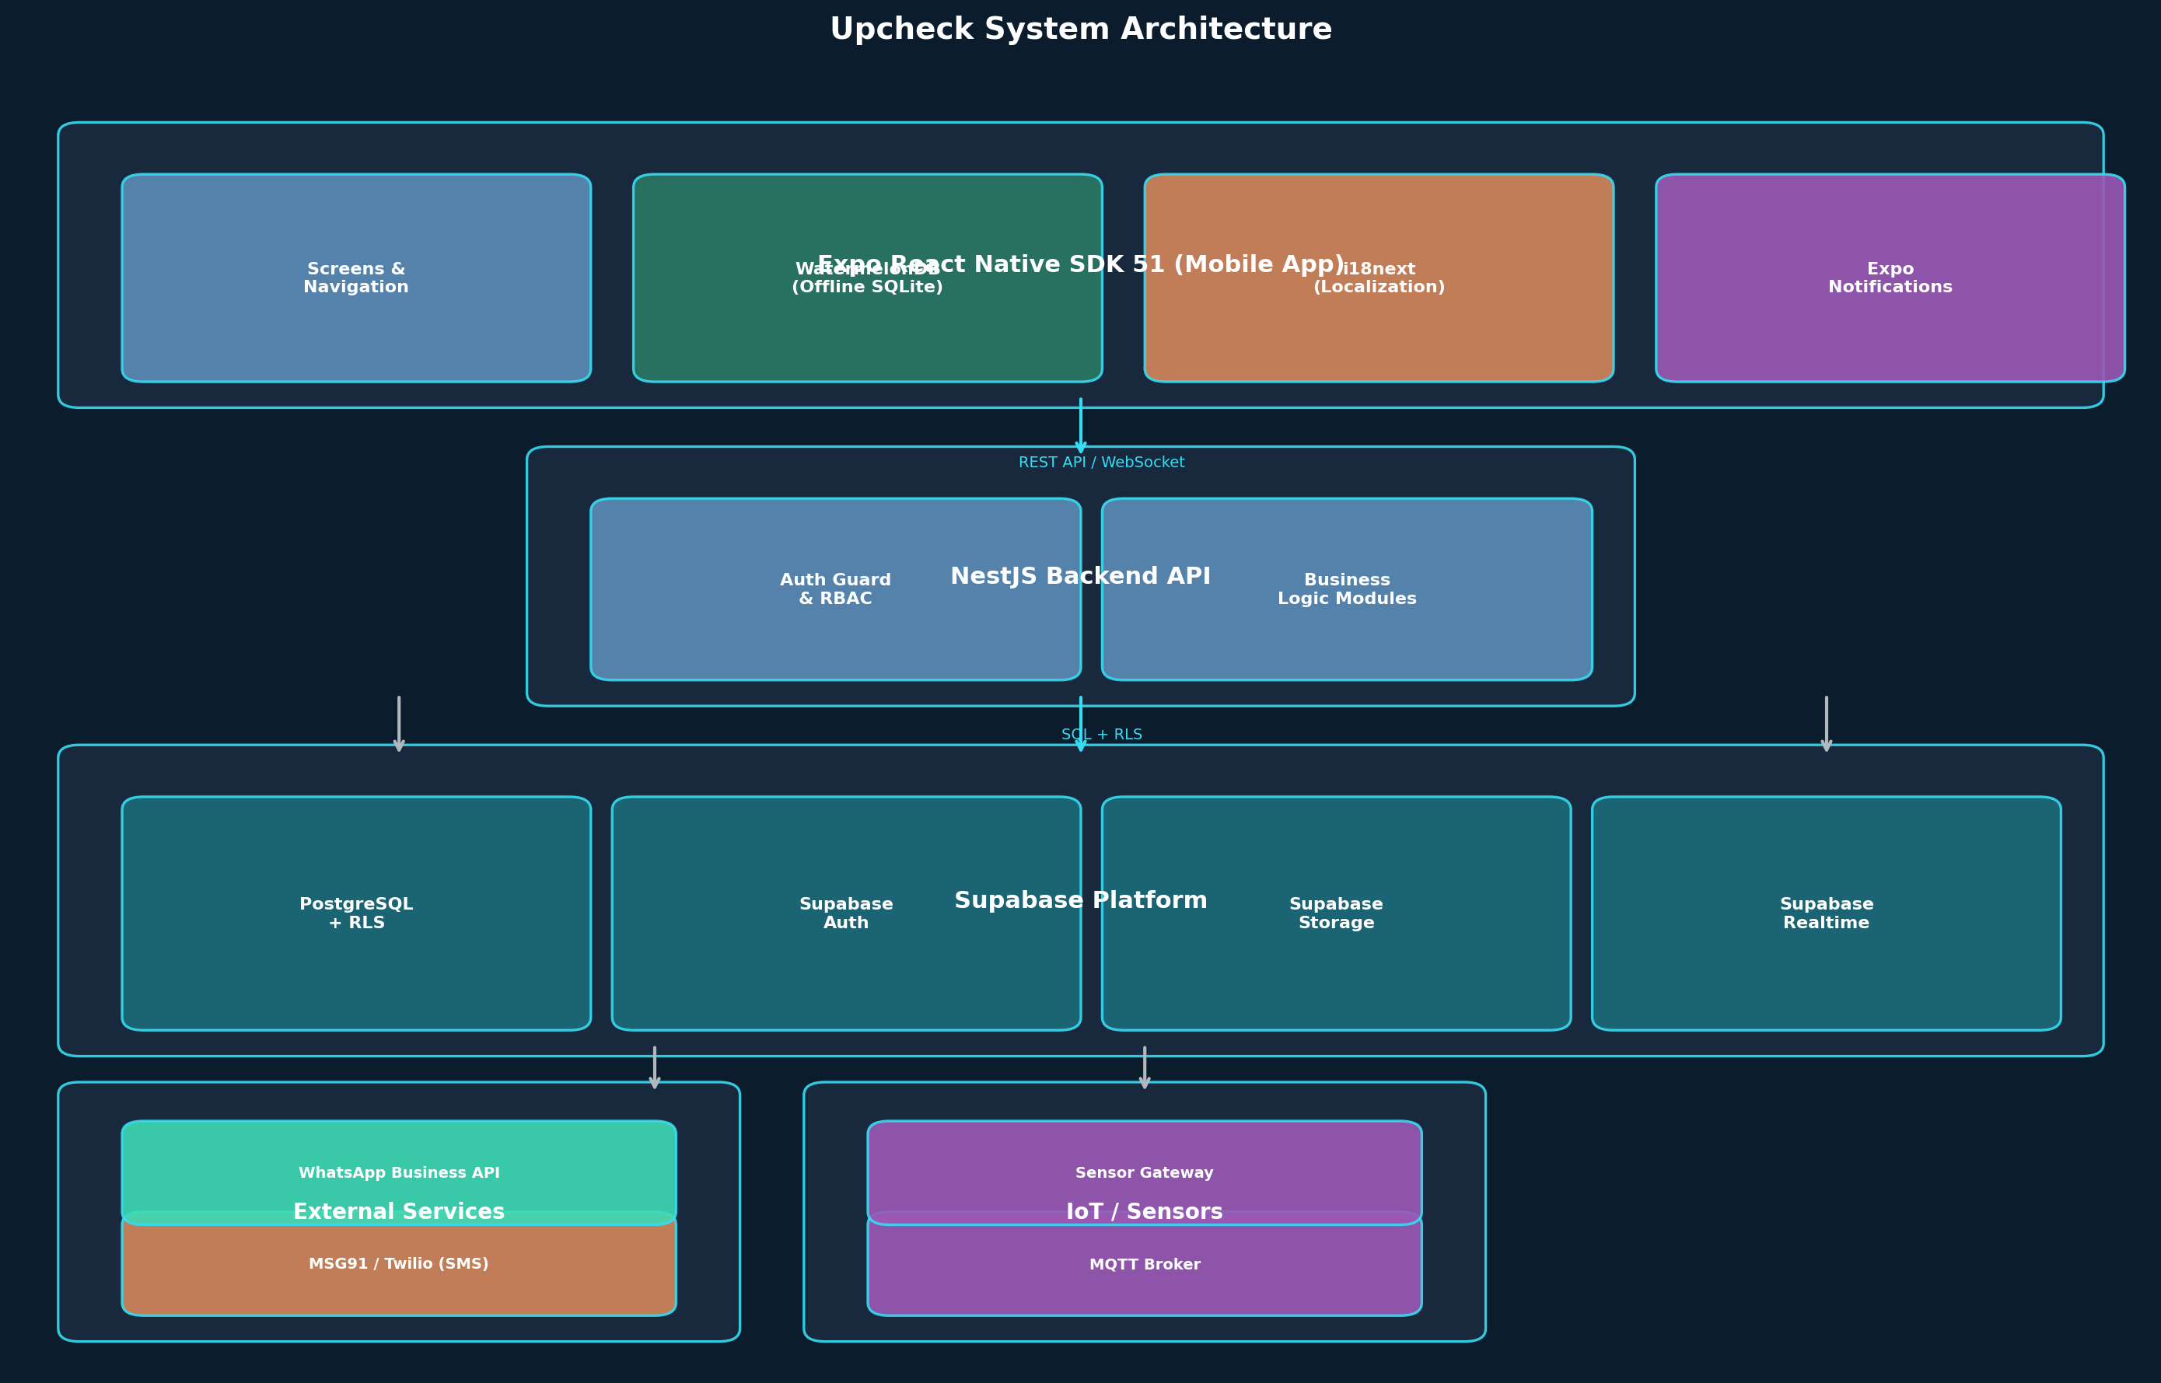
Figure 1: System Architecture Diagram

3.1 Mermaid Source
graph TB
subgraph Mobile[Expo React Native SDK 51]
UI[Screens & Navigation] --> WM[WatermelonDB SQLite]
UI --> I18N[i18next Localization]
UI --> NOTIF[Expo Notifications]
end
subgraph API[NestJS Backend]
AUTH[Auth Guard & RBAC] --> BIZ[Business Logic Modules]
end
subgraph Data[Supabase Platform]
PG[PostgreSQL + RLS]
SA[Supabase Auth]
SS[Supabase Storage]
SR[Supabase Realtime]
end
Mobile -->|REST API / WebSocket| API
API --> Data
EXT[MSG91 / WhatsApp API] --> API
IoT[MQTT / Sensor Gateway] --> API

4. Technology Stack & Rationale
Every technology choice for Upcheck was evaluated against three constraints specific to the Indian shrimp farming context: intermittent connectivity, low-end Android devices, and multilingual non-technical users. The following table documents each choice and its rationale.
Layer | Technology | Version | Rationale
Mobile Framework | Expo React Native | SDK 51 | Managed workflow simplifies OTA updates; single codebase for Android; Expo Go for rapid testing; native module support for offline SQLite
Offline Database | WatermelonDB | 0.27+ | Built for React Native offline-first apps; lazy loading for large datasets; sync adapter pattern; performant on 2GB RAM devices
State Management | Zustand | 4.x | Lightweight (1KB); no boilerplate; works seamlessly with WatermelonDB observables; minimal re-renders on low-end devices
Localization | i18next + expo-localization | 23.x | Industry standard for React i18n; JSON resource files per language; dynamic language switching; RTL-ready for future Urdu support
Backend Framework | NestJS | 10.x | TypeScript-first; modular architecture; guard-based RBAC; WebSocket support; structured error handling; Swagger auto-docs
Database | Supabase PostgreSQL | 15.x | Managed Postgres with RLS; built-in auth; real-time subscriptions; storage; eliminates need for separate auth/file services
Authentication | Supabase Auth + MSG91 | Latest | OTP-based mobile login (no passwords); MSG91 for SMS delivery in India; Supabase handles JWT issuance and refresh
File Storage | Supabase Storage | Latest | S3-compatible; RLS on buckets; image transformation; used for task photos, disease photos, and report exports
Push Notifications | Expo Push + FCM | Latest | Expo handles token management; FCM for Android; fallback to SMS via MSG91 for critical alerts
SMS Provider | MSG91 | API v2 | Indian SMS gateway; DLT-compliant; high delivery rate in rural AP/Tamil Nadu; transactional and promotional routes
WhatsApp | WhatsApp Business API | Latest | For task assignment notifications and alert delivery; higher engagement than SMS among Indian farmers
ORM (Backend) | Prisma | 5.x | Type-safe queries; migration management; introspection for Supabase schema; complements RLS with application-level validation
API Documentation | Swagger/OpenAPI | 3.x | Auto-generated from NestJS decorators; interactive API explorer; essential for developer onboarding
CI/CD | EAS Build + GitHub Actions | Latest | EAS for managed Android builds; GitHub Actions for backend tests and migration deploys

5. Data Model & Database Schema
The data model centers on the Farm → Pond → Crop Cycle hierarchy. Every other entity in the system is either a member of this hierarchy or a record that belongs to a point in it. This section provides the complete schema definition with column names, types, constraints, and relationships. All tables use UUID primary keys generated by the application layer, and all timestamps are stored as timestamptz in UTC.
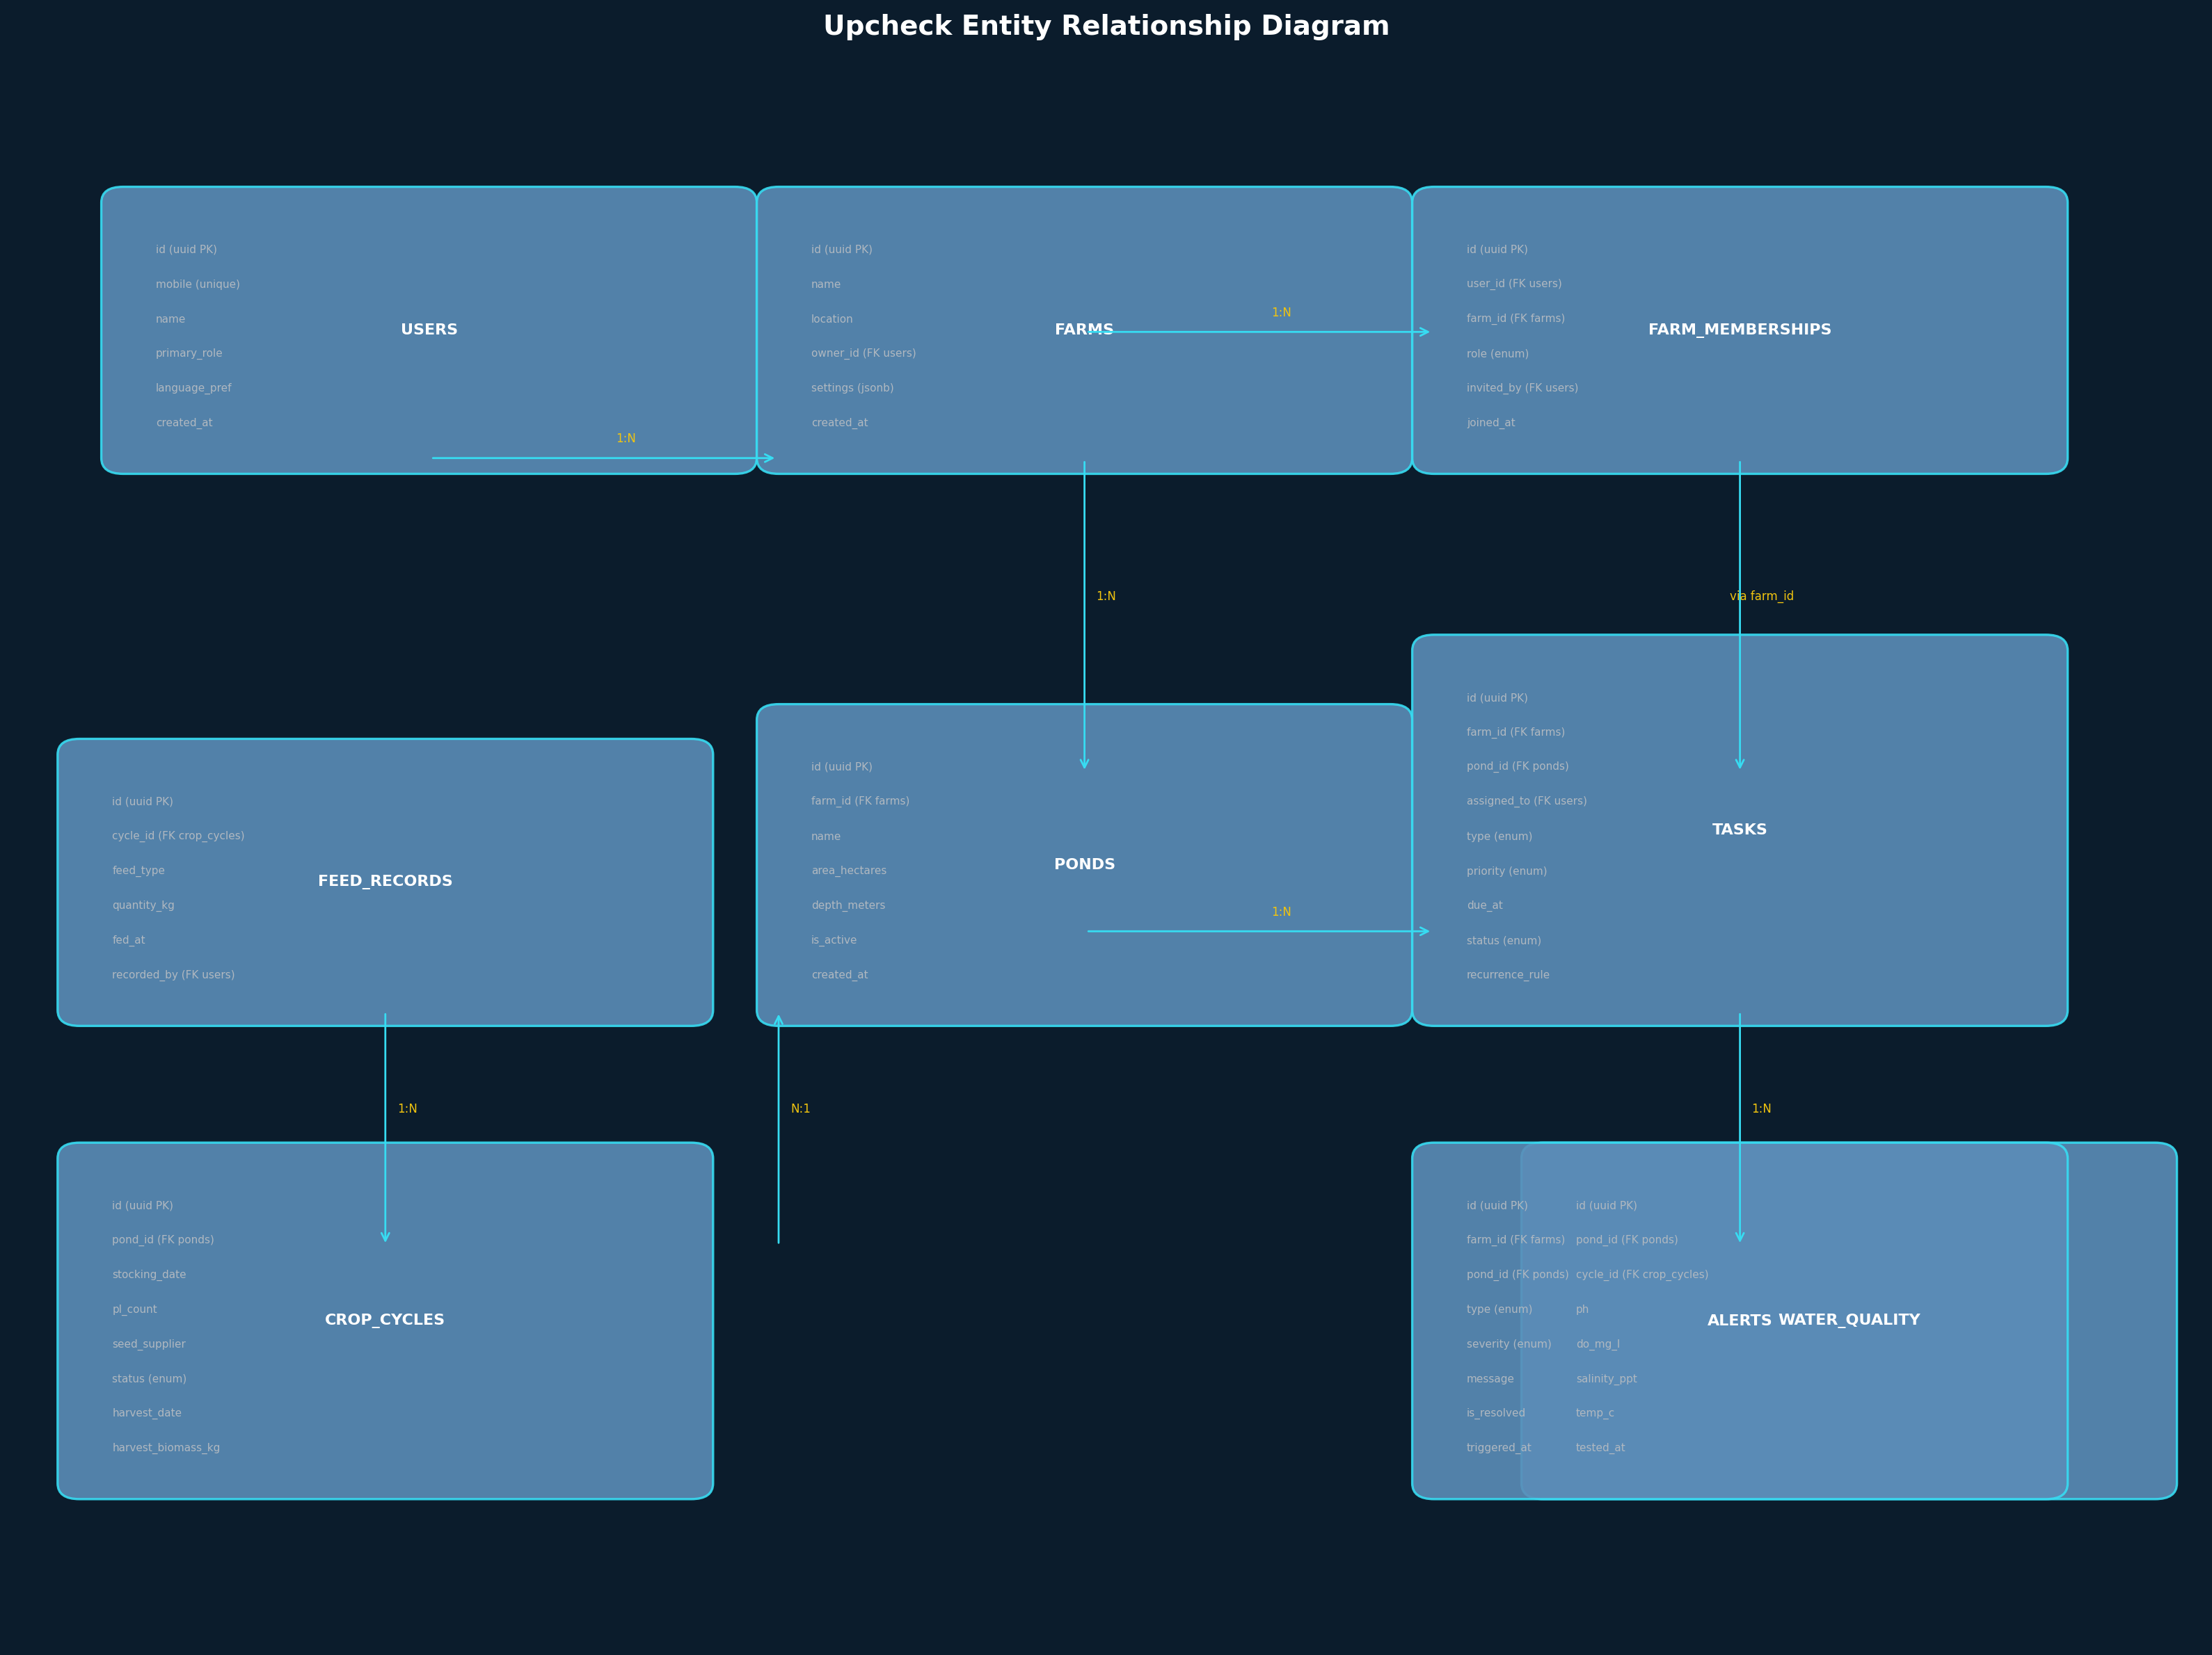
Figure 2: Entity Relationship Diagram

5.1 Users Table
Column | Type | Constraints | Description
id | uuid | PK, default gen_random_uuid() | Unique user identifier
mobile | text | UNIQUE, NOT NULL | 10-digit Indian mobile number (+91 prefix stored)
name | text | NOT NULL | Display name (editable)
primary_role | enum | NOT NULL | OWNER | MANAGER | WORKER — controls default UX only, NOT permissions
language_pref | text | DEFAULT 'en' | Preferred language code: en, te, ta, or, bn, gu
avatar_url | text | NULLABLE | Supabase Storage URL for profile photo
fcm_token | text | NULLABLE | Expo Push Notification token
whatsapp_opted | boolean | DEFAULT false | Whether user wants WhatsApp notifications
created_at | timestamptz | DEFAULT now() | Account creation timestamp
updated_at | timestamptz | DEFAULT now() | Last profile update

5.2 Farms Table
Column | Type | Constraints | Description
id | uuid | PK | Unique farm identifier
name | text | NOT NULL | Farm display name
location | text | NULLABLE | Village/district/state text (not geocoded in V1)
owner_id | uuid | FK users.id, NOT NULL | Farm owner — always has OWNER membership
settings | jsonb | DEFAULT '{}' | Farm-level settings: alert thresholds, language, etc.
is_active | boolean | DEFAULT true | Soft-delete flag
created_at | timestamptz | DEFAULT now() | Farm creation timestamp

5.3 Farm Memberships Table
Column | Type | Constraints | Description
id | uuid | PK | Membership identifier
user_id | uuid | FK users.id, NOT NULL | The user who holds this membership
farm_id | uuid | FK farms.id, NOT NULL | The farm this membership belongs to
role | enum | NOT NULL | OWNER | MANAGER | WORKER | VIEWER
invited_by | uuid | FK users.id, NULLABLE | Who sent the invitation (null for self-created farms)
status | enum | DEFAULT 'ACTIVE' | PENDING | ACTIVE | REMOVED
joined_at | timestamptz | DEFAULT now() | When membership was accepted
UNIQUE | (user_id, farm_id) |  | A user has exactly one role per farm
The farm_memberships table is the most critical table in the system. It implements the core insight that roles belong to farm memberships, not to accounts. When a user switches farm context in the app, the application reads their role from this table for the selected farm and adjusts the UI and available features accordingly.

5.4 Ponds Table
Column | Type | Constraints | Description
id | uuid | PK | Unique pond identifier
farm_id | uuid | FK farms.id, NOT NULL | Parent farm
name | text | NOT NULL | Pond name/number within farm
area_hectares | decimal(8,2) | NULLABLE | Pond surface area
depth_meters | decimal(4,2) | NULLABLE | Average water depth
pond_type | text | DEFAULT 'shrimp' | Type: shrimp, fish, nursery, reservoir
is_active | boolean | DEFAULT true | Soft-delete flag
created_at | timestamptz | DEFAULT now() | Pond creation timestamp

5.5 Crop Cycles Table
Column | Type | Constraints | Description
id | uuid | PK | Unique cycle identifier
pond_id | uuid | FK ponds.id, NOT NULL | Parent pond
stocking_date | date | NOT NULL | Date PL were stocked
pl_count | integer | NOT NULL | Number of post-larvae stocked
seed_supplier | text | NULLABLE | Hatchery/supplier name
species | text | DEFAULT 'L. vannamei' | Shrimp species
status | enum | NOT NULL | DRAFT | ACTIVE | COMPLETED | ABORTED
harvest_date | date | NULLABLE | Actual or planned harvest date
harvest_biomass_kg | decimal(10,2) | NULLABLE | Total harvested biomass in kg
survival_rate_pct | decimal(5,2) | NULLABLE | Computed: (harvested count / pl_count) * 100
total_feed_kg | decimal(10,2) | NULLABLE | Computed: SUM of all feed records for this cycle
fcr | decimal(5,2) | NULLABLE | Computed: total_feed_kg / harvest_biomass_kg
notes | text | NULLABLE | Cycle-level notes
created_at | timestamptz | DEFAULT now() | Cycle creation timestamp
The crop_cycles table includes FCR and survival rate as computed columns. FCR (Feed Conversion Ratio) is the single most tracked metric in shrimp farming — it represents how many kilograms of feed produce one kilogram of shrimp. A typical FCR for L. vannamei ranges from 1.2 to 1.8. DOC (Days of Culture) is computed on-the-fly as the difference between the current date and stocking_date when the cycle is active, or between harvest_date and stocking_date when completed. These metrics were entirely absent from the original draft.

5.6 Tasks Table
Column | Type | Constraints | Description
id | uuid | PK | Unique task identifier
farm_id | uuid | FK farms.id, NOT NULL | Farm scope
pond_id | uuid | FK ponds.id, NULLABLE | Specific pond (null = farm-wide task)
cycle_id | uuid | FK crop_cycles.id, NULLABLE | Specific cycle (auto-filled from pond’s active cycle)
assigned_to | uuid | FK users.id, NULLABLE | Worker assigned (null = unassigned)
created_by | uuid | FK users.id, NOT NULL | Who created the task
type | enum | NOT NULL | FEED | WATER_TEST | SAMPLING | AERATOR_CHECK | HARVEST_PREP | MORTALITY_CHECK | OTHER
title | text | NOT NULL | Task title
description | text | NULLABLE | Detailed instructions
priority | enum | DEFAULT 'NORMAL' | LOW | NORMAL | HIGH | CRITICAL
status | enum | DEFAULT 'CREATED' | CREATED | ASSIGNED | IN_PROGRESS | COMPLETED | VERIFIED | CANCELLED | OVERDUE
due_at | timestamptz | NULLABLE | Deadline for task completion
time_window_start | time | NULLABLE | e.g., 06:00 — feeding must start before this
time_window_end | time | NULLABLE | e.g., 07:00 — feeding must finish by this
recurrence_rule | text | NULLABLE | RFC 5545 RRULE string (e.g., FREQ=DAILY;COUNT=90)
parent_task_id | uuid | FK tasks.id, NULLABLE | For recurring tasks: links to original task
completed_at | timestamptz | NULLABLE | When worker marked complete
verified_at | timestamptz | NULLABLE | When manager verified
verified_by | uuid | FK users.id, NULLABLE | Who verified the task
created_at | timestamptz | DEFAULT now() | Task creation timestamp

5.7 Feed Records Table
Column | Type | Constraints | Description
id | uuid | PK | Unique record identifier
cycle_id | uuid | FK crop_cycles.id, NOT NULL | Parent crop cycle
feed_type | text | NOT NULL | Starter, Grower, Finisher, etc.
brand | text | NULLABLE | Feed brand name
quantity_kg | decimal(8,2) | NOT NULL | Amount of feed given
fed_at | timestamptz | NOT NULL | When feed was applied
feeding_method | text | NULLABLE | Broadcast, tray, auto-feeder
notes | text | NULLABLE | Observations (e.g., low consumption)
recorded_by | uuid | FK users.id, NOT NULL | Who recorded this entry
created_at | timestamptz | DEFAULT now() | Record creation timestamp

5.8 Water Quality Records Table
Column | Type | Constraints | Description
id | uuid | PK | Unique record identifier
pond_id | uuid | FK ponds.id, NOT NULL | Pond tested
cycle_id | uuid | FK crop_cycles.id, NOT NULL | Active cycle at time of test
ph | decimal(4,2) | NULLABLE | pH level (target: 7.5–8.5)
do_mg_l | decimal(5,2) | NULLABLE | Dissolved oxygen in mg/L (critical metric)
salinity_ppt | decimal(5,2) | NULLABLE | Salinity in ppt
temperature_c | decimal(4,1) | NULLABLE | Water temperature in Celsius
alkalinity_ppm | decimal(6,2) | NULLABLE | Total alkalinity in ppm
ammonia_ppm | decimal(5,2) | NULLABLE | Total ammonia nitrogen
tested_at | timestamptz | NOT NULL | When test was performed
recorded_by | uuid | FK users.id, NOT NULL | Who recorded this entry

5.9 Sampling Records Table
Column | Type | Constraints | Description
id | uuid | PK | Unique record identifier
cycle_id | uuid | FK crop_cycles.id, NOT NULL | Parent crop cycle
avg_body_weight_g | decimal(6,2) | NOT NULL | Average body weight in grams
sample_count | integer | NOT NULL | Number of shrimp sampled
biomass_estimate_kg | decimal(10,2) | NOT NULL | Estimated total biomass
survival_estimate_pct | decimal(5,2) | NULLABLE | Estimated survival percentage
sampled_at | timestamptz | NOT NULL | When sampling was done
recorded_by | uuid | FK users.id, NOT NULL | Who recorded this entry

5.10 Mortality Records Table
Column | Type | Constraints | Description
id | uuid | PK | Unique record identifier
cycle_id | uuid | FK crop_cycles.id, NOT NULL | Parent crop cycle
count | integer | NOT NULL | Number of dead shrimp observed
possible_cause | text | NULLABLE | Suspected cause: disease, stress, predation, unknown
treatment_given | text | NULLABLE | Treatment applied (if any)
photo_url | text | NULLABLE | Supabase Storage URL for photo evidence
observed_at | timestamptz | NOT NULL | When mortality was observed
recorded_by | uuid | FK users.id, NOT NULL | Who recorded this entry

5.11 Alerts Table
Column | Type | Constraints | Description
id | uuid | PK | Unique alert identifier
farm_id | uuid | FK farms.id, NOT NULL | Farm scope
pond_id | uuid | FK ponds.id, NULLABLE | Specific pond (null = farm-wide)
type | enum | NOT NULL | LOW_DO | HIGH_AMMONIA | ABNORMAL_MORTALITY | MISSED_FEED | TASK_OVERDUE | CYCLE_MILESTONE | CUSTOM
severity | enum | NOT NULL | INFO | WARNING | CRITICAL
message | text | NOT NULL | Alert message text (localized)
data | jsonb | DEFAULT '{}' | Structured alert data for programmatic handling
is_resolved | boolean | DEFAULT false | Whether the alert has been acknowledged
resolved_by | uuid | FK users.id, NULLABLE | Who resolved the alert
triggered_at | timestamptz | DEFAULT now() | When alert was triggered

6. Authentication & Account System

6.1 Design Decision: Single Account Type
The original draft correctly identified that separate account types for Owners, Managers, and Workers create an inflexible system. This specification formalizes that decision: there is exactly one account type. Every user creates an account with a mobile number and name. Their role is determined by their farm membership, not by their account type. A user can be an Owner in one farm and a Worker in another without any account-level conflict.
This has an important implication for the signup flow: there is no “I am a Worker” signup path vs. an “I am an Owner” signup path. The primary_role field selected during onboarding only affects the initial home screen layout and the default onboarding flow (owners are prompted to create a farm, workers are prompted to join one). It does not gate any features or data access.

6.2 OTP-Based Mobile Login
Indian farmers do not reliably remember passwords. OTP (One-Time Password) authentication via SMS is the standard for Indian consumer apps and is mandated by the regulatory framework for financial applications. Upcheck uses MSG91 as the SMS provider, integrated with Supabase Auth for token management.
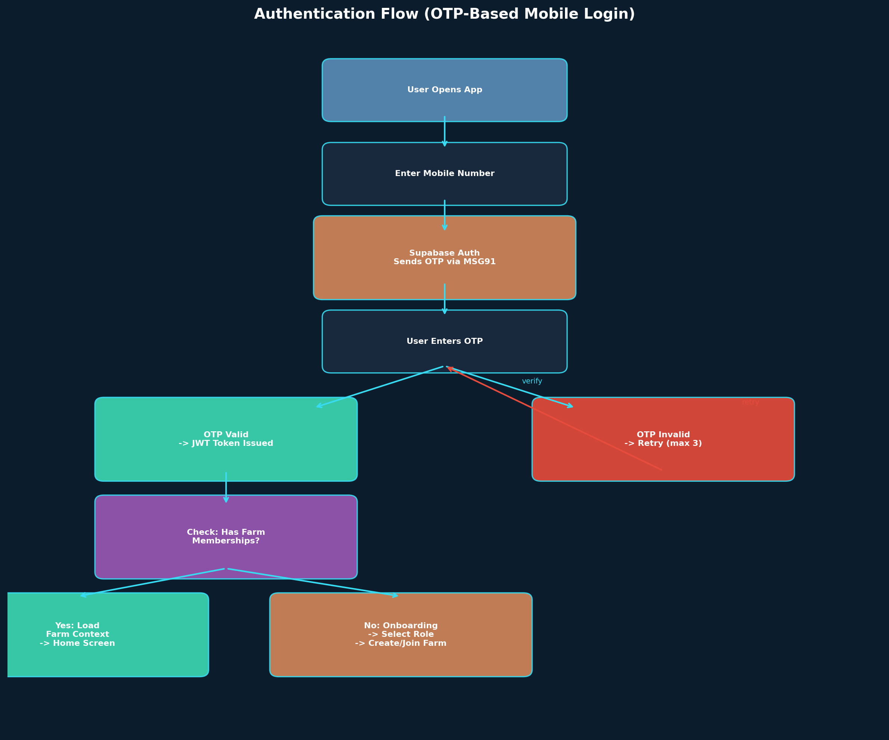
Figure 3: Authentication Flow

6.3 Authentication Flow Steps
Step 1: User enters 10-digit mobile number. The app validates the format (starts with 6-9, exactly 10 digits) before making any API call.
Step 2: The NestJS backend calls Supabase Auth signInWithOtp, which triggers an SMS via MSG91 to the provided number. The OTP is valid for 60 seconds.
Step 3: User enters the 6-digit OTP. The app calls the verify endpoint. Supabase validates the OTP and returns a JWT access token (1 hour expiry) and refresh token (30 day expiry).
Step 4: The app stores tokens securely using expo-secure-store (not AsyncStorage). The refresh token is used automatically to obtain new access tokens without requiring re-login.
Step 5: After authentication, the app queries farm_memberships for the authenticated user. If memberships exist, the user is taken to the home screen with the most recently accessed farm as the default context. If no memberships exist, the user enters the onboarding flow.

6.4 Session Management
Aspect | Implementation | Notes
Token Storage | expo-secure-store | Encrypted on-device storage; not accessible to other apps
Access Token | 1 hour expiry | Auto-refreshed by Supabase client SDK
Refresh Token | 30 day expiry | On expiry, user must re-authenticate with OTP
Offline Auth | JWT cached locally | App verifies token signature locally for offline operations
Multi-Device | Supported | Same account can be logged in on multiple devices
Logout | Revoke refresh token | Supabase invalidates the refresh token; local tokens cleared

7. Role & Permission System

7.1 The Farm Membership Model
Roles in Upcheck are not global account properties. They are farm-specific memberships stored in the farm_memberships table. This means a single user can have different roles across different farms, and changing a role in one farm has no effect on their role in another farm. This is the correct model for Indian shrimp farming, where a small farm owner might also work as a laborer on a larger neighbor’s farm.
The farm_memberships table enforces a UNIQUE constraint on (user_id, farm_id), ensuring that a user has exactly one role per farm. When a user’s role needs to change, the existing membership record is updated — no new account or migration is needed.

7.2 Complete Permission Matrix
The following matrix enumerates every permission in the system. Each cell indicates whether the role can perform the action. “Y” means yes, “N” means no, and conditional permissions are spelled out explicitly.
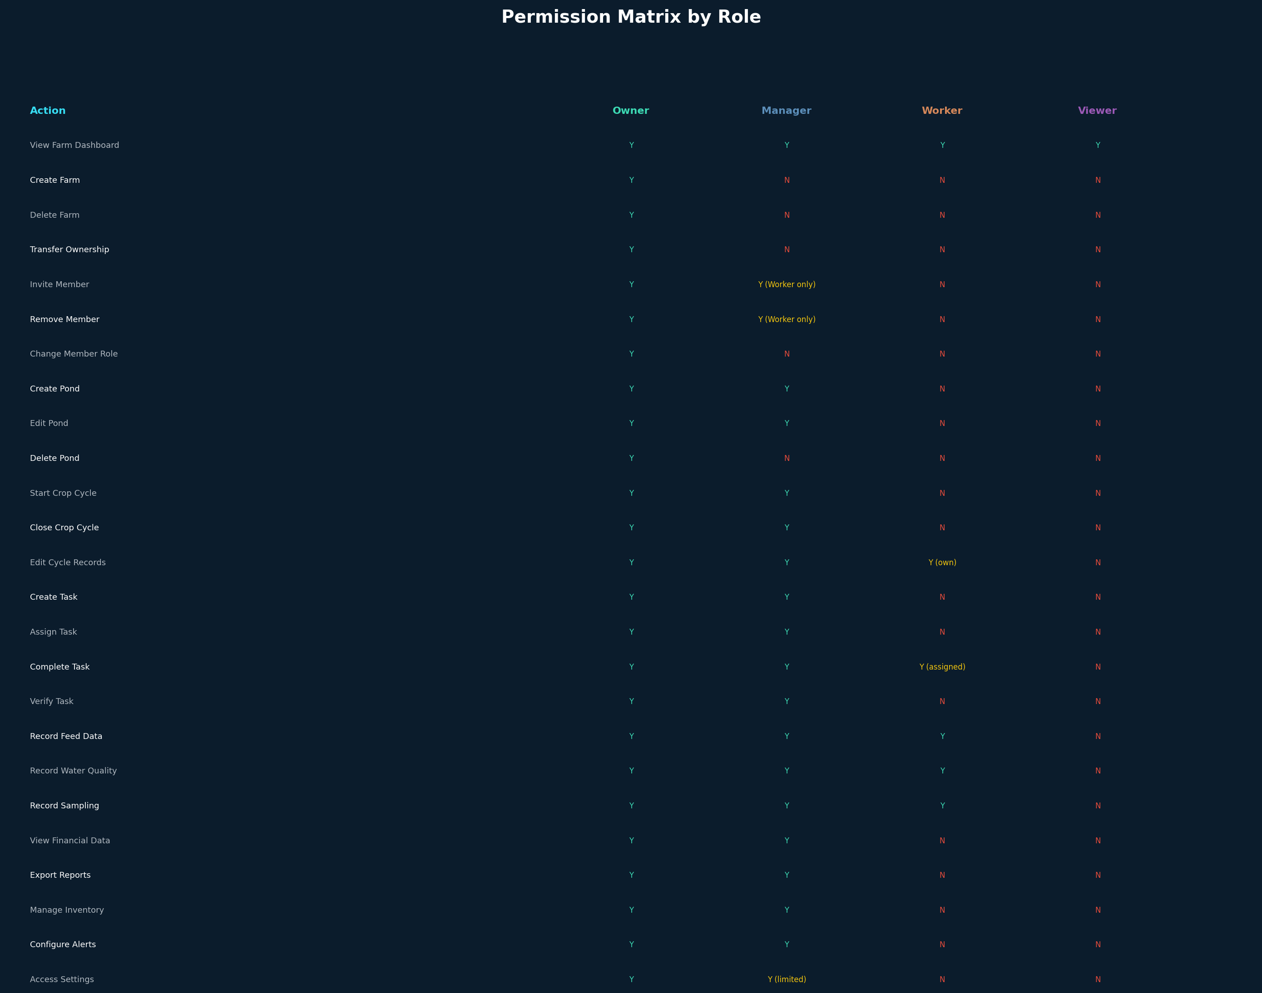
Figure 4: Permission Matrix Visual Overview
Action | Owner | Manager | Worker | Viewer
View Farm Dashboard | Y | Y | Y | Y
Create Farm | Y | N | N | N
Delete Farm | Y | N | N | N
Transfer Farm Ownership | Y | N | N | N
Invite Member (Worker) | Y | Y | N | N
Invite Member (Manager+) | Y | N | N | N
Remove Member (Worker) | Y | Y | N | N
Remove Member (Manager+) | Y | N | N | N
Change Member Role | Y | N | N | N
Create Pond | Y | Y | N | N
Edit Pond Details | Y | Y | N | N
Delete Pond | Y | N | N | N
Start Crop Cycle | Y | Y | N | N
Close Crop Cycle | Y | Y | N | N
Edit Cycle Records (own) | Y | Y | Y | N
Edit Cycle Records (others) | Y | Y | N | N
Create Task | Y | Y | N | N
Assign Task to Worker | Y | Y | N | N
Complete Assigned Task | Y | Y | Y (own only) | N
Verify Task Completion | Y | Y | N | N
Record Feed Data | Y | Y | Y | N
Record Water Quality | Y | Y | Y | N
Record Sampling Data | Y | Y | Y | N
Record Mortality Data | Y | Y | Y | N
View Financial Data | Y | Y | N | N
Export Reports | Y | Y | N | N
Manage Inventory | Y | Y | N | N
Configure Alert Thresholds | Y | Y | N | N
Access Farm Settings | Y | Y (limited) | N | N

7.3 The Viewer Role
The Viewer role is new to this specification and was absent from the original draft. It exists because real-world shrimp farming involves third parties who need read-only access: bank loan officers monitoring farm performance for loan disbursement, insurance companies verifying crop health for claim processing, feed company representatives checking usage data for account management, and disease consultants reviewing water quality and mortality records for diagnosis. Viewers can see data but cannot create, edit, or delete anything. They also cannot see financial data, which is restricted to Owner and Manager roles.

7.4 Permission Enforcement Architecture
Permissions are enforced at two layers simultaneously. The first layer is Row Level Security (RLS) in PostgreSQL, which ensures that even a compromised API cannot return unauthorized data. The second layer is NestJS route guards, which check the user’s farm membership role before the controller method executes and return a 403 Forbidden response if the action is not permitted. This dual-layer approach provides defense in depth: RLS protects the data layer, and guards protect the API layer.

8. Farm Membership & Multi-Role Resolution
The original draft identified that users can have different roles across different farms but did not answer the critical question: when a user is an Owner of Farm A and a Worker of Farm B, what home screen do they see? This section provides the complete resolution algorithm.

8.1 The Problem
Ravi is the Owner of Farm A (his own farm with 12 ponds) and also works as a Worker on Farm B (his brother’s farm). When Ravi opens the app, should he see the Owner home (farm portfolio, production summary, alerts) or the Worker home (task list for today)? The answer cannot be “show both” because that creates a confusing hybrid screen. The answer cannot be “use Primary Role” because Ravi’s Primary Role is Owner, but he may be opening the app specifically to complete his tasks on Farm B.

8.2 The Resolution Algorithm
The solution is farm-context-based home screens. The app always renders the home screen based on the currently selected farm context, not the user’s global Primary Role. The algorithm works as follows:
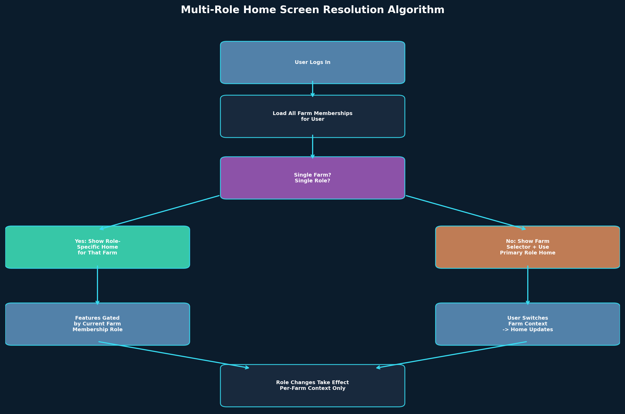
Figure 5: Multi-Role Home Screen Resolution
Step 1: On login, load all active farm_memberships for the user, ordered by most recently accessed.
Step 2: If the user has exactly one farm membership, set that farm as the active context and show the role-specific home for their role in that farm.
Step 3: If the user has multiple farm memberships, set the most recently accessed farm as the active context and show the role-specific home for their role in that farm. Display a farm selector chip at the top of the home screen.
Step 4: When the user switches farm context (via the farm selector or the Farm tab), the entire home screen re-renders based on their role in the newly selected farm. Navigation items, available actions, and data scope all update instantly.
Step 5: The farm context persists across app restarts using WatermelonDB local storage. The user does not need to re-select their farm every time they open the app.

8.3 Context Scoping Rules
UI Element | How It Changes with Farm Context
Home Screen | Owner sees portfolio; Manager sees ops dashboard; Worker sees task list
Tasks Tab | Shows only tasks for the active farm; Worker sees only their assigned tasks
Records Tab | Shows only records for ponds in the active farm
Farm Tab | Lists all accessible farms; highlights the active one
Create Actions | Enabled/disabled based on role in active farm (Worker cannot create ponds)
Notifications | Filtered to alerts relevant to the active farm

9. Offline-First Architecture
This is the single most important architectural decision in the entire system. Shrimp farms operate in rural coastal areas of Andhra Pradesh, Tamil Nadu, Odisha, and Gujarat where 4G connectivity ranges from unreliable to nonexistent. A worker recording a feed event at 6:00 AM from a pond bund cannot wait for a network connection. If the app requires internet to submit data, workers will revert to notebooks immediately and the entire value proposition collapses.

9.1 Offline Strategy Overview
The app uses WatermelonDB as its local database layer, backed by SQLite on the device. All read and write operations target the local database first. When the device has connectivity, a background sync process pushes pending mutations to the server and pulls remote updates. The user never sees a “loading” spinner while waiting for a network request on data that is already available locally.
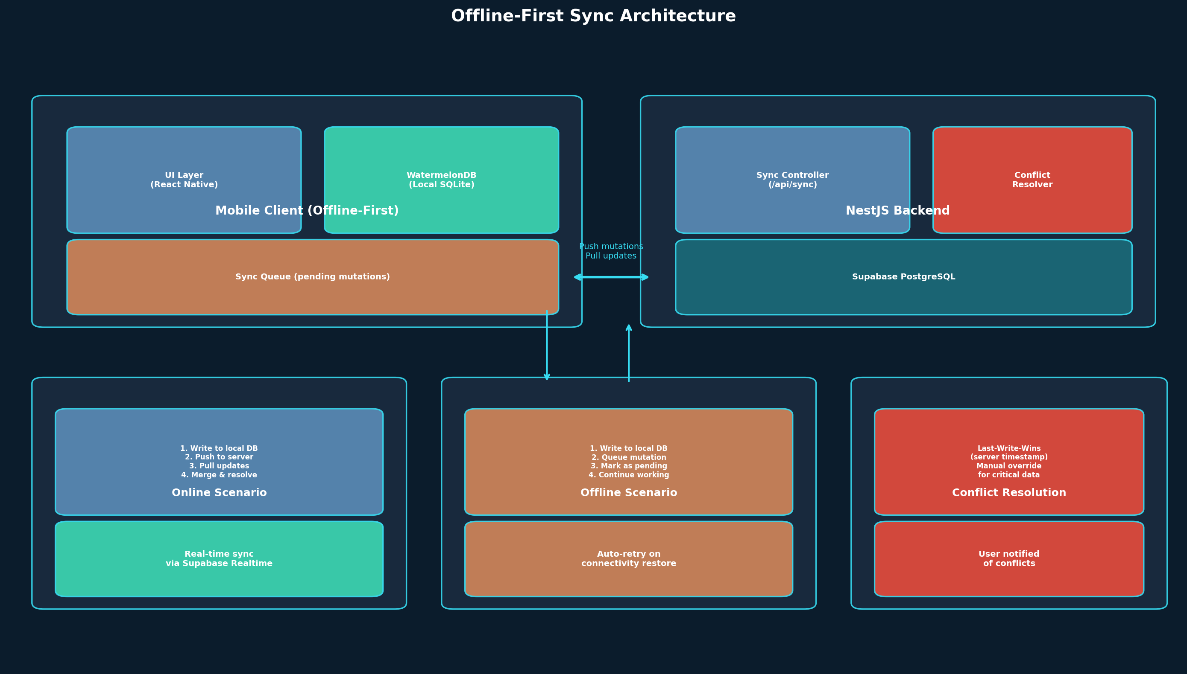
Figure 6: Offline-First Sync Architecture

9.2 Local Data Schema
WatermelonDB mirrors the server-side PostgreSQL schema with some differences for offline optimization. Every table includes two additional columns: _status (created, updated, deleted, synced) and _changed (comma-separated list of modified column names). These are used by the sync engine to determine what needs to be pushed to the server.
Not all data is cached locally. The full offline dataset includes: farms the user is a member of, ponds in those farms, active and recently completed crop cycles, tasks assigned to or created by the user, the last 30 days of feed, water quality, and sampling records, and unread alerts. Historical data beyond 30 days is fetched on-demand when the user navigates to it and is not cached for offline access.

9.3 Sync Protocol
The sync protocol is pull-based with push-on-mutation. When the app detects network connectivity (using NetInfo from @react-native-community/netinfo), it initiates a sync cycle:
Step 1: Push Phase — The app sends all pending mutations (created, updated, deleted records) to the NestJS sync endpoint. Each mutation includes the record ID, table name, changed columns, and the local timestamp.
Step 2: Pull Phase — The app requests all changes from the server since the last sync timestamp. The server returns a batch of records that have been created, updated, or deleted since that timestamp, scoped to the user’s farm memberships via RLS.
Step 3: Merge Phase — The app merges remote changes into the local database. For records that were not modified locally, this is a simple overwrite. For records that were modified both locally and remotely, the conflict resolution strategy applies.

9.4 Conflict Resolution
The default conflict resolution strategy is Last-Write-Wins (LWW) using server timestamps. When a conflict is detected (the same record was modified both locally and remotely between syncs), the server’s version wins because the server timestamp is authoritative. The local change is preserved in a conflict log that the user can review.
For critical data (feed records, mortality records, water quality readings), the app also supports manual conflict resolution. When a conflict is detected on a critical record, the app displays a notification to the user showing both versions and asking which one to keep. This prevents accidental data loss in situations where a worker’s offline observation might be more accurate than a manager’s later edit.

9.5 Sync Error Handling
Error Scenario | Handling Strategy | User Impact
Network timeout during push | Retry with exponential backoff (1s, 2s, 4s, 8s, max 5 retries) | None — mutation stays in queue
Server rejects mutation (403) | Remove from queue; show error notification | User notified of permission issue
Server rejects mutation (409 conflict) | Apply conflict resolution | Possible data override with notification
Device storage full | Stop syncing; show storage warning; suggest clearing old data | New records still saved locally
Token expired during sync | Attempt refresh; if refresh fails, queue mutation and prompt re-login | Prompted to re-authenticate

10. Localization Strategy
The original draft had zero mention of multi-language support. This is a critical omission for an app targeting Indian shrimp farmers, whose working language on the farm is Telugu, Tamil, Odia, Bengali, or Gujarati — not English. A farm worker in West Godavari district reading “Biomass Estimates” or “Active Cycles” in English will not engage with the app. Localization is not optional; it is existential.

10.1 Language Support Phases
Phase | Languages | Rationale | Timeline
V1 Launch | English + Telugu | AP is the largest shrimp farming state; Telugu is the primary language of operations there | Weeks 1–10
V2 Launch | Add Tamil | Tamil Nadu is the second largest shrimp farming state; significant aquaculture in Nagapattinam district | Weeks 11–18
V3 Launch | Add Odia + Bengali | Odisha and West Bengal are growing shrimp farming states with government push for aquaculture | Weeks 19–28
V4 Launch | Add Gujarati | Gujarat has emerging aquaculture in the Saurashtra region | Weeks 29–40

10.2 Technical Implementation
Localization uses i18next with expo-localization for device language detection. Language resource files are JSON files stored in the app bundle under locales/{lang}/translation.json. The app detects the device language on first launch and offers it as the default if supported, falling back to English otherwise.
- i18next for runtime translation — handles interpolation, pluralization, and fallback chains
- expo-localization for device language detection — reads system locale on app launch
- JSON resource files per language — simple key-value structure, easy for translators to edit
- Dynamic language switching — user can change language in Settings without restarting the app
- Fallback chain: selected language → English — missing keys fall back to English translation

10.3 Translation Key Strategy
All user-facing strings in the app use i18next translation keys. No string literals appear in component code. Keys are organized by feature module: home.*, tasks.*, ponds.*, cycles.*, auth.*, common.*. This allows partial translations to be shipped (e.g., if Telugu translation covers 90% of keys and English covers the remaining 10% via fallback) without blocking a release.

10.4 Localization Considerations for Aquaculture Terms
Shrimp farming has domain-specific terminology that does not always have direct translations. The translation strategy handles this as follows: technical terms that are commonly used in English on farms (e.g., “FCR”, “DOC”, “PL”) are kept as-is in all languages because farmers use these abbreviations. Descriptive terms (e.g., “Feed Conversion Ratio”) are translated with the English abbreviation in parentheses. UI labels (e.g., “Add Feed Record”) are fully translated into the local language.

11. UI/UX Philosophy & Navigation

11.1 Replacing the “More” Tab
The original draft used a bottom navigation with Home, Tasks, Farms, and More. The “More” tab is a known anti-pattern in mobile app design — it becomes a graveyard for features that have no natural home, and within two versions it becomes unnavigable. This specification replaces it with a “Records” tab that serves as the home for all data entry and historical data access, which is the primary action in V1.
The revised bottom navigation is: Home, Tasks, Records, Farm. The Farm tab doubles as the entry point to settings and member management, which are accessed from the farm detail screen rather than from a separate settings screen. This keeps all farm-related actions in one place and avoids the “More” dumping ground.

11.2 Bottom Navigation Structure
Tab | Icon | Owner Sees | Manager Sees | Worker Sees
Home | House | Farm portfolio, production summary, critical alerts | Today’s operations, pending tasks, worker status | My tasks for today, quick record button
Tasks | CheckSquare | All farm tasks + create task FAB | Assigned + unassigned tasks + create task FAB | My assigned tasks only, sorted by due time
Records | Clipboard | All records (feed, water, sampling, mortality) | All records for managed ponds | Record entry forms + recent entries
Farm | Building2 | Farm list, pond list, settings, members, invite | Farm detail, pond list, member list | Farm selector, pond list (read-only)
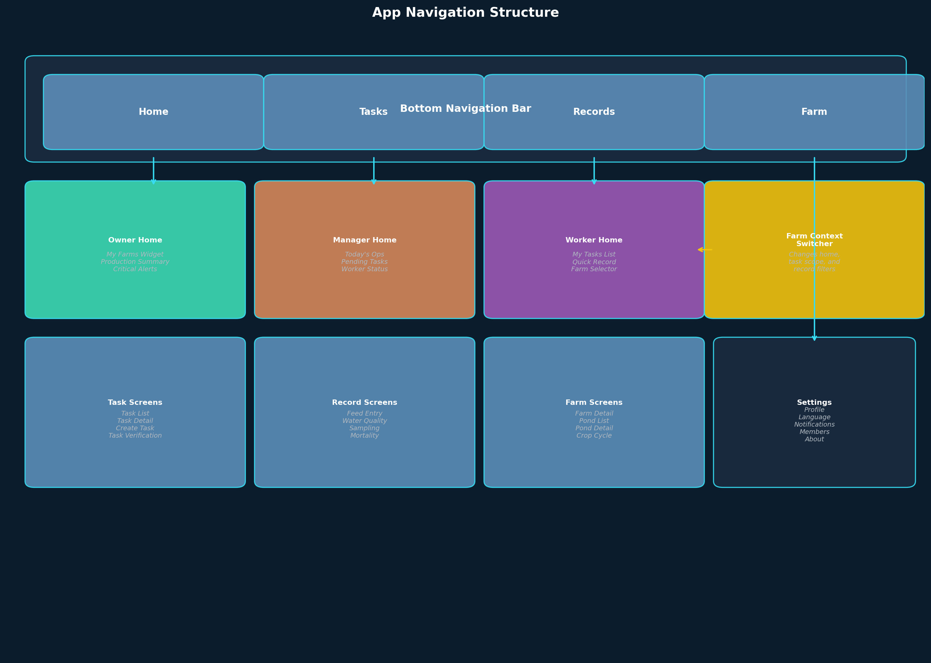
Figure 7: App Navigation Structure

11.3 Role-Adaptive Home Screens
The home screen is the most important screen in the app because it answers the question: “What should I care about right now?” Different users have fundamentally different priorities, and the home screen must reflect this immediately.

Owner Home Screen
The Owner home screen shows a portfolio view across all owned farms. It prioritizes high-level metrics and alerts over operational details. The specific widgets, in order of display priority:
- Farm Selector Chip (if multiple farms) — tap to switch farm context
- Critical Alerts Banner — red banner showing unresolved critical alerts across farms
- My Farms Card List — each farm card shows: name, pond count, active cycle count, alert count
- Production Summary — total biomass across all farms, total feed consumed, average FCR (computed from completed cycles)
- Active Cycles Overview — list of currently active cycles with DOC and estimated biomass
- Quick Actions Row — Add Pond, Start Cycle, Invite Member buttons

Manager Home Screen
The Manager home screen focuses on daily operations and team oversight. It answers: “What needs my attention today?”
- Farm Selector Chip (if managing multiple farms)
- Today’s Operations — scheduled tasks for today grouped by type (feed, water test, sampling)
- Pending Tasks — count of unassigned and overdue tasks
- Worker Summary — number of active workers, tasks completed today, tasks remaining
- Recent Alerts — unresolved warnings and critical alerts
- Quick Actions Row — Create Task, Record Entry, Assign Task

Worker Home Screen
The Worker home screen is the simplest screen in the app. It must be usable within 60 seconds of first opening the app, with zero training. It answers: “What do I need to do now?”
- Current Farm Name (tap to switch if multiple memberships)
- My Tasks Today — list of tasks due today, sorted by time window, with completion buttons
- Quick Record Button — large floating action button for recording feed, water quality, or observations
- Completed Today — count of tasks completed today (motivational)

11.4 Low-End Device Constraints
The majority of farm workers use entry-level Android devices priced between 6,000 and 10,000 INR, with 2GB RAM, weak processors, and small screens (5.0–5.5 inches). The app must perform well on these devices. The following constraints are enforced:
Constraint | Implementation | Rationale
Max 2 API calls on home load | Batch requests; use local DB for initial render | Avoid spinner on slow 3G connections
No heavy charts on worker screens | Worker views use numbers and lists only | Chart rendering is CPU-intensive on low-end devices
Skeleton loading, not spinners | Show content placeholders while data loads from local DB | Perceived performance is better than spinner
Image compression on upload | Compress photos to 800px max dimension before upload | Reduce storage and bandwidth; photos are for reference, not print
Lazy load non-critical data | Historical records load on scroll, not on screen mount | Avoid loading 90 days of data the user may never scroll to
Minimize re-renders | Use Zustand selectors; WatermelonDB observables with memo | React Native re-renders are expensive on weak processors
Target <3s cold start | Splash screen while local DB initializes | Workers will close the app if it takes too long to open

12. App Flow: Opening to Daily Use
This section traces the complete user journey from opening the app for the first time to performing daily operations. It covers three distinct flows: first-time onboarding, daily startup, and routine operations for each role.

12.1 First-Time Onboarding Flow
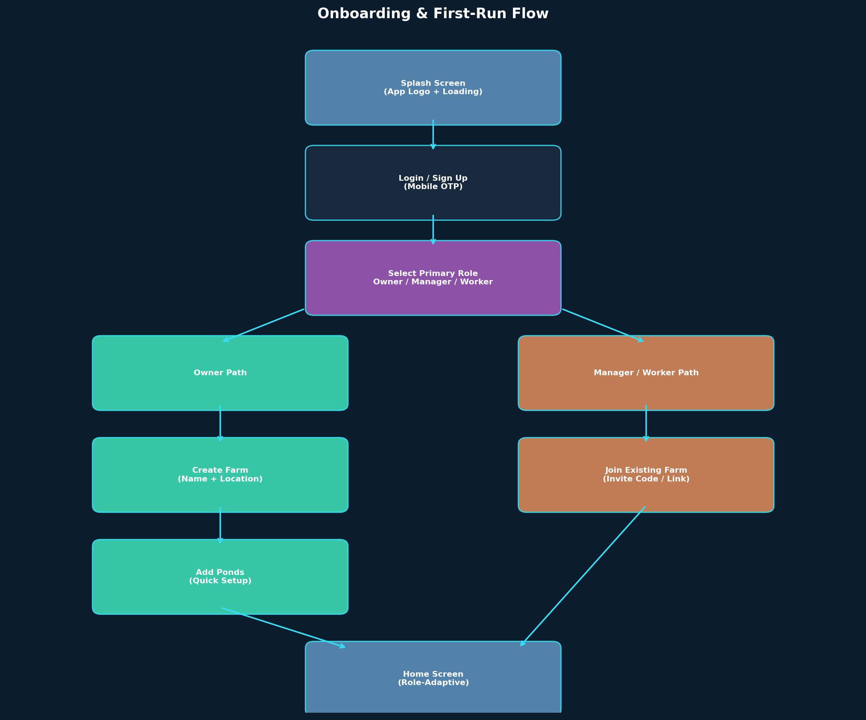
Figure 8: Onboarding & First-Run Flow
The onboarding flow is designed to get the user to their home screen in under 90 seconds. It collects only the information absolutely necessary and defers everything else to in-app settings.
Step 1 — Splash Screen: The app logo displays for 2 seconds while WatermelonDB initializes and the cached auth token is checked. If a valid token exists, skip to Step 5.
Step 2 — Login: User enters their 10-digit mobile number. OTP is sent via MSG91. User enters the 6-digit OTP. On verification, a JWT is issued and cached.
Step 3 — Role Selection: User is asked “What best describes you?” with three options: Farm Owner, Farm Manager, Farm Worker. This sets primary_role which controls the default onboarding path. It does NOT set permissions.
Step 4 — Farm Setup: Owners are taken to “Create Your Farm” (name, location). Managers and Workers are taken to “Join a Farm” (enter invite code or scan QR). Owners can also skip farm creation and join an existing farm if they were invited.
Step 5 — Home Screen: Based on role in the farm, the appropriate home screen is displayed. For owners who just created a farm, a prompt to add their first pond appears.

12.2 Daily Startup Flow
For returning users, the flow is: Splash (2s, token check) → Home Screen (loaded from local DB). No network call is needed to render the home screen. All data displayed comes from the local WatermelonDB cache. Background sync runs silently after the home screen is visible, updating data in place as responses arrive.

12.3 Owner Daily Operations
- Check home screen for critical alerts across farms
- Switch farm context if managing multiple farms
- View production summary — total biomass, FCR trends, active cycles
- Add a new pond (name, area, depth)
- Start a new crop cycle on a pond (stocking date, PL count, seed supplier)
- Invite a manager or worker via mobile number (sends SMS invite link)
- Review and verify completed tasks
- Record feed, water quality, or sampling data directly (owners can also record)
- View reports for a specific cycle (FCR timeline, growth curve, feed breakdown)

12.4 Manager Daily Operations
- Check today’s operations on home screen
- Create tasks for workers (feed pond, water test, sampling, aerator check)
- Assign tasks to specific workers with time windows
- Monitor task completion — see which tasks are overdue
- Verify completed tasks (review attached data or photos)
- Record operational data (feed, water quality) on behalf of workers if needed
- Respond to alerts — low DO, abnormal mortality, missed feeds
- Review worker activity logs

12.5 Worker Daily Operations
- Open app → see “My Tasks Today” immediately
- Tap a task to see details (which pond, what to do, time window)
- Complete a task by tapping “Done” — may require entering data (feed quantity, DO reading) or attaching a photo
- Use Quick Record button to log feed, water quality, or observations outside of assigned tasks
- View completed tasks for today (count and list)
The worker flow is deliberately minimal. Workers should never need to navigate beyond the Home and Tasks tabs. The Records tab is available for entering unscheduled observations, but the primary workflow is task-driven.

13. Core Feature: Farm Management

13.1 Farm Creation
Farm creation is available only to users with a primary_role of OWNER (or any user who later gains Owner membership in a farm). The creation flow collects: farm name (required, 3-50 characters), location (optional, free-text village/district/state), and the creating user automatically becomes the farm’s owner via a farm_memberships record with role=OWNER.
After creation, the owner is prompted to add their first pond. This is a soft prompt, not a blocking modal — the owner can dismiss it and add ponds later from the Farm tab.

13.2 Farm Settings
Farm settings are stored in the settings jsonb column of the farms table. This allows flexible configuration without schema changes. The default settings object includes:
Setting Key | Type | Default | Description
alert_thresholds.do_low | number | 3.0 | Dissolved oxygen below this triggers a CRITICAL alert (mg/L)
alert_thresholds.ammonia_high | number | 1.0 | Ammonia above this triggers a WARNING alert (ppm)
alert_thresholds.mortality_daily | number | 50 | Daily mortality above this count triggers WARNING alert
default_language | string | en | Farm-level default language override (per-user pref takes priority)
time_zone | string | Asia/Kolkata | Timezone for scheduling and timestamps
feeding_slots | array | ["06:00","10:00","14:00","18:00"] | Default feeding time windows for recurring task creation

13.3 Member Invitation Flow
The invitation flow resolves a gap in the original draft, which stated that owners “invite managers” and “invite workers” but did not define how invitations work. The flow is as follows:
Step 1: The inviter enters the invitee’s 10-digit mobile number and selects the target role (Worker, Manager, or Viewer). Owners can invite any role. Managers can only invite Workers.
Step 2: The backend checks that the inviter has permission to invite the target role for this farm. It creates a farm_memberships record with status=PENDING and an invitation record containing a unique invite code.
Step 3: An SMS is sent to the invitee’s mobile number via MSG91, containing a deep link to the app with the invite code. If the invitee already has the app installed, the deep link opens it directly to the invitation acceptance screen.
Step 4: The invitee opens the link, reviews the farm name and role, and accepts or declines. On acceptance, the membership status changes to ACTIVE and the invitee gains access to the farm.

13.4 Ownership Transfer
Ownership transfer is a sensitive operation that requires explicit confirmation from both parties. The current owner initiates the transfer by selecting a new owner from the farm’s active members (must be an existing Manager or Owner-level member). The new owner receives a confirmation prompt. On confirmation, the current owner’s membership role changes to MANAGER (or their choice of role), and the new owner’s membership changes to OWNER. The farms.owner_id column is also updated. This operation is logged in an audit trail.

13.5 Member Offboarding
When a member is removed from a farm (by the owner, or by a manager removing a worker), their farm_memberships record is updated to status=REMOVED with the removed_at timestamp. They lose access to the farm immediately. Their previously created records (feed entries, water quality readings, etc.) remain in the farm’s data with their recorded_by field intact — data ownership belongs to the farm, not the individual. The removed member can no longer view or edit any data in that farm.

14. Core Feature: Pond Management
Ponds are permanent physical entities within a farm. Unlike crop cycles which have a defined start and end, ponds persist across cycles. A pond can have zero or one active crop cycle at any given time, and multiple historical cycles. This model enables performance comparison across cycles for the same pond.

14.1 Pond Detail Screen
The pond detail screen is the operational center of the platform. It aggregates all data and actions related to a single pond. The screen layout is:
- Pond header: name, area, depth, current status (empty, active cycle with DOC, or between cycles)
- Active Cycle Card: if a cycle is active, shows DOC, estimated biomass, FCR to date, days since last sampling
- Quick Actions: Record Feed, Record Water Quality, Record Sampling, View Full History
- Recent Records: last 5 entries across all record types, sorted by timestamp
- Alert History: alerts triggered for this pond
- Cycle History: list of all completed cycles with key metrics (FCR, survival rate, harvest biomass)

14.2 Pond CRUD Operations
Operation | Who Can Perform | Required Fields | Notes
Create Pond | Owner, Manager | Name (required), Area, Depth, Type | Pond name must be unique within the farm
Edit Pond | Owner, Manager | Any updatable field | Changes to area/depth do not affect active cycle data
Delete Pond | Owner only | Confirmation prompt | Soft delete (is_active=false); only allowed if no active cycle
View Pond | All members | None | Workers see limited details (no financial data)

15. Core Feature: Crop Cycle Management
The crop cycle is the temporal heart of the platform. Every operational record — feed, water quality, sampling, mortality, disease treatment — belongs to a crop cycle. The original draft’s cycle data model was critically incomplete, missing FCR, DOC, mortality records, disease treatments, and survival rate. This specification provides the complete aquaculture data model.
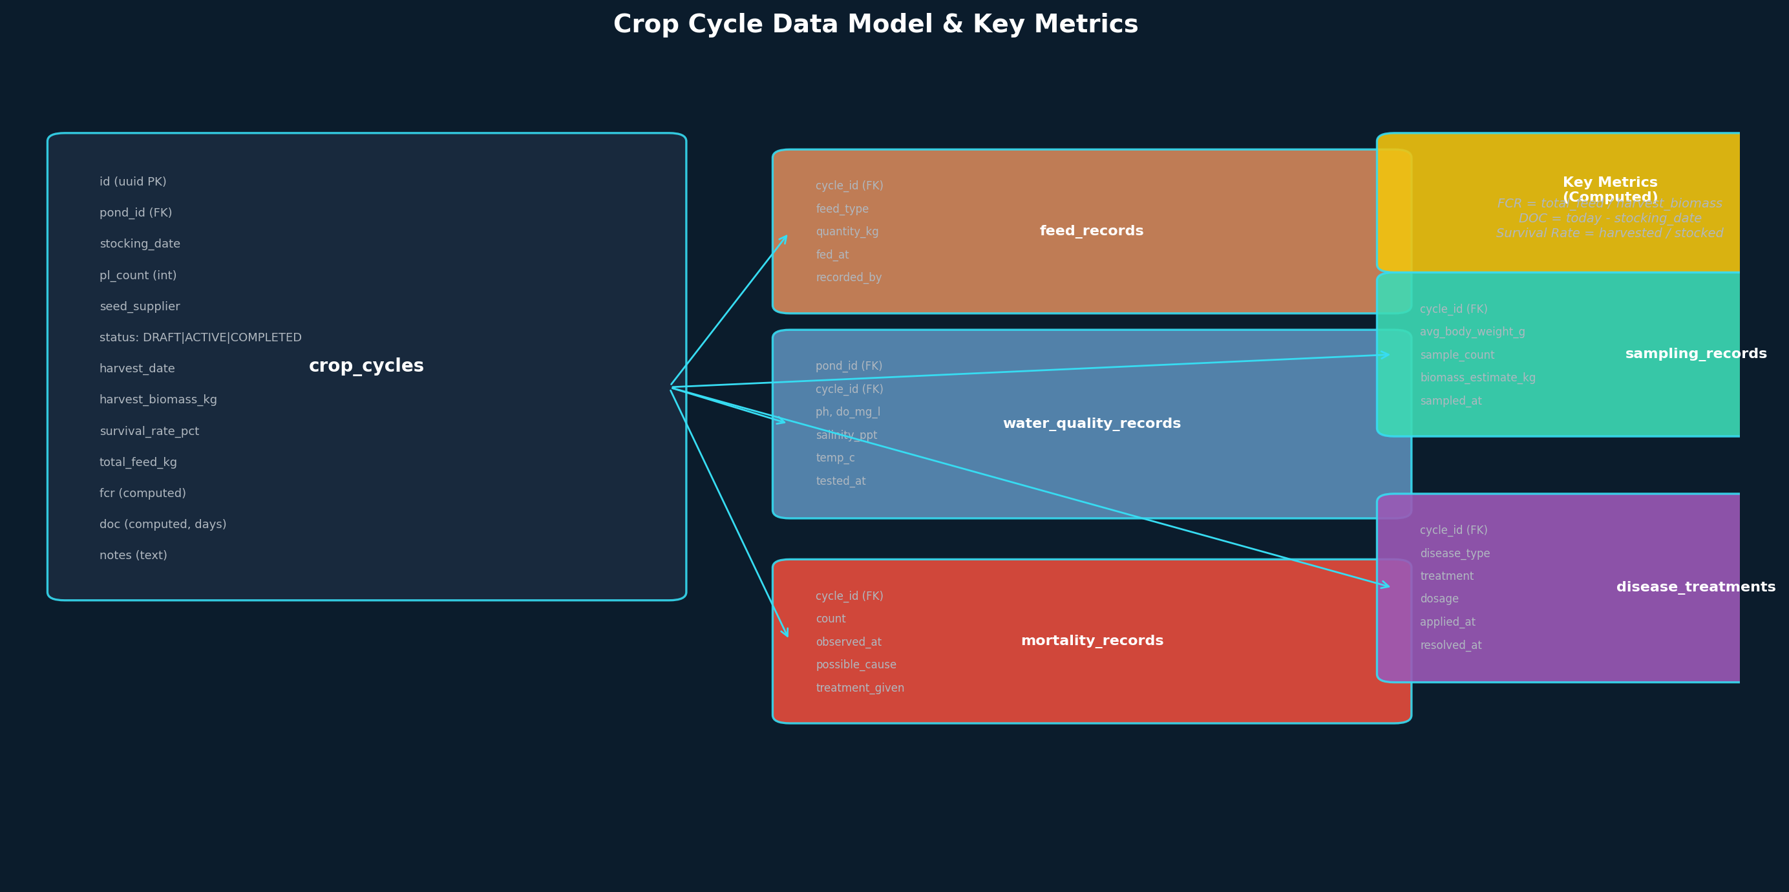
Figure 9: Crop Cycle Data Model & Key Metrics

15.1 Cycle Lifecycle
A crop cycle has four states: DRAFT, ACTIVE, COMPLETED, and ABORTED. The typical flow is:
- DRAFT: Owner or Manager creates a cycle with stocking details. The cycle is not yet visible on the pond dashboard.
- ACTIVE: When the stocking date arrives (or is manually confirmed), the cycle becomes active. The pond’s current_cycle_id points to this cycle. All new records for this pond are associated with this cycle.
- COMPLETED: When the harvest is complete, the cycle is closed. Final metrics (harvest biomass, survival rate, total feed, FCR) are computed and locked. No more records can be added to a completed cycle.
- ABORTED: If the cycle is terminated early (disease outbreak, mass mortality, market conditions), the cycle is aborted with a reason. All existing records are preserved.

15.2 Critical Aquaculture Metrics
Metric | Formula / Source | Typical Range | Importance
DOC (Days of Culture) | current_date - stocking_date | 0–120 days | Every operational decision is referenced against DOC
FCR (Feed Conversion Ratio) | total_feed_kg / harvest_biomass_kg | 1.2–1.8 (good), >2.0 (poor) | Most watched metric; determines profitability
Survival Rate | (harvested_count / pl_count) * 100 | 60–85% | Indicates overall cycle health
ADG (Average Daily Gain) | (current_avg_weight - previous_avg_weight) / days_between | 0.3–0.5 g/day | Growth rate tracking; feed adjustment signal
Biomass Estimate | pl_count * survival_pct * avg_body_weight / 1000 | Varies | Used for feed quantity calculations
Daily Mortality | count from mortality_records | 0–10 (normal), >50 (alert) | Early disease detection

15.3 Disease Treatment Records
Disease treatment records are a new data model introduced by this specification, absent from the original draft. They are both operationally critical (farmers need to know what was applied, when, and at what dosage) and legally important (export markets require documentation of all chemical treatments applied to shrimp). The disease_treatments table stores: disease_type (text description), treatment (product name), dosage (amount and unit), application_method (pond-wide, feed-mixed, etc.), applied_at (timestamp), resolved_at (timestamp, nullable if ongoing), and recorded_by (FK to users).

16. Core Feature: Disease Encyclopedia
Disease outbreaks are the single largest cause of financial loss in Indian shrimp farming. A single White Spot Syndrome Virus (WSSV) outbreak can wipe out an entire pond within 7–10 days, costing a farmer lakhs of rupees. The Disease Encyclopedia is therefore not a nice-to-have reference feature — it is an operational necessity that must be available offline, in the farmer’s language, and integrated into the daily workflow so that disease identification happens in minutes rather than days.
The original draft made no mention of disease management. This specification introduces a complete Disease Encyclopedia module: a bundled database of common shrimp diseases with symptoms, causes, prevention, and treatment protocols; a symptom-based diagnostic flow that suggests likely diseases from observed signs; integration with the mortality_records and disease_treatments tables so that diagnoses are linked to actual farm events; and an optional expert consultation channel for cases that cannot be self-diagnosed.
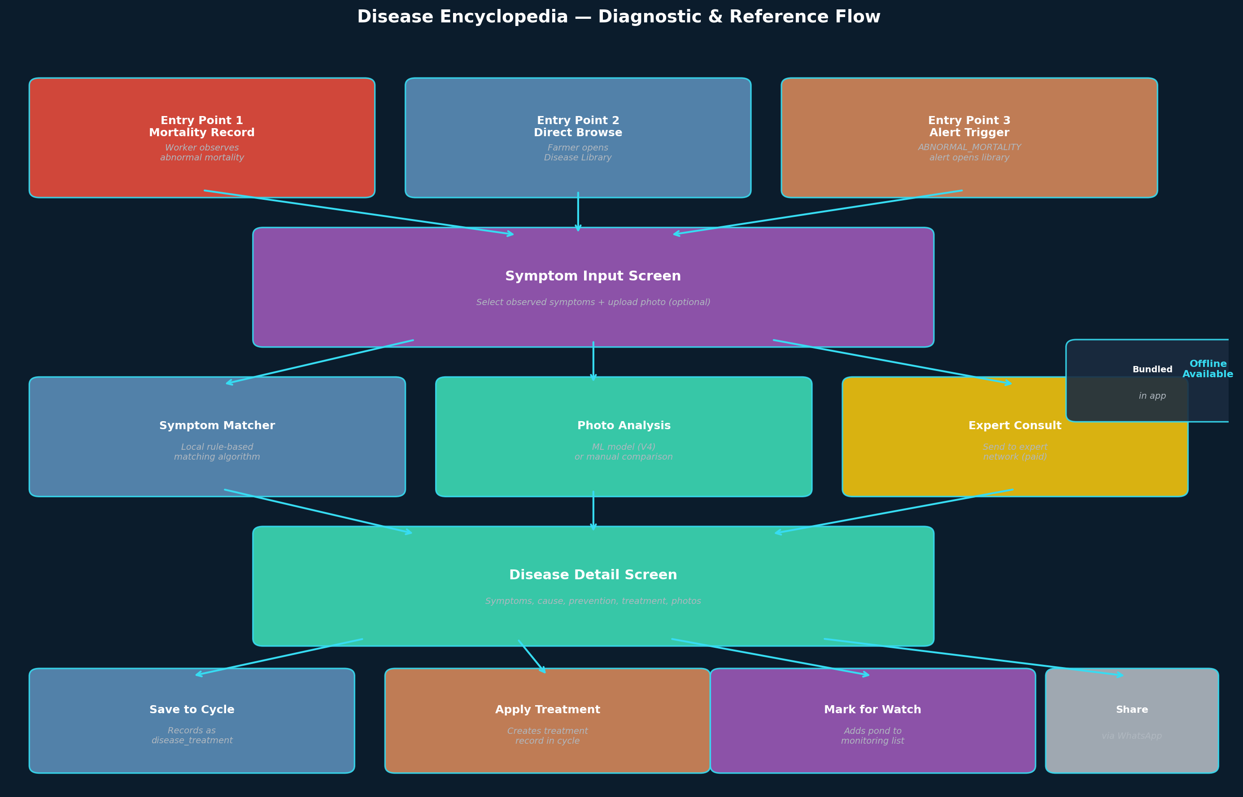
Figure 10: Disease Encyclopedia Diagnostic Flow

16.1 Disease Database Content
The encyclopedia ships with curated content for the most economically significant diseases affecting L. vannamei and P. monodon farming in India. Each disease entry includes: disease name (English + scientific), local language names where commonly used (e.g., “వైట్ స్పాట్” in Telugu), causal agent (virus, bacteria, parasite, environmental), affected species, typical DOC range when outbreaks occur, clinical signs (visible symptoms), behavioral signs (feeding reduction, swimming pattern), prevention measures, treatment options (with disclaimer that treatment should be confirmed by an expert), photo gallery showing typical symptoms, and severity classification (outbreak risk level).
Disease | Causal Agent | Severity | Typical DOC | Mortality Risk
White Spot Syndrome (WSSV) | Virus (Whispovirus) | CRITICAL | 20–60 days | 80–100% within 7–10 days
Early Mortality Syndrome (EMS/AHPND) | Bacteria (V. parahaemolyticus) | CRITICAL | 10–40 days | up to 100% in acute phase
Enterocytozoon hepatopenaei (EHP) | Microsporidian parasite | HIGH | 30–90 days | Chronic; 20–60% growth retardation
White Feces Syndrome (WFS) | Bacterial + environmental | HIGH | 40–80 days | 10–30% with secondary infections
Vibriosis | Bacteria (Vibrio spp.) | MEDIUM | Any DOC | 20–70% if untreated
Black Gill Disease | Fungal + environmental | MEDIUM | 30–60 days | 5–20% chronic
Infectious Myonecrosis (IMNV) | Virus | HIGH | 60–100 days | 20–70% cumulative
White Muscle Disease | Nutritional + viral | MEDIUM | Any DOC | 10–40% if untreated
Taura Syndrome (TSV) | Virus | HIGH | 20–40 days | 40–90% in acute phase
Yellow Head Disease (YHD) | Virus | CRITICAL | 50–70 days | 80–100% within 3–5 days

16.2 Disease Encyclopedia Data Model
The encyclopedia content is bundled with the app (JSON files in the app bundle) so it works offline without any network call. The same content is mirrored in a server-side PostgreSQL table for the web admin (where aquatic experts can update the encyclopedia and push updates via OTA app updates).
Table | Key Columns | Purpose
disease_encyclopedia | id, name_en, name_scientific, name_local (jsonb for multi-lang), causal_agent, severity, typical_doc_min, typical_doc_max, description (jsonb), prevention (jsonb), treatment (jsonb), photo_urls (jsonb), last_updated | Master disease reference
disease_symptoms | id, disease_id (FK), symptom_text (jsonb), symptom_category (BEHAVIORAL/PHYSICAL/ENVIRONMENTAL), photo_url, is_primary | Symptoms per disease
disease_diagnoses | id, cycle_id (FK), pond_id (FK), disease_id (FK nullable), observed_symptoms (jsonb), photo_urls (jsonb), suggested_diseases (jsonb ranked), expert_consulted (bool), confirmed_by (FK users nullable), diagnosed_at | Records each diagnostic session
expert_consultations | id, diagnosis_id (FK), expert_id (FK), consultation_status (PENDING/ACCEPTED/RESOLVED), expert_response (text), fee_charged, requested_at, resolved_at | Links to expert network

16.3 Disease Library Screen
The Disease Library is accessible from multiple entry points: directly from the Records tab (Disease Library section), from any mortality record creation flow (a “Need help identifying?” link), and from alert notifications when an ABNORMAL_MORTALITY alert is triggered. The library screen has three sections:
- Search bar with autocomplete on disease name (English + local language) and symptom keywords
- Categorized list of diseases sorted by severity (CRITICAL first), with quick visual indicators (red/orange/yellow badges)
- Filter chips by species, DOC range, and symptom category
Tapping a disease opens the Disease Detail screen which has scrollable sections: overview, symptoms (with photos), cause, prevention, treatment, similar diseases, and a “Report this in my pond” button that creates a disease_diagnosis record pre-filled with the selected disease.

16.4 Symptom-Based Diagnostic Flow
The diagnostic flow is the most-used feature of the encyclopedia. It is accessible from mortality record creation (“Need help identifying?” link), from alert notifications, and from a standalone “Diagnose” button in the Records tab. The flow is:
Step 1 — Symptom Selection: User is presented with a multi-select checklist of common symptoms grouped by category (Physical: white spots, red discoloration, soft shell, black gills, swollen body; Behavioral: reduced feeding, lethargy, swimming at surface, cannibalism; Environmental: low DO, high ammonia, abnormal water color). Tapping a symptom may show a reference photo for confirmation.
Step 2 — Photo Upload (Optional): User can attach up to 3 photos of affected shrimp. Photos are uploaded to Supabase Storage and linked to the diagnosis record. In V4, these photos will be processed by an ML model for automated disease detection.
Step 3 — Suggestion Ranking: A local rule-based matching algorithm ranks diseases by symptom overlap. Each disease has a weighted symptom profile (primary symptoms weight 3, secondary symptoms weight 1). The algorithm computes a match score for each disease and returns the top 3 suggestions with confidence percentages.
Step 4 — Result Screen: Top 3 matching diseases are displayed with confidence scores, key symptoms to verify, and links to full disease detail pages. The user can confirm one of the suggestions (creating a confirmed diagnosis), dismiss all and consult an expert (creating an expert_consultations record), or save as inconclusive.
Step 5 — Action: After confirmation, the user is prompted to record a treatment in the disease_treatments table linked to the active crop cycle. The diagnosis is also linked to the triggering mortality_record (if the flow was entered from a mortality entry).

16.5 Expert Consultation Channel
Not all diseases can be self-diagnosed. The expert consultation channel allows a farmer to escalate a diagnosis to a network of aquaculture experts (veterinarians, fisheries consultants, hatchery technical staff). The flow is: user submits the diagnosis record (with symptoms, photos, and suggested diseases) to the expert network → the request is routed to available experts → an expert accepts the consultation → expert reviews the case and provides a response (text + optional voice note) → the farmer receives a notification with the expert’s diagnosis and treatment recommendation. A consultation fee is charged to the farmer (via UPI) and shared with the expert. This feature is gated behind V3 launch because it requires expert network partnerships and a payment integration.

16.6 Multilingual Content Strategy
Disease names and descriptions are translated into all five supported languages. The translation strategy handles scientific terminology carefully: scientific names (L. vannamei, V. parahaemolyticus) are kept in Latin across all languages because they are universally used in aquaculture; common English disease names (White Spot, White Feces) are translated where a local name exists, otherwise kept in English with the local transliteration in parentheses; symptom descriptions are fully translated into the local language with photo references that are language-independent.
The encyclopedia content is bundled as JSON resource files in the app under encyclopedias/{lang}/diseases.json. Updates to the encyclopedia are delivered via OTA app updates (Expo Updates) rather than requiring a full app store release. This allows rapid response to new disease outbreaks or updated treatment protocols without app review delays.

16.7 Integration with Existing Modules
Integration Point | Trigger | Action
Mortality Records | User creates mortality record with abnormal count | Show inline prompt: “Need help identifying the cause?” opens diagnostic flow
Alert Engine | ABNORMAL_MORTALITY alert triggered | Notification includes “Open Disease Library” deep link
Crop Cycle | Confirmed disease diagnosis on a cycle | Disease badge appears on cycle dashboard; treatments logged
Reports | Cycle completion | Disease incidents included in cycle summary report
Inventory | Treatment recommended | Check if treatment chemicals are in stock; suggest reorder if low
Notifications | Diagnosis confirmed as CRITICAL disease | Notify all managers and owners in the farm

16.8 Privacy & Data Sharing
Disease diagnoses are private to the farm. They are not shared with other farms, feed companies, or government agencies without explicit farmer consent. However, aggregated and anonymized disease outbreak data (region, month, disease type, but no farm identification) may be shared with research institutions and fisheries departments to support epidemiological surveillance. This sharing requires explicit opt-in from each farmer in the Settings screen and can be revoked at any time.

17. Core Feature: Task Module
The task module is the coordination layer of the platform. It transforms Upcheck from a passive record book into an active operations management tool. The original draft described tasks as a “major operational feature” but the task model was thin — missing recurrence, time windows, verification workflows, data attachments, and priority levels. This specification provides a complete task model.
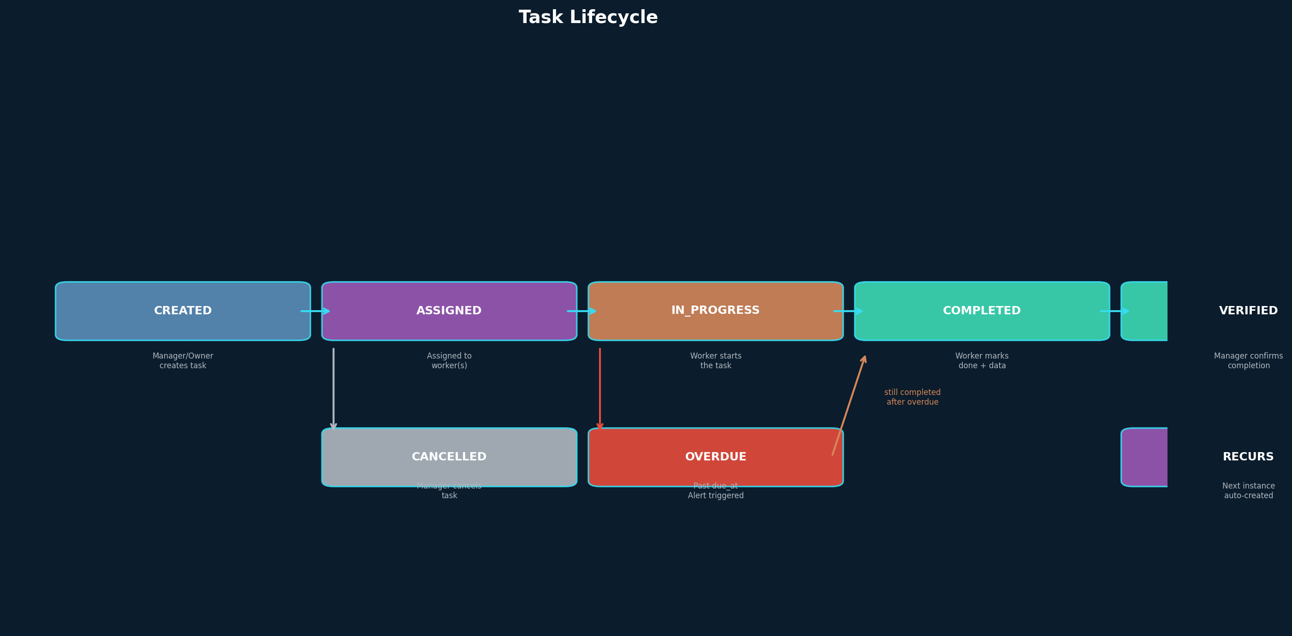
Figure 11: Task Lifecycle State Machine

17.1 Task Types
Task Type | Typical Frequency | Required Data on Completion | Priority Default
FEED | 2–4x daily per pond | Feed type, quantity (kg) | HIGH
WATER_TEST | 1–2x daily per pond | pH, DO, salinity, temperature readings | HIGH
SAMPLING | Weekly or biweekly | Avg body weight, sample count, biomass estimate | NORMAL
AERATOR_CHECK | 2–4x daily | Working/not working, photo if broken | CRITICAL (if not working)
MORTALITY_CHECK | Daily | Dead count, possible cause, photo if unusual | HIGH (if count > threshold)
HARVEST_PREP | Once per cycle | Confirmation checklist | NORMAL
OTHER | As needed | Free-text notes | LOW

17.2 Recurring Tasks
Feeding happens two to four times per day at set times. A task model without recurrence means the manager manually creates hundreds of individual task records. This specification introduces recurring tasks using RFC 5545 RRULE syntax stored in the recurrence_rule column.
When a manager creates a recurring task (e.g., “Feed Pond 3, every day, 6:00 AM–8:00 AM, for 90 days”), the system creates the first task instance immediately and stores the recurrence rule. A scheduled job (NestJS cron) generates upcoming task instances 7 days in advance. Each generated instance has a parent_task_id pointing back to the original recurring task, allowing the manager to edit or cancel the entire series.

17.3 Time Windows
Tasks include time_window_start and time_window_end fields (stored as TIME type, not timestamp). A feeding task with time_window_start=06:00 and time_window_end=07:00 means the worker should perform this task between 6 AM and 7 AM. If the task is not completed by time_window_end, it is marked as OVERDUE and an alert is triggered to the manager. Time windows are critical for operations where timing affects outcomes — late feeding in hot weather can stress shrimp.

17.4 Task Verification Workflow
Task verification is a two-step process. When a worker marks a task as COMPLETED, the task enters a verification queue visible to the manager (or owner). The manager reviews the submitted data (feed quantity, water quality readings, photos) and either verifies the task (status → VERIFIED) or sends it back for correction (status → IN_PROGRESS with a comment). Unverified tasks are flagged in reports. Verification is not mandatory for all task types — it is configurable per task type in farm settings.

17.5 Data Attachments
Tasks are not just checklists — they are data entry forms. Each task type has a required data schema that must be filled in on completion. For FEED tasks, the worker must enter feed type and quantity. For WATER_TEST, the worker must enter pH, DO, and other readings. For MORTALITY_CHECK, the worker can attach a photo of dead shrimp. This data is saved as the corresponding record type (feed_record, water_quality_record, etc.) linked to the task’s pond and active cycle. The task and the record are created together in a single transaction.

17.6 Priority Levels
Priority | Color Code | Behavior | Example
CRITICAL | Red | Immediate notification; alert if not completed within 1 hour of time window | Aerator not working at midnight
HIGH | Orange | Notification at task creation; alert if overdue | Daily feeding, water testing
NORMAL | Blue | Standard task; no proactive alert unless overdue | Weekly sampling, routine checks
LOW | Gray | Can be rescheduled; no alerts | General maintenance, equipment inspection

18. Alert System
The original draft mentioned “2 Alerts” on Farm A and “Critical Alerts” on the Owner Home, but never defined what triggers an alert, what severity levels exist, or who receives them. This specification provides a complete alert definition.

18.1 Alert Triggers & Severity
Alert Type | Trigger Condition | Severity | Who Receives | Auto-Resolve?
LOW_DO | Dissolved oxygen < farm threshold (default 3.0 mg/L) | CRITICAL | Owner, Manager | Yes, when next reading > threshold
HIGH_AMMONIA | Ammonia > farm threshold (default 1.0 ppm) | WARNING | Owner, Manager | Yes, when next reading < threshold
ABNORMAL_MORTALITY | Daily mortality > farm threshold (default 50) | WARNING | Owner, Manager | No, manual resolve
MISSED_FEED | Feed task not completed by time_window_end | WARNING | Manager | Yes, when feed is recorded
TASK_OVERDUE | Any task not completed by due_at | INFO | Task creator | Yes, when task completed
CYCLE_MILESTONE | DOC reaches 30, 60, 90 days; or harvest window | INFO | Owner, Manager | No, manual acknowledge
CUSTOM | User-defined condition (V3+) | Varies | Configurable | Configurable

18.2 Alert Lifecycle
Alerts follow a simple lifecycle: Triggered → Active → Resolved. An alert is created when a trigger condition is met. It remains active until either the condition auto-resolves (e.g., the next DO reading is above threshold) or a user manually resolves it. Critical alerts require explicit acknowledgment from an Owner or Manager. Auto-resolved alerts are still visible in the alert history but are marked as resolved.

18.3 Alert Routing
Not all users see all alerts. Alert routing follows the farm membership model: Owners and Managers receive all alert types for their farms. Workers receive only alerts for tasks assigned to them (e.g., TASK_OVERDUE for their own tasks). Viewers do not receive any alerts. This prevents alert fatigue among workers who cannot act on most alert types.

19. Notification & Messaging Layer
The original draft positioned Upcheck as a replacement for WhatsApp. This is naive. WhatsApp is not just a communication tool for Indian farmers — it is the notification layer, the file sharing system, and the informal task assignment mechanism. Ignoring it means losing. A task assigned in Upcheck that also sends a WhatsApp message will have far higher completion rates than one that only triggers an in-app push notification.

19.1 Multi-Channel Notification Architecture
Channel | Provider | Use Case | Delivery Guarantee | Cost
In-App Push | Expo Push Notifications (FCM) | All task assignments, alerts, membership changes | Best effort | Free
SMS | MSG91 (DLT-compliant) | Critical alerts (LOW_DO, ABNORMAL_MORTALITY), OTP, invitations | High (DLT-registered sender) | Per-SMS
WhatsApp | WhatsApp Business API | Task reminders, daily summary, alert escalation | High (Meta delivery) | Per-message

19.2 Notification Preferences
Users can configure their notification preferences per channel in the Settings screen. The default configuration is: Push enabled for all notification types, SMS enabled for CRITICAL severity only, WhatsApp opt-in (off by default, requires explicit user consent per WhatsApp policy). Users can also configure quiet hours (no notifications between 10 PM and 6 AM) and per-farm notification toggles (mute a specific farm’s non-critical alerts).

19.3 Notification Templates
Common notifications use templates with variable interpolation. All templates are stored in the i18next resource files for localization. For example, a task assignment notification template in Telugu would be: “{farm_name} లో {pond_name} కోసం {task_type} పని అప్పగించబడింది. {due_time} లోకండి పూర్తి చేయండి.”

20. Extended Feature: Calculators & Simulations
Calculators and simulations are high-value features that transform Upcheck from a data recording tool into a decision-support system. They are planned for V3 but their data dependencies must be considered in V1 schema design to avoid rework.

20.1 Calculator Inventory
Calculator | Input Data | Output | Data Source | Offline?
Feed Quantity Calculator | Biomass estimate, DOC, feed type | Recommended feed amount in kg | Current cycle biomass + species feed chart | Yes
FCR Calculator | Total feed consumed, total biomass | Current FCR value | Cycle aggregate data | Yes
Biomass Estimator | PL count, survival rate, avg body weight | Estimated total biomass in kg | Cycle data + latest sampling | Yes
Stocking Density Calculator | Pond area, desired stocking density | Recommended PL count | Pond dimensions + species guidelines | Yes
Profit/Loss Simulator | Projected harvest, market price, costs | Projected profit or loss | Cycle data + user-input market price | Yes

20.2 Architecture Decisions
All calculators run client-side using data from the local WatermelonDB cache. No server call is needed. This ensures they work offline and respond instantly. Feed charts and species guidelines are bundled as JSON files in the app (not fetched from the server) because they change infrequently and need to be available offline. Updated charts can be delivered via OTA updates.
The Profit/Loss Simulator is the only calculator that requires user input beyond existing data (projected market price, expected harvest date). It provides a “what-if” analysis rather than a definitive answer and is clearly labeled as an estimate.

21. Extended Feature: Inventory Management
Inventory management tracks physical stock of feed, chemicals, treatments, and equipment. It is planned for V3, but the data model must be considered now because inventory entries are linked to farm records.

21.1 Data Model Additions
Table | Key Columns | Relationship
inventory_items | id, farm_id, name, category (FEED/CHEMICAL/EQUIPMENT/OTHER), unit, current_stock, reorder_level | Belongs to farm
inventory_transactions | id, item_id, type (IN/OUT), quantity, reason, reference_id (FK to feed_record etc.), recorded_at | Linked to inventory item and optionally to farm records
Inventory transactions are automatically created when a feed record or treatment is entered — recording a feed event of 50kg of Grower feed automatically creates an OUT transaction reducing the feed inventory by 50kg. This ensures inventory stays in sync with actual usage without requiring double entry. Reorder alerts trigger when current_stock falls below reorder_level.

22. Extended Feature: Cost Management
Cost management enables per-cycle profitability analysis. It is planned for V3. The data model extends the existing crop cycle with cost tracking rather than creating a parallel system.

22.1 Data Model Additions
Table | Key Columns | Relationship
cost_entries | id, farm_id, cycle_id, category (FEED/SEED/LABOR/CHEMICAL/ENERGY/RENT/OTHER), amount, currency (default INR), description, incurred_at | Belongs to farm and optionally to cycle
Cost entries are semi-automated: feed costs are computed from feed_records multiplied by the cost per kg (stored in inventory_items or entered manually), while labor, rent, and energy costs are entered manually. The cost vs. revenue comparison view shows break-even analysis: at what harvest price does the cycle become profitable given the total costs incurred?

23. Extended Feature: E-commerce Integration
E-commerce integration connects farmers with suppliers for feed, chemicals, PL seed, and equipment. It is planned for V4 because it requires vendor partnerships, payment integration, and logistics coordination that are not feasible in earlier versions.

22.1 Architecture Outline
The marketplace will be implemented as a separate module within the NestJS backend, with its own database schema for vendors, products, orders, and deliveries. The mobile app will display a “Marketplace” section accessible from the Farm tab. Key architectural decisions:
- Vendor catalog API — vendors manage their product listings via a web dashboard (separate from the mobile app)
- Order creation — orders are created in the app and synced to the vendor’s dashboard via webhook
- Payment — UPI-based payment via Razorpay integration (UPI is the dominant payment method in rural India)
- Delivery tracking — simple status updates (Placed → Confirmed → Shipped → Delivered), not real-time GPS tracking
- Inventory sync — delivered items automatically update inventory_items in the farm’s data
The e-commerce module does not change the core data model. It adds new tables but does not modify existing ones, ensuring that V1–V3 features are unaffected by its introduction.

24. Extended Feature: Reports & Analytics
Reports and analytics transform raw farm data into actionable insights. This is a V3 feature because it depends on having sufficient historical data (at least 2–3 completed cycles) to generate meaningful comparisons and trends.

24.1 Report Types
Report | Data Sources | Output Format | Frequency
Farm Performance Summary | Cycle aggregates across all ponds | PDF / In-app dashboard | On-demand
Cycle Comparison | Two or more cycles for the same pond | In-app comparison table + charts | On-demand
FCR Trend Analysis | Feed records + sampling across cycles | Line chart in-app | On-demand
Cost vs. Revenue | Cost entries + harvest data per cycle | Bar chart + summary table | On-demand
Daily Operations Log | Tasks, feed, water quality for a date range | PDF export | Daily/weekly

24.2 Data Aggregation Pipeline
Reports use a server-side aggregation pipeline in NestJS. Raw data is fetched from PostgreSQL using optimized queries with materialized views for frequently accessed aggregates (e.g., total_feed_per_cycle, average_fcr_per_farm). The materialized views are refreshed every 15 minutes via a scheduled job. For real-time dashboards, the app uses Supabase Realtime subscriptions on pre-computed summary tables.

25. Extended Feature: Traceability
Traceability provides a seed-to-harvest chain of custody for shrimp produced on the platform. This is important for export markets (EU, USA, Japan) that require documentation of the entire production process, and is planned for V4.

25.1 Architecture Outline
The traceability module does not require new data — it repurposes existing records (stocking, feed, water quality, treatments, harvest) into a chronological chain. Each harvest generates a QR code that, when scanned, displays the full production history: PL source, stocking date, DOC, all feed and treatment records, water quality history, and harvest details. The QR code links to a public web page (not the mobile app) so that buyers and regulators can access the data without an Upcheck account.
Key additions: a traceability_links table mapping harvest batches to QR codes, a public API endpoint for reading traceability data without authentication, and PDF generation for batch certificates. Data is read-only in the traceability view — it reflects the actual records and cannot be edited for compliance purposes.

26. Extended Feature: Custom Sensor Hardware Integration
Custom sensor integration enables real-time monitoring of pond water parameters (DO, pH, temperature, salinity) without manual testing. This is a V4 feature because it requires hardware partnerships, MQTT infrastructure, and real-time data pipelines that are complex to build and maintain.

26.1 Architecture Outline
The sensor data pipeline follows this flow: Physical Sensors (DO, pH, temperature, salinity probes) → IoT Gateway (ESP32/ARM-based device on the farm, connects via WiFi/4G) → MQTT Broker (Mosquitto or AWS IoT Core) → NestJS Consumer (subscribes to MQTT topics, validates data, writes to PostgreSQL) → Supabase Realtime (pushes updates to the mobile app when online) → Alert Engine (checks thresholds, triggers alerts).
The data model adds a sensor_readings table: id, pond_id, sensor_type (DO/PH/TEMP/SALINITY), value, unit, reading_timestamp, device_id. This table is append-only — sensor data is never updated or deleted. Readings are downsampled for long-term storage (1-minute readings are aggregated to 15-minute averages after 7 days, and to hourly averages after 30 days) to manage storage growth.
The mobile app displays a real-time dashboard for each pond with the latest sensor readings and a 24-hour trend chart. When offline, the app shows the last received reading with a “last updated” timestamp. Critical low-DO readings from sensors trigger the same LOW_DO alerts as manual water quality entries, ensuring the alert system works with both manual and automated data sources.

27. Core Feature: Support & Help System
The original draft assumed that simplicity alone would eliminate user confusion. In practice, every consumer app targeting non-technical users in rural India needs a robust support system. Shrimp farmers using Upcheck will encounter situations that no amount of UI clarity can resolve: a sync conflict they do not understand, a disease diagnosis they want to verify with a human expert, a feature they cannot locate, or a bug that prevents them from recording critical data. Without accessible support, these users will abandon the app and revert to notebooks.
The Support & Help System is designed around four pillars: self-service (FAQs, tutorial videos, in-app guides that solve 80% of issues without human contact), live support (WhatsApp, phone helpline, in-app chat for the remaining 20%), feedback loop (structured feedback and bug reports that feed product improvement), and expert help (escalation to aquaculture consultants for domain-specific questions that general support staff cannot answer). All support features are accessible from a single Help Center screen reachable from Settings.
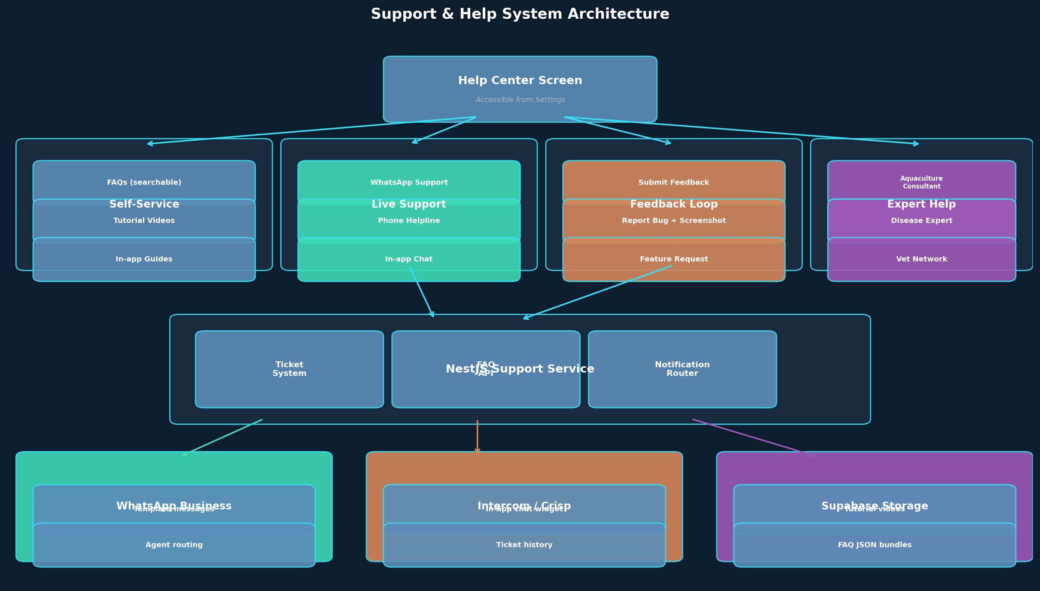
Figure 12: Support & Help System Architecture

27.1 Help Center Screen
The Help Center is the single entry point for all support features. It is accessible from the Settings menu and from a “Help” button that appears in the top-right corner of every screen (a small question-mark icon that does not interfere with the main UI). The Help Center screen has four large cards, each representing one of the support pillars:
- Self-Service — Browse FAQs, Watch Tutorials, Read Guides
- Live Support — Chat with us, Call Helpline, WhatsApp Support
- Feedback — Send Feedback, Report a Bug, Request a Feature
- Expert Help — Talk to Aquaculture Expert (V3+), Disease Consultation
Each card expands to a sub-screen with the specific options. The card order is intentional: self-service is the cheapest option for the business (zero marginal cost) and is presented first; live support is more expensive but necessary for issues that cannot be self-solved; feedback is passive and does not block the user; expert help is the most expensive and is gated behind V3 because it requires expert network partnerships.

27.2 Self-Service: FAQs and Tutorials
FAQs are organized by category: Getting Started (account creation, onboarding, farm setup), Daily Operations (recording data, completing tasks, switching farms), Team Management (inviting members, roles, permissions), Troubleshooting (sync issues, login problems, missing data), and Billing (subscription, payments, refunds). Each FAQ has a question, an answer with optional screenshots, and a “Was this helpful?” feedback button that helps prioritize FAQ updates.
FAQ content is stored as JSON resource files in the app bundle (faqs/{lang}/categories.json) so it works offline. The FAQ list is searchable with full-text search on question and answer text. Server-side FAQ updates are delivered via OTA app updates. The most-accessed FAQs (determined by analytics) are surfaced as “Common Questions” on the Help Center home screen for one-tap access.
Tutorial videos are short (60–90 seconds) screen recordings with voice-over in the user’s preferred language, demonstrating common workflows: creating a farm, recording feed, completing a task, inviting a worker, reading the production dashboard. Videos are hosted in Supabase Storage and streamed via Expo Video. For low-end devices and poor connectivity, a “Download for Offline” option pre-caches the tutorial videos. The first three tutorials are shown automatically after onboarding (with a “Skip” option); subsequent tutorials are accessible from the Help Center.

27.3 In-App Guides
In-app guides are contextual help overlays that appear on specific screens when the user first visits them. For example, the first time a user opens the Task Creation screen, a tooltip overlay highlights the recurrence field and explains “Set up recurring tasks for daily feeding — the system will create them automatically each day.” Guides can be dismissed with a single tap and re-triggered from the Help Center if the user wants to see them again. Guide completion state is tracked locally (not synced to server) to avoid re-showing guides the user has already dismissed.

27.4 Live Support Channels
Channel | Provider | Hours | Use Case | SLA
In-App Chat | Intercom (or Crisp) | 9 AM – 9 PM IST | General questions, account issues, feature help | First response within 30 minutes during hours
WhatsApp Support | WhatsApp Business API | 9 AM – 9 PM IST | Quick questions, screenshot sharing, voice notes | First response within 60 minutes during hours
Phone Helpline | Toll-free (1800-XXX-XXXX) via Exotel | 8 AM – 8 PM IST | Complex issues, sync problems, account lockout | Live answer during hours
Email Support | support@upcheck.app | 24/7 (async) | Bug reports with attachments, formal complaints | First response within 24 hours
Live support is staffed by a tier-1 support team fluent in Telugu, Tamil, and English. Tier-2 escalation (to product or engineering) is handled via the ticketing system in the NestJS backend. Out-of-hours support requests are queued and responded to when hours resume, with the exception of CRITICAL account-lockout issues which are escalated to an on-call engineer.

27.5 In-App Chat Implementation
The in-app chat uses Intercom’s React Native SDK (or Crisp as a lower-cost alternative). The chat widget is initialized when the user opens the Help Center’s “Live Support” card. Pre-chat form collects: issue category (dropdown), short description (text), and farm name (auto-filled). The chat transcript is stored in Intercom (not in Upcheck’s database) for 12 months. When a support agent resolves an issue, the chat is marked as resolved and the user is prompted to rate the support experience (1–5 stars).

27.6 WhatsApp Support Integration
WhatsApp is the most natural support channel for Indian farmers because they already use it daily. Tapping the “WhatsApp Support” card opens WhatsApp with a pre-filled message containing the user’s Upcheck user ID, farm name, and a brief description of the issue (auto-filled based on the current screen). The WhatsApp Business API is used on the backend so that messages from the farmer are routed to the support team’s WhatsApp Business account. The support team responds from a shared inbox tool (such as WATI or Gallabox) that supports multiple agents.

27.7 Feedback Submission Screen
The Feedback screen is a simple form with three fields: feedback type (Bug Report, Feature Request, General Feedback, Praise), rating (1–5 stars), and description (free text, minimum 10 characters). For Bug Reports, an optional screenshot capture button is available that uses expo-screen-capture to grab the current screen. The screenshot is uploaded to Supabase Storage and linked to the feedback record. The feedback is stored in a feedback_submissions table: id, user_id, type, rating, description, screenshot_url, app_version, device_info (jsonb), farm_id (optional), created_at, status (NEW/REVIEWED/RESOLVED).
All feedback is reviewed by the product team within 7 days. Users who submit feedback receive an in-app notification when their feedback status changes (e.g., a feature request is marked as “Under Consideration” or “Planned for V3”). This closes the feedback loop and encourages continued engagement with the support system.

27.8 Support Ticket Data Model
Table | Key Columns | Purpose
support_tickets | id, user_id, channel (CHAT/WHATSAPP/PHONE/EMAIL/IN_APP), category, subject, description, status (OPEN/IN_PROGRESS/RESOLVED/CLOSED), priority (LOW/NORMAL/HIGH/URGENT), assigned_agent_id, intercom_conversation_id (nullable), created_at, resolved_at, satisfaction_rating | Master ticket record
ticket_messages | id, ticket_id (FK), sender_type (USER/AGENT/SYSTEM), message_text, attachments (jsonb), sent_at | Conversation history per ticket
feedback_submissions | id, user_id, type (BUG/FEATURE/GENERAL/PRAISE), rating, description, screenshot_url, app_version, device_info (jsonb), farm_id, created_at, status | Product feedback channel
faq_articles | id, category, question, answer (jsonb for multi-lang), helpful_count, not_helpful_count, last_updated, is_published | FAQ content (managed via admin dashboard)

27.9 Offline Help Content
All FAQ content and in-app guides are bundled with the app and available offline. Tutorial videos can be pre-downloaded for offline viewing. Live support channels (chat, WhatsApp, phone) require connectivity and are clearly marked with an “Online Only” badge on their cards. If a user taps a live support card while offline, a dialog explains “This feature requires internet. Please connect to Wi-Fi or mobile data, or call our helpline at 1800-XXX-XXXX.”

27.10 Multilingual Support
All support content — FAQs, tutorial videos, in-app guides, and pre-chat form labels — is localized into all five supported languages. Live support agents are hired with Telugu and Tamil fluency as a requirement; Odia, Bengali, and Gujarati support is added as those language phases launch. Until native speakers are available for a language, live support in that language is provided via translation tools (Google Translate API) with a disclaimer that the response may not be perfectly natural.

27.11 Privacy & Data Retention
Support chat transcripts and feedback submissions may contain sensitive farm information (pond names, cycle data, disease diagnoses). This data is stored in compliance with India’s DPDP (Digital Personal Data Protection) Act: chat transcripts are retained for 12 months, feedback submissions for 24 months, and call recordings (for phone support) for 6 months. Users can request export or deletion of their support data via the Settings screen, with deletion completing within 30 days.

28. Role-Based Feature & Screen Access Matrix
This section consolidates, in one place, exactly which role can access which screen, which features are exposed on each screen, and what each role can do inside each feature. Earlier sections describe the four farm-scoped roles (Owner, Manager, Worker, Viewer) and the multi-role resolution algorithm; this section answers the practical question every developer and product manager asks during implementation: “On screen X, what buttons does role Y see, and what happens when they tap them?” The matrices below are the authoritative source for frontend feature flags, backend route guards, and RLS policy design. When a feature is added in a future phase, the corresponding row must be added here before any code is written — this is the contract between product, design, and engineering.
All access is scoped to the active farm context. A user’s role on Farm A has no bearing on what they can do on Farm B. When a user switches farms, the entire UI re-renders against the new role’s permission set. Multi-role users (e.g., Owner on Farm A, Worker on Farm B) see different home screens and different menu items depending on the active farm.
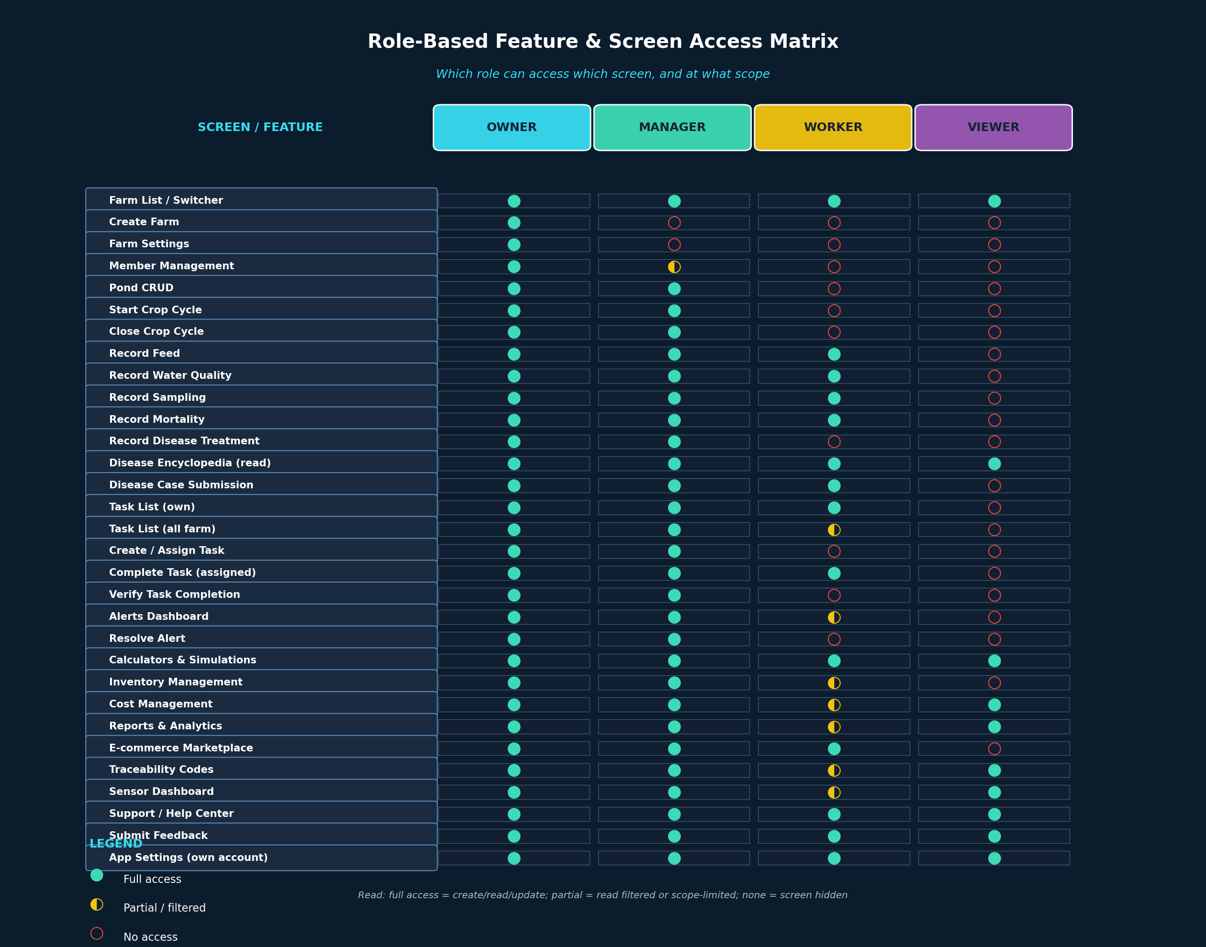
Figure 13: Role-Based Feature & Screen Access Matrix

28.1 Permission Scope Legend
Three permission scopes are used throughout the matrices. They map directly to implementation patterns in the codebase: feature flags for visible UI, route guards for backend endpoints, and RLS policies for database rows.
Symbol | Scope | Meaning | Implementation
● | Full | Screen is visible; user can read all records and create/update records they are allowed to own | Feature flag true; route guard passes; RLS permits INSERT/UPDATE
◐ | Partial | Screen is visible but data is filtered (e.g., Worker sees only their assigned tasks) or some actions are hidden (e.g., Viewer sees costs but cannot edit them) | Feature flag true; route guard passes for reads; RLS adds WHERE filter; write endpoints return 403
○ | None | Screen is hidden from navigation and direct deep-links redirect to home; backend returns 404 or 403 | Feature flag false; nav item not rendered; deep-link handler redirects; route guard rejects

28.2 Master Role × Feature Matrix
The master matrix lists every feature in the product and the access level granted to each role. This is the single source of truth for “who can do what.” Features are grouped by domain. Note that some features (Disease Encyclopedia read, Calculators, Support Center) are available to all roles including Viewer — these are reference / utility features that do not modify farm data.
Feature | Owner | Manager | Worker | Viewer
Farm List & Switcher | Full | Full | Full | Full
Create New Farm | Full | None | None | None
Farm Settings (name, address, timezone) | Full | None | None | None
Member Management (invite/remove/role-change) | Full | Partial (Worker only) | None | None
Transfer Farm Ownership | Full | None | None | None
Pond Create / Edit | Full | Full | None | None
Pond Delete | Full | None | None | None
Start Crop Cycle | Full | Full | None | None
Close / Complete Crop Cycle | Full | Full | None | None
Record Feed Entry | Full | Full | Full | None
Record Water Quality | Full | Full | Full | None
Record Sampling Data | Full | Full | Full | None
Record Mortality | Full | Full | Full | None
Record Disease Treatment | Full | Full | None | None
View Crop Cycle Metrics (DOC, FCR, Survival) | Full | Full | Partial | Full
Disease Encyclopedia — Browse & Search | Full | Full | Full | Full
Disease Case Submission (with photos) | Full | Full | Full | None
Disease Expert Consultation | Full | Full | None | None
Task List (own assigned) | Full | Full | Full | None
Task List (all farm tasks) | Full | Full | Partial (own pond) | None
Create / Assign Task | Full | Full | None | None
Edit Task Details | Full | Full | None | None
Complete Task (assigned to them) | Full | Full | Full | None
Verify Task Completion | Full | Full | None | None
Delete Task | Full | None | None | None
Alerts Dashboard | Full | Full | Partial (own pond) | None
Resolve / Dismiss Alert | Full | Full | None | None
Alert Rule Configuration | Full | Partial | None | None
Calculators (Feed, FCR, Biomass, Stocking) | Full | Full | Full | Full
Profit & Loss Simulator | Full | Full | None | Full
Inventory Dashboard | Full | Full | Partial (read) | None
Inventory Stock-In / Stock-Out | Full | Full | Full | None
Inventory Reorder Configuration | Full | Full | None | None
Cost Entry (create/edit) | Full | Full | None | None
Cost Reports (per cycle, per pond) | Full | Full | None | Full
Reports & Analytics | Full | Full | Partial (own pond) | Full
Export PDF / Excel | Full | Full | None | Full
E-commerce Marketplace — Browse | Full | Full | Full | None
Place Order | Full | Full | Full | None
Approve Order (farm-level approval) | Full | Full | None | None
Traceability — Generate QR Code | Full | Full | None | None
Traceability — Public Web Page View | Full | Full | Partial | Full
IoT Sensor Dashboard | Full | Full | Partial (own pond) | Full
Sensor Threshold Configuration | Full | Full | None | None
Notifications — Receive | Full | Full | Full | Full
Notification Preferences | Full | Full | Full | Full
Support / Help Center | Full | Full | Full | Full
Submit Feedback / Bug Report | Full | Full | Full | Full
App Settings (own account, language, theme) | Full | Full | Full | Full

28.3 Screen × Available Features Mapping
This table answers “On screen X, which features are exposed and which roles see them?” It is the bridge between the role-feature matrix above and the actual UI implementation. Each screen lists the primary interactive elements (buttons, FABs, menu items, action sheets) and the minimum role required to see them. Hidden actions are not rendered — not just disabled — to avoid confusing non-technical users with greyed-out buttons they cannot tap.
Screen | Exposed Feature / Action | Min Role to See
Farm Switcher (modal) | List of farms | Viewer
Farm Switcher (modal) | “Create new farm” button | Any authenticated user
Farm Dashboard (Home) | Production summary cards (DOC, FCR, biomass) | Viewer
Farm Dashboard (Home) | Alerts banner | Manager
Farm Dashboard (Home) | “Start New Cycle” FAB | Manager
Farm Settings | Edit farm details | Owner
Farm Settings > Members | Invite member button | Owner (any role) / Manager (Worker only)
Farm Settings > Members | Change role dropdown | Owner
Farm Settings > Members | Remove member button | Owner (any) / Manager (Worker)
Farm Settings > Members | Transfer ownership button | Owner
Pond List | Pond cards with status | Viewer
Pond List | “Add Pond” button | Manager
Pond Detail | Edit pond button | Manager
Pond Detail | Delete pond button | Owner
Pond Detail > Active Cycle | Cycle metrics dashboard | Viewer
Pond Detail > Active Cycle | Record feed / WQ / sampling / mortality FAB | Worker
Pond Detail > Active Cycle | Record disease treatment | Manager
Pond Detail > Active Cycle | Close cycle button | Manager
Pond Detail > Cycle History | List of past cycles | Viewer
Disease Encyclopedia | Search bar, category filter | Viewer
Disease Encyclopedia | Disease detail cards (read) | Viewer
Disease Encyclopedia | “Submit case” button | Worker
Disease Encyclopedia | “Request expert consultation” button | Manager
Task List (filtered by assignee) | Task cards (own only for Worker) | Worker
Task List | “Create Task” FAB | Manager
Task Detail | Edit task button | Manager
Task Detail | “Complete” button | Worker (if assigned)
Task Detail | “Verify” button | Manager
Task Detail | Delete task button | Owner
Alerts Center | Alert list (filtered by pond for Worker) | Manager
Alerts Center | “Resolve” button | Manager
Alerts Center | “Configure rules” button | Owner
Calculators Hub | Calculator cards (Feed, FCR, Biomass, Stocking) | Viewer
Calculators Hub | P&L Simulator card | Viewer
Inventory | Stock level dashboard | Manager
Inventory | “Stock-in” / “Stock-out” buttons | Worker
Inventory | Reorder rules configuration | Manager
Cost Management | Cost entry list + “Add cost” FAB | Manager
Cost Management | Cost reports (read-only) | Viewer
Reports | Report categories (Cycle, FCR, Mortality, Cost) | Viewer
Reports | “Export PDF” / “Export Excel” buttons | Viewer
Marketplace | Vendor catalog, product search | Worker
Marketplace > Cart | Checkout button | Worker
Marketplace > Orders | Approve / Reject pending order | Manager
Traceability | Generate QR code for harvest batch | Manager
Traceability > Public Web Page | View public traceability page | Viewer (public, no login)
Sensor Dashboard | Real-time sensor readings | Viewer
Sensor Dashboard | Threshold configuration | Manager
Notifications | Notification list | Viewer
Notifications | Per-channel preference toggles | Viewer
Help Center | Self-service / Live support / Feedback / Expert cards | Viewer
Settings | Language, theme, account, sign out | Viewer (own account only)

28.4 Role × Screen Visibility
This matrix shows which screens appear in each role’s bottom tab bar and side menu. Screens marked as hidden are not rendered in navigation; if a user deep-links to them (e.g., via a push notification), they are redirected to their role’s home screen with an informational toast. The bottom tab bar adapts per role to surface the 3–4 most-used screens for that role.
Screen | Owner | Manager | Worker | Viewer
Home (Farm Dashboard) | Visible | Visible | Visible | Visible
Ponds Tab | Visible | Visible | Visible | Visible
Tasks Tab | Visible | Visible | Visible | Hidden
Records Tab | Visible | Visible | Hidden | Hidden
Alerts Tab | Visible | Visible | Hidden | Hidden
Reports Tab | Visible | Visible | Hidden | Visible
Marketplace Tab | Visible | Visible | Visible | Hidden
Sensors Tab (V4) | Visible | Visible | Hidden | Visible
Disease Encyclopedia (in Ponds tab drill-in) | Visible | Visible | Visible | Visible
Inventory (in Records tab) | Visible | Visible | Hidden | Hidden
Cost Management (in Records tab) | Visible | Visible | Hidden | Visible (read-only)
Calculators (in Records tab) | Visible | Visible | Visible | Visible
Traceability (in Records tab) | Visible | Visible | Hidden | Visible
Help Center (in Settings) | Visible | Visible | Visible | Visible
Farm Settings (in Settings) | Visible | Hidden | Hidden | Hidden
Member Management (in Farm Settings) | Visible | Hidden | Hidden | Hidden
Notification Preferences (in Settings) | Visible | Visible | Visible | Visible
App Settings (in Settings) | Visible | Visible | Visible | Visible

28.5 Action-Level Permission Detail
Some actions warrant extra clarity because they sit at the boundary between roles or have conditional logic (e.g., “Worker can complete a task only if it is assigned to them”). The table below enumerates these boundary actions, the rule that governs them, and the enforcement layer (UI, route guard, or RLS).
Action | Rule | Enforcement Layer
Worker records data on a pond | Must be a member of the pond’s farm (any role >= Worker) | RLS + Route Guard
Worker completes a task | Task must have status ASSIGNED and assigned_to = current user | Route Guard (backend checks assignee)
Worker views task list | Sees only tasks where assigned_to = current user; does NOT see unassigned or other-worker tasks | RLS (WHERE clause) + UI filter
Worker views alerts | Sees alerts only for ponds where they have at least one assigned task in the last 14 days | RLS (subquery filter)
Manager invites a member | Can only invite users to the WORKER role; inviting Manager or Viewer requires Owner | Route Guard (role check on target role)
Manager removes a member | Can only remove WORKERs; removing Managers requires Owner | Route Guard
Manager edits cost entries | Can edit any cost entry in the farm; Worker cannot edit any | RLS (UPDATE policy)
Manager configures alert rules | Can configure non-critical rules; rules flagged CRITICAL (e.g., harvest triggers) require Owner | Route Guard + Rule type flag
Owner transfers ownership | Requires a target active member; ownership transfer is a two-step confirm with re-auth (OTP) | UI (confirm modal) + Route Guard (OTP re-verify)
Owner deletes farm | Soft-delete only; requires OTP re-verification; cycles in ACTIVE state must be closed first or explicitly force-closed | Route Guard (multi-condition)
Viewer exports reports | Can export aggregate reports but NOT raw per-pond data unless Owner has granted export permission in Farm Settings | RLS + per-farm config flag
Viewer sees cost data | Owner can toggle “Share costs with Viewer” per farm; default is OFF | Per-farm config flag in farms table
Any role creates a farm | User is auto-assigned OWNER of any farm they create | Application logic (post-INSERT trigger)
Any role submits feedback | Feedback is scoped to the user, not the farm — users can submit feedback even with no farm membership | RLS (user_id = auth.uid())

28.6 Conditional & Scoped Access
Beyond the static role-permission model, several dynamic scopes modify access at runtime. These are not exceptions to the role model — they are explicit, auditable rules that gate specific actions based on contextual state. The implementation must enforce these scopes in the route guard (never only in the UI), because a missed UI check could allow unauthorized writes.
- Time-bound ownership — A Worker who has been removed from a farm (status = REMOVED) loses access immediately; their JWT’s farm_membership claim is refreshed on next sync. Until refresh, RLS still blocks writes because membership status is checked at query time, not at token-issuance time.
- Cycle-state gating — Recording feed, water quality, sampling, or mortality requires the pond to have a crop cycle in ACTIVE state. Records cannot be added to DRAFT or COMPLETED cycles (this prevents accidental backfilling and tampering with historical data).
- Task assignment scope — A Worker can only complete a task where assigned_to = their user ID. Attempting to complete another worker’s task returns 403 with a clear error message; this is enforced both in the route guard and the RLS UPDATE policy.
- Approval workflow — Orders placed by Workers on the Marketplace enter PENDING_APPROVAL state and require Manager or Owner approval if the order value exceeds the farm’s approval threshold (default ₹5,000, configurable per farm by Owner). Below-threshold orders auto-approve.
- Export permission flag — By default, Viewers can export aggregate reports but not raw per-pond data. Owners can grant per-farm raw-export permission to specific Viewers (e.g., a consultant who needs raw data for analysis) via the Farm Settings > Members screen.
- Cross-farm visibility — A user’s notifications, feedback, and support tickets are user-scoped (not farm-scoped) and visible across all their farm memberships. Task, alert, and record data is strictly farm-scoped.
- Owner-only operations — Delete farm, transfer ownership, delete pond, change member roles, and configure critical alert rules require Owner. These actions also require OTP re-verification (send and verify a fresh OTP within 5 minutes) to prevent account-takeover damage.
- V4 feature gating — Sensor dashboard, traceability code generation, and AI disease prediction are V4 features. Even after V4 launch, they require per-farm enablement (Owner opts in via Farm Settings) because they involve third-party costs (sensor data ingestion, AI inference).

28.7 Implementation Notes for Developers
The matrices above translate into three concrete implementation layers. Each layer must agree on permissions; mismatches create security holes. The recommended pattern is: define the permission once in a shared spec (this section), derive the frontend feature flags from it, derive the route guards from it, and derive the RLS policies from it. All three are generated from the same source of truth.

Frontend (Expo React Native)
Use a usePermissions(activeFarmId) hook that returns an object of boolean flags keyed by feature: { canCreateTask, canResolveAlert, canEditCost, … }. The hook reads the current user’s role on the active farm from the local WatermelonDB membership cache. Components consume the hook and conditionally render UI: “{canCreateTask && <FAB onPress={openCreateTask} />}”. Never rely on hiding UI alone — always assume the user could call the backend directly. The hook also drives bottom-tab visibility: the tab bar component maps role → visible tabs.

Backend (NestJS)
Each route is wrapped in a @Roles() decorator combined with a @FarmRoles() guard. The guard extracts the farmId from the route (or request body), queries the farm_memberships table for the requesting user’s role on that farm, and rejects with 403 if the role is insufficient. For boundary actions (e.g., complete task), the guard additionally queries the task’s assigned_to field. Guards never trust client-supplied role claims — they always re-check the database.

Database (Supabase RLS)
RLS is the final defense. Even if a route guard is misconfigured, RLS prevents unauthorized writes. Every table that contains farm-scoped data has policies of the form: SELECT requires is_active_member(farm_id, auth.uid()); INSERT requires role >= min_role; UPDATE / DELETE require role >= min_role (with extra conditions for boundary actions like task completion). The is_active_member() helper function is the single source of truth for farm membership.
These three layers create defense-in-depth: a malicious user who bypasses the UI still hits the route guard; a misconfigured route guard still hits RLS. The matrices in 28.2–28.5 are the spec that all three layers must satisfy. When adding a new feature, update this section first, then implement the three layers in lock-step.

29. API Endpoint Catalog
The NestJS backend exposes RESTful API endpoints organized by domain. All endpoints require JWT authentication (except OTP endpoints). Authorization is enforced by route guards that check farm membership role. The following table lists all endpoints planned for V1–V2.
Method | Path | Description | Min Role
POST | /auth/otp/send | Send OTP to mobile number | Public
POST | /auth/otp/verify | Verify OTP and return JWT | Public
POST | /auth/refresh | Refresh access token | Authenticated
GET | /farms | List farms where user is a member | Authenticated
POST | /farms | Create a new farm | Any (auto-becomes OWNER)
GET | /farms/:farmId | Get farm details | VIEWER
PATCH | /farms/:farmId | Update farm settings | OWNER
DELETE | /farms/:farmId | Soft-delete farm | OWNER
POST | /farms/:farmId/invite | Invite a member to farm | MANAGER (Worker only) / OWNER (any)
PATCH | /farms/:farmId/members/:userId | Change member role | OWNER
DELETE | /farms/:farmId/members/:userId | Remove member from farm | MANAGER (Worker) / OWNER (any)
POST | /farms/:farmId/transfer-ownership | Transfer farm ownership | OWNER
GET | /farms/:farmId/ponds | List ponds in farm | VIEWER
POST | /farms/:farmId/ponds | Create a pond | MANAGER
GET | /ponds/:pondId | Get pond details | VIEWER
PATCH | /ponds/:pondId | Update pond details | MANAGER
DELETE | /ponds/:pondId | Soft-delete pond | OWNER
GET | /ponds/:pondId/cycles | List cycles for pond | VIEWER
POST | /ponds/:pondId/cycles | Start a new crop cycle | MANAGER
GET | /cycles/:cycleId | Get cycle details + metrics | VIEWER
PATCH | /cycles/:cycleId | Update cycle details | MANAGER
POST | /cycles/:cycleId/close | Close/complete a cycle | MANAGER
POST | /cycles/:cycleId/feed | Record feed entry | WORKER
POST | /cycles/:cycleId/water-quality | Record water quality | WORKER
POST | /cycles/:cycleId/sampling | Record sampling data | WORKER
POST | /cycles/:cycleId/mortality | Record mortality | WORKER
POST | /cycles/:cycleId/treatment | Record disease treatment | MANAGER
GET | /farms/:farmId/tasks | List tasks for farm | VIEWER (filtered)
POST | /farms/:farmId/tasks | Create a task | MANAGER
GET | /tasks/:taskId | Get task details | VIEWER (filtered)
PATCH | /tasks/:taskId | Update task (assign, change status) | Per action
POST | /tasks/:taskId/complete | Mark task complete with data | WORKER (assigned)
POST | /tasks/:taskId/verify | Verify task completion | MANAGER
GET | /farms/:farmId/alerts | List alerts for farm | MANAGER
PATCH | /alerts/:alertId/resolve | Resolve an alert | MANAGER
POST | /sync/push | Push local mutations to server | Authenticated
GET | /sync/pull?since=:timestamp | Pull changes since timestamp | Authenticated

30. Supabase Row Level Security Policies
Row Level Security (RLS) is the primary data access control mechanism. Every table has RLS enabled. Policies are defined to ensure that users can only access data for farms where they have an active membership. The service role (used by the NestJS backend for system operations like sync processing and cron jobs) bypasses RLS.

30.1 Policy Definitions
Table | Operation | Policy Condition | Roles
farms | SELECT | user has active membership in farm | All members
farms | INSERT | user is authenticated (auto-assigns OWNER) | Any user
farms | UPDATE | user has OWNER membership in farm | Owner only
farms | DELETE | user has OWNER membership in farm | Owner only
farm_memberships | SELECT | user is a member of the same farm | All members
farm_memberships | INSERT | inviter has permission to invite target role | Owner, Manager (Worker only)
farm_memberships | UPDATE | user has OWNER membership in farm | Owner only
ponds | SELECT | user has active membership in pond's farm | All members
ponds | INSERT | user has MANAGER+ membership in farm | Manager, Owner
ponds | UPDATE | user has MANAGER+ membership in farm | Manager, Owner
ponds | DELETE | user has OWNER membership in farm | Owner only
crop_cycles | SELECT | user has active membership in farm | All members
crop_cycles | INSERT | user has MANAGER+ membership in farm | Manager, Owner
crop_cycles | UPDATE | user has MANAGER+ membership in farm | Manager, Owner
tasks | SELECT | user is member of farm; Workers see only assigned tasks | All (filtered)
tasks | INSERT | user has MANAGER+ membership in farm | Manager, Owner
tasks | UPDATE | depends on action (complete=assigned worker, verify=manager+) | Per action
feed_records | SELECT | user has active membership in farm | All members
feed_records | INSERT | user has WORKER+ membership in farm | Worker, Manager, Owner
water_quality_records | SELECT | user has active membership in farm | All members
water_quality_records | INSERT | user has WORKER+ membership in farm | Worker, Manager, Owner
alerts | SELECT | user has MANAGER+ membership in farm | Manager, Owner
alerts | UPDATE | user has MANAGER+ membership in farm | Manager, Owner

30.2 Helper Function
A PostgreSQL helper function simplifies policy definitions. The function is_active_member(farm_id, user_id) returns true if the user has an active membership in the specified farm. It is used in most RLS policies:
CREATE OR REPLACE FUNCTION is_active_member(
target_farm_id UUID, target_user_id UUID
) RETURNS BOOLEAN AS $$
SELECT EXISTS (
SELECT 1 FROM farm_memberships
WHERE farm_id = target_farm_id
AND user_id = target_user_id
AND status = 'ACTIVE'
)
$$ LANGUAGE sql STABLE;

31. Phased MVP Roadmap
The original draft’s MVP was overloaded: three role-specific home screens with real data, full task assignment and tracking, farm/pond/cycle management, and permissions across three roles. This is a 6-to-9 month build for a small team. An actual MVP should ship one coherent chapter of the product, get it into users’ hands, learn, and then expand. The following roadmap breaks the product into four phases, each shipping a complete, usable product.
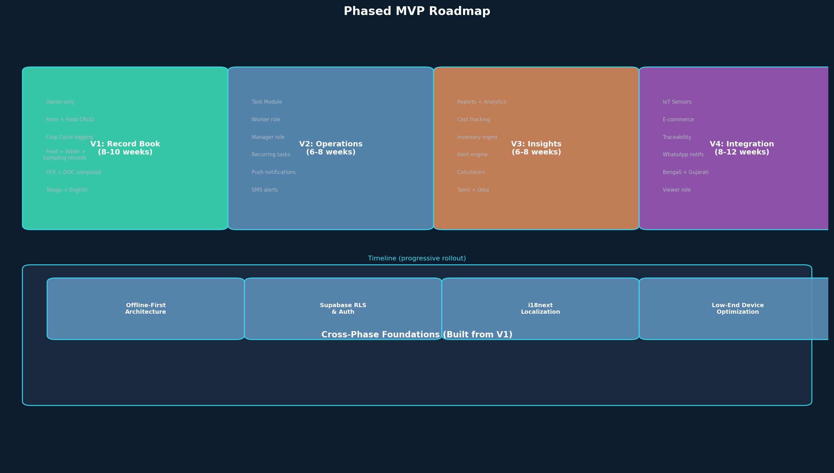
Figure 14: Phased MVP Roadmap

31.1 V1: Record Book (8–10 Weeks)
V1 is a digital record book for a single farm owner. No task module, no team features, no alerts. Just the ability to create a farm, add ponds, start crop cycles, and record feed, water quality, sampling, and mortality data. The owner sees basic computed metrics (DOC, FCR, survival rate). This is the smallest possible product that delivers value — it replaces the notebook.
Feature | Included | Notes
Farm + Pond CRUD | Yes | Single owner, no team features
Crop Cycle lifecycle | Yes | DRAFT → ACTIVE → COMPLETED
Feed Records | Yes | Manual entry with feed type and quantity
Water Quality Records | Yes | pH, DO, salinity, temperature
Sampling Records | Yes | Avg body weight, biomass estimate
Mortality Records | Yes | Count, cause, photo
Computed Metrics | Yes | DOC, FCR, survival rate, biomass estimate
Offline Mode | Yes | WatermelonDB local storage with sync
Localization | Yes | English + Telugu
Task Module | No | Deferred to V2
Alerts | No | Deferred to V2
Team Features | No | Owner-only in V1

31.2 V2: Operations (6–8 Weeks)
V2 adds team coordination. The owner can invite managers and workers. The task module is introduced with recurring tasks, time windows, and verification. Push notifications and SMS alerts are enabled. This transforms the record book into a coordination tool.
Feature | Included | Notes
Task Module | Yes | All task types, recurrence, time windows, verification
Manager Role | Yes | Invited by owner, can create/assign tasks
Worker Role | Yes | Invited by owner/manager, completes assigned tasks
Push Notifications | Yes | Expo Push + FCM
SMS Alerts | Yes | MSG91 for critical alerts and OTP
Alert Engine | Yes | All V2 alert types
WhatsApp Notifications | Partial | Opt-in beta for task reminders
Localization | Add Tamil | Three languages total
Calculators | No | Deferred to V3

31.3 V3: Insights (6–8 Weeks)
V3 adds intelligence. Reports, cost tracking, inventory management, and calculators transform the coordination tool into a decision-support system. By this point, farms should have 2–3 completed cycles of data, making comparisons and trend analysis meaningful.
Feature | Included | Notes
Reports & Analytics | Yes | Farm performance, cycle comparison, FCR trends
Cost Management | Yes | Per-cycle cost tracking, break-even analysis
Inventory Management | Yes | Feed, chemical, equipment tracking with reorder alerts
Calculators | Yes | Feed quantity, FCR, biomass, stocking density, P&L simulator
Viewer Role | Yes | Read-only access for banks, insurers, consultants
PDF/Excel Export | Yes | Report generation and sharing
Localization | Add Odia + Bengali | Five languages total
E-commerce | No | Deferred to V4

31.4 V4: Integration (8–12 Weeks)
V4 adds external integrations that connect the farm to the broader ecosystem: IoT sensors for real-time monitoring, marketplace for buying inputs, traceability for export compliance, and full WhatsApp integration for communication. This is where Upcheck becomes an operating system rather than just an app.
Feature | Included | Notes
IoT Sensor Integration | Yes | MQTT pipeline, real-time dashboard, threshold alerts
E-commerce Marketplace | Yes | Vendor catalog, ordering, UPI payment, delivery tracking
Traceability | Yes | Seed-to-harvest chain, QR codes, public web pages
WhatsApp Full Integration | Yes | Task assignment, daily summary, alert escalation via WhatsApp
Localization | Add Gujarati | Six languages total
Disease Prediction (AI) | Maybe | If sufficient data exists; optional V4 or V5

31.5 Cross-Phase Foundations
Some technical capabilities must be built from V1 because they affect the entire architecture and cannot be retrofitted later. These are: offline-first architecture (WatermelonDB sync from day one), Supabase RLS (all tables have RLS from V1), i18next localization infrastructure (even if V1 only ships English + Telugu, the i18n framework must be in place), and low-end device optimization (performance budget enforced from V1). Building these foundations in V1 means V2–V4 features layer on top naturally without architectural rewrites.

32. Mermaid Diagram Source Code
The following Mermaid source code corresponds to the diagrams rendered as images throughout this document. Developers can paste this code into mermaid.live or any Mermaid-compatible editor to view, edit, and export the diagrams.

32.1 System Architecture
graph TB
subgraph Mobile[Expo React Native SDK 51]
UI[Screens & Navigation] --> WM[WatermelonDB SQLite]
UI --> I18N[i18next Localization]
UI --> NOTIF[Expo Notifications]
end
subgraph API[NestJS Backend]
AUTH[Auth Guard & RBAC] --> BIZ[Business Logic Modules]
end
subgraph Data[Supabase Platform]
PG[PostgreSQL + RLS]
SA[Supabase Auth]
SS[Supabase Storage]
SR[Supabase Realtime]
end
Mobile -->|REST API / WebSocket| API
API --> Data
EXT[MSG91 / WhatsApp API] --> API
IoT[MQTT / Sensor Gateway] --> API

32.2 ER Diagram
erDiagram
USERS ||--o{ FARM_MEMBERSHIPS : has
FARMS ||--o{ FARM_MEMBERSHIPS : has
FARMS ||--o{ PONDS : contains
PONDS ||--o{ CROP_CYCLES : has
PONDS ||--o{ WATER_QUALITY_RECORDS : tested_in
CROP_CYCLES ||--o{ FEED_RECORDS : records
CROP_CYCLES ||--o{ SAMPLING_RECORDS : measured_in
CROP_CYCLES ||--o{ MORTALITY_RECORDS : observed_in
CROP_CYCLES ||--o{ DISEASE_TREATMENTS : treated_with
FARMS ||--o{ TASKS : assigns
FARMS ||--o{ ALERTS : triggers
USERS ||--o{ TASKS : assigned_to

32.3 Auth Flow
flowchart TD
A[User Opens App] --> B[Enter Mobile Number]
B --> C[Supabase Auth Sends OTP via MSG91]
C --> D[User Enters OTP]
D -->|Valid| E[JWT Token Issued]
D -->|Invalid| F[Retry Max 3] --> D
E --> G{Has Farm Memberships?}
G -->|Yes| H[Load Farm Context -> Home Screen]
G -->|No| I[Onboarding -> Select Role -> Create/Join Farm]

32.4 Multi-Role Resolution
flowchart TD
A[User Logs In] --> B[Load All Farm Memberships]
B --> C{Single Farm? Single Role?}
C -->|Yes| D[Show Role-Specific Home]
C -->|No| E[Show Farm Selector + Primary Role Home]
E --> F[User Switches Farm Context]
F --> G[Home Updates to Role in New Farm]
D --> H[Features Gated by Current Farm Role]

32.5 Offline Sync
flowchart LR
subgraph Client[Mobile Client]
UI[UI Layer] --> WDB[WatermelonDB SQLite]
WDB --> SQ[Sync Queue]
end
subgraph Server[NestJS Backend]
SC[Sync Controller] --> CR[Conflict Resolver]
CR --> PG[PostgreSQL]
end
SQ -->|Push mutations| SC
SC -->|Pull updates| SQ

32.6 Task Lifecycle
stateDiagram-v2
[*] --> CREATED: Manager creates task
CREATED --> ASSIGNED: Assigned to worker
ASSIGNED --> IN_PROGRESS: Worker starts
IN_PROGRESS --> COMPLETED: Worker marks done
COMPLETED --> VERIFIED: Manager confirms
IN_PROGRESS --> OVERDUE: Past due_at
OVERDUE --> COMPLETED: Still completed after overdue
ASSIGNED --> CANCELLED: Manager cancels
VERIFIED --> [*]
CANCELLED --> [*]

32.7 Disease Diagnostic Flow
flowchart TD
M[Mortality Record] --> S[Symptom Input Screen]
D[Direct Browse] --> S
A[Alert Trigger] --> S
S --> SM[Symptom Matcher - local rule-based]
S --> PA[Photo Analysis - V4 ML model]
S --> EC[Expert Consult - paid service]
SM --> R[Disease Detail Screen]
PA --> R
EC --> R
R --> SC[Save to Cycle as treatment]
R --> AT[Apply Treatment]
R --> MW[Mark Pond for Watch]
R --> SH[Share via WhatsApp]

32.8 Support System Architecture
flowchart TD
HC[Help Center Screen] --> SS[Self-Service: FAQs, Tutorials, Guides]
HC --> LS[Live Support: WhatsApp, Phone, Chat]
HC --> FB[Feedback: Submit, Bug Report, Feature Request]
HC --> EH[Expert Help: Aquaculture Consultant, Disease Expert]
LS --> NESTJS[NestJS Support Service]
NESTJS --> TS[Ticket System]
NESTJS --> FAQ[FAQ API]
NESTJS --> NR[Notification Router]
LS --> WA[WhatsApp Business API]
SS --> IC[Intercom / Crisp Chat]
SS --> SBS[Supabase Storage - Videos + FAQ JSON]

