The University of the West Indies
Department of Computing & Information Technology

Engineering and Evaluating a Source-Traceable Research-Intelligence Platform for a Laboratory Corpus
Design, Full-Text Retrieval, Offline Evaluation, and Reproducibility of the TTLAB Platform
MSc Data Science Project
Jarod Esareesingh
jarod.esareesingh@my.uwi.edu
816026811
Trinidad and Tobago
Evidence snapshot corpus-04a010207327069a; editable manuscript and generated metrics are version controlled.

Abstract
Publication archives expose bibliographic records but do not directly support full-text discovery, evidence-linked question answering, author/topic exploration, or the formulation of bounded thesis extensions. This thesis presents the design and controlled offline evaluation of a source-traceable research-intelligence platform for a TTLAB laboratory corpus. Source-traceable means that paper, chunk, page, section, provider, timestamp, warning, and review-state identifiers persist through retrieval and generated-output workflows; it does not mean that every claim is factually entailed.
The executed methodology combines an artefact-oriented engineering case study with source-derived, two-pass AI-reviewed silver evaluation. A frozen snapshot contains 134 catalog records, 98 available PDFs, 96 eligible full-text papers, and 719 eligible chunks after excluding 2 PDF/title mismatches. Keyword, 256-dimensional feature-hashing, and a pinned 384-dimensional all-MiniLM-L6-v2 dense index each cover 719/719 eligible chunks. On a held-out set of 20 questions, keyword retrieval achieved set Recall@3 of 0.939, MRR 0.947, and nDCG@10 0.958; the tuned hybrid achieved 0.856, 0.860, and 0.871, respectively. Corrected paired tests did not demonstrate hybrid superiority. All modes failed to abstain on the single held-out unanswerable case.
AI-assisted review of 400 checkable claims from 50 offline extractive answers found a strict supported-claim rate of 0.995 (95% CI 0.987–1.000) and complete citation presence, but citation correctness was 0.625 and strict answer-point coverage only 0.136. A 28-profile AI-proxy study found a small, inconclusive relevance difference of 0.024 (95% CI -0.024–0.071) between the full extension finder and an evidence-only baseline. Topic evaluation favored the controlled lexical method’s precision (0.652) over a dense prototype (0.417), while neither established human-validated expertise. These negative and mixed results show that visible provenance and high local claim support can coexist with incomplete answers, imperfect citation choice, and weak abstention. The principal contribution is therefore a reproducible, evidence-calibrated platform and evaluation package, not a claim of validated student benefit.
Keywords: research intelligence, information retrieval, retrieval-augmented generation, scholarly recommendation, responsible AI, reproducibility.

Statement of Scope and AI Assistance
This thesis reports software engineering, document processing, controlled offline experiments, and AI-assisted formative review. No human participants were recruited. TTLAB authorized the project and use of the laboratory corpus; that authorization is not represented as research-ethics approval or as permission to redistribute third-party PDFs. OpenAI Codex assisted materially with repository inspection, code changes, test preparation, AI-silver label creation and verification, analysis, and manuscript editing. The reviewer identity is retained as codex-ai-review; all resulting labels are described as AI-reviewed silver labels rather than human judgments. Jarod Esareesingh is the named thesis author. Any institution-specific authorship declaration, conflict statement, or submission attestation remains an external submission requirement and is not fabricated here.

Table of Contents
Abstract ii
Statement of Scope and AI Assistance iii
Table of Contents iv
List of Figures ix
List of Tables x
List of Abbreviations xi
1 Introduction 1
1.1 Aim 1
1.2 Objectives 2
1.3 Contributions 2
1.4 Thesis structure 3
2 Problem Statement 4
2.1 Stakeholders and failure consequences 4
2.2 Scope 5
2.3 Operational definitions 5
2.4 Success criteria 6
3 Research Questions and Objectives 7
3.1 Research-question design 7
3.2 Claim boundaries 8
4 Literature Review 9
4.1 Scholarly discovery and research intelligence 9
4.2 Scholarly recommendation and expert finding 9
4.3 Lexical, hashed, and learned dense retrieval 9
4.4 Topics and author–topic relations 10
4.5 RAG, claim support, and citation evaluation 10
4.6 Human review, documentation, and responsible AI 10
4.7 Research gap and positioning 11
5 Methodology 12
5.1 Study design 12
5.2 Evidence hierarchy and reproducibility controls 12
5.3 Corpus freeze and inclusion rules 13
5.4 AI-reviewed silver annotation 13
5.5 Retrieval metrics 13
5.6 Tuning, uncertainty, and statistical analysis 14
5.7 QA, recommendation, and topic metrics 14
5.8 Performance and external sanity methodology 15
5.9 Ethics and authorization protocol 15
6 System Architecture and Design 16
6.1 Layered architecture 16
6.2 Design principles 16
6.3 Persistence and traceability model 17
6.4 Authoritative index design 17
6.5 Security and privacy boundaries 18
7 Data Collection and Processing 19
7.1 Catalog and acquisition 19
7.2 Extraction and OCR-aware diagnostics 20
7.3 Page-aware chunking and sections 20
7.4 Metadata and author identity 21
7.5 Corpus distribution and release boundary 21
8 Implementation 23
8.1 Backend and persistence 23
8.2 Retrieval modes 23
8.3 Question answering and citation checks 24
8.4 Thesis Extension Finder 25
8.5 Topics, authors, artifacts, and review 26
8.6 Frontend and evidence communication 27
8.7 Generated-output governance and deployment boundary 28
9 Experimental Design 29
9.1 Overview 29
9.2 Experiment inventory 29
9.3 Retrieval configuration 30
9.4 QA review procedure 31
9.5 Recommendation, topic, and review protocols 31
9.6 Performance and reproducibility protocol 32
10 Results 33
10.1 RQ1: corpus, extraction, and index integrity 33
10.2 RQ2: held-out retrieval 33
10.3 RQ3: claim support, citations, completeness, and abstention 34
10.4 RQ4: recommendation proxy evaluation 35
10.5 RQ4: topics, authors, and generated review 36
10.6 RQ5: engineering verification, performance, and external sanity 36
11 Discussion 39
11.1 Traceability is an engineering property, not an accuracy score 39
11.2 Simple lexical retrieval remained competitive 39
11.3 Abstention is the principal end-to-end safety gap 40
11.4 Recommendation structure is stronger than recommendation validation 40
11.5 Controlled discovery favors inspectability 40
11.6 Review and governance as first-class data 41
11.7 Reproducibility with rights constraints 41
12 Limitations, Ethics and Threats to Validity 42
12.1 Technical and empirical limitations 42
12.2 Ethics, permissions, and responsible AI 42
12.3 Construct validity 43
12.4 Internal validity 43
12.5 External validity 44
12.6 Reproducibility validity 44
12.7 Security and deployment limitations 44
13 Conclusion and Future Work 45
13.1 Prioritised future work 46
Appendix A: Research-Question Traceability Matrix 47
Appendix B: Reproducibility Guide 50
B.1 One-command paths 50
B.2 Evidence and manuscript generation 50
B.3 Evaluation commands 50
B.4 Application and document verification 51
B.5 Key identifiers 51
B.6 Availability boundary 51
Appendix C: Schema and API Summary 53
C.1 Principal persisted contracts 53
C.2 Principal API surfaces 54
C.3 Review-state semantics 55
Appendix D: Executed AI-Review Instruments 56
D.1 Retrieval relevance 56
D.2 Answer and citation review 56
D.3 Recommendation review 56
D.4 Topic and author review 57
D.5 Generated-output review 57
D.6 Future human instrument boundary 57
References 58

List of Figures
Figure 6.1. Layered system architecture. The dashed path represents provenance and review data returned from storage to public evidence displays. Text labels provide the non-color encoding. 16
Figure 6.2. Principal persistence and provenance entities. Solid arrows denote ownership/foreign-key relations; dashed arrows denote evidence or polymorphic references. 17
Figure 7.1. Deterministic ingestion and authoritative indexing pipeline. The optional OCR stage records status/provenance but was not used in the frozen corpus. 19
Figure 7.2. Frozen catalog eligibility: 96 eligible full-text papers, 36 records without eligible text, and 2 PDF/title mismatch exclusions. These are inventory counts, not quality scores. 20
Figure 7.3. Publication-year distribution in the catalog metadata. Missing or uncertain years remain represented in the generated source data rather than being imputed. 21
Figure 8.1. Authoritative index coverage. Keyword FTS, feature hashing, and learned dense retrieval each cover all 719 eligible chunks. 24
Figure 8.2. Search and RAG workflow. All retrieval modes preserve source locators; structural verification is distinct from claim-level support review. 25
Figure 8.3. Recommendation workflow and its 28-profile AI-proxy evaluation. The final suggestion remains advice requiring external feasibility and novelty confirmation. 26
Figure 8.4. Ask TTLAB result showing generated-content notice, source locators, evidence snippets, and grounding/review warnings. The screenshot is an implementation record, not a quality rating. 27
Figure 8.5. Current Evaluation Dashboard cards presenting retrieval, QA, recommendation, and generated-output review evidence with explicit AI-review boundaries. 28
Figure 9.1. Executed evaluation workflow. AI-reviewed silver evidence is versioned separately from external human or institutional validation. 29

List of Tables
Table 2.1. Stakeholders, tasks, and principal failure risks. 4
Table 3.1. Research questions connected to executed method, evidence, and conclusion type. 7
Table 9.1. Executed experiments, units, and primary outcomes. 29
Table 10.1. Held-out retrieval results on 19 answerable questions. Recall@3 intervals are 10,000-replicate query bootstrap 95% CIs. 33
Table 10.2. AI-assisted QA review over 50 offline extractive answers. Partial labels do not count in strict estimates. 35
Table 10.3. Held-out multi-label topic results on 24 AI-silver paper cases. 36
Table 10.4. Selected full-corpus Phase 6 performance results. Times are seconds; p95 is a coarse interpolation over three repetitions. 37
Table A.1. Complete connection from each research question to method, evidence, result, and conclusion. 47
Table B.1. Key frozen identifiers. Full values are retained in manifests. 51
Table C.1. Principal persisted entities and traceability fields. 53
Table C.2. User-facing API groups and security boundary. 54

List of Abbreviations
API
Application Programming Interface
CI
Confidence Interval
DOI
Digital Object Identifier
FTS
Full-Text Search
LLM
Large Language Model
MRR
Mean Reciprocal Rank
MVP
Minimum Viable Product
nDCG
Normalized Discounted Cumulative Gain
OCR
Optical Character Recognition
PDF
Portable Document Format
QA
Question Answering
RAG
Retrieval-Augmented Generation
RQ
Research Question
TTLAB
Laboratory/project identifier used by the source archive and platform;
UI
User Interface

1 Introduction
Laboratory publication pages answer a bibliographic question—what has been published—but place the remaining analytical burden on the reader. A student must locate accessible full text, compare methods and limitations, identify a feasible extension, and avoid mistaking a generated proposal for an author-stated research gap. Researchers and public or industry users face related problems when locating work by topic or identifying a possible collaborator. The TTLAB precursor automated publication collection and display, lay summarisation, notifications, and a manual podcast workflow, and identified RAG querying as future work [1]. This project extends that direction from a publication archive into a full-text, source-traceable research-intelligence platform.
The wider scholarly-discovery landscape includes autonomous citation indexing in CiteSeer [2], expert and topic mining in ArnetMiner [3], literature graphs and large corpora such as Semantic Scholar and S2ORC [4], [5], and open bibliographic infrastructure such as OpenAlex [6]. These services demonstrate the value of linked scholarly metadata at scale. The present project addresses a narrower setting: a local laboratory corpus, full-text evidence with page and chunk locators, student-facing extension structures, public explanation, and explicit review state.
RAG can condition generation on retrieved documents [7], but a citation-bearing interface is not itself proof of retrieval completeness, entailment, recommendation feasibility, or user benefit. This distinction motivates the thesis’s evidence boundary. Software tests establish implemented behavior. Corpus manifests establish coverage. Source-reviewed cases establish bounded empirical quality. Human usefulness, author endorsement, supervisor fit, and institutional approval require evidence that was not collected in this study.

1.1 Aim
The aim is to design, implement, and reproducibly evaluate a source-traceable research-intelligence platform that converts a bounded laboratory publication snapshot into searchable full text, citation-bearing answers, evidence-separated thesis-extension suggestions, and reviewable topic/author relations, while making failures and evidential limits visible.

1.2 Objectives
The objectives were to:
- construct a deterministic, page-aware pipeline from catalog records and permitted local PDFs to eligible chunks and authoritative indexes;
- implement keyword, lexical feature-hashing, learned dense, and hybrid retrieval over one frozen corpus;
- preserve source identifiers and review state through search, RAG, recommendation, generated-artifact, and user-interface workflows;
- evaluate retrieval, claim support, citations, answer completeness, recommendation structure, controlled topics, author identity, generated outputs, and performance using persisted raw evidence;
- implement review, privacy, authentication, security, accessibility, and data-freshness controls appropriate to a demonstrable public-facing prototype; and
- provide one-command reproduction and a versioned sanitized release that excludes restricted full text and secrets.

1.3 Contributions
The thesis makes five bounded contributions:
- a layered research-intelligence artefact joining deterministic acquisition, page-aware chunking, four retrieval modes, answer and recommendation workflows, controlled topic/author discovery, and attributable review;
- an authoritative index-manifest design that binds corpus identity, ordered chunk/source hashes, model configuration, code commit, index hash, and completeness state, with atomic writes and fail-loud validation;
- reproducible source-derived evaluation sets and raw outputs for retrieval, QA faithfulness/citations, recommendations, topics/authors, generated-output review, section detection, performance, and an external format sanity check;
- empirical evidence that simple keyword retrieval had the highest held-out point estimates in this corpus, without an equivalence claim for dense retrieval, and that high extractive claim support did not imply adequate citation selection, answer completeness, or abstention; and
- an evidence-calibrated responsible-AI interface and sanitized release process that separates source facts, paper-stated future work, inference, suggestions, AI review, and external human validation.
No new retrieval algorithm, human-validated recommendation benefit, researcher endorsement, production-scale capacity, or cross-institutional generalisation is claimed.

1.4 Thesis structure
Chapter 2 and Chapter 3 define the problem and research questions. Chapter 4 positions the work. Chapter 5, Chapter 6, Chapter 7, and Chapter 8 describe the executed study, system, corpus, and implementation. Chapter 9 and Chapter 10 define and report the controlled evaluations. Chapter 11, Chapter 12, and Chapter 13 interpret the findings, state threats and governance boundaries, and answer RQ1–RQ5. The appendices provide the complete RQ traceability matrix, reproduction commands, schema/API summary, and executed AI-review instruments.

2 Problem Statement
The practical problem is a mismatch between a publication archive and the questions its users need answered. A student may ask which paper matches a set of interests and constraints, what the paper actually did, which extension is new system advice, and how the extension could be evaluated. A researcher may want an accurate technical or public summary. A public or industry user may seek publications related to a problem or authors whose indexed work provides evidence of a possible connection. These answers require evidence distributed across full papers, metadata, authorship relations, and generated interpretation.
Four risks make a naive archive chatbot unsuitable. First, metadata-only retrieval omits methods, results, limitations, and future work present only in the paper body. Second, PDF acquisition and extraction can silently introduce missing text, scanned pages, malformed metadata, or document-identity errors. Third, generation can merge retrieved facts with inferred gaps and novel suggestions. Fourth, a polished interface can conceal incomplete indexes, weak abstention, low answer coverage, unresolved identities, or unreviewed outputs. RAG supplies evidence to a generator [7]; it does not eliminate these risks.
The research problem is therefore:
How can a small, locally operated system transform a laboratory publication snapshot into a reproducible and inspectable research-intelligence workflow in which full-text evidence, generated interpretation, review state, evaluation state, and residual uncertainty remain distinguishable?

2.1 Stakeholders and failure consequences
The task/risk mapping in Table 2.1 determines which evidence and warnings each interface must expose.
Table 2.1. Stakeholders, tasks, and principal failure risks.
Stakeholder | Primary task | Principal risk
Student | find papers and scope a feasible extension | system suggestion presented as source fact, or feasibility presented as validated
Researcher | improve discoverability and explanation | inaccurate, incomplete, or decontextualised representation
Public/industry user | connect a problem to papers or people | publication-derived topic relation presented as endorsement or current availability
Reviewer/admin | correct metadata and generated outputs | unauthorised mutation, unattributed decisions, or AI review confused with approval
Evaluator | assess retrieval, grounding, and usefulness | coverage or structural traceability mistaken for quality

2.2 Scope
The implemented scope comprises a 134-record catalog; permitted local PDFs; deterministic and optional OCR-aware extraction; page-aware chunks; SQLite persistence; React/Vite presentation; FastAPI services; keyword, feature-hashing, learned dense, and hybrid retrieval; an offline extractive answerer and optional local Ollama adapter; evidence-only and full extension workflows; controlled topic/author discovery; generated summaries and text podcast scripts; AI and human review states; and offline evaluation.
The study does not include unrestricted crawling, paywall bypass, hosted proprietary generation, participant recruitment, supervisor validation, researcher endorsement, audio synthesis, capacity/load testing, or production deployment. The optional OCR path is implemented and tested, but the frozen corpus records no OCR-completed pages; no OCR performance result is reported. The platform name uses the laboratory identifier present in repository and archive evidence without asserting an unverified acronym expansion.

2.3 Operational definitions
Source-traceable means that an output retains persistent paper, chunk, page/section, provider/model, timestamp, warning, and review-state fields. Structurally grounded means required citation fields and retrieved-chunk membership pass deterministic checks. Neither term is synonymous with factual entailment. AI-reviewed silver denotes labels created and verified in two passes by the same declared AI reviewer process; it is not human gold data or human inter-rater agreement. Eligible corpus denotes records with a verified or accepted PDF/text identity under the frozen inclusion rules; catalog records without text and suspected PDF/title mismatches remain visible but are excluded from retrieval experiments.

2.4 Success criteria
Engineering success requires deterministic processing, complete authoritative indexes for every eligible chunk, stable provenance fields, explicit degraded states, protected review mutations, reproducible builds, and a sanitized release. Empirical success is evaluated separately: retrieval quality relative to baselines, atomic claim support, citation correctness and completeness, answer-point coverage, abstention, recommendation proxy criteria, controlled-topic performance, section-label quality, review consistency, and bounded performance. Human usefulness remains outside the evidential scope.

3 Research Questions and Objectives
The research questions span the data pipeline, retrieval and RAG quality, recommendation structure, research discovery and governance, and reproducibility. Each question is answered by a method–evidence–result–conclusion chain rather than by implementation claims alone.
RQ1
With what coverage, structural quality, and observable failure modes can the catalog snapshot be transformed into an eligible page-aware corpus and complete authoritative indexes?
RQ2
How do keyword, feature-hashing, learned dense, heuristic hybrid, and development-tuned hybrid retrieval compare on held-out source-derived questions, and which heuristic terms materially change rankings?
RQ3
To what extent does the offline extractive answerer produce source-supported claims, correct and complete citations, answer-point coverage, and appropriate abstention?
RQ4
What does AI-assisted proxy review reveal about the evidence fidelity and limitations of thesis-extension recommendations, controlled topic labels, publication-derived author links, and persisted generated outputs?
RQ5
To what extent is the bounded artefact reproducible and reviewable on documented local hardware, externally format-compatible, and governed by privacy-minimizing, authenticated, accessible evidence interfaces without redistributing restricted PDFs?

3.1 Research-question design
Table 3.1 states the authoritative evidence and bounded conclusion type for each question.
Table 3.1. Research questions connected to executed method, evidence, and conclusion type.
RQ | Method | Authoritative evidence | Conclusion type
1 | corpus eligibility audit; extraction diagnostics; section silver review; manifest validation | Phase 1 evidence; database integrity; three index manifests; 40 section cases | coverage, integrity, and observed data failures
2 | 30/20 development/test evaluation; baselines; tuning; ablations; paired statistics | raw per-query rankings; retrieval summary/statistics/errors | bounded offline retrieval quality and term sensitivity
3 | 50-case atomic claim/citation/answer-point review; answerability checks | 400 claim labels; 81 answer points; case-bootstrap intervals; error taxonomy | bounded offline RAG evidence quality, not human-perceived usefulness
4 | paired 28-profile recommendation comparison; 60-case topic comparison; identity audit; complete stored-output review | 168 recommendation arm outputs; topic predictions/metrics; author audit; 48 append-only review events | advisory/discovery behavior, not student benefit, endorsement, or human approval
5 | repeated performance benchmark; automated verification; review-state and interface checks; external open-corpus sanity check; release scan | Phase 6 raw results; test/build logs; review evidence; Europe PMC manifest; release checksums | bounded reproducibility, reviewability, format compatibility, and evidence-interface governance

3.2 Claim boundaries
RQ2 tests retrieval against AI-silver evidence and does not establish broader-corpus performance. RQ3 tests extractive answers against AI-silver evidence but does not establish human-perceived answer quality. RQ4 combines AI-proxy recommendation, controlled-label, identity, and review evidence; novelty, feasibility, data access, supervisor fit, expertise, and availability remain externally confirmable. RQ5 reports local concurrency-one performance, attributable review and interface controls, restricted-PDF exclusion, and a three-article external format sanity check; it does not establish production capacity or broad generalisation. The complete mapping appears in Appendix A.

4 Literature Review

4.1 Scholarly discovery and research intelligence
CiteSeer demonstrated autonomous acquisition, citation extraction, and search over online papers [2]. ArnetMiner combined extraction and mining for expert and topic discovery [3]. Semantic Scholar’s literature graph, S2ORC, and OpenAlex illustrate complementary graph, full-text-corpus, and open-metadata infrastructures [4], [5], [6]. The TTLAB precursor automated publication collection, display, lay summaries, notifications, and manual podcast preparation, with RAG presented as future work [1]. The present artefact differs by retaining local full-text/page provenance, recommendation claim boundaries, review state, and offline quality evidence for one laboratory corpus.
Large scholarly systems offer scale and citation networks. A bounded laboratory system instead makes source passages and processing failures directly inspectable, but inherits corpus incompleteness and cannot claim broad coverage. This trade-off motivates an artefact evaluation focused on manifest integrity, evidence retention, and explicit limits.

4.2 Scholarly recommendation and expert finding
Research-paper recommendation combines content, citations, profiles, and hybrid signals; surveys identify reproducible evaluation and realistic user modelling as continuing challenges [8]. Publication history can represent recent research interests [9]. Expert finding has been formalised through candidate- and document-centric language models [10], [11]. The platform is intentionally more conservative: it ranks papers for a declared project profile and derives possible author/topic connections only from indexed authorship. It does not infer willingness, availability, endorsement, or complete expertise.

4.3 Lexical, hashed, and learned dense retrieval
BM25 remains a strong lexical baseline [12]. Feature hashing projects sparse lexical features into a fixed memory footprint [13]; it should not be described as a learned semantic encoder. Sentence-BERT learns sentence representations suitable for cosine comparison [14]; Dense Passage Retrieval learns query and passage representations for open-domain QA [15]; SPECTER uses citation signals for scholarly document representations [16]. BEIR shows that zero-shot effectiveness varies by dataset and that dense retrieval should not be presumed superior [17]. This thesis therefore compares keyword, 256-dimensional signed feature hashing, a pinned 384-dimensional Sentence-Transformer, and two hybrid configurations on identical cases.

4.4 Topics and author–topic relations
Latent Dirichlet allocation represents documents as distributions over latent topics [18]. BERTopic combines transformer embeddings, clustering, and class-based term weighting [19]. Topic interpretability remains difficult to reduce to one numerical measure [20]. For a small curated corpus, the project retains an editable 39-label controlled vocabulary and evaluates it against a dense label-prototype alternative. The design trades topic discovery for determinism and governance; measured precision, recall, and coverage are reported rather than assumed.

4.5 RAG, claim support, and citation evaluation
RAG conditions generation on retrieved documents [7]. Fusion-in-Decoder aggregates evidence from multiple passages [21], while Self-RAG integrates retrieval and self-reflection decisions [22]. These architectures motivate evidence-aware generation but do not make displayed citations automatically correct.
RAGAS and ARES propose automated RAG evaluation dimensions and synthetic evaluation workflows [23], [24]. FActScore decomposes long-form text into atomic factual claims [25]. SummEval and G-Eval illustrate both the need for multidimensional review and the limitations of automatic or model-based judges [26], [27]. Following that literature, this study segments offline answers into atomic claims, judges support and claim–citation links, measures answer-point coverage and abstention, and identifies the reviewer as AI. The procedure is formative silver evaluation, not a substitute for independent human assessment.

4.6 Human review, documentation, and responsible AI
Interactive machine learning emphasizes the role of feedback in system improvement [28]. Datasheets and model cards formalise provenance, intended use, and limitation reporting [29], [30]. Language-model risk taxonomies include misinformation and interaction harms [31]; the NIST AI Risk Management Framework structures governance around mapping, measurement, management, and oversight [32]. The platform operationalises related controls through visible provenance, generated-content notices, separate AI/human review states, authenticated mutations, append-only event hashes, privacy minimisation, and explicit correction states.

4.7 Research gap and positioning
Prior work supplies mature components for scholarly graphs, recommendation, expert finding, retrieval, topic modelling, RAG, and evaluation. The gap addressed here is their evidence-calibrated integration for a small laboratory: full-paper ingestion; paper/chunk/page/section traceability; source-fact, future-work, inference, and suggestion separation; evidence-only and generative recommendation modes; attributable review; and an evaluation dashboard that can report failure rather than imply success. The contribution is an engineered and evaluated integration, not a new foundational model or validated educational intervention.

5 Methodology

5.1 Study design
The study is an executed artefact-oriented design-science/engineering case study combined with controlled offline evaluation. The unit of engineering analysis is a versioned corpus-and-system snapshot. The unit of retrieval and QA analysis is a question case. The unit of recommendation analysis is a synthetic project profile. The unit of topic analysis is a paper case. Performance measurements use one operation or route workload per repetition. No human participants were recruited.
The study proceeded in six evidence phases: (1) corpus, extraction, identity, and index repair; (2) source-derived retrieval evaluation; (3) atomic QA and citation review; (4) recommendation, topic/author, and generated-output review; (5) frontend, privacy, authentication, security, and accessibility verification; and (6) performance, external-format sanity, reproduction, and sanitized release preparation. All empirical labels produced in this pass identify reviewer_type=ai.

5.2 Evidence hierarchy and reproducibility controls
Claims were admitted only when supported by an authoritative source:
- immutable or hash-linked manifests establish corpus, model, index, and release identity;
- raw case-level outputs establish executed experimental observations;
- evaluation code and unit tests establish metric definitions and implementation behavior;
- database integrity checks and protected runtime probes establish current operational state;
- automated frontend and security tests establish the tested interface contracts; and
- compiled/rendered documents establish publication artefact quality.
Generated manuscript macros and tables are produced from frozen JSON artefacts by thesis/scripts/generate_manuscript_assets.py; their input and output hashes are recorded in thesis/generated/manuscript_metrics_manifest.json. Tests and build counts are reported only as engineering verification, never as quality metrics.

5.3 Corpus freeze and inclusion rules
Catalog records were retained even when full text was unavailable. A paper entered the experimental full-text corpus only when its PDF was present, extractable, and its identity passed title/document checks. Suspected PDF/title mismatches were excluded, not repaired by assumption. Every eligible chunk’s identifier and source hash contributes to the ordered corpus snapshot hash. The authoritative corpus is corpus-04a010207327069a, comprising 96 papers and 719 chunks. The catalog additionally contains 36 records requiring text acquisition/review and 2 mismatch exclusions.

5.4 AI-reviewed silver annotation
Retrieval cases were constructed from source passages and stratified by exact fact, methods, results, limitations/future work, title/author/venue, topic/application, comparison, broad intent, multi-paper synthesis, hard negative, and out-of-corpus intent. A creation pass recorded relevant paper IDs, supporting chunks/pages, rationale, and answerability. A later shuffled verification pass checked labels without access to system rankings. Creation/verification disagreements and adjudication were retained. Because the same AI reviewer process performed both passes, consistency is described as annotation consistency, not inter-rater reliability.
QA review used a related 50-case set with 46 answerable and 4 unanswerable questions. Answers were segmented into atomic checkable claims; each claim–citation relation was assessed as supported, partial, or unsupported. AI-reviewed silver reference answer points were assessed separately. Recommendation and topic reviews used the same two-pass AI-silver principle. Human validation remains a limitation throughout.

5.5 Retrieval metrics
For a query $q$ with relevant-paper set $R_{q}$ and returned top-$k$ paper set $S_{q,k}$, set recall and precision are
$$Recall@k\left(q\right)=\frac{\left|R_{q}∩S_{q,k}\right|}{\left|R_{q}\right|}$$
$$Precision@k\left(q\right)=\frac{\left|R_{q}∩S_{q,k}\right|}{k}$$
Hit@$k$ is one when $R_{q}∩S_{q,k}≠∅$ and zero otherwise. Reciprocal rank is $1/r_{q}$ for the rank $r_{q}$ of the first relevant paper, and zero when none is retrieved. nDCG@10 uses graded source labels and logarithmic rank discount. Unanswerable false-positive rate is the proportion of out-of-corpus cases for which a mode returns a positive result instead of abstaining. This corrects the earlier ambiguity in which a binary hit measure had been called recall.

5.6 Tuning, uncertainty, and statistical analysis
30 of 50 retrieval cases formed the development partition and 20 formed the held-out test partition. Keyword, feature-hashing, learned dense, and heuristic hybrid modes used identical corpus, filters, candidate-pool depth, unique-paper cut-offs, and cases. Hybrid weights were selected on development MRR from a recorded search space; test labels were not used for selection. Individual and cumulative ablations disabled query expansion, metadata, section, evidence, topic, and diversity terms. Weight sensitivity varied keyword/dense proportions around the selected values.
Percentile bootstrap 95% CIs used 10,000 query-level resamples with fixed seeds. Paired randomisation tests compared the tuned hybrid with baselines on answerable test cases. Holm correction controlled multiplicity within metric and experiment families. These intervals reflect query-sample uncertainty, not uncertainty in AI-silver labels or corpus selection.

5.7 QA, recommendation, and topic metrics
Strict supported-claim rate counts only fully supported checkable claims. Citation correctness divides correct claim–citation links by all reviewed links; citation completeness measures citation presence, not correctness. Answer-point coverage divides fully covered points by all expected points. Abstention accuracy distinguishes answering answerable cases from declining unanswerable ones.
The recommendation experiment compared three evidence-only paper/passages with three full-finder recommendations for each of 28 profiles. AI-proxy criteria included relevance, source fidelity, fact/future-work/gap/suggestion separation, novelty caution, feasibility, MVP and stretch scope, risk, skills, evaluation plan, and proxy usefulness. The paired contrast resampled profiles. Topic evaluation reported multi-label micro precision, recall, F1, exact match, and coverage for the controlled lexical and learned-dense prototype methods on a development/test split.

5.8 Performance and external sanity methodology
The Phase 6 harness runs process-cold and warm repetitions at concurrency one for discovery, import, extraction, chunking, keyword/hashing/dense indexing, four retrieval modes, offline answering, recommendation, read-only APIs, frontend production build, and primary route loads. It reports median, linearly interpolated p95, failures, processed units, and maximum resident set size where available. “Cold” means a fresh process, not a flushed operating-system cache. The external sanity check reacquires three pinned CC BY articles from the official Europe PMC API, validates embedded license evidence, chunks them, and tests three fixed lexical-discrimination queries. This establishes only format compatibility and trivial discrimination, not external TTLAB effectiveness.

5.9 Ethics and authorization protocol
TTLAB authorized the project and use of the laboratory corpus. The study does not convert that authorization into a claim of ethics-board approval, blanket copyright ownership, or redistribution rights. No participants were recruited. Student-profile fields are transient by default. Restricted PDFs, full extracted text, interface screenshots, private prompts, databases, indexes, and secrets are excluded from the sanitized bundle. AI assistance and reviewer identity are disclosed in the front matter and evidence manifests.

6 System Architecture and Design

6.1 Layered architecture
The system uses four layers (Figure 6.1). The React 19/Vite/TypeScript presentation layer provides route-based public and protected screens. FastAPI supplies public read APIs, transient generation endpoints, authenticated reviewer/admin mutations, request/rate limits, security headers, exact CORS/host policies, and readiness checks. The intelligence layer implements acquisition, extraction, chunking, four retrieval modes, QA, recommendation, topics, generated artifacts, review, and evaluation. SQLite and local files retain entities, source material, atomic index files, manifests, silver labels, and raw results.
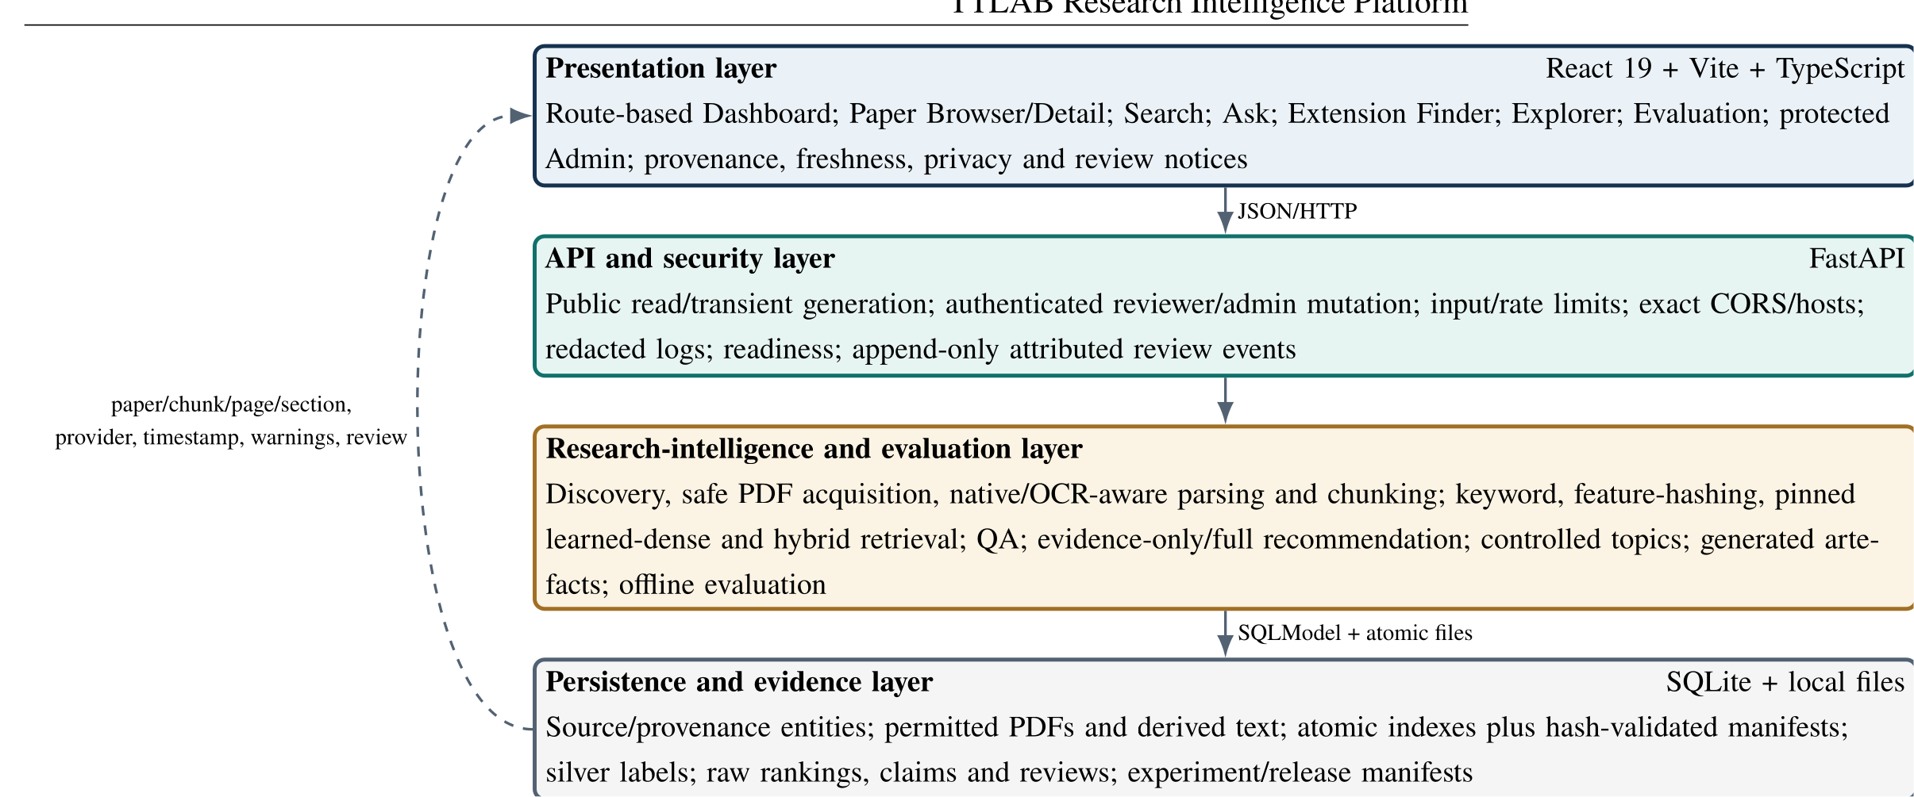
Figure 6.1. Layered system architecture. The dashed path represents provenance and review data returned from storage to public evidence displays. Text labels provide the non-color encoding.

6.2 Design principles
Five principles govern the design. First, derived index state is authoritative only when its manifest matches the current corpus. Second, source facts and generated interpretation use distinct fields and labels. Third, AI review has a distinct ai_reviewed state and cannot create human approval. Fourth, public requests are privacy-minimised and administrative mutations are authenticated. Fifth, missing dependencies or evidence produce explicit unavailable, stale, partial, unsupported, or needs-reprocess states instead of silent success.

6.3 Persistence and traceability model
Figure 6.2 summarises the principal entities. A paper owns page-aware chunks and generated artifacts. RAG answers and thesis recommendations retain retrieved chunk and citation identifiers as structured JSON. Controlled topics link to papers and canonical author identities. Every administrative or AI-review transition creates an append-only ReviewEvent containing actor identity/type/role, request ID, field diff, previous hash, and event hash. This polymorphic audit model preserves historical decisions without falsely treating an AI event as human approval.
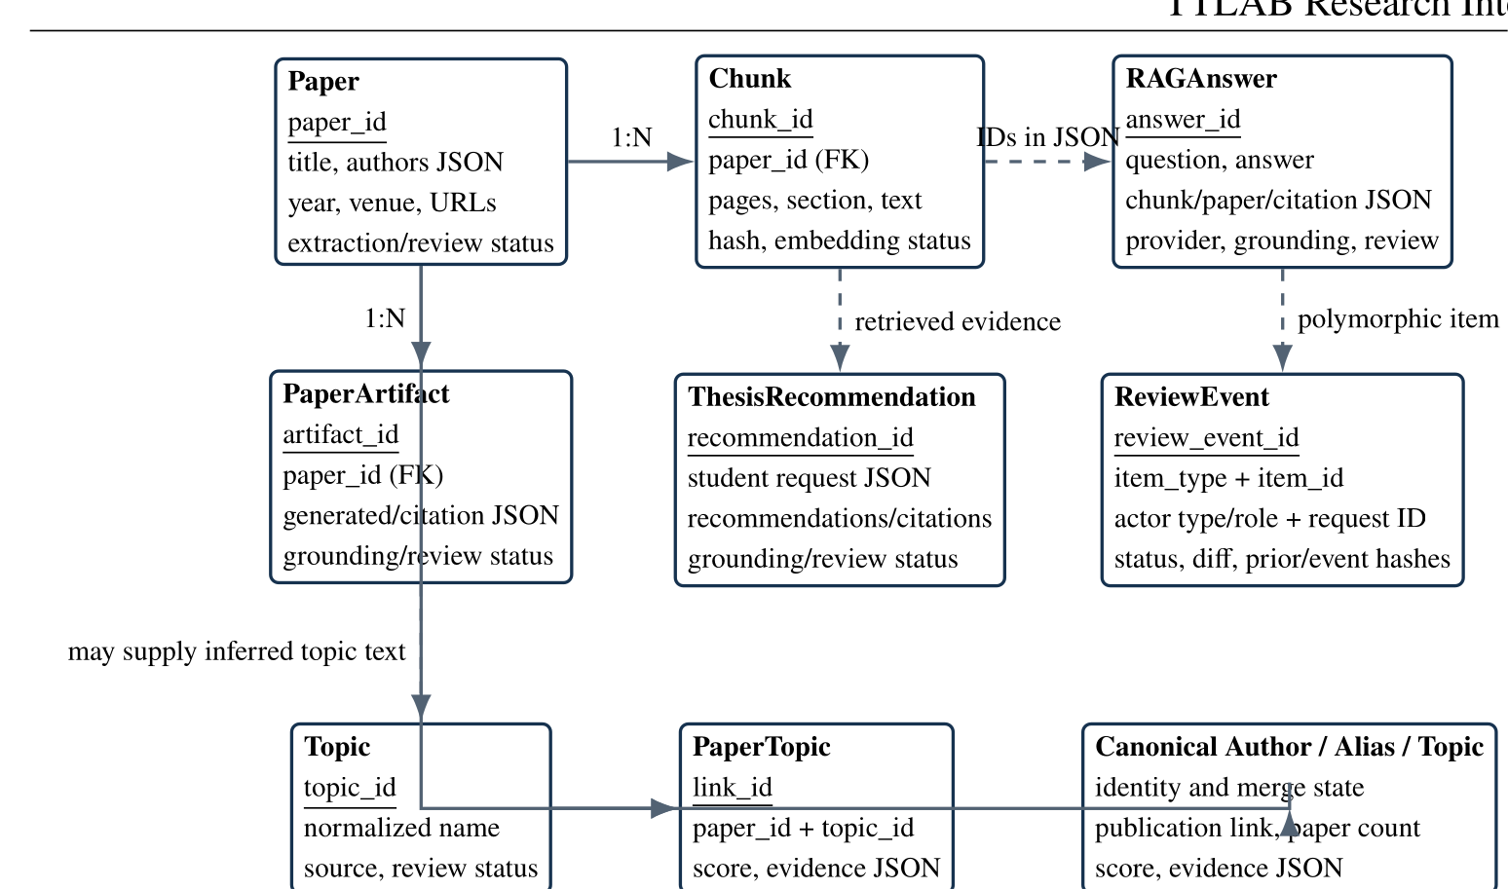
Figure 6.2. Principal persistence and provenance entities. Solid arrows denote ownership/foreign-key relations; dashed arrows denote evidence or polymorphic references.

6.4 Authoritative index design
Each vector manifest binds corpus snapshot ID and SHA-256, eligible paper/chunk counts, ordered chunk IDs and source hashes, provider/model, exact revision or algorithm version, vector dimension, normalisation, configuration hash, creation timestamp, code commit, index role, and index-file hash. Index output is written atomically, and statuses are updated only for the successfully validated eligible set. A bounded demo index is assigned a non-authoritative role and cannot overwrite or validate the complete index. Startup and evaluation validate present authoritative indexes and fail on corpus, configuration, hash, or completeness mismatch.
The feature-hashing manifest identifies a 256-dimensional SHA-256 signed token projection. The learned-dense manifest identifies sentence-transformers/all-MiniLM-L6-v2, revision 826711e54e001c83835913827a843d8dd0a1def9, 384 dimensions, L2 normalisation, CPU execution, token-window mean pooling, Apache-2.0 licensing, and model-artifact SHA-256 18309e...a7c. This distinction prevents a lexical hashing baseline from being mislabelled as learned semantic search.

6.5 Security and privacy boundaries
Public reads and transient generation are separated from reviewer/admin mutations. Bearer credentials are configured through environment-provided SHA-256 token digests; no default secret is committed. Production mode requires an active admin actor, HTTPS public URL, explicit trusted host, and HTTPS CORS origins, and rejects insecure local-demo bypass. Review transitions enforce roles and prevent AI reviewers from issuing human approval states. Request-size limits, generation rate limits, exact CORS/hosts, redacted error responses/logs, output escaping, downloader host allowlists, public-IP checks, redirect limits, PDF signature/size/page checks, and readiness diagnostics address the principal deployment threats.
Student interests, skills, time, constraints, and topic preferences remain client-side/in-request and are not persisted by default. Public generated-output serializers omit private reviewer notes and draft corrections. This minimisation reduces privacy risk but does not replace an institutional privacy review for a deployed service.

7 Data Collection and Processing

7.1 Catalog and acquisition
The catalog contains 134 publication records derived from the TTLAB archive and stored in deterministic seed JSON. The discovery/import path normalises titles and URLs, assigns stable identifiers, preserves absent metadata as missing, and records provenance/review state. PDF acquisition uses allowed hosts and public IP resolution, bounded redirects, timeouts, content-length and byte limits, content-type and PDF-signature validation, and explicit failure categories. It does not bypass authentication, paywalls, or access controls.
The frozen audit records 98 available PDFs, 34 records with no PDF URL, 1 network error, and 1 not-found result. Of the available documents, 96 matched their catalog identity and entered the experimental corpus; 2 possible PDF/title mismatches were excluded. The remaining 36 catalog records are visible as needs-review/no-text records rather than being silently absent. Figure 7.1 shows the full pipeline, and Figure 7.2 shows the resulting paper-level eligibility categories.
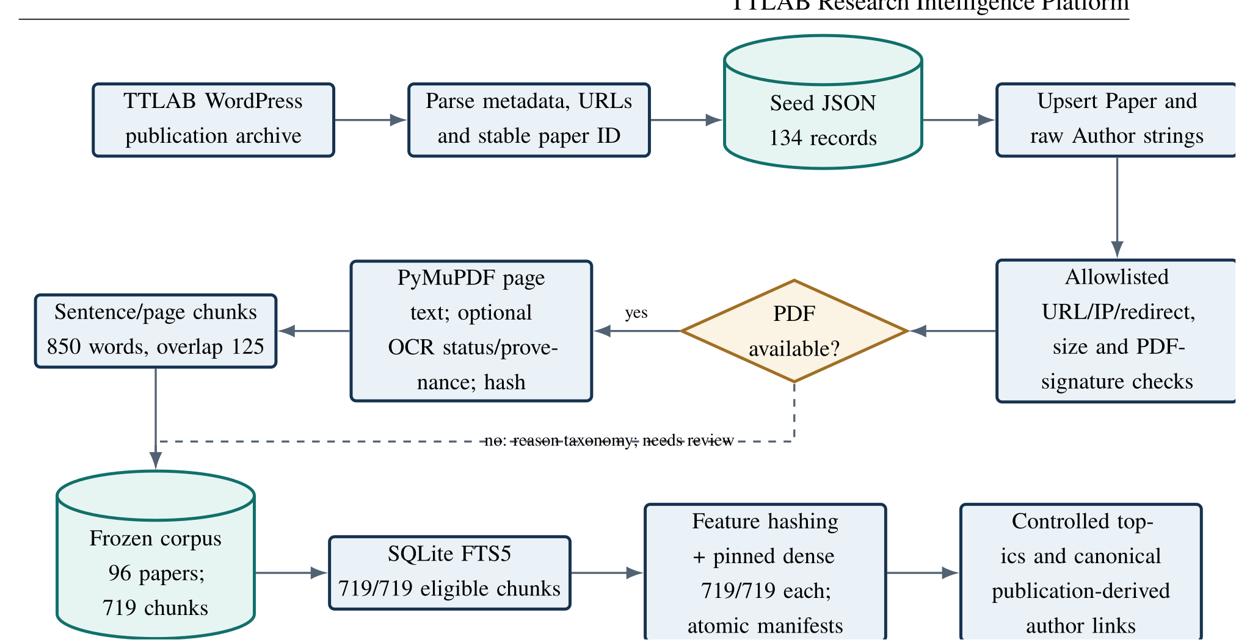
Figure 7.1. Deterministic ingestion and authoritative indexing pipeline. The optional OCR stage records status/provenance but was not used in the frozen corpus.
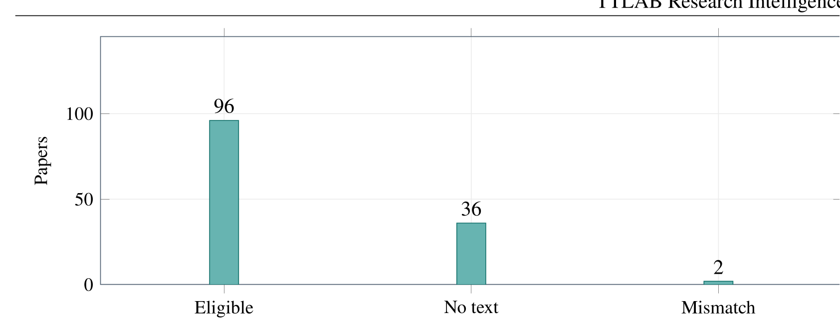
Figure 7.2. Frozen catalog eligibility: 96 eligible full-text papers, 36 records without eligible text, and 2 PDF/title mismatch exclusions. These are inventory counts, not quality scores.

7.2 Extraction and OCR-aware diagnostics
PyMuPDF extracts native text page by page and records page/character/word counts, empty pages, extraction status, and hashes. Content classification distinguishes textual, mixed, and unknown records. The repaired pipeline detects low-text/image-heavy pages and supports optional OCR with page-level engine/configuration, confidence/status, and review flags. OCR dependencies are optional and fail explicitly. All 134 records in the frozen snapshot have ocr_status=not_requested; therefore, the thesis reports no OCR accuracy or latency.
The 98 extracted PDFs contain 698 pages and 455,601 native-extraction words. These totals describe the local source snapshot; they are not included in the sanitized release. The suspected identity mismatches account for 16 excluded chunks. The raw chunk table contains 735 rows, while the eligible experiment and authoritative indexes contain 719 rows.

7.3 Page-aware chunking and sections
Extracted sentences retain their page number. Chunks target 850 words with a 5,000-character limit and 125-word overlap; identifiers incorporate paper, sequence, page span, and source hash. Section names are inferred from headings and layout cues, with Unknown preserved when evidence is insufficient. Among eligible chunks, 199 are unknown-section chunks (27.7%).
A 40-case stratified AI-reviewed silver sample compared current section labels with source passages. Exact accuracy was 0.900, labeled coverage 0.900, macro precision 0.892, and macro recall 0.904. Seven creation decisions required revision. These results support using section labels as a reranking feature with caution, not as authoritative document structure.

7.4 Metadata and author identity
The malformed Click to View author parser artifact was removed by an idempotent migration. The schema now stores canonical author rows, aliases, identity/merge state, and review status. The audit found 136 author rows: 133 unresolved active canonical identities, two merged rows, and one invalid row. Exact alias collisions, eligible authorship mismatches, excluded-paper leakage, and prohibited expertise overclaims were all zero in the executed audit. 13 possible initial/full-name or spelling pairs remain deliberately unmerged pending authoritative confirmation.
DOI, abstract, keyword, venue, and date fields carry provenance and review fields. Unverified metadata remain empty. Author-topic links are derived only from eligible indexed publication authorship and paper topics; their UI wording explicitly disclaims availability, endorsement, supervision, or expertise beyond this corpus.

7.5 Corpus distribution and release boundary
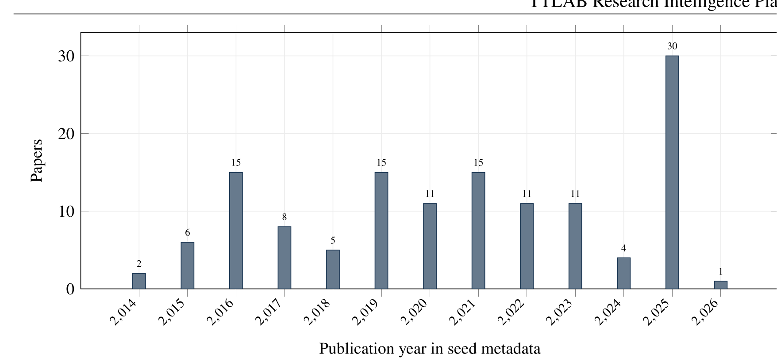
Figure 7.3. Publication-year distribution in the catalog metadata. Missing or uncertain years remain represented in the generated source data rather than being imputed.
The year distribution in Figure 7.3 characterises the seed, not full-text eligibility. Raw PDFs, extracted text, chunks, local database, and indexes are excluded from the sanitized release because TTLAB project authorization does not itself confer redistribution rights for every third-party paper. The release retains redistributable metadata, schemas, prompts without restricted passages, labels, aggregate/raw sanitized results, source hashes, and reacquisition instructions.

8 Implementation

8.1 Backend and persistence
FastAPI registers papers, search, Ask, local-model status, recommendations, artifacts, topics/authors, evaluation, and protected admin routers. SQLModel maps entities to SQLite and applies additive compatibility migrations. Startup validates security configuration, creates tables, and rejects present authoritative indexes whose corpus, configuration, file hash, or coverage is invalid. /health reports process liveness; /ready separately reports database, keyword, feature-hashing, and optional dense readiness without exposing local paths.
JSON-like response fields remain structured across the service boundary. RAG answers retain question, answer, retrieved chunks/papers, citations, provider/model, grounding state, warnings, unsupported-claim list, timestamps, and review metadata. Recommendations retain the submitted profile, ranked papers, evidence, gap class, system suggestion, MVP/stretch scope, skills, data needs, risk, difficulty, evaluation plan, provider, and review state.

8.2 Retrieval modes
Keyword retrieval uses SQLite FTS5 and its bm25() rank, with a deterministic token-frequency fallback. Feature hashing maps lower-cased alphanumeric tokens through signed SHA-256 buckets into 256 L2-normalised dimensions. Learned dense retrieval uses the pinned all-MiniLM-L6-v2 encoder and 384-dimensional L2-normalised vectors. Long chunks are encoded as overlapping 254-token windows, mean pooled, and renormalised. Query/chunk similarity is cosine similarity.
The heuristic hybrid combines normalised keyword/vector scores with hand-authored metadata, section, evidence, topic, and diversity terms. The tuned configuration retains those terms but sets keyword weight to 0.10 and dense weight to 0.80 based on development MRR. Search APIs and UI expose keyword, feature_hashing, dense, and hybrid; they return mode, expanded query, component scores, manifest/freshness diagnostics, snippets, pages, sections, and warnings.
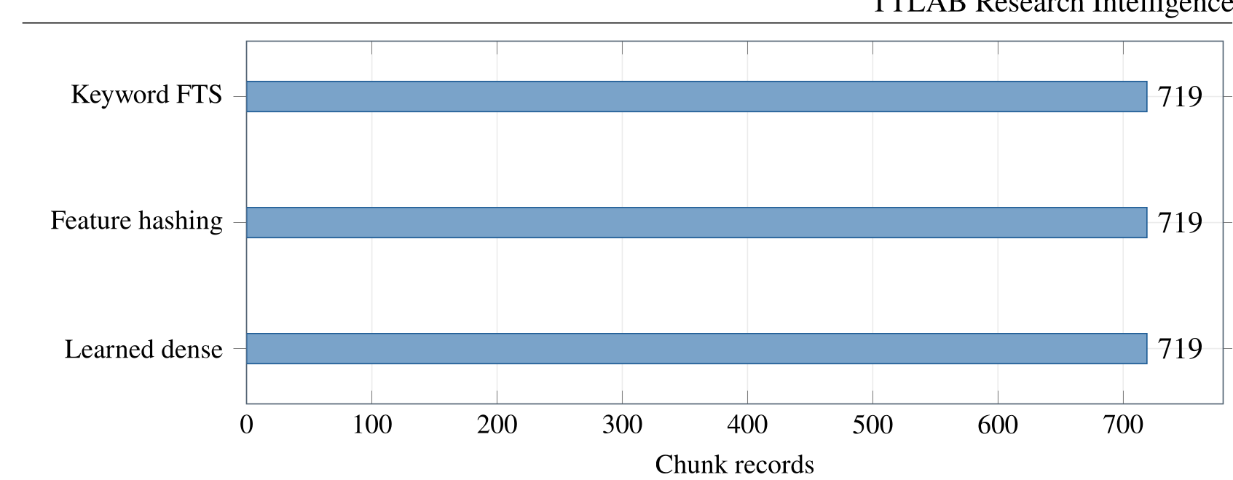
Figure 8.1. Authoritative index coverage. Keyword FTS, feature hashing, and learned dense retrieval each cover all 719 eligible chunks.

8.3 Question answering and citation checks
Figure 8.2 traces an Ask request. The default reproducible answerer is offline and extractive: it orders retrieved sentences by intent and composes a bounded response. An Ollama adapter can call a local model with a source-restricted prompt and temperature 0.1; provider failure produces a visible fallback. The configured Ollama service was unavailable during Phase 3, so no model tag, digest, quantisation, quality, or latency comparison is claimed.
The deterministic verifier checks source identifiers, page/chunk membership, required fields, and minimum lexical overlap. Its status is labelled structural grounding. The later atomic review evaluates support, citation choice, answer-point coverage, and abstention separately.
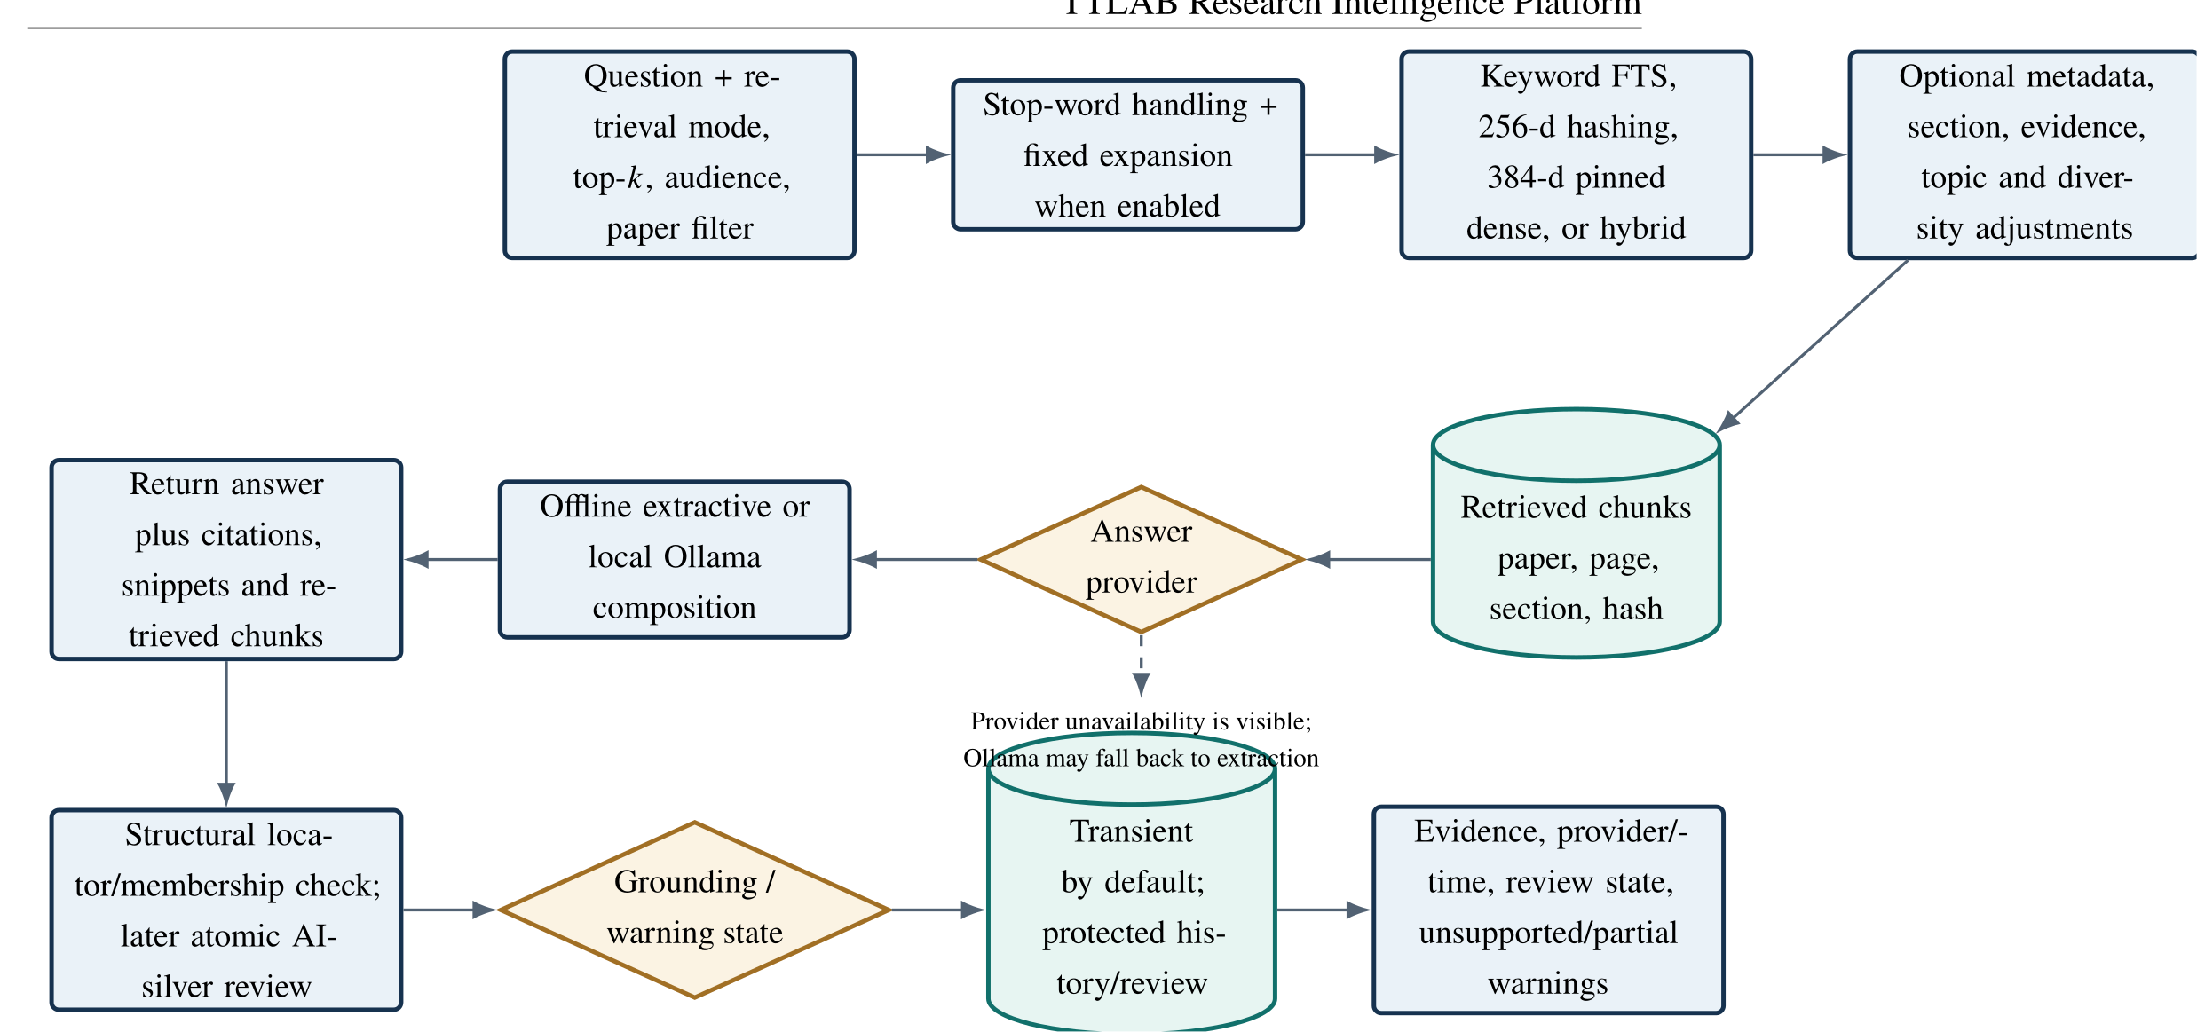
Figure 8.2. Search and RAG workflow. All retrieval modes preserve source locators; structural verification is distinct from claim-level support review.

8.4 Thesis Extension Finder
The finder accepts interests, skills, time, project type, data constraints, preferred difficulty/topics, avoid-topics, retrieval mode, and result count. It retrieves an expanded candidate set, groups evidence by paper, and computes a deterministic score: retrieval relevance 0.30, interest/topic match 0.20, skill match 0.15, data/time/difficulty 0.10 each, evidence strength 0.05, and an avoid-topic penalty of 0.20.
Each output separates paper-supported baseline work; explicit, inferred, or missing gap evidence; and a system-suggested extension. It includes MVP, stretch goals, skills, risks, data assumptions, evaluation plan, citations, warnings, and review state. An evidence-only mode returns ranked papers and passages without a generated extension, providing both a safer user choice and the experimental baseline shown in Figure 8.3.
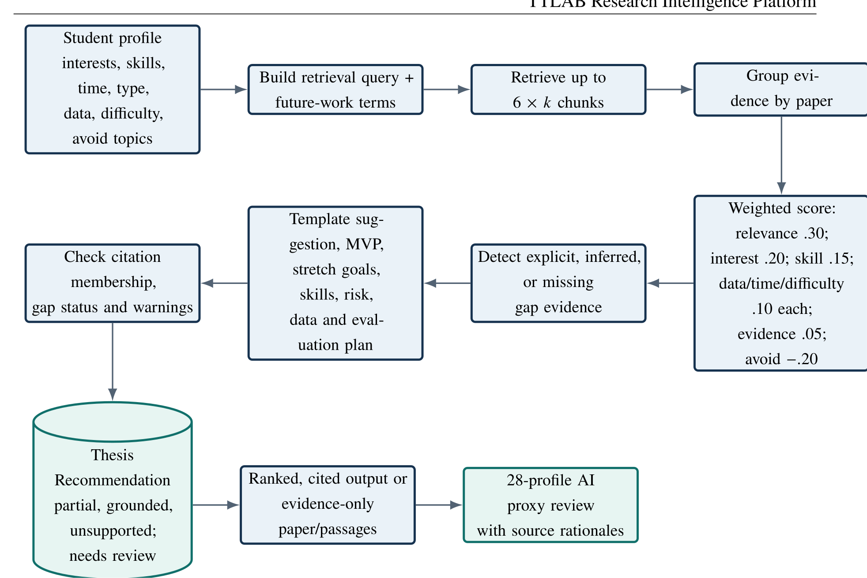
Figure 8.3. Recommendation workflow and its 28-profile AI-proxy evaluation. The final suggestion remains advice requiring external feasibility and novelty confirmation.

8.5 Topics, authors, artifacts, and review
The explorer uses a controlled 39-label lexical taxonomy with synonym rules and source-weighted evidence. A learned-dense prototype compares paper primary-source centroids with label prototypes at a development-selected threshold. Author-topic scores aggregate only eligible publication-topic links under canonical identities. Related-paper ranking combines shared topics/authors, venue/year proximity, lexical overlap, and optional vector similarity.
The deterministic artifact generator produces public and technical summaries, contributions, methods, limitations, future work, suggested extensions, skills, evaluation plans, and text podcast scripts. Fact, inference, and suggestion types are explicit. The Phase 4 review processed every 27 historical RAG answers, 7 recommendation runs, and 14 artifacts. It regenerated evidence-safe artifacts/recommendations where configuration was sufficient; historical RAG configuration was insufficient, so those 27 records were preserved and marked needs_reprocess. 48 hash-chained events record the corrections. A second pass changed zero rows, demonstrating idempotence.

8.6 Frontend and evidence communication
The route-based frontend provides Dashboard, Paper Browser/Detail, Search, Ask TTLAB, Thesis Extension Finder, Topic/Author Explorer, Evaluation, and protected Admin Review. Relevant screens expose paper/chunk/page/section evidence, provider/time, grounding and review status, data/index freshness, generated-content warnings, and empty/error/retry/offline states. Profile inputs are not stored by default. Keyboard focus, semantic landmarks, form labels, reduced-motion behavior, chart alternatives, and 360/768/1024/1440-pixel layouts are covered by automated tests.
Figure 8.4 illustrates the evidence-rich Ask result, while Figure 8.5 shows the evaluation surface. These screenshots demonstrate implemented presentation only; they are not user-study evidence.
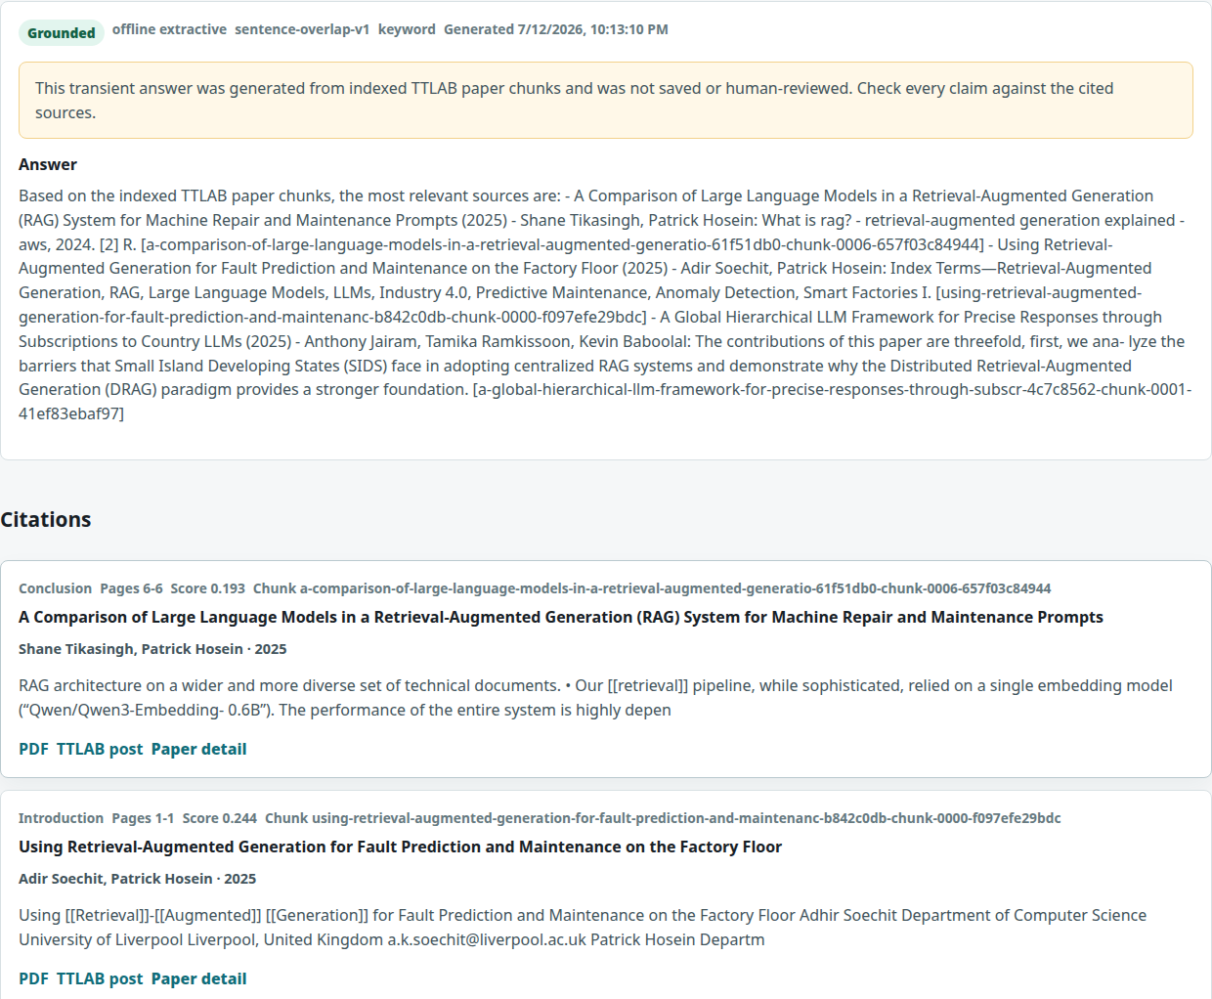
Figure 8.4. Ask TTLAB result showing generated-content notice, source locators, evidence snippets, and grounding/review warnings. The screenshot is an implementation record, not a quality rating.
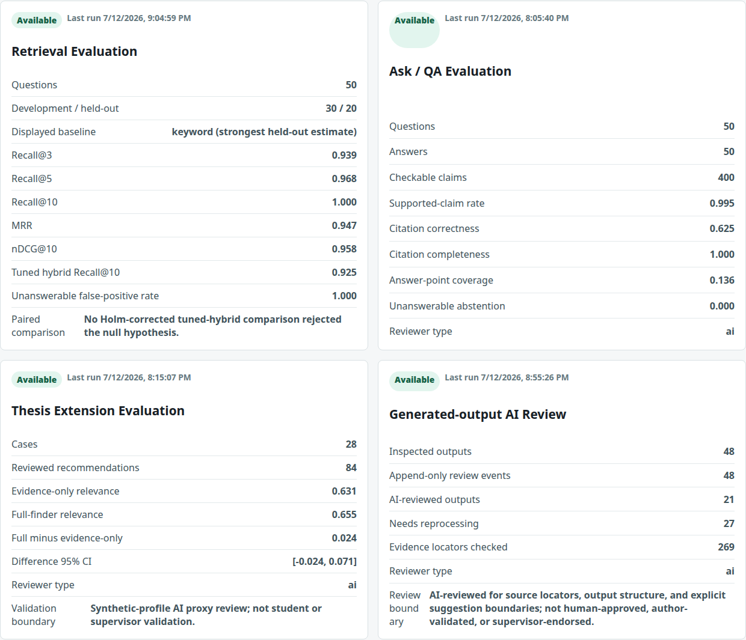
Figure 8.5. Current Evaluation Dashboard cards presenting retrieval, QA, recommendation, and generated-output review evidence with explicit AI-review boundaries.

8.7 Generated-output governance and deployment boundary
Admin mutations require reviewer/admin authentication except when an operator explicitly enables a loopback-only insecure demo. Production configuration fails closed without HTTPS and an active admin actor. Human and AI actors have distinct reviewer types; AI actors cannot issue reviewed/approved/rejected human states. The threat model covers path traversal, SSRF, PDF bombs, XSS, injection, secrets, rate limits, logging, backups, dependency auditing, and correction/incident procedures. A reverse proxy, TLS termination, monitoring service, and production identity provider remain deployment responsibilities, not repository claims.

9 Experimental Design

9.1 Overview
Figure 9.1 separates evaluation evidence into offline quality, engineering verification, and external-only validation. All datasets store schemas, source/rationale fields, reviewer type, timestamps, review passes, and hashes. Raw full-text prompts remain local when redistribution would expose third-party passages; sanitized labels and hashes remain in the release.
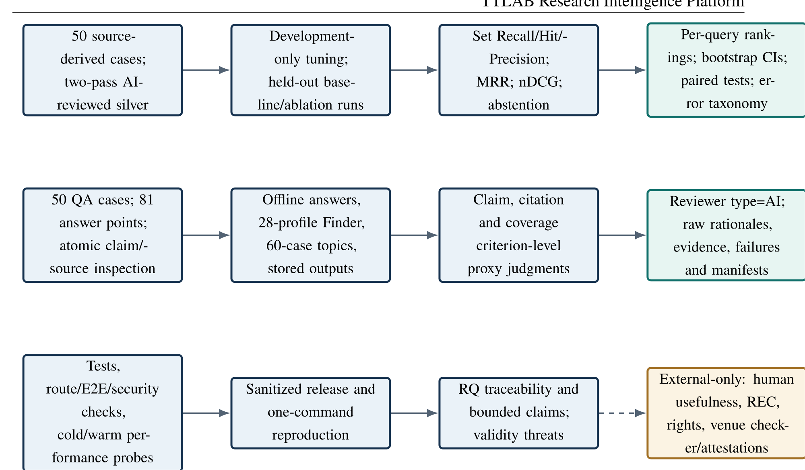
Figure 9.1. Executed evaluation workflow. AI-reviewed silver evidence is versioned separately from external human or institutional validation.

9.2 Experiment inventory
Table 9.1 lists the executed unit, comparison, and primary outcomes for every experiment family.
Table 9.1. Executed experiments, units, and primary outcomes.
Experiment | Cases/unit | Comparison | Primary outcomes
Section quality | 40 chunks | predicted versus AI-silver section | accuracy, coverage, macro precision/recall
Retrieval | 50 questions (30 dev/20 test) | keyword, hashing, dense, heuristic/tuned hybrid | set Recall, Hit, Precision, MRR, nDCG, abstention, paired tests
QA | 50 answers; 400 claims; 81 points | offline extractive outputs against source evidence | claim support, citation correctness/completeness, point coverage, abstention
Recommendation | 28 profiles; 84 items/arm | evidence-only versus full finder | proxy relevance, source/claim boundaries, feasibility, scope, risk, sensitivity
Topics | 60 papers (36 dev/24 test) | controlled lexical versus dense prototype | multi-label precision, recall, F1, coverage
Author identity | 136 rows | schema/source invariants | leakage, collisions, mismatches, overclaims, unresolved candidates
Generated outputs | 48 stored records | review pass one versus idempotence pass | status/correction/event integrity
Performance | full-corpus workloads | process-cold versus warm | median, p95, RSS, failures, units
External sanity | 3 CC BY papers | fixed lexical discriminators | acquisition/license validation, top-1 format smoke result

9.3 Retrieval configuration
The retrieval dataset contains all eleven specified strata, including four out-of-corpus cases overall. The deterministic split assigns 30 cases to development and 20 to test; the held-out set contains 19 answerable and 1 unanswerable case. All methods use the corpus-04a010207327069a corpus, top 150 chunks per component for frozen candidate pools, a top-50 chunk depth, and top ten unique papers. Unjudged papers count as non-relevant.
Development tuning searched nine keyword/dense weight pairs from 0.10/0.80 to 0.80/0.10, with a 0.42/0.48 implementation reference. The objective was development MRR with fixed secondary rules. The selected tuned configuration used keyword 0.10, dense 0.80, and all heuristic adjustments enabled. Sensitivity tested nearby 0.05/0.85, 0.15/0.75, 0.20/0.70, and 0.30/0.60 weights. Individual ablations removed one component from the selected hybrid; cumulative ablations added components in the documented order.

9.4 QA review procedure
The offline extractive answerer generated all 50 reviewed answers. Each atomic corpus claim was linked to inline source IDs and returned citation records. The AI reviewer performed a support-first creation pass and a shuffled contradiction-focused verification pass; the verification label was final, with disagreements retained. The metrics use strict treatment of partial labels. Confidence intervals resample whole QA cases 10,000 times, preserving within-case claim correlation. They do not include AI-label uncertainty.
An Ollama comparison was attempted at the configured local endpoint on port 11434. CLI version 0.21.2 was present, but version, tags, and process endpoints refused connections. No installed model, digest, quantisation, response, or latency could be verified, so the comparison is reported as unavailable rather than approximated.

9.5 Recommendation, topic, and review protocols
The 28 synthetic profiles span one-month, two-week, and semester timelines; software, ML, analysis, dashboard, literature-support, and other project types; public/synthetic/no-external/supervisor data constraints; easy/medium/hard preferences; and avoid topics. Both arms return three items. Review criteria are applied to every item in two shuffled AI passes. The paired relevance contrast and sensitivity results resample profiles, not individual recommendations.
The topic dataset contains 36 development and 24 test papers, covers all controlled labels across the full dataset, includes 51 multi-label cases and four other/unknown cases. The dense threshold (0.20) was selected by development micro-F1, with macro-F1 and higher threshold as tie-breakers. Test data were not used for selection. The author audit checks only source-backed invariants; candidate merges are preserved for external identity confirmation.
Generated-output review covers every stored RAG answer, recommendation run, and paper artifact. The procedure records rationale, citation locators, corrections, actor type, and chained event hashes. Configuration-incomplete historical outputs remain needs_reprocess; they are not deleted or silently regenerated.

9.6 Performance and reproducibility protocol
The full benchmark uses three process-cold and three warm repetitions at concurrency one. Each workload runs in an isolated database/index/output context and retains raw timing and bounded errors. The operating-system cache is not flushed. A linearly interpolated p95 over three observations is coarse and is reported only as a local baseline. The one-command reproduction path verifies dependencies, rebuilds allowed derived state, runs evaluations and tests, compiles both manuscripts, performs PDF preflight, builds the sanitized release, and emits hashes. Exact full-corpus reruns require lawful access to local PDFs and the pinned dense model.

10 Results

10.1 RQ1: corpus, extraction, and index integrity
The catalog contains 134 records. 98 PDFs were available; 96 papers passed the frozen inclusion rules, 36 had no eligible full text, and 2 were excluded for suspected PDF/title mismatch. The raw database contains 735 chunks; 719 are eligible, and 199 of those retain an unknown section. SQLite quick check returned ok and foreign-key checking found no violations.
The 40-case AI-silver section review produced exact accuracy 0.900, labeled coverage 0.900, macro precision 0.892, and macro recall 0.904. The unknown-section share remains material, so section-aware ranking is a fallible signal.
Keyword, feature-hashing, and learned-dense indexes each cover 719/719 eligible chunks (Figure 8.1). Their manifests share corpus snapshot corpus-04a010207327069a; the feature-hashing and dense index SHA-256 values are f233...fa5 and ac0d...6a3. The prior partial-index/stale-status defect is therefore closed for the frozen corpus. The bounded conclusion for RQ1 is that complete derived-state coverage is achieved for the eligible subset, while 38 catalog records remain outside that subset and 199 eligible chunks lack a confident section label.

10.2 RQ2: held-out retrieval
Table 10.1 reports held-out estimates. Keyword retrieval had the highest point estimate on all four headline answerable-query measures. Learned dense achieved MRR 0.939, set Recall@3 0.916, and set Recall@10 0.989, compared with keyword values 0.947, 0.939, and 1.000. Feature hashing had lower point estimates. The tuned hybrid improved over feature hashing but did not exceed keyword or learned dense on these point estimates.
Table 10.1. Held-out retrieval results on 19 answerable questions. Recall@3 intervals are 10,000-replicate query bootstrap 95% CIs.
Mode | Set R@3 (95% CI) | Set R@10 | MRR | nDCG@10 | Unans. FP
Keyword | 0.939 [0.866, 1.000] | 1.000 | 0.947 | 0.958 | 1/1
Feature hashing | 0.654 [0.443, 0.851] | 0.704 | 0.588 | 0.582 | 1/1
Learned dense | 0.916 [0.821, 1.000] | 0.989 | 0.939 | 0.939 | 1/1
Heuristic hybrid | 0.795 [0.611, 0.947] | 0.917 | 0.813 | 0.829 | 1/1
Tuned hybrid | 0.856 [0.707, 0.974] | 0.925 | 0.860 | 0.871 | 1/1
The tuned-minus-keyword MRR contrast was $-0.088$ (95% CI $-0.237$ to $0.044$; exact paired randomisation $p=0.375$, experiment-family Holm-adjusted $p=1.000$). Tuned-minus-dense was $-0.079$ (95% CI $-0.175$ to $0.000$; adjusted $p=1.000$). Tuned-minus-feature-hashing was $+0.272$ (95% CI $0.026$ to $0.518$), but the paired $p=0.061$ and family-adjusted $p=1.000$ did not reject the null. No corrected comparison demonstrated superiority.
Cumulative ablations were descriptive because they were examined after configuration selection. Adding topic adjustment produced set Recall@3 0.916, Recall@10 1.000, MRR 0.947, and nDCG@10 0.952; adding diversity did not change those aggregates. The error taxonomy flagged 1 extraction/unknown-section case, 2 intent/ranking cases in which relevant papers fell below rank ten, and 1 unanswerable corpus-absence case. All five modes returned a positive result for the one held-out unanswerable query. This single case is too small for a stable rate; it shows only that none of the evaluated configurations abstained on that case. The RQ2 conclusion is that keyword had the highest held-out point estimates, learned dense was lower on every headline point estimate, and no corrected comparison established tuned-hybrid superiority.

10.3 RQ3: claim support, citations, completeness, and abstention
Table 10.2 separates support from completeness. Of 400 checkable claims, 398 were supported, 2 partially supported, and 0 unsupported. Strict supported-claim rate was 0.995 (95% CI 0.987–1.000). Every checkable claim carried a citation, but only 250/400 claim–citation links were fully correct: 0.625 (95% CI 0.564–0.691). Strict answer-point coverage was 11/81, or 0.136 (95% CI 0.067–0.211). Returned citation utilisation was 0.592.
Table 10.2. AI-assisted QA review over 50 offline extractive answers. Partial labels do not count in strict estimates.
Metric | Estimate | 95% CI | Interpretation
Supported-claim rate | 0.995 | [0.987, 1.000] | local claim/source support
Citation correctness | 0.625 | [0.564, 0.691] | correct claim–citation links
Citation completeness | 1.000 | [1.000, 1.000] | citation presence only
Answer-point coverage | 0.136 | [0.067, 0.211] | strict expected-content coverage
Answerability accuracy | 0.920 | [0.840, 0.980] | answer/abstain decision
Unanswerable abstention | 0.000 | [0.000, 0.000] | 0/4 cases abstained
The error analysis found incomplete answers in 44/50 cases, off-topic retrieval in 42, within-paper evidence misses in 14, full answer-point omissions in 13, answer sentence-selection misses in 12, incorrect citations in 4, and false-positive answers for all 4 unanswerable cases. Thus, source-traceable extraction produced few locally unsupported claims in this sample, but it did not deliver complete answers or correct abstention. The RQ3 conclusion is a negative/mixed result: high local claim support coexists with weak citation choice, low answer-point coverage, and failed abstention, so structural citation presence overstates end-to-end answer quality.

10.4 RQ4: recommendation proxy evaluation
Across 28 profiles, each arm produced 84 reviewed items. Evidence-only AI-proxy paper relevance was 0.631 (95% CI 0.524–0.726); full-finder relevance was 0.655 (95% CI 0.560–0.750). The paired full-minus-baseline estimate was 0.024 (95% CI -0.024–0.071), so improvement was not demonstrated.
All 84 full-finder outputs passed source-fidelity, fact/future-work/gap/suggestion separation, novelty-caution, MVP, stretch-goal, risk, and required-skill checks. All 84 feasibility judgments were partial because the source evidence could not validate time, skill mastery, or data access. Evaluation-plan quality passed in 72 cases and was partial in 12. The two AI passes agreed exactly at 0.994 over 1092 criterion judgments; this is same-reviewer consistency, not human reliability. Weight sensitivity showed the interest term was the most disruptive removal, while most $±25\%$ changes retained high top-three overlap. This component of RQ4 finds that claim separation is structurally strong, but relevance improvement is small and inconclusive and feasibility remains external.

10.5 RQ4: topics, authors, and generated review
The held-out topic results in Table 10.3 show a precision–recall trade-off. The controlled lexical method achieved higher precision and F1; the dense prototype achieved higher recall and coverage but produced more semantic overreach. The controlled vocabulary was retained for its precision, inspectability, and editability.
Table 10.3. Held-out multi-label topic results on 24 AI-silver paper cases.
Method | Micro precision | Micro recall | Micro F1 | Coverage
Controlled lexical | 0.652 | 0.484 | 0.556 | 0.875
Dense prototype | 0.417 | 0.694 | 0.521 | 0.958
The author audit found zero excluded-evidence leakage, alias collision, eligible authorship mismatch, excluded-paper topic link, or overclaim-output violation. It retained 13 possible same-person pairs for external confirmation and derived 313 author-topic links from eligible publications. Consequently, topic/author exploration is inspectable but not author-validated.
Generated-output review processed all 48 stored records. 21 artifacts/recommendation records were regenerated or verified and marked ai_reviewed. 27 historical RAG answers lacked sufficient generation configuration for safe reproduction; they remain preserved as needs_reprocess. The first pass created 48 hash-verified audit events and changed 48 records; the second pass created zero events and changed zero records. The combined RQ4 conclusion is that advisory/discovery outputs are inspectable and AI review is attributable and idempotent, while recommendation benefit, human approval, novelty, feasibility, and comprehensive expertise remain unestablished.

10.6 RQ5: engineering verification, performance, and external sanity
The final benchmark results are generated from the strictly validated artifacts/phase6/performance/performance_full_results.json and summarised in Table 10.4. The benchmark uses 3 cold and 3 warm repetitions at concurrency one on AMD Ryzen 7 5800X 8-Core Processor with 3.8 GiB available memory under WSL2. Across all 17 workloads, 102 cold/warm samples and all 102 RSS observations passed validation with 0 failures; maximum observed process RSS was 751.5 MiB. The clean benchmark source commit is 5ccf22ec and the provenance-hash prefix is 61378b9aa78a.
Table 10.4. Selected full-corpus Phase 6 performance results. Times are seconds; p95 is a coarse interpolation over three repetitions.
Workload | Cold median | Cold p95 | Warm median | Warm p95
Dense indexing | 145.005 | 145.020 | 66.169 | 134.066
Keyword retrieval | 9.809 | 10.126 | 8.091 | 9.526
Dense retrieval | 84.487 | 86.265 | 12.215 | 78.342
Hybrid retrieval | 93.355 | 93.616 | 20.326 | 86.385
Offline answer | 83.355 | 83.736 | 9.842 | 75.800
Recommendation | 83.604 | 85.675 | 10.482 | 76.668
ASGI endpoint set | 79.606 | 81.178 | 3.948 | 72.397
Frontend route set | 12.496 | 12.807 | 12.463 | 12.631
The external sanity harness mapped three CC BY JATS/XML articles into the production chunker contract and achieved 3/3 fixed lexical top-one matches; it did not validate the main PDF-ingestion pipeline or cross-domain retrieval quality.
The sanitized release scanner excludes PDFs, SQLite, indexes, local paths, secrets, raw/full extracted text, interface screenshots, private prompts, and raw Europe PMC XML. It verifies safe archive members and per-file/archive SHA-256 checksums. Authenticated mutations, attributable review states, automated accessibility regression checks, and visible evidence boundaries make the local artefact reviewable without redistributing restricted PDFs. The accessibility checks passed, but they do not establish WCAG conformance or usability with assistive technologies. The final engineering test, frontend, document, preflight, release, and reproduction outcomes are recorded in thesis/PROJECT_EVIDENCE.md. The bounded RQ5 conclusion is local reproducibility and reviewability under the documented configuration, protected evidence interfaces, privacy-minimizing release, and limited JATS/XML format compatibility; production scale, WCAG conformance, assistive-technology usability, main-pipeline external compatibility, and unrestricted corpus reproduction are not established.

11 Discussion

11.1 Traceability is an engineering property, not an accuracy score
The platform now preserves paper, chunk, page/section, provider, warning, timestamp, and review state through its principal workflows. Complete manifest coverage eliminates the earlier ambiguity between active index files and stale database flags. These are meaningful engineering results because they make an output auditable and a stale index detectable. They do not make the output correct.
The QA evaluation illustrates the distinction. Strict local claim support was 0.995 and citation presence was 1.000, yet citation correctness was 0.625 and answer-point coverage was 0.136. Extractive composition largely avoided unsupported statements by copying supported passages, but it selected too much off-topic evidence and omitted much of the requested information. Traceability reduces the cost of diagnosis; it does not substitute for diagnosis.

11.2 Simple lexical retrieval remained competitive
Keyword retrieval produced the highest held-out MRR and nDCG@10 point estimates. Learned dense produced MRR 0.939 and nDCG@10 0.939, versus keyword values 0.947 and 0.958; the study was not designed as an equivalence or non-inferiority test. The tuned hybrid had lower point estimates than both and did not yield a corrected significant gain even over feature hashing. This result agrees with the broader lesson of heterogeneous retrieval benchmarks: learned representations are not automatically superior for every corpus [17].
Several features may explain the keyword result without establishing causality. The laboratory questions and paper titles share specialised vocabulary; relevant-paper labels may favour explicit lexical matches; the corpus is small; and the candidate pool is already rich. The post-selection ablation showing a stronger cumulative configuration is hypothesis-generating, not an invitation to retune on the held-out set. A future release needs a larger preregistered test partition and hard paraphrase cases.

11.3 Abstention is the principal end-to-end safety gap
All retrieval modes returned a positive result on the single held-out unanswerable case, and the answerer failed to abstain on all four QA unanswerable cases. This limitation is more consequential than small ranking differences: a user may receive a fluent, supported but irrelevant answer to a question the corpus cannot answer. An abstention mechanism should therefore combine calibrated top-score/margin signals, evidence coverage, corpus-scope classification, and explicit fallback wording, then be evaluated on a substantially larger unanswerable set.

11.4 Recommendation structure is stronger than recommendation validation
The extension schema successfully separates baseline evidence, explicit versus inferred gaps, system suggestions, MVP/stretch scope, risk, skills, data assumptions, and evaluation plans. All reviewed outputs retained those boundaries. However, every feasibility judgment was partial, and the relevance difference over an evidence-only baseline crossed zero. The full finder should be presented as a structured brainstorming aid, not as proof that an idea is novel, feasible, suitable for a degree, or approved by a supervisor. The evidence-only mode is valuable because it lets a cautious user stop before generation.

11.5 Controlled discovery favors inspectability
The topic comparison exposes a practical trade-off. Dense prototypes increased coverage and recall but reduced precision. The controlled vocabulary had higher precision, slightly higher F1, deterministic rules, and an editable governance surface. That profile better suits a public laboratory archive where over-attributing a topic to a researcher can cause reputational harm. The remaining 13 identity candidates show why automatic name merging is intentionally conservative. Publication-derived relations should remain qualified even after identity resolution.

11.6 Review and governance as first-class data
Forty-eight append-only AI review events close the earlier empty-governance state and demonstrate deterministic idempotence. The design does not conflate that activity with human approval: 21 outputs are AI-reviewed, while configuration-incomplete historical answers are needs-reprocess. Authentication, actor roles, chain hashes, and protected status transitions make future human review attributable. A deployed institution still needs operational ownership, identity lifecycle, correction response times, and legal/privacy decisions.

11.7 Reproducibility with rights constraints
An exact full-corpus replication requires lawful access to the third-party papers; publishing their text would improve convenience by violating the evidential and rights boundary. The sanitized release therefore favours computational transparency over unrestricted data redistribution. It includes code, schemas, labels, sanitized results, prompts/configurations, hashes, code-native figure sources, and instructions, while requiring recipients to reacquire permitted documents. Interface screenshots are excluded because rendered source/answer text cannot be field-redacted reliably. The external sanity harness mapped three JATS/XML documents into the production chunker’s extraction contract. It did not exercise the primary PDF-ingestion path, and three life-science articles do not establish domain transfer.

12 Limitations, Ethics and Threats to Validity

12.1 Technical and empirical limitations
Only 96 of 134 catalog records enter full-text experiments. Thirty-six lack eligible text and two suspected PDF/title mismatches require external resolution. Native extraction is heuristic; no frozen-corpus document used OCR. The 199 unknown-section chunks constrain section-aware ranking. Metadata lacks verified DOI, abstract, and keyword coverage for many records. Thirteen author identity candidates remain unresolved.
The retrieval set has 50 AI-silver cases and only 20 held-out cases. Its single held-out unanswerable case makes the false-positive rate unstable. AI-created relevance pools may omit relevant papers; unjudged documents are treated as non-relevant. The strongest cumulative ablation was inspected after final configuration selection. Confidence intervals omit label and corpus-selection uncertainty.
QA results are derived from one offline extractive answerer and one AI-review process. High support partly reflects extraction rather than synthesis ability. Citation correctness and answer coverage are weak, and all unanswerable cases received answers. The local Ollama service was unavailable, so no generative-model comparison exists. Recommendation and topic findings are AI-proxy/silver results, not student, supervisor, researcher, or public judgments. The performance benchmark uses concurrency one, three cold and three warm repetitions, one machine, and a local WSL2 environment; it is not capacity or production testing.

12.2 Ethics, permissions, and responsible AI
TTLAB explicitly authorized the project and use of the laboratory corpus. This fact does not establish research-ethics-board approval or exemption, ownership of third-party publications, or blanket redistribution permission. No human participants were recruited; no satisfaction, usability, educational benefit, or supervisor-approval claim is made. If a later human study is undertaken, institutional ethics determination, informed consent, recruitment, retention, compensation, and withdrawal procedures must precede data collection.
Potential harms include source misrepresentation, inappropriate thesis advice, expertise misattribution, copyright overexposure, privacy leakage from project profiles, malicious documents, and unauthorised review changes. Controls include source locators, fact/inference/suggestion labels, AI/human review separation, warnings, evidence-only mode, transient profiles, authenticated mutations, append-only event hashes, PDF/downloader limits, and a sanitized release. These controls reduce risk; they do not amount to institutional approval or human verification.
Codex/LLM assistance was material in coding, evidence inspection, test and evaluation preparation, AI-silver labeling, analysis, and manuscript editing. Reviewer IDs, prompts or prompt hashes, seeds, and limitations are persisted. The exact underlying Codex model digest was not exposed by the runtime and was not invented. This disclosure should be reconciled with the University’s current submission policy by the author/institution before formal submission.

12.3 Construct validity
Set Recall@$k$, Hit@$k$, MRR, nDCG, citation correctness, citation completeness, supported-claim rate, answer-point coverage, and abstention are defined separately. “Grounded” in operational records denotes structural checks, not entailment. Topic score denotes controlled or prototype label evidence, not topic truth. Recommendation score denotes heuristic fit, not usefulness, novelty, or feasibility. AI-review consistency is not human inter-rater reliability. Index coverage and test counts are engineering properties, not effectiveness.

12.4 Internal validity
Development/test separation reduces direct tuning leakage, and the retrieval runner freezes candidate pools and controls. Nevertheless, source-derived questions and labels were produced within one remediation process and may reflect the system’s corpus vocabulary. The same AI reviewer created and verified labels, even though order and review lens changed. Error taxonomy tags are diagnostic signals and do not establish causal mechanisms. Background load, WSL scheduling, caches, and remote-server behavior influence performance.

12.5 External validity
The system and controlled taxonomy are tailored to one laboratory, English-language records, and a small local corpus. Archive markup, disciplinary terminology, PDF quality, and user goals will differ elsewhere. The three-document Europe PMC check covers only CC BY life-science JATS/XML and trivial lexical queries. It cannot support claims about other institutions, languages, domains, or large corpora. No human study supports generalisation to student decision-making or public understanding.

12.6 Reproducibility validity
Code, schemas, labels, raw sanitized results, model revision/hash, environment metadata, seeds, and manifests are versioned. Index validators bind derived state to the corpus. Exact replication still depends on lawful source access, changing remote archives, availability of the pinned model artifact, operating-system/toolchain differences, and externally excluded full-text review prompts. The release distinguishes open analytical reproduction from conditional full-corpus reproduction rather than claiming that both are identical.

12.7 Security and deployment limitations
The repository provides a fail-closed production configuration boundary, but it is not a hosted service. TLS, reverse proxy, identity-provider lifecycle, central monitoring, backups, incident response staffing, legal notices, accessibility conformance assessment, and operational correction processes remain deployment-specific. External IEEE PDF Express/Checker validation and any venue/institutional declarations require credentials and authorized human attestations.

13 Conclusion and Future Work
This thesis designed, repaired, and evaluated a source-traceable research-intelligence platform for a laboratory publication corpus. The system represents 134 catalog records, admits 96 papers and 719 chunks to the frozen experimental corpus, and maintains complete keyword, feature-hashing, and learned-dense authoritative indexes. It exposes search, citation-bearing QA, evidence-only and full thesis-extension workflows, controlled topic/author exploration, generated paper artifacts, evaluation state, and authenticated review through a responsive public interface.
The answers to the research questions are:
RQ1
The pipeline achieves complete authoritative index coverage for all 719 eligible chunks, excludes 2 suspected document mismatches, and records 36 no-text records. Section labeling reached 0.900 AI-silver accuracy, but 199 eligible chunks remain unknown-section.
RQ2
Keyword retrieval had the highest held-out point estimates (set Recall@3 0.939; MRR 0.947); learned dense produced 0.916 and 0.939, respectively. The study did not establish equivalence between those modes, and corrected paired tests did not demonstrate tuned-hybrid superiority.
RQ3
Offline extraction yielded local claim support 0.995 but only 0.625 citation correctness, 0.136 answer-point coverage, and no abstention on 4 unanswerable cases. Source traceability therefore did not imply complete or appropriately scoped answers.
RQ4
The finder preserved fact/future-work/gap/suggestion boundaries, but the 0.024 relevance difference over an evidence-only baseline had a 95% CI spanning zero and every feasibility judgment remained partial. The controlled lexical taxonomy had higher held-out precision than the dense prototype; author auditing removed known parser contamination without unsafe merges; and every stored generated output received attributable AI review or needs-reprocess status. These are inspectable advisory/discovery outputs, not validated thesis advice, endorsement, or human approval.
RQ5
Engineering evidence supports local reproducibility and reviewability under the documented configuration, protected evidence interfaces, and a privacy-minimizing release that excludes restricted PDFs. Automated accessibility regression checks passed, but they do not establish WCAG conformance or assistive-technology usability. The external sanity harness mapped three CC BY JATS/XML articles into the production chunker contract and achieved 3/3 fixed lexical top-one matches; it did not validate the main PDF-ingestion pipeline or cross-domain retrieval quality. Performance is characterised on one machine at concurrency one; production capacity and broad external validity remain unestablished.
The principal conclusion is deliberately restrained: the project provides a rigorous, inspectable research-intelligence artefact and evidence package, but not a human-validated research advisor. Its most important empirical finding is the gap between traceability and utility: supported, fully cited extractive claims can still be incomplete, weakly matched to citations, and inappropriate for out-of-corpus questions.

13.1 Prioritised future work
- Calibrate abstention. Expand unanswerable and adversarial cases, learn or calibrate evidence/score thresholds on development data, and measure selective risk and coverage.
- Improve evidence selection. Use answer-point-aware reranking and within-paper passage retrieval, then re-evaluate citation correctness and content coverage without tuning on the present test set.
- Run independent human studies. After institutional ethics determination, recruit appropriate students, supervisors, researchers, and public users to evaluate relevance, comprehension, feasibility, trust, accessibility, and workflow utility.
- Resolve corpus and identity gaps. Acquire only permitted missing PDFs, externally verify mismatch documents and candidate author merges, populate provenance-backed metadata, and evaluate OCR on a real scanned-document subset.
- Replicate externally and at scale. Apply the frozen protocol to additional authorized laboratories, disciplines, and languages; enlarge the test set; and conduct concurrent load/endurance testing in a production-like deployment.
- Strengthen operational governance. Integrate institutional identity, documented correction and appeal processes, retention/deletion controls, monitoring, backups, incident response, and independent security/accessibility assessment.
Venue PDF validation, official declaration language, conflict/funding attestations, and institutional policy confirmation are external submission steps. They are kept outside the manuscript’s empirical claims rather than filled with unsupported text.

Appendix A: Research-Question Traceability Matrix
Table A.1. Complete connection from each research question to method, evidence, result, and conclusion.
RQ | Method | Evidence | Result | Conclusion
1 | eligibility and identity audit; native extraction; 40-case section review; authoritative index validation | Phase 1 JSON; database integrity; section silver cases; keyword/hashing/dense manifests | 134 catalog; 98 PDFs; 96 eligible papers; 719/719 chunks indexed in all three representations; two mismatch exclusions; 199 unknown-section; section accuracy 0.900 | the eligible corpus is internally complete and fail-loud; catalog/text and structural-label limitations remain
2 | 30/20 dev/test baseline comparison; development tuning; ablation, bootstrap and paired tests | per-query rankings; retrieval summary/statistics/errors; tuning and sensitivity outputs | keyword MRR 0.947 and set R@3 0.939; dense 0.939 and 0.916; tuned hybrid 0.860 and 0.856; no corrected tuned-hybrid superiority | keyword has the highest point estimates; dense equivalence is not established; the small silver set does not establish broader-corpus behavior
3 | 50-case atomic claim, citation, and answer-point review; answerability checks; bootstrap intervals; Ollama availability probe | 400 claim labels; 81 answer points; source rationales; QA metrics/errors; provider probe | support 0.995; citation correctness 0.625; point coverage 0.136; 0/4 unanswerable abstentions; Ollama unavailable | traceability constrains local claim support but does not establish correct citation choice, answer completeness, abstention, or human-perceived quality
4 | paired recommendation comparison over 28 profiles; 60-case topic comparison; author identity/source audit; complete generated-output review | 168 recommendation arm items; topic predictions/metrics; author audit; 48 decisions/events and idempotence manifest | recommendation difference 0.024 [–0.024, 0.071]; all feasibility partial; lexical topic P/R/F1 0.652/0.484/0.556; 13 unresolved identity candidates; 21 AI-reviewed and 27 needs-reprocess | advisory/discovery outputs are inspectable, but improvement, feasibility, novelty, expertise, endorsement, and human approval are not established
5 | full repeated benchmark; automated tests/builds; review/interface checks; release scan; external Europe PMC sanity; PDF preflight | Phase 6 performance/raw results; reproduction manifest; review evidence; accessibility/authentication tests; sanitized release hashes; three CC BY acquisition records | concurrency-one cold/warm measurements; attributable review state; protected mutations; automated accessibility checks passed; three of three external lexical top-1 matches; restricted PDFs excluded; documents build and preflight locally | bounded local reproducibility and reviewability are supported without restricted-PDF redistribution; WCAG conformance, assistive-technology usability, production scale, human validation, and venue checks remain external
Table A.1 is the authoritative thesis claim map. Inventory counts support RQ1, not effectiveness. AI-silver experiments support bounded RQ2–RQ4 observations, not human usefulness. Engineering, interface, review, and release evidence support RQ5 local reproducibility and reviewability, not production deployment.

Appendix B: Reproducibility Guide
Run commands from the repository root on Linux/WSL. The exact code revision, working-tree state at execution, environment, input hashes, and output hashes are embedded in phase and reproduction manifests. The corpus snapshot is corpus-04a010207327069a.

B.1 One-command paths
make reproduce-quick # code/sanitized evidence path
make reproduce # full authorized-corpus path
make release # deterministic sanitized bundle
The full path requires a lawful local database/PDF corpus and the pinned dense model. It imports/repairs metadata, extracts and chunks, validates/rebuilds indexes, executes evaluations and performance workloads, runs tests/builds, generates manuscript evidence, compiles paper and thesis, performs local PDF preflight, builds the release, and emits a final manifest/checksums. The quick path verifies distributable code and sanitized evidence without claiming to recreate restricted inputs.

B.2 Evidence and manuscript generation
PYTHONPATH=backend .venv/bin/python thesis/scripts/collect_evidence.py
PYTHONPATH=backend .venv/bin/python thesis/scripts/runtime_probe.py
PYTHONPATH=backend .venv/bin/python thesis/scripts/generate_manuscript_assets.py
# With the backend on :8000 and frontend on :4173:
node thesis/scripts/capture_interface_screenshots.mjs
make thesis
The runtime probe copies the SQLite database to a temporary directory, uses transient generation, verifies public routes, and confirms that anonymous admin access is denied. It never adds evidence rows to the source database. The screenshot command executes one transient offline Ask request and captures the current Ask and Evaluation components; it requires a running local backend/frontend and Playwright’s browser dependency. The manuscript generator fails when a required frozen artefact is missing.

B.3 Evaluation commands
PYTHONPATH=backend .venv/bin/python -m app.evaluation.retrieval_experiment
PYTHONPATH=backend .venv/bin/python data/evaluation/validate_qa_faithfulness_v1.py
PYTHONPATH=backend .venv/bin/python data/evaluation/validate_recommendation_proxy_v1.py
PYTHONPATH=backend .venv/bin/python data/evaluation/validate_topic_author_silver_v1.py
PYTHONPATH=backend .venv/bin/python data/evaluation/validate_section_quality_silver_v1.py \
--database data/papers.db --evaluate-current
Exact CLI arguments and phase-specific seeds are preserved in their manifests and the reproduction script. The retrieval outputs retain per-query rankings rather than only aggregate metrics.

B.4 Application and document verification
PYTHONPATH=backend .venv/bin/python -m pytest
cd frontend && npm ci && npm test && npm run build && npm run test:e2e
cd ..
make thesis
.venv/bin/python scripts/validate_manuscripts.py --source-only
.venv/bin/python scripts/validate_manuscripts.py
pdfinfo build/thesis.pdf
pdffonts build/thesis.pdf
pdftoppm -png build/thesis.pdf tmp/pdfs/thesis
Local preflight verifies A4 thesis page size, metadata, embedded fonts, absence of Type 3 fonts and visible placeholder markers, citation/reference resolution, and serious overflow. PDF Express/Checker is external because it requires venue credentials.

B.5 Key identifiers
Table B.1 provides compact identifiers for checking that a rerun uses the intended corpus, indexes, model, and labels.
Table B.1. Key frozen identifiers. Full values are retained in manifests.
Artefact | Identifier
Corpus snapshot | corpus-04a010207327069a; SHA-256 prefix 04a010207327069a
Feature-hashing index | SHA-256 f23353187252...f319fa5
Learned-dense index | SHA-256 ac0d12427877...1b15673
Dense model | all-MiniLM-L6-v2 revision 826711e54e001c...a1def9
Dense model artifact | SHA-256 18309e334c02...048c0a7c
Retrieval labels | SHA-256 ccd16f6428c9...949a3cbe1

B.6 Availability boundary
The sanitized bundle contains code, tests, schemas, redistributable metadata, evaluation cases/labels, sanitized raw results, prompts/configurations, code-native figure sources, manuscript sources, hashes, and instructions. It excludes every PDF, SQLite database, runtime index, extracted/chunked publication text, interface screenshot, raw full-text prompt, raw external XML, secret, and absolute local path. Screenshots are binary and may render source or answer text that cannot be field-redacted reliably; their Git/manuscript distribution boundary is reviewed separately. Exact full-corpus results are reproducible only for an authorized recipient who reacquires or receives the lawful source material.

Appendix C: Schema and API Summary

C.1 Principal persisted contracts
The persisted contracts in Table C.1 define where provenance and review state survive beyond one request.
Table C.1. Principal persisted entities and traceability fields.
Entity | Principal fields
Paper | identifier; title; source authors; canonical identity links; year/date/venue; abstract; source/PDF paths; DOI; keywords; provenance; ingestion, extraction, eligibility, OCR, and review statuses; timestamps
Chunk | identifier; paper foreign key; page start/end; inferred section; text; word/token count; source hash; eligibility/index status; timestamp
Index manifest | corpus snapshot/hash; ordered chunk/source hashes; provider/model/revision; dimension/normalisation; configuration/code/index hashes; index role; completeness
RAGAnswer | question; answer; retrieved chunk/paper/citation structures; provider/model/configuration; grounding and unsupported-claim warnings; reviewer fields; timestamps
Thesis Recommendation | transient request profile; ranked recommendation structures; evidence/gap/suggestion boundaries; citations; provider/model; grounding/review state; timestamp
Paper Artifact | paper foreign key; artifact type; generated text/JSON; citations and source sections; provider/model; grounding/review state
Canonical Author / Alias | canonical name; alias/provenance; identity/merge and review states; publication relation
Topic / PaperTopic / AuthorTopic | controlled name; paper/author links; score; source/evidence JSON; review state
ReviewEvent | item type/ID; previous/new state; reviewer ID/name/type/role; request ID; notes; field diff; previous/event hashes; timestamp

C.2 Principal API surfaces
Table C.2 separates public/transient functions from protected history and mutation operations.
Table C.2. User-facing API groups and security boundary.
Group | Purpose | Access
papers | statistics, browse/detail, extraction and public artifact views | public read
search | keyword, feature-hashing, dense, and hybrid retrieval with evidence/diagnostics | public read
ask | transient generation; persisted history/review operations separated | public transient; protected persistence
recommendations | transient evidence-only/full profile-driven results | public transient
topics/authors | explorer overview/detail and related papers; rebuild separated | public read; protected rebuild
artifacts | public reviewed-safe output; generation/review operations | mixed public/protected
evaluation | evaluation state, corpus/index freshness, and public-safe results | public read
admin | review queues, mutations, events, corrections | reviewer/admin bearer
health/readiness | liveness and database/index completeness state | public read
FastAPI’s generated OpenAPI document is available only in local-demo mode. Production disables interactive docs unless an operator creates an explicit boundary. Public serializers redact local paths, private reviewer notes, draft corrections, and restricted source text where appropriate.

C.3 Review-state semantics
needs_review denotes unreviewed content; ai_reviewed denotes declared AI formative review; needs_reprocess denotes preserved content that cannot be safely reproduced under current configuration; reviewed, approved, and rejected require a human actor with an appropriate role. Structural grounding remains separate from every review state.

Appendix D: Executed AI-Review Instruments
The following instruments were executed by a declared AI reviewer and produced silver evidence. They were not administered to human participants. Full records, rationales, source IDs, review passes, disagreements, and prompt hashes are stored under data/evaluation and artifacts/phase3--phase4; private full-text prompts are excluded from the release.

D.1 Retrieval relevance
For each question, the reviewer recorded category, answerability, relevant paper IDs, graded relevance, supporting chunk/page evidence, source rationale, creation decision, shuffled verification decision, disagreement, and adjudication. Rankings were unavailable to the label-creation process. Test cases were not used for tuning.

D.2 Answer and citation review
Every answer was segmented into atomic checkable claims. For each claim the instrument recorded support (supported/partial/unsupported), inline source IDs, correct paper/chunk/page, citation relation (correct/partial/incorrect), unsupported general knowledge, and error tags. At answer level it recorded expected answer points (covered/partial/missing), answerability decision, abstention, returned-citation use, and notes.

D.3 Recommendation review
Each of three evidence-only and three full-finder results per profile was reviewed for paper relevance and source fidelity. Full outputs were also reviewed for fact/future-work/gap/suggestion separation, novelty caution, skills/time/data feasibility, MVP scope, stretch scope, risk, required skills, evaluation-plan quality, and usefulness as an AI proxy. The proxy judgment is not evidence of student or supervisor benefit.

D.4 Topic and author review
Paper cases retained applicable controlled labels, explicit source passages, multi-label and other/unknown state, and two review passes. Author auditing first checked canonical/alias identity, excluded-paper leakage, authorship mismatch, and possible same-person candidates. Topic associations were then constrained to eligible indexed publications. No availability, endorsement, or supervision judgment was requested.

D.5 Generated-output review
Every stored RAG answer, recommendation, summary, technical summary, contribution, method, limitation, future-work section, suggested extension, skill/evaluation-plan structure, and podcast script was inspected for source locators, claim boundaries, configuration sufficiency, and safe status. Corrections were applied through append-only attributed events. AI review could assign only ai_reviewed or needs_reprocess; it could not approve content as human-reviewed.

D.6 Future human instrument boundary
A later human study would require an institutional ethics determination and a separate protocol covering recruitment, consent, inclusion criteria, sample-size rationale, assessor training, anonymity, retention, withdrawal, compensation, rating scales, agreement/adjudication, and adverse-event/correction handling. Nothing in the AI-silver process is presented as satisfying those requirements.

References
[1] T. Narine and P. Hosein, “Automating the collection, display, summarization and podcasting of academic research,” in 2025 IEEE 9th forum on research and technologies for society and industry (RTSI), Tunis, Tunisia: IEEE, Aug. 2025, pp. 35–40. doi: 10.1109/RTSI64020.2025.11212505.
[2] C. L. Giles, K. D. Bollacker, and S. Lawrence, “CiteSeer: An automatic citation indexing system,” in Proceedings of the third ACM conference on digital libraries, New York, NY, USA: ACM Press, 1998, pp. 89–98. doi: 10.1145/276675.276685.
[3] J. Tang, J. Zhang, L. Yao, J. Li, L. Zhang, and Z. Su, “ArnetMiner: Extraction and mining of academic social networks,” in Proceedings of the 14th ACM SIGKDD international conference on knowledge discovery and data mining, New York, NY, USA: ACM, 2008, pp. 990–998. doi: 10.1145/1401890.1402008.
[4] W. Ammar et al., “Construction of the literature graph in Semantic Scholar,” in Proceedings of the 2018 conference of the north american chapter of the association for computational linguistics: Human language technologies, volume 3 (industry papers), New Orleans, Louisiana: Association for Computational Linguistics, Jun. 2018, pp. 84–91. doi: 10.18653/v1/N18-3011.
[5] K. Lo, L. L. Wang, M. Neumann, R. Kinney, and D. Weld, “S2ORC: The semantic scholar open research corpus,” in Proceedings of the 58th annual meeting of the association for computational linguistics, Online: Association for Computational Linguistics, Jul. 2020, pp. 4969–4983. doi: 10.18653/v1/2020.acl-main.447.
[6] J. Priem, H. Piwowar, and R. Orr, “OpenAlex: A fully-open index of scholarly works, authors, venues, institutions, and concepts,” arXiv preprint arXiv:2205.01833, 2022, doi: 10.48550/arXiv.2205.01833.
[7] P. Lewis et al., “Retrieval-augmented generation for knowledge-intensive NLP tasks,” in Advances in neural information processing systems, Curran Associates, Inc., 2020, pp. 9459–9474. Available: https://proceedings.neurips.cc/paper/2020/hash/6b493230-Abstract.html
[8] J. Beel, B. Gipp, S. Langer, and C. Breitinger, “Research-paper recommender systems: A literature survey,” International Journal on Digital Libraries, vol. 17, no. 4, pp. 305–338, 2016, doi: 10.1007/s00799-015-0156-0.
[9] K. Sugiyama and M.-Y. Kan, “Scholarly paper recommendation via user’s recent research interests,” in Proceedings of the 10th annual joint conference on digital libraries, New York, NY, USA: ACM, 2010, pp. 29–38. doi: 10.1145/1816123.1816129.
[10] K. Balog, L. Azzopardi, and M. de Rijke, “Formal models for expert finding in enterprise corpora,” in Proceedings of the 29th annual international ACM SIGIR conference on research and development in information retrieval, New York, NY, USA: ACM, 2006, pp. 43–50. doi: 10.1145/1148170.1148181.
[11] K. Balog, L. Azzopardi, and M. de Rijke, “A language modeling framework for expert finding,” Information Processing & Management, vol. 45, no. 1, pp. 1–19, 2009, doi: 10.1016/j.ipm.2008.06.003.
[12] S. Robertson and H. Zaragoza, “The probabilistic relevance framework: BM25 and beyond,” Foundations and Trends in Information Retrieval, vol. 4, no. 1–2, pp. 1–174, 2009, doi: 10.1561/1500000019.
[13] K. Weinberger, A. Dasgupta, J. Langford, A. Smola, and J. Attenberg, “Feature hashing for large scale multitask learning,” in Proceedings of the 26th annual international conference on machine learning, New York, NY, USA: ACM, 2009, pp. 1113–1120. doi: 10.1145/1553374.1553516.
[14] N. Reimers and I. Gurevych, “Sentence-BERT: Sentence embeddings using siamese BERT-networks,” in Proceedings of the 2019 conference on empirical methods in natural language processing and the 9th international joint conference on natural language processing (EMNLP-IJCNLP), Hong Kong, China: Association for Computational Linguistics, 2019, pp. 3982–3992. doi: 10.18653/v1/D19-1410.
[15] V. Karpukhin et al., “Dense passage retrieval for open-domain question answering,” in Proceedings of the 2020 conference on empirical methods in natural language processing (EMNLP), Online: Association for Computational Linguistics, 2020, pp. 6769–6781. doi: 10.18653/v1/2020.emnlp-main.550.
[16] A. Cohan, S. Feldman, I. Beltagy, D. Downey, and D. Weld, “SPECTER: Document-level representation learning using citation-informed transformers,” in Proceedings of the 58th annual meeting of the association for computational linguistics, Online: Association for Computational Linguistics, 2020, pp. 2270–2282. doi: 10.18653/v1/2020.acl-main.207.
[17] N. Thakur, N. Reimers, A. Rücklé, A. Srivastava, and I. Gurevych, “BEIR: A heterogeneous benchmark for zero-shot evaluation of information retrieval models,” in Proceedings of the neural information processing systems track on datasets and benchmarks, 2021. Available: https://openreview.net/forum?id=wCu6T5xFjeJ
[18] D. M. Blei, A. Y. Ng, and M. I. Jordan, “Latent dirichlet allocation,” Journal of Machine Learning Research, vol. 3, pp. 993–1022, 2003, Available: https://www.jmlr.org/papers/v3/blei03a.html
[19] M. Grootendorst, “BERTopic: Neural topic modeling with a class-based TF-IDF procedure,” arXiv preprint arXiv:2203.05794, 2022, doi: 10.48550/arXiv.2203.05794.
[20] C. Doogan and W. Buntine, “Topic model or topic twaddle? Re-evaluating semantic interpretability measures,” in Proceedings of the 2021 conference of the north american chapter of the association for computational linguistics: Human language technologies, Online: Association for Computational Linguistics, 2021, pp. 3824–3848. doi: 10.18653/v1/2021.naacl-main.300.
[21] G. Izacard and E. Grave, “Leveraging passage retrieval with generative models for open domain question answering,” in Proceedings of the 16th conference of the european chapter of the association for computational linguistics: Main volume, Online: Association for Computational Linguistics, 2021, pp. 874–880. doi: 10.18653/v1/2021.eacl-main.74.
[22] A. Asai, Z. Wu, Y. Wang, A. Sil, and H. Hajishirzi, “SELF-RAG: Learning to retrieve, generate, and critique through self-reflection,” in The twelfth international conference on learning representations, 2024. Available: https://openreview.net/forum?id=hSyW5go0v8
[23] S. Es, J. James, L. E. Anke, and S. Schockaert, “RAGAS: Automated evaluation of retrieval augmented generation,” in Proceedings of the 18th conference of the european chapter of the association for computational linguistics: System demonstrations, St. Julians, Malta: Association for Computational Linguistics, 2024, pp. 150–158. doi: 10.18653/v1/2024.eacl-demo.16.
[24] J. Saad-Falcon, O. Khattab, C. Potts, and M. Zaharia, “ARES: An automated evaluation framework for retrieval-augmented generation systems,” in Proceedings of the 2024 conference of the north american chapter of the association for computational linguistics: Human language technologies (volume 1: Long papers), Mexico City, Mexico: Association for Computational Linguistics, 2024, pp. 338–354. doi: 10.18653/v1/2024.naacl-long.20.
[25] S. Min et al., “FActScore: Fine-grained atomic evaluation of factual precision in long-form text generation,” in Proceedings of the 2023 conference on empirical methods in natural language processing, Singapore: Association for Computational Linguistics, 2023, pp. 12076–12100. doi: 10.18653/v1/2023.emnlp-main.741.
[26] A. R. Fabbri, W. Kryściński, B. McCann, C. Xiong, R. Socher, and D. Radev, “SummEval: Re-evaluating summarization evaluation,” Transactions of the Association for Computational Linguistics, vol. 9, pp. 391–409, 2021, doi: 10.1162/tacl_a_00373.
[27] Y. Liu, D. Iter, Y. Xu, S. Wang, R. Xu, and C. Zhu, “G-Eval: NLG evaluation using GPT-4 with better human alignment,” in Proceedings of the 2023 conference on empirical methods in natural language processing, Singapore: Association for Computational Linguistics, 2023, pp. 2511–2522. doi: 10.18653/v1/2023.emnlp-main.153.
[28] S. Amershi, M. Cakmak, W. B. Knox, and T. Kulesza, “Power to the people: The role of humans in interactive machine learning,” AI Magazine, vol. 35, no. 4, pp. 105–120, 2014, doi: 10.1609/aimag.v35i4.2513.
[29] T. Gebru et al., “Datasheets for datasets,” Communications of the ACM, vol. 64, no. 12, pp. 86–92, 2021, doi: 10.1145/3458723.
[30] M. Mitchell et al., “Model cards for model reporting,” in Proceedings of the conference on fairness, accountability, and transparency, New York, NY, USA: ACM, 2019, pp. 220–229. doi: 10.1145/3287560.3287596.
[31] L. Weidinger et al., “Taxonomy of risks posed by language models,” in Proceedings of the 2022 ACM conference on fairness, accountability, and transparency, New York, NY, USA: ACM, 2022, pp. 214–229. doi: 10.1145/3531146.3533088.
[32] E. Tabassi, “Artificial intelligence risk management framework (AI RMF 1.0),” National Institute of Standards; Technology, Gaithersburg, MD, USA, NIST AI 100-1, Jan. 2023. doi: 10.6028/NIST.AI.100-1.

