**NEWMARK;S MODEL OF LANDSLIDES**

**Datasets required**

1. **Landslides inventory**
2. **Strong motion records of the main shocks recorded throughout the region of interest**
3. **1:24000 scale geological map of the region**
4. **Datasets of engineering properties of geologic units.**
5. **High resolution DEM**

**Procedure-**

1. **Digitize all the datasets at 10m grid spacing**
2. **Combining these datasets in the Newmark’s permanent- deformation model, results in estimation of coseismic landslides displacement in each grid cell from any significant earthquake event.**

**Flowchart of the process**

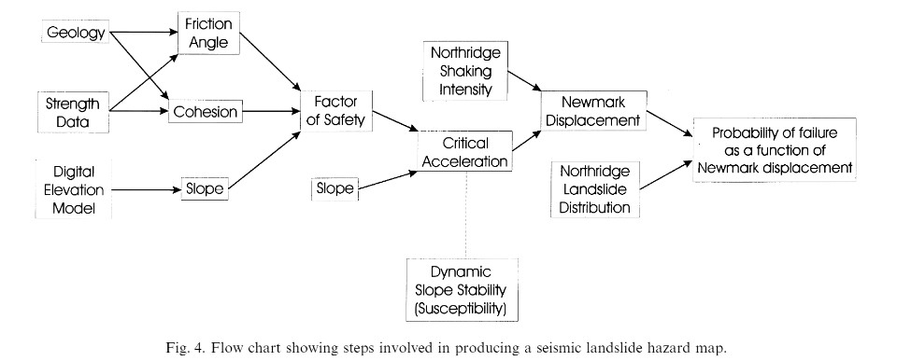

1. Computation of friction angle and cohesion and derive slope map using digital elevation model.
2. Combine shear strength (Friction angle + cohesion) and slope to estimate critical acceleration which represents seismic landslide susceptibility.
3. Estimate newmark’s displacement from the regression equation to combine critical acceleration grid with the grid containing shaking-intensity values from the significant earthquake.