NEWMARK;S MODEL OF LANDSLIDES

Datasets required
- Landslides inventory
- Strong motion records of the main shocks recorded throughout the region of interest
- 1:24000 scale geological map of the region
- Datasets of engineering properties of geologic units.
- High resolution DEM

Procedure-
- Digitize all the datasets at 10m grid spacing
- Combining these datasets in the Newmark’s permanent- deformation model, results in estimation of coseismic landslides displacement in each grid cell from any significant earthquake event.

Flowchart of the process

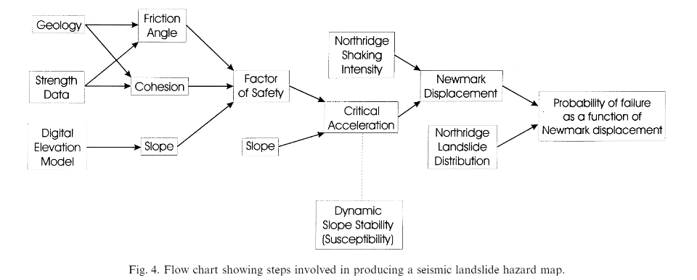

- Computation of friction angle and cohesion and derive slope map using digital elevation model.
- Combine shear strength (Friction angle + cohesion) and slope to estimate critical acceleration which represents seismic landslide susceptibility.
- Estimate newmark’s displacement from the regression equation to combine critical acceleration grid with the grid containing shaking-intensity values from the significant earthquake.

