**Git Hub Link:** [**https://github.com/Upender12/Assignment5_Neural**](https://github.com/Upender12/Assignment5_Neural)

**Spring 2024: CS5720**

**Neural Networks & Deep Learning - ICP-5**

**Name: Upender Reddy Bokka**

**#700: 700746118**

1. **Implement Naïve Bayes method using scikit-learn library**

**Use dataset available with name glass**

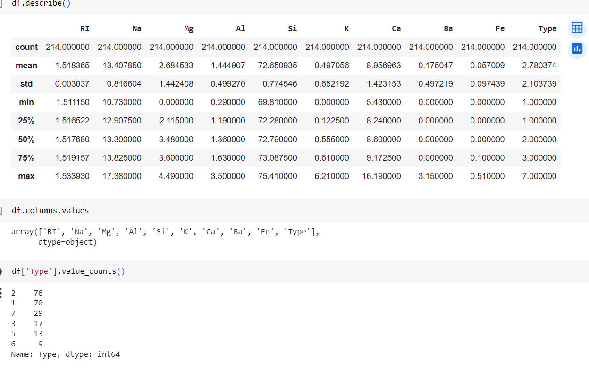

**Use train_test_split to create training and testing part**

**Evaluate the model on test part using score**

**classification_report(y_true, y_pred)**

1. **Implement linear SVM method using scikit library**

**Use the same dataset above**

**Use train_test_split to create training and testing part**

**Evaluate the model on test part using score and**

**classification_report(y_true, y_pred)**

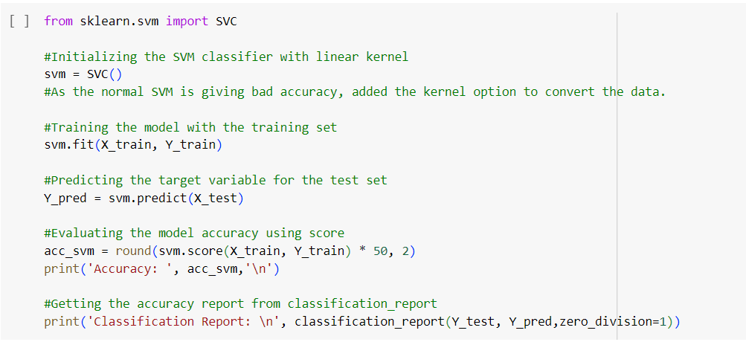

**Which algorithm you got better accuracy? Can you justify why?**

In my opinion, Naive bayes gave better results when compared SVM in terms of accuracy, precission, recall, f1-score.

As the data has 6 classifiers and wasn't transmitted into upper dimension, the SVM couldn't produce better results.

SVM would've given better results, had the data got transmitted using kernel option.

Summarizing, if one has to choose between naive bayes and plain SVM , choosing Naive bayes would be better.