**Neural Networks and Deep Learning – Programming Quiz**

**GitHub Link:** [**https://github.com/Upender12/programming_quiz**](https://github.com/Upender12/programming_quiz)

**Name: Upender Reddy Bokka**

**Student ID: 700746118**

Time Series Forecasting Task:

• Load a time series dataset (e.g., stock prices, weather data).

• Build a recurrent neural network (RNN) or LSTM model using Keras.

• Train the model to forecast future values based on historical data.

• Evaluate the model's performance using appropriate metrics (e.g., MAE, RMSE).

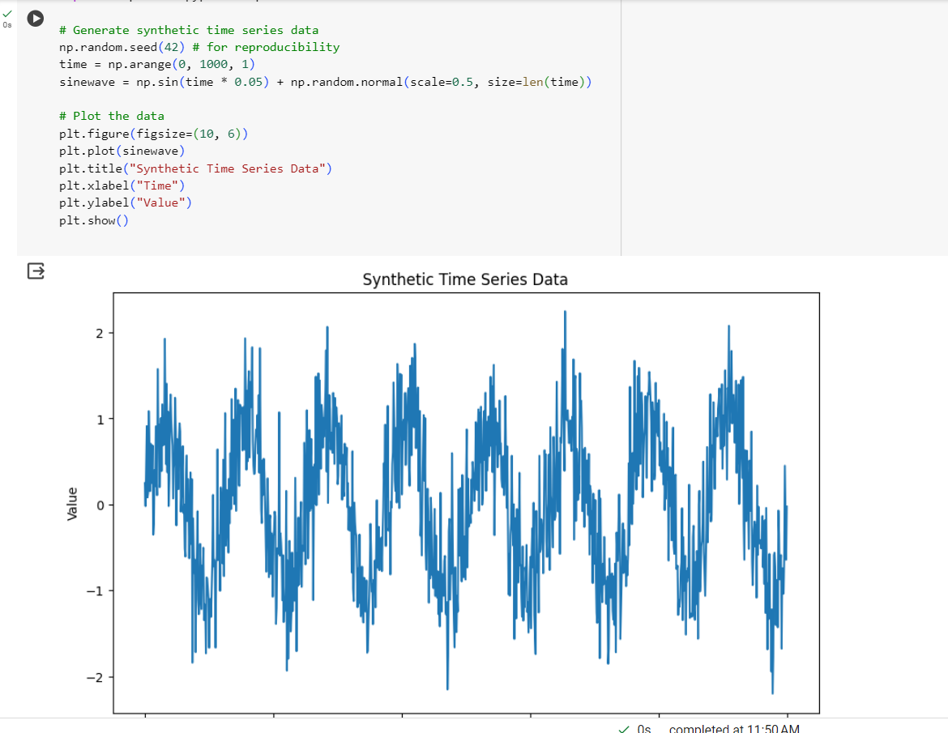

Image Classification Task:

* Load the MNIST dataset.
* Build a simple convolutional neural network (CNN) using Keras Sequential model.
* Train the CNN model on the MNIST dataset.
* Evaluate the model's performance on a test set and report accuracy.
* Use grid search to optimize hyperparameters such as learning rate, batch size, and optimizer choice.
* Use Callback functions to automate training process like “ReduceLROnPlateau” and keep check on validation loss. Also use history object for result visualization.

