Steps of exporting jar after making relevant changes in ServerManagementJMX project.

Step 1: Right click on project and choose Export

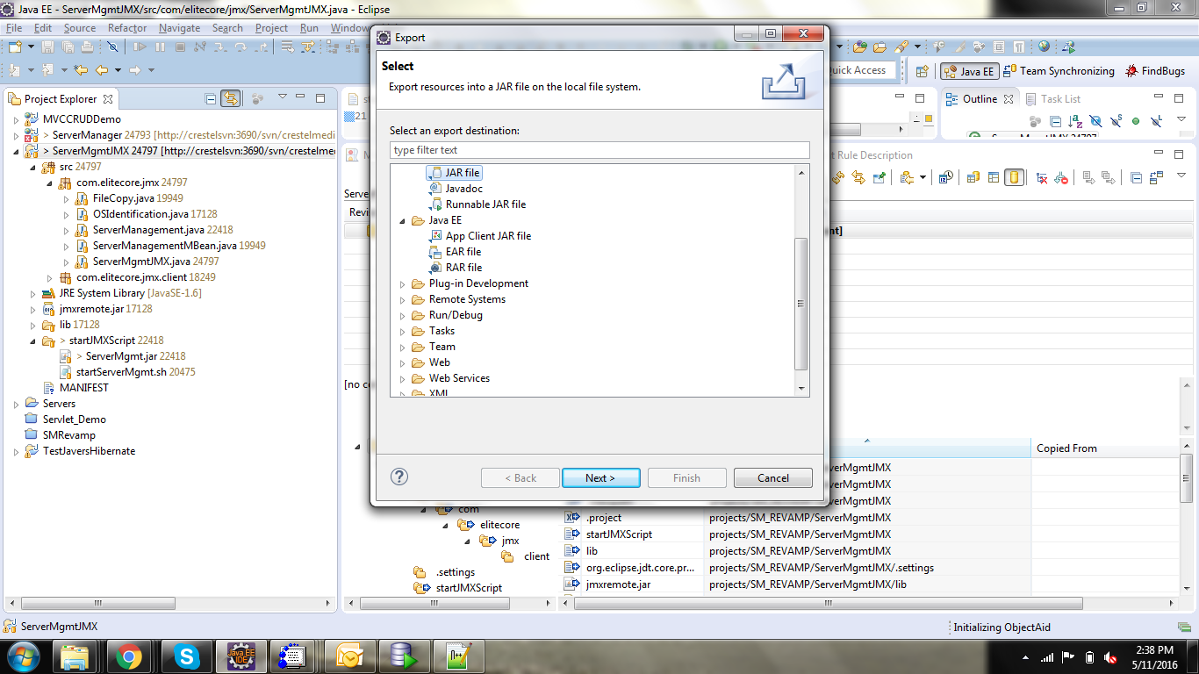

Select Jar File

Step2: In next page, for resources to be exported choose only src and lib as shown in this screenshot . all other settings as shown in the screenshot.

Choose export location as below:

ServerMgmtJMX/startJMXScript/ServerMgmt.jar

And then checkin this to svn after testing that reelvant changes are working properly.

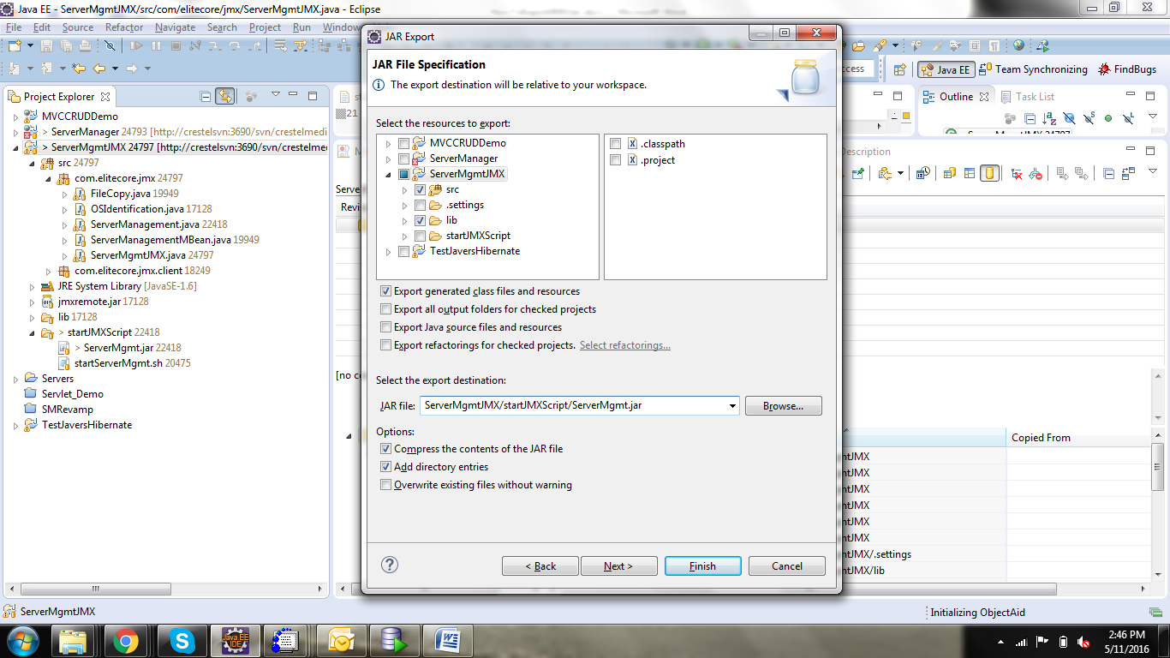

Step3: Keep defaults in next screen

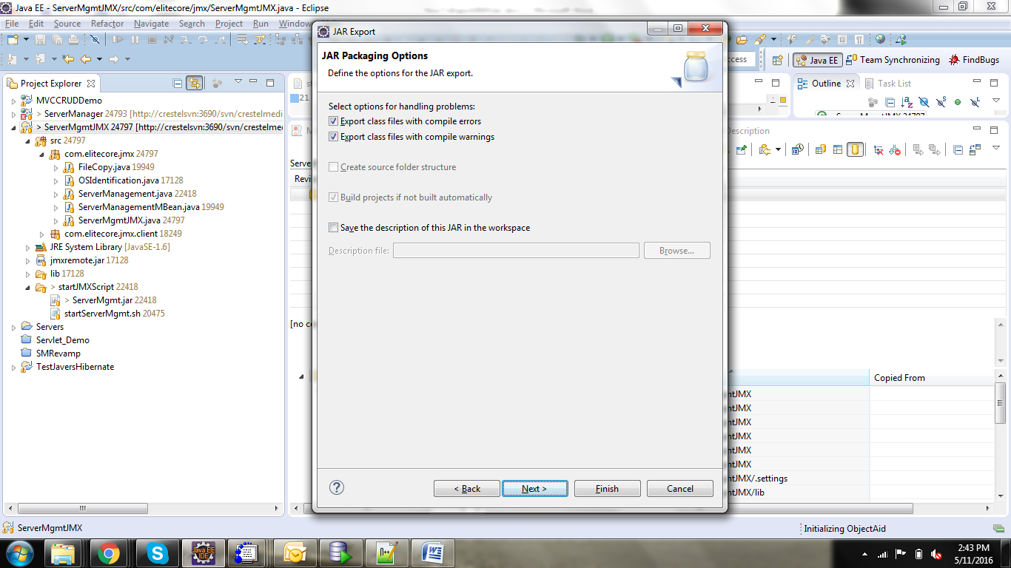

Step 4: Choose main file in next screen as com.elitecore.jmx.ServerMgmtJMX

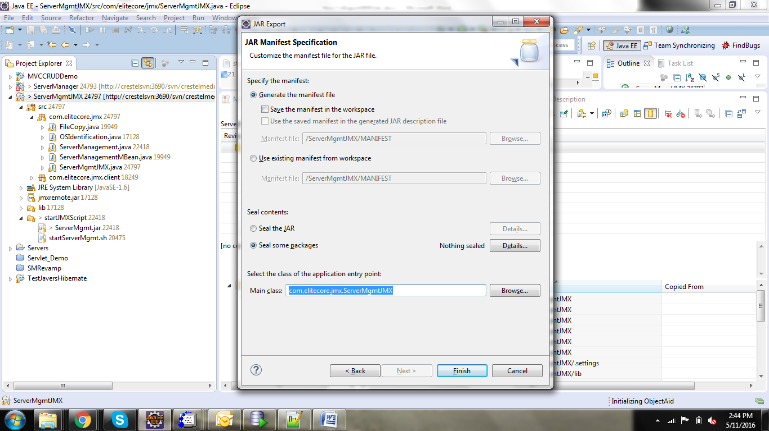

Check if the generated file has Manifest file contents as below :

Manifest-Version: 1.0

Main-Class: com.elitecore.jmx.ServerMgmtJMX

Run the script in linux environment before committing changes to SVN.