**An Hybrid Application For Students in Rural Areas**

Anuradha T

*Dept. of Information Technology Velagapudi Ramakrishna Siddhartha Engineering College*

Vijayawada, India [atadiparty@gmail.com](mailto:atadiparty@gmail.com)

Lakshmi Surekha T

*Dept. of Information Technology Velagapudi Ramakrishna Siddhartha Engineering College*

Vijayawada, India [Lakshmi.surekha2412@gmail.com](mailto:Lakshmi.surekha2412@gmail.com)

Sita Kumari.K

*Dept. of Information Technology Velagapudi Ramakrishna Siddhartha Engineering College*

Vijayawada, India [sitakumari.kotha@gmail.com](mailto:sitakumari.kotha@gmail.com)

***Abstract*— This research introduces an innovative educational application comprising two integral modules, namely the "DataSync" and "StudyHub." Tailored for students grappling with limited internet access in rural regions, DataSync empowers users to seamlessly download class-specific GitHub repositories. The companion module, StudyHub, serves as an offline repository viewer, offering students convenient access to previously downloaded materials. This application not only mitigates connectivity challenges but also envisions future augmentations, including collaborative features and an expansive content repository. As a testament to inclusive education, this research propounds a practical solution for enhancing learning experiences in low-connectivity environments.**

**Keywords: Thunkable App Maker, HTML Web Scraping, JavaScript LocalStorage, GitHub API Integration, Web-to-App Communication, Offline Data Viewing, Responsive Web Design, Dynamic HTML Creation, Web File Download,**

INTRODUCTION

In our groundbreaking project, we address the challenges faced by students in rural areas with limited internet connectivity. Our application, consisting of two components - DataSync and StudyHub, aims to facilitate seamless access to educational resources. DataSync serves as a synchronization platform, where users input their class number, triggering the automatic download of relevant GitHub repositories. This offline accessibility is crucial for students grappling with poor network conditions. On the other hand, StudyHub acts as a viewer, providing an organized interface for students to peruse and interact with the downloaded content offline.

The motivation behind this initiative stems from the prevalent struggles faced by students in remote areas, where internet access is unreliable. By centralizing educational materials and enabling offline access, our application seeks to bridge the digital divide, ensuring that educational resources are not hindered by connectivity issues.

DataSync, formerly Syncer, streamlines the download process by interfacing with a dedicated webpage. Users input their class number, triggering the retrieval of pertinent GitHub repositories, which are then downloaded and made available offline. The synchronization process is designed to be user-friendly and efficient, catering to the unique challenges posed by limited internet access.

StudyHub, formerly Viewer, functions as a hub for accessing downloaded content offline. This component addresses the need for organized and accessible offline educational materials. The transition from Syncer to DataSync and Viewer to StudyHub emphasizes the application's role in harmonizing data synchronization and offline content consumption..

LITERATURE REVIEW

Decision making with respect to an object or a physical thing may be based on various non physical things or criteria and so while taking the decisions priority should be given to those criteria. Thomas Saati proposed a method of giving priorities and constructing a hierarchical tree using the criteria and different alternatives for taking the decision in [1]. The steps involved in conducting analytical hierarchical process was summarized in [4]. The effect of weightage given to evaluation criteria in decision making of project alternatives was studied in [5]. Usage of analytical hierarchy process in the e-banking security system of Indonesian banks and identification of different criteria in the banking security is analyzed by [6]. Fuzzy numbers and fuzzy means were used in calculating priority vectors of AHP in the case study of construction management [7]. AHP is an effective approach in selecting the alternatives especially the decision is based on un measurable criteria but when it is applied for an industrial engineering application there may be many practical issues [8]. Selecting a student for an all round excellence award using AHP based on different academic and nonacademic activities was done by [9].Comparison between different methods in getting the priorities was done in [10]. Efficiency of AHP using different number of objects was tested in [11] and it was concluded that consistency ratio was constant irrespective of the number of objects. The study was made to analyze which of the existing pairwise comparison matrix methods was coherent with decision makers and

978-1-5386-8158-9/19/$31.00©2019IEEE

concluded additive approach has least coherence [12]. Different clustering methods were compared in customer churn prediction based on customer behavior in [13]. Customers were grouped for RFM analysis using k-means clustering and churn causing products were predicted in [14]. Usage of K-means clustering in YouTube data analysis. was done in [15].

CAA ANALYSIS

CAA Analysis will be very useful in the Indian college scenario to make the students competitive. All students are different even though they get the same facilities and encouragement from the department and faculty. CAA analysis assigns a value to a student based on the CGPA, Attendance and Activity count (i.e., number of participations in different academic and nonacademic activities) inside and outside the college. Each value of C, A, A is given a value on 1 to 5 scale , 5 being the highest and 1 being the lowest value. The CAA value is the combination of individual C,A,A values of the student and it indicates the overall performance of the student. Each student can have a CAA value in the range 111 to 555. Using this CAA, students will be divided into five groups namely Excellent, Above average, Average, Below average and weak. The analysis of each of these groups is useful for every department of the college in many ways. The students in weak group having low CAA are the one who require special attention. The department should assign separate proctors to monitor these students continuously to improve their attendance, marks and participation in different activities. The students with high CAA will be in excellent group and these are the one who are studious, regular to the college and active in participation of different academic, technical and co curricular events either within or outside the college. The department can select students from this group when it wants to send the students for different external competitions or nominate a student for academic or cocurricular awards. The analysis of below average, average and above average will give the idea on which of the three C, A or A parameters the particular students are weak and encouragement is required.

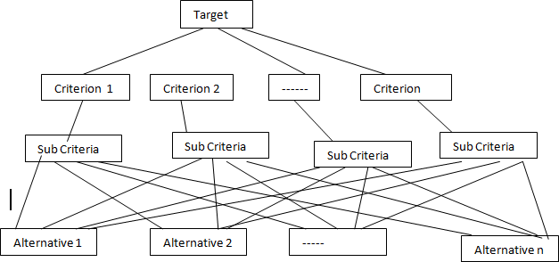

Fig. 1. AHP Tree Structure

*A. AHP implementation Steps*

* Creating a Pairwise Comparison matrix: If there

are n criteria, the pairwise comparison matrix, P is a n x n square matrix . Each entry pij in the matrix indicates the significance of criterion i with respect to criterion j.

If pij>1, then criterion i is more significant than criterion j and if pij<1, then criterion j is more significant than criterion i and if pij =1, then both criterion are having equal significance. The value pij takes different values on the scale of 1 to 9 based on the significance of i with respect to j (i is equally significant, slightly more significant, more significant, strongly more significant or absolutely more significant) and the entries in the matrix should satisfy the constraint given in (1)

 (1)

* Calculation of Criterion Weights: From matrix P, normalized matrix Pnorm is a n x n matrix where each element  of the matrix is given by (2)

# (2)

ANALYTICAL HIERARCHY PROCESS

There are different ways of selecting a best object from multiple objects and one of the methods proposed by Thomas Saati (1) is Analytical Hierarchy Process (AHP). AHP constructs a hierarchical tree of target, criteria and alternative objects. The criteria and sub criteria can be numeric or categorical. For each criteria and sub criteria, a pair wise comparison matrix will be defined based on which the priority of the object will be calculated. Fig. 1 shows the hierarchical structure of AHP tree.

and sum of entries in each column is 1.

Criteria Weight vector, W is a nx1 column vector and is given by average of each row of the Pnorm matrix. Each entry wi is given by (3)

 (3)

* Checking the Consistency : The criterion weights are finalized by finding the consistency index, CI as in (4).

 (4)

Where λmax =PW/W , P is the pairwise comparison matrix of the criterion and W is the criterion weight vector. The Consistency Ratio , CR is given by (5)

# (5)

where RI is the random index defined by Saati based on the number of criteria , n as shown in Table 1.



Apply AHP to get the Best Student

Calculate the detailed scores of Academic, Technical and Co curricular activities

Consider the cluster with high CAA values

Pre processing

Cluster similar CAA values using k-means clustering

Assign CAA values

CR<=0.1 indicates the consistency of criterion and can go to the next step and if CR>0.1 indicates there is an inconsistency in the criterion pair wise comparison matrix and the preferences need to be rechecked and first three steps should be repeated.

TABLE 1. NUMBER OF CRITERIA Vs RI VALUE

|  |  |  |  |  |  |
| --- | --- | --- | --- | --- | --- |
| n | 1 | 2 | 3 | 4 | 5 |
| RI | 0.00 | 0.00 | 0.58 | 0.90 | 1.12 |
| n | 6 | 7 | 8 | 9 | 10 |
| RI | 1.24 | 1.32 | 1.41 | 1.45 | 1.49 |

* Calculation of Object Scores: Object score

matrix, will be of size m x n where m is the number of alternative objects that are considered for selection and n is the number of criteria. For each criterion, a separate pairwise comparison matrix of objects is created. The above steps are repeated again and the weight vector of each criterion for all objects is computed. The object score matrix O is given by (6)

O=[o(1) … o(n)] (6)

where o(i) represents a column vector of weights of m objects with respect to criterion i.

* Giving the priority to Objects: The object priority vector V is given by multiplying object score matrix O with criterion weight vector W as in (7)

# (7)

Finally the best object will be the one having highest priority and is given by (8)

 (8)

Where vi represents the priority given to object i.

EXPERIMENTAL WORK AND RESULTS

The proposed work is to identify a student for the award of “Best outgoing student” from a department of an Indian engineering college. It was implemented in three steps using R programming language and AHP tool. As the preference will be given to a student who is regular, has good CGPA and has excellent performance in all activities, the first step was to identify the Excellent student group from all the outgoing students of the department. For doing this CAA analysis was applied on the CGPA, Attendance and Activity score data of all 120 outgoing students of the department. A scale of 1-5 was assigned for each C,A,A parameter separately and the three values were combined as a single table. Fig. 2 shows architectural diagram of the proposed work.

Fig. 2. Architectural diagram of Proposed Work

For dividing the students into different groups based on CAA value, k-means clustering algorithm was applied on CAA values using R language. After clustering, the Excellent student group was found in 3rd cluster with high CAA values. Table 2 shows the Roll number, actual values of CGPA, Attendance, Number of certificates and corresponding CAA scores of the Excellent student cluster.

In the second step, detailed scores of the three criteria namely Academics, Technical and Co curricular for the students in the excellent group were calculated by giving a weightage to every activity that comes under these three categories. Academic score was calculated based on the CGPA and number of self learning courses completed by the student during the period of study in the department by giving a weightage of 70% to C.G.P.A and 30% to MOOCS. Technical score was calculated based on number of paper presentations, coding contests or Project expos by giving a weightage of 70% to papers and 30% to total of coding competitions, project expos. While calculating papers score, more weightage is given to IEEE, ACM, SCI or Springer papers compared to other refereed journals or conference papers. Co curricular score was calculated based on the participation in sports and cultural activities by giving 60% weightage to sports and 40% weightage to cultural. In calculating these scores, points were awarded for international, national, university and college level competition certificates in decreasing order. The final criteria scores for the excellent student group are shown in Table 3.

In the third Step, AHP technique was applied on the excellent student group using their Academics, Technical and Co curricular scores. The AHP tree generated by defining the target as Best Student , criteria as Academics, Technical, Co curricular and the alternatives as the roll numbers of students is shown in Fig. 3. The pair wise comparison matrix based on the significances for the criteria is given in Table 4. The comparison values were based on the feedback from senior members of the department.

TABLE 2: RESULT OF K-MEANS CLUSTER _EXCELLENT GROUP

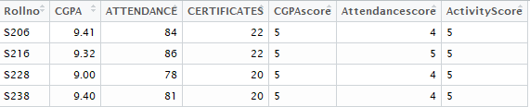

TABLE 3: CRITERIA SCORES OF EXCELLENT GROUP

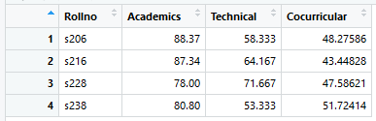

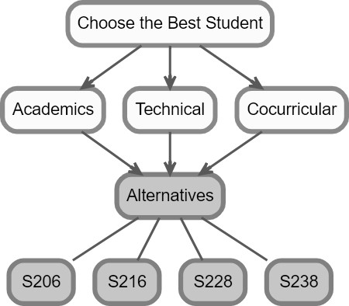

student with Roll no S228 was more compared to the overall score of other students. So S228 was considered as the best student.

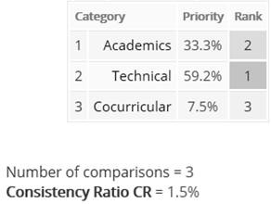

Fig. 4. Priority matrix and consistency ratio of criteria

TABLE 5. PAIRWISE COMPARISON OF EXCELLENT GROUP FOR ACADEMICS

|  |  |  |  |  |
| --- | --- | --- | --- | --- |
| Academics | S206 | S216 | S228 | S238 |
| S206 | 1 | 2 | 9 | 7 |
| S216 | ½ | 1 | 8 | 6 |
| S228 | 1/9 | 1/8 | 1 | 1/3 |
| S238 | 1/7 | 1/6 | 3 | 1 |

TABLE 6. PAIRWISE COMPARISON OF EXCELLENT GROUP FOR TECHNICAL

Fig. 3. AHP Tree of the given target

|  |  |  |  |  |
| --- | --- | --- | --- | --- |
| Technical | S206 | S216 | S228 | S238 |
| S206 | 1 | 1/3 | 1/7 | 3 |
| S216 | 3 | 1 | ¼ | 6 |
| S228 | 7 | 4 | 1 | 9 |
| S238 | 1/3 | 1/6 | 1/9 | 1 |

TABLE 4. CRITERIA PAIRWISE COMPARISON MATRIX

|  |  |  |  |
| --- | --- | --- | --- |
| Criteria | Academics | Technical | Co curricular |
| Academics | 1 | 1/ 2 | 5 |
| Technical | 2 | 1 | 7 |
| Co curricular | 1/5 | 1/7 | 1 |

Fig. 4 shows the priority matrix which represents the weights obtained for academics, technical and co curricular as per the pair wise comparison between them. As the consistency ratio obtained was 1.5% which is less than 10%, the significances given to the criterion was considered as correct. After that, the pair wise comparison matrices for each criterion with respect to the students considered were constructed based on Academic, Technical and Co curricular scores of the students. The individual matrices are shown in Table 5, Table 6 and Table 7.

Fig. 5 Shows the result of the target problem after applying AHP. The overall scores of different students considering the three criteria taken was shown in the first row of the figure. It was observed that the overall score of

TABLE 7. PAIRWISE COMPARISON OF EXCELLENT GROUP FOR COCURRICULAR

|  |  |  |  |  |
| --- | --- | --- | --- | --- |
| Co curricular | S206 | S216 | S228 | S238 |
| S206 | 1 | 6 | 2 | 1/3 |
| S216 | 1/6 | 1 | 1/5 | 1/9 |
| S228 | ½ | 5 | 1 | 1/5 |
| S238 | 3 | 9 | 5 | 1 |

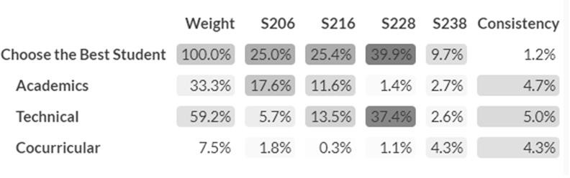

Fig. 5. Overall scores of students in Excellent Group

CONCLUSIONS

Analyzing the students is easy once we make them into different homogeneous clusters. In the present work, this was done by CAA analysis combined with k-means clustering. Then the best outgoing student was selected using AHP on the excellent student cluster by giving the detailed scores to Academic, Technical and Co curricular parameters. Though the experimentation was done on a single department data of 120 students, it can be easily extended to entire college or university data of any size as we have used k means clustering to group the students. The proposed CAA analysis can be used by any educational institute in the beginning of every semester based on the students previous CAA scores to analyze students performance and appropriate counseling and encouragement can be given to improve their overall performance.

REFERENCES

1. Saaty TL., “Decision making with the analytic hierarchy process”, International journal of services sciences. 2008 Jan 1(1), pp.83-98,Jan 2008
2. R. Aitdaoud, A. Amine, B. Bouikhalene And R. Lbibb, "Combining Rfm Model And Clustering Techniques For Customer Value Analysis Of A Company Selling Online," Ieee/Acs 12th International

Conference Of Computer Systems And Applications (Aiccsa), Marrakech, pp. 1-6, 2015.

1. Han, J., Kamber, M, Data Mining: Concepts And Techniques, 2nd Edition. Morgan Kaufmann 2000.
2. Taherdoost H, “Decision Making Using the Analytic Hierarchy Process (ahp); A Step by Step Approach”, International Journal of Economics and Management Systems, 14;2, Nov 2017.
3. Cabała P, “Using the analytic hierarchy process in evaluating decision alternatives”, Operations research and decisions, 20(1):pp.5-23, 2010.
4. Syamsuddin I, Hwang J., “The application of AHP model to guide decision makers: a case study of e-banking security”, InComputer Sciences and Convergence Information Technology, ICCIT'09. Fourth International Conference on ,pp.1469-1473 IEEE, Nov 24, 2009 .
5. Prascevic N, Prascevic Z, “Application of fuzzy AHP for ranking and selection of alternatives in construction project management”, Journal of Civil Engineering and Management, 23(8),pp.1123-35,Nov 2017.
6. Triantaphyllou E, Mann SH, “Using the analytic hierarchy process for decision making in engineering applications: some challenges”, International Journal of Industrial Engineering: Applications and Practice ,2(1),pp.35-44,Jan 1995.
7. Kousalya P, Reddy GM, Supraja S, Prasad VS, “Analytical Hierarchy Process approach–An application of engineering education”, Mathematica Aeterna,2(10),pp.861-78, Oct 2012.
8. Ishizaka A, Lusti M, “How to derive priorities in AHP: a comparative study”, Central European Journal of Operations Research, 1;14(4), pp.387-400, Dec 2006.
9. Mazurek J, Perzina R, “On the Inconsistency of Pairwise Comparisons: An Experimental Stud”,. Scientific Papers of the University of Pardubice 1:102, Sep 2017.
10. Cavallo B, Ishizaka A, Olivieri MG, Squillante M, “Comparing

inconsistency of pairwise comparison matrices depending on entries”,

Journal of the Operational Research Society, pp. 1-9, Apr 2018.

1. Samira Khodabandehlou, Mahmoud Zi vari Rahman, "Comparison Of Supervised MachineLearning Techniques for Customer Churn Prediction Based On Analysis Of Customer Behavior", Journal Of Systems And Information Technology, Vol. 19, Issue: 1/ 2, Pp.65-93, 2017.
2. Anuradha.T, T. Lakshmi Surekha, "Identifying Attrition Causing Products Using RFM Analysis", pp.598-604, 2018.
3. G.Ravali, P.Swathi Moulika, A.Aparna, J.Abhinaya, T.Anuradha, “Analysing YouTube Data Using K-means Clustering”, International Journal of Emerging Trends & Technology in Computer Science ,Vol.6(2),pp.62-66, April 2017.