SQL PRACTICE QUESTIONS

BASIC SQL
Q1.
-- Retrieve the total number of orders placed.
SELECT
COUNT(order_id) AS total_order
FROM
orders;
OUTPUT:
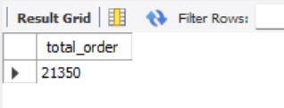
Q2.
-- Calculate the total revenue generated from pizza sales.
SELECT
ROUND(SUM(orders_details.quantity * pizzas.price),
2) AS revenue
FROM
orders_details
JOIN
pizzas ON pizzas.pizza_id = orders_details.pizza_id;
OUTPUT:
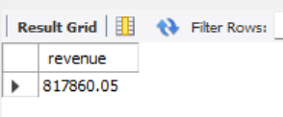

Q3.
-- Identify the highest-priced pizza.
SELECT
pizzas.price, pizza_types.name
FROM
pizzas
JOIN
pizza_types ON pizzas.pizza_type_id = pizza_types.pizza_type_id
order by price desc limit 1;
OUTPUT:
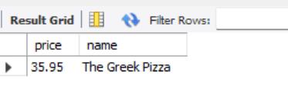
Q4.
-- Identify the most common pizza size ordered.
SELECT
pizzas.size,
COUNT(orders_details.order_details_id) AS order_count
FROM
pizzas
JOIN
orders_details ON pizzas.pizza_id = orders_details.pizza_id
GROUP BY pizzas.size
ORDER BY order_count DESC;
OUTPUT:
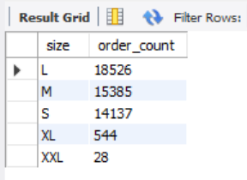
Q5.
-- List the top 5 most ordered pizza types along with their quantities.
SELECT
pizza_types.name,
SUM(orders_details.quantity) AS total_quantity
FROM
pizzas
JOIN
pizza_types ON pizzas.pizza_type_id = pizza_types.pizza_type_id
JOIN
orders_details ON pizzas.pizza_id = orders_details.pizza_id
GROUP BY pizza_types.name
ORDER BY total_quantity DESC
LIMIT 5;
OUTPUT:
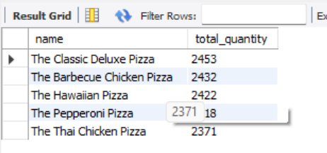

INTERMEDIATE SQL
Q1.
-- Join the necessary tables to find the total quantity of each pizza category ordered.
SELECT
pizza_types.category,
SUM(orders_details.quantity) AS total_quantity
FROM
pizzas
JOIN
pizza_types ON pizzas.pizza_type_id = pizza_types.pizza_type_id
JOIN
orders_details ON pizzas.pizza_id = orders_details.pizza_id
GROUP BY pizza_types.category
ORDER BY total_quantity DESC;
OUTPUT:
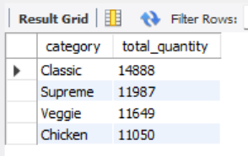

Q2.
-- Determine the distribution of orders by hour of the day.
SELECT
HOUR(order_time) AS hours, COUNT(order_id) AS order_count
FROM
orders
GROUP BY hours;
OUTPUT:
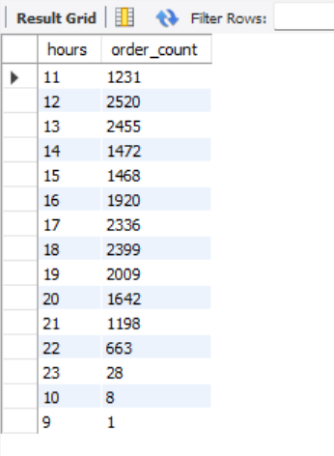

Q3.
-- Join relevant tables to find the category-wise distribution of pizzas.
select category, count(name) from pizza_types
group by category;
OUTPUT:
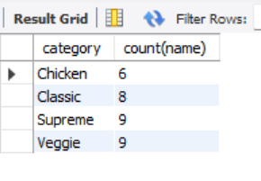

Q4.
-- Group the orders by date and calculate the average number of pizzas ordered per day.
SELECT
AVG(quantity)
FROM
(SELECT
orders.order_date, SUM(orders_details.quantity) AS quantity
FROM
orders
JOIN orders_details ON orders.order_id = orders_details.order_id
GROUP BY orders.order_date) AS data;
OUTPUT:
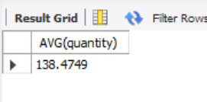
Q5.
-- Determine the top 3 most ordered pizza types based on revenue.
SELECT
pizza_types.name,
SUM(orders_details.quantity * pizzas.price) AS revenue
FROM
pizza_types
JOIN
pizzas ON pizza_types.pizza_type_id = pizzas.pizza_type_id
JOIN
orders_details ON pizzas.pizza_id = orders_details.pizza_id
GROUP BY pizza_types.name
ORDER BY revenue DESC
LIMIT 3;
OUTPUT:
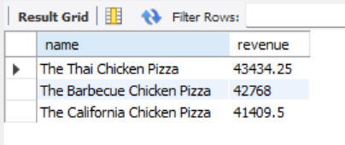

ADVANCED SQL
Q1.
-- Calculate the percentage contribution of each pizza type to total revenue.
SELECT
pizza_types.category,
ROUND((SUM(orders_details.quantity * pizzas.price) / (SELECT
ROUND(SUM(orders_details.quantity * pizzas.price),
2)
FROM
pizzas
JOIN
orders_details ON orders_details.pizza_id = pizzas.pizza_id)) * 100,
2) AS percent_revenue
FROM
pizzas
JOIN
pizza_types ON pizzas.pizza_type_id = pizza_types.pizza_type_id
JOIN
orders_details ON orders_details.pizza_id = pizzas.pizza_id
GROUP BY pizza_types.category
ORDER BY percent_revenue DESC;
OUTPUT:
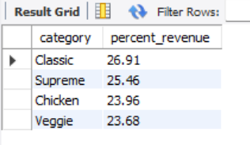
Q2.
-- Analyze the cumulative revenue generated over time.
select order_date, sum(revenue) over(order by order_date) as cum_rev
from
(select orders.order_date, sum(orders_details.quantity*pizzas.price)
as revenue
from orders_details join pizzas
on pizzas.pizza_id=orders_details.pizza_id
join orders on
orders.order_id=orders_details.order_id
group by orders.order_date) as sales;
OUTPUT:
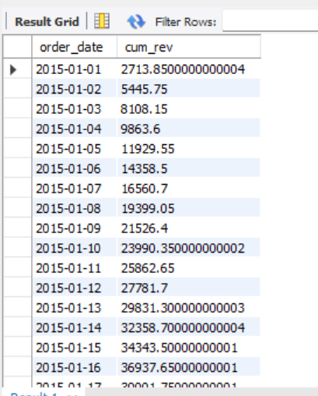
Q3.
-- Determine the top 3 most ordered pizza types based on revenue for each pizza category.
select name, revenue
from
(select category, name, revenue,
rank() over(partition by category order by revenue) as rn
from
(select pizza_types.category,pizza_types.name,
sum(orders_details.quantity*pizzas.price) as revenue
from orders_details join pizzas
on
orders_details.pizza_id=pizzas.pizza_id
join pizza_types on
pizzas.pizza_type_id = pizza_types.pizza_type_id
group by pizza_types.category,pizza_types.name) as a) as b
where rn<= 3;
OUTPUT:
