3D Maze Game Project Report

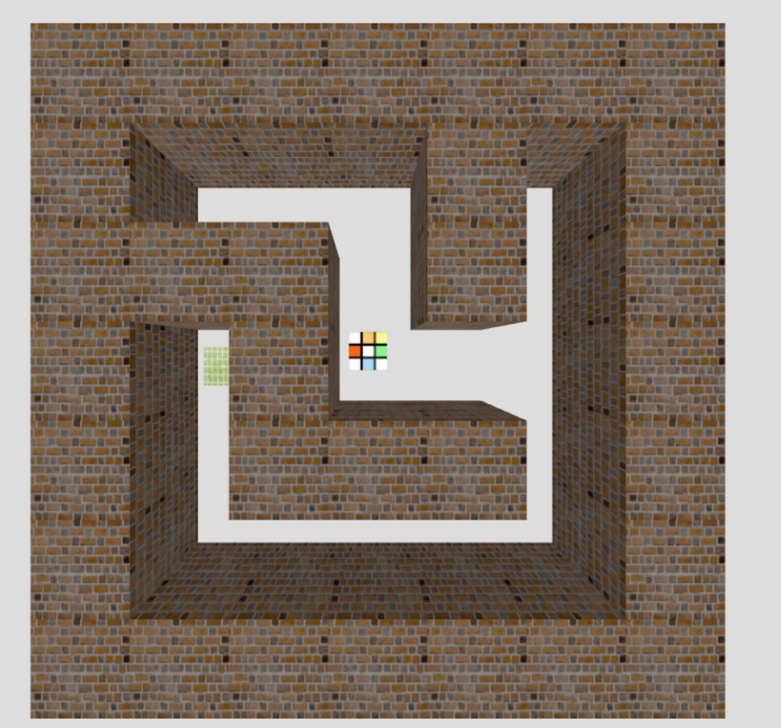

# Introduction

## Overview of the Project

The 3D Maze Game is an immersive and interactive project developed using Three.js, a cross-browser JavaScript library/API used to create and display animated 3D computer graphics in a web browser. The game offers a unique blend of challenge and engagement through a dynamically generated maze that players must navigate to find the exit.

At its core, the game employs fundamental concepts of 3D graphics, including geometry, textures, lighting, and camera manipulation. The maze is rendered in a 3D environment, where walls and paths are distinctly marked and can be navigated from a first-person perspective or a top-down view, adding to the player's spatial awareness and overall experience.

## Purpose and Objectives

The primary purpose of this project is to demonstrate the capabilities of Three.js in creating an interactive 3D gaming environment. Key objectives include:

* **Learning and Applying Three.js:** Gaining hands-on experience with Three.js and its various components such as scenes, cameras, lights, textures, and meshes. Understanding how these elements work together to create a cohesive 3D environment.
* **Game Mechanics Development:** Designing and implementing fundamental game mechanics such as player movement, collision detection, and win conditions. These mechanics are crucial in making the game engaging and playable.
* **Dynamic Difficulty Adjustment:** Introducing a system where the game’s difficulty level adjusts dynamically based on player choice. This feature aims to make the game accessible and challenging for players of different skill levels.
* **Enhancing User Experience:** Ensuring a seamless and intuitive user interface, allowing players to easily interact with the game. This involves the thoughtful design of game controls, camera modes, and visual feedback for the player.
* **Problem-Solving and Creativity:** Tackling challenges in 3D game development such as optimizing performance, resolving bugs, and creative problem-solving in design and implementation phases.

The project serves as a practical application of 3D graphics programming, showcasing the intersection of technical skill and creative vision. It's designed not only as a testament to the power of web-based gaming platforms but also as a learning tool for those interested in the field of 3D game development.

# Technology Stack

## Introduction to Three.js

Three.js is a powerful and versatile JavaScript library that enables developers to create and display animated 3D graphics within a web browser. It abstracts the complexities of WebGL, the web standard for 3D rendering, offering an intuitive and more accessible approach to 3D graphics programming. Key features of Three.js that are particularly relevant to the development of our 3D Maze Game include:

* **Scene Graph:** Three.js uses a concept called a 'scene graph' to organize and manage objects in 3D space. The library allows for the easy addition and manipulation of objects like cameras, lights, and geometries in a scene.
* **Camera Controls:** It offers various camera controls, allowing for different perspectives and viewpoints within the 3D environment. This is crucial for games where the player viewpoint can enhance the gaming experience.
* **Lighting and Textures:** Three.js supports complex lighting and texture effects, giving developers the tools to create realistic and visually appealing graphics.
* **Animation and Interaction:** The library provides functionalities for animation and interactive controls, enabling the creation of dynamic and responsive gaming experiences.
* **Community and Support:** With a large community and extensive documentation, Three.js is a well-supported library, making it a popular choice for both beginners and experienced developers in the realm of 3D web graphics.

## Other Technologies Used

Alongside Three.js, several other technologies were utilized in the creation of the 3D Maze Game, each contributing to different aspects of the game's development:

* **HTML and CSS:** The game's user interface is built using HTML and CSS. HTML5 provides the structural framework, while CSS is used to style elements like buttons and overlays, ensuring a clean and user-friendly interface.
* **JavaScript:** As the primary programming language for web development, JavaScript is used for the game's logic and interaction handling. It integrates seamlessly with Three.js, allowing for efficient development of game functionalities.
* **WebGL Renderer:** Three.js internally uses WebGL to render graphics. WebGL's ability to harness the power of the computer's graphics processing unit (GPU) enables the rendering of complex 3D graphics directly in the browser.
* **Texture and Asset Management:** For texturing the maze walls, player, and goal, external texture files are loaded and managed. This enhances the visual aesthetics of the game, making it more engaging.

This technology stack was chosen for its synergy and ability to collectively deliver a rich, interactive 3D gaming experience within a web browser. It showcases the integration of 3D graphics with standard web technologies, highlighting the possibilities within the realm of web-based game development.

# Game Design

## Concept and Gameplay

The 3D Maze Game is designed around the classic concept of a maze or labyrinth, with a modern twist of three-dimensional gameplay. The player is placed in a randomly generated maze and must navigate through to find the exit. This simple yet engaging premise tests the player's spatial awareness, memory, and problem-solving skills.

Key gameplay elements include:

**Maze Navigation:** Players move through the maze, encountering various paths and dead ends. The 3D perspective adds depth to the challenge, as players must orient themselves within a complex space.

**Player Perspective:** The game offers different camera modes, including first-person and top-down views, each providing a unique experience and challenge in navigation.

**Interactivity:** Players interact with the game using keyboard controls, moving forward, backward, and turning left or right to explore the maze.

**Goal Discovery:** The primary objective is to locate the exit of the maze, marked by a distinctive goal object. Reaching this goal signifies the completion of the maze.

## User Interface Design

The user interface (UI) of the 3D Maze Game is designed to be minimalistic and intuitive, ensuring that players can focus on the gameplay without unnecessary distractions. Key aspects include:

**Start Menu:** Players are greeted with a simple start menu, allowing them to select the difficulty level before beginning the game.

**In-game Overlay:** Messages and prompts, such as the win message, are displayed via an overlay that does not obstruct gameplay.

**Responsive Design:** The UI elements adjust to different screen sizes and resolutions, ensuring a consistent experience across various devices.

## Difficulty Levels and Dynamic Game Environment

The game features dynamic difficulty levels, catering to a wide range of players, from beginners to experienced gamers:

**Difficulty Selection:** Players can choose between 'Easy', 'Medium', and 'Hard' difficulty levels, influencing the size and complexity of the maze.

**Dynamic Maze Generation:** The maze is procedurally generated based on the chosen difficulty, ensuring a unique experience each time. The algorithm adjusts the number of paths and dead ends, increasing the maze's complexity with higher difficulty levels.

**Adaptive Gameplay:** The game's difficulty can dynamically change, either based on player choice or as a built-in feature that adjusts the challenge based on the player's performance.

This design approach not only enhances replayability but also allows players to gradually build their skills and tackle more complex mazes as they become more experienced. The dynamic game environment is a key feature that keeps the gameplay fresh and engaging.

# 3D Graphics and Scene Setup

## Scene and Camera Configuration

In the 3D Maze Game, the creation of a compelling and functional 3D environment is central to the gameplay experience. This is achieved through careful scene and camera configuration:

* **Scene Initialization:** The Three.js scene acts as a container for all 3D objects, including the maze, player, goal, and lights. It's the virtual space where our game takes place.
* **Camera Setup:** The game uses a PerspectiveCamera which provides a natural depth perception similar to human vision. The camera's position and orientation are critical in determining the player's viewpoint. To cater to different playstyles, multiple camera modes are implemented, including a first-person perspective and a top-down view.
* **Viewport Adaptation:** The camera's aspect ratio is set to match the browser window's dimensions, ensuring that the game looks correct regardless of the screen size. Event listeners are used to update the camera's settings in response to window resizing, maintaining the game's visual integrity across devices.

## Lighting in Three.js

Lighting plays a significant role in setting the mood and realism of the 3D environment. In the game, various lighting techniques are employed:

* **Ambient Light:** A soft ambient light illuminates the entire scene uniformly without causing shadows, providing the base level of light and ensuring no part of the maze is completely dark.
* **Directional Light:** A directional light simulates sunlight, casting shadows and highlighting the 3D nature of the maze walls. It enhances the depth and texture of the scene, adding to the immersive experience.

## Renderer Settings

The Three.js WebGL renderer is responsible for drawing the scene on the canvas element. Key settings include:

* **Antialiasing:** This is enabled to smooth out the edges of geometry, reducing the jagged look and improving visual quality.
* **Shadow Mapping:** The renderer's shadow map is enabled, allowing lights to cast shadows, which adds realism to the game environment. Proper shadow mapping is crucial in a 3D maze game to maintain spatial awareness and depth perception.
* **Performance Considerations:** While higher quality settings improve the game's visual appeal, they can also demand more from the hardware. A balance is struck to ensure smooth performance across a range of devices.

Through these configurations, the 3D Maze Game provides a visually appealing and engaging experience, showcasing the capabilities of Three.js in rendering interactive 3D graphics directly in the web browser.

# Maze Generation and Mechanics

## Maze Generation Algorithm

The algorithm at the heart of the 3D Maze Game is designed to create a complex and navigable maze. It works as follows:

* **Grid Initialization:** The maze is initially represented as a grid, where each cell can either be a wall or a path.
* **Recursive Backtracking:** This algorithm is a depth-first search algorithm with backtracking. Starting from an initial cell, the algorithm carves out a path in one of the four cardinal directions. If it hits a dead-end (no unvisited neighbors), it backtracks to the previous cell and tries a different direction.
* **Maze Complexity:** The complexity of the maze is controlled by the size of the grid. A larger grid results in a more complex maze.

## Wall Creation and Texturing

Once the maze layout is generated, the next step is to render it in 3D:

* **3D Walls:** Each cell in the grid that represents a wall is rendered as a 3D object using Three.js geometries (such as BoxGeometry).
* **Texturing:** Textures are applied to the walls to give them a realistic appearance. These textures are loaded using Three.js's TextureLoader, and different textures can be randomly assigned to walls to add variety.

## Random Maze Generation Based on Difficulty

The game features different difficulty levels which affect the maze's size and complexity:

* **Dynamic Sizing:** The size of the maze grid is adjusted based on the selected difficulty level. For instance, 'Easy' might have a smaller grid, while 'Hard' has a much larger one.
* **Algorithm Adaptation:** The maze generation algorithm remains the same across difficulty levels, but its parameters (like grid size) are adjusted to modify the maze's complexity.
* **Player Experience:** The idea is to offer a different experience each time, not just in terms of maze layout but also in the challenge posed by the maze’s size and complexity.

This approach ensures that the maze remains a central and dynamic aspect of the game, offering replayability and a scalable challenge to suit different player skill levels.

# Player Dynamics

## Player Model and Texturing

In the 3D Maze Game, the player's representation and visual appeal are crucial for an immersive experience.

* **Model Design:** The player is modeled as a simple geometric shape (e.g., a cube) to keep the focus on the maze navigation. This simplicity also aids in performance optimization.
* **Texturing:** A unique texture is applied to the player model to distinguish it from the maze walls and the goal. This texture is loaded and applied using Three.js's TextureLoader, enhancing the visual identification of the player in the 3D space.

## Movement Mechanics

Movement mechanics are central to the gameplay, allowing players to navigate through the maze.

* **Directional Movement:** The player can move forward, backward, and sideways. This is achieved by updating the player's position in response to keyboard inputs (WASD keys).
* **Viewpoint and Orientation:** In the first-person camera mode, the movement is relative to the player's current viewpoint, enhancing the feeling of being in the maze. In the top-down view, movement is more map-oriented.
* **Speed and Fluidity:** The player's movement speed is carefully calibrated to ensure a balance between control and challenge. Smooth transitions and animations contribute to a more realistic and enjoyable experience.

## Collision Detection and Maze Navigation

Effective collision detection is essential to prevent the player from moving through walls, adding realism and challenge to the game.

* **Maze Grid and Player Position:** The maze is conceptualized as a grid, and the player's position is continuously checked against this grid to determine if they are in contact with a wall.
* **Axis-Aligned Bounding Boxes (AABB):** Collision detection is implemented using AABB. This technique checks if the player's bounding box, representing their physical space, intersects with the bounding boxes of the walls.
* **Navigation Logic:** When a collision is detected, the player's movement in that direction is restricted, simulating a real-world encounter with a physical barrier.

These dynamics not only make the game realistic but also add a level of complexity to the gameplay. Players must carefully navigate the maze, avoiding collisions and finding the most efficient path to the goal. This setup not only tests spatial awareness but also adds a strategic element to the game.

# Goal Mechanics

## Goal Placement Strategy

The placement of the goal in the 3D Maze Game is a critical aspect of its design, as it defines the objective for the player to achieve.

* **Strategic Placement:** The goal is strategically placed to ensure that reaching it is challenging yet attainable. It's positioned far from the starting point, often in one of the farthest corners of the maze.
* **Randomization:** To enhance replayability, the goal's placement is randomized in each game session. This randomness ensures that each playthrough presents a new challenge.

## Calculating the Furthest Point for Goal Placement

To determine the optimal location for the goal, the game employs an algorithm to calculate the furthest point from the player's starting position within the maze:

* **Breadth-First Search (BFS):** This algorithm traverses the maze from the starting point and calculates the distance to all reachable points. It identifies the point that is furthest from the start, ensuring maximum challenge in reaching the goal.
* **Ensuring Navigability:** The algorithm also ensures that the chosen point is accessible, not blocked by walls or other obstacles. This is crucial to avoid unsolvable mazes.

## Win Condition and End-Game Scenario

The win condition is straightforward yet fundamental to the game's purpose.

* **Reaching the Goal:** The primary objective for the player is to navigate the maze and reach the goal. The game continuously checks the player's position relative to the goal.
* **Collision Detection with Goal:** When the player's position intersects with the goal's position (using collision detection similar to wall collisions), the win condition is met.
* **End-Game Feedback:** Upon winning, the game displays a congratulatory message and offers options to replay or exit. This feedback is crucial for player satisfaction and encouraging further engagement with the game.

The goal mechanics are designed to provide a clear objective and rewarding conclusion to the game, driving the player's motivation and engagement throughout the gameplay. The combination of strategic placement and dynamic calculation ensures that the game remains challenging and engaging with each new session.

# Camera Modes and Viewport Handling

## Implementing Different Camera Modes

The 3D Maze Game enhances player experience by offering various camera modes, each offering a unique perspective and challenge:

* **Top-Down View:** This mode provides an overhead view of the maze, allowing players to see a larger portion of the maze at once. It's helpful for planning routes and understanding the maze's layout.
* **First-Person View:** In this mode, the camera is positioned to mimic the player's eye view, offering an immersive experience. It adds realism and can make navigation more challenging due to the limited field of view.
* **Dynamic Mode:** This mode adjusts the camera's position and orientation based on the player's movement and actions, offering a balance between the first-person and top-down perspectives.

Switching between these modes is facilitated through user inputs, allowing players to choose their preferred style of play.

## Camera Movement and Player Perspective

The camera's movement and orientation are closely tied to the player's actions and the selected camera mode:

* **Player-Centric Camera:** In all modes, the camera is designed to keep the player in focus, ensuring they are always central to the action.
* **Smooth Transitions:** As the player moves or switches camera modes, the camera transitions smoothly to avoid disorienting the player. This includes gradual movements and rotations rather than abrupt changes.
* **Orientation Adjustments:** In the first-person view, the camera's orientation changes with the player's direction, simulating a real-life perspective. In the top-down view, it maintains a fixed orientation to provide a consistent overview of the maze.

## Handling Window Resizing

Responsive design is crucial for maintaining a consistent experience across different devices and window sizes:

* **Viewport Adjustment:** When the window is resized, the camera's aspect ratio is updated to match the new viewport dimensions. This ensures that the 3D scene does not become stretched or skewed.
* **Dynamic Rendering:** The renderer adjusts the output to fit the new window size, ensuring that graphics quality remains high regardless of the dimensions.
* **Event Listeners:** JavaScript event listeners detect window size changes, triggering the necessary adjustments in camera settings and renderer dimensions.

These camera modes and viewport handling techniques are integral to providing a flexible and user-friendly gaming experience, accommodating different play styles and device capabilities. They contribute to the game's accessibility and appeal, ensuring that players have the best possible experience navigating the 3D maze.

# Challenges and Problem Solving

## Key Challenges Faced During Development

Developing the 3D Maze Game presented several challenges, each requiring thoughtful solutions to ensure a seamless and enjoyable gaming experience.

* **Complex Maze Generation:** Creating a maze that is both challenging and solvable presented a significant challenge. The maze needed to be complex enough to be engaging but not so difficult that it became frustrating.
* **Performance Optimization:** Rendering 3D graphics can be resource-intensive, especially for devices with lower processing power. Ensuring the game ran smoothly across various devices was crucial.
* **User Interface Responsiveness:** Developing an intuitive and responsive user interface that adapts to different screen sizes and resolutions was vital for user engagement.
* **Collision Detection Accuracy:** Implementing reliable collision detection was essential for the game's realism and playability, especially in a 3D environment where spatial calculations can be complex.

## Solutions and Workarounds Implemented

For each challenge, specific strategies and solutions were employed:

* **Adaptive Maze Algorithm:** The maze generation algorithm used a recursive backtracking approach, which ensured that every maze created was solvable. The difficulty level was adjustable by changing the maze's size, allowing for a scalable challenge.
* **Graphics and Rendering Efficiency:** To optimize performance, the game's graphics were kept simple, and textures were used strategically to enhance visual appeal without overloading the GPU. The Three.js renderer settings, like shadow mapping and antialiasing, were fine-tuned for the best balance between quality and performance.
* **Flexible UI Design:** The UI was designed using responsive CSS principles, allowing it to adapt dynamically to different screen sizes. HTML overlays were used for messages and menus, ensuring compatibility across different browsers and devices.
* **Robust Collision Detection:** Collision detection used Axis-Aligned Bounding Boxes (AABB), a straightforward yet effective method for a grid-based game like a maze. This approach provided a good balance between accuracy and computational efficiency.

Addressing these challenges not only improved the game's quality but also provided valuable learning experiences in 3D game development, particularly in areas like algorithm design, performance optimization, and user interface design. These solutions demonstrate the adaptability and problem-solving skills necessary in the field of game development.

# Conclusion and Future Work

## Summary of Achievements

The development of the 3D Maze Game has been a fulfilling academic project, demonstrating the successful integration of various technologies and game development principles. The project's achievements can be summarized as follows:

* **3D Game Development:** This project marked the creation of a fully functional 3D game using the Three.js library. It allowed for the exploration of 3D graphics, physics, and interactive gameplay.
* **Maze Generation:** The implementation of a maze generation algorithm ensured that each game level presented a unique challenge, with mazes that were both solvable and engaging.
* **User Interface:** A responsive and intuitive user interface was designed to provide players with an accessible and enjoyable gaming experience.
* **Camera Modes:** The inclusion of multiple camera modes, including first-person and top-down views, added depth and variety to gameplay.
* **Collision Detection:** Robust collision detection mechanisms were integrated to enhance realism and gameplay.

## Potential Improvements and Future Features

While the 3D Maze Game is a significant achievement, there is always room for improvement and expansion:

* **Enhanced Graphics:** Future iterations of the game could incorporate more advanced graphics techniques, such as shaders, to further enhance visual appeal.
* **Additional Levels:** Expanding the game with a variety of maze layouts and difficulty levels would provide players with more diverse challenges.
* **Sound and Music:** Integrating sound effects and music would create a more immersive gaming experience.
* **Mobile Compatibility**: Optimizing the game for mobile devices would broaden its accessibility to a wider audience.

This project has laid a solid foundation for future exploration and development in the field of 3D game design and can serve as an inspiration for expanding and enhancing the 3D Maze Game further. It showcases the potential for combining creative and technical skills to create interactive and entertaining experiences for players.

# References and Resources

Throughout the development of the 3D Maze Game, several resources and references were instrumental in gaining knowledge and guidance. Here are some of the key references and resources used:

* **Three.js Documentation:** The official documentation for the Three.js library served as the primary reference for understanding its features, functions, and usage. It provided valuable insights into 3D graphics and game development with Three.js.
* **MDN Web Docs:** The Mozilla Developer Network (MDN) web documentation was a valuable resource for understanding JavaScript, HTML, and CSS concepts. It provided detailed explanations and examples for web development technologies.
* **Stack Overflow:** The Stack Overflow community played a crucial role in problem-solving and debugging. Many coding challenges and issues were resolved by referring to solutions and discussions on Stack Overflow.
* **YouTube Tutorials:** Various YouTube tutorials on Three.js and game development were used to grasp practical aspects of creating 3D games. Video tutorials often provided step-by-step demonstrations and insights.
* **Online Forums:** Participation in online forums related to game development and Three.js allowed for the exchange of ideas and problem-solving with the broader developer community.
* **Texture Resources:** Online texture resources and repositories were used to obtain textures for walls, player models, and game elements. These textures added visual appeal to the game.
* **W3Schools:** W3Schools' online tutorials and references were helpful for brushing up on HTML, CSS, and JavaScript concepts, ensuring a solid foundation for web development.
* **GitHub:** GitHub repositories and open-source projects were explored for inspiration and understanding of best practices in game development.
* **Academic Materials:** Academic articles and research papers on maze generation algorithms and 3D graphics were referenced to gain a deeper understanding of the underlying principles.

These references and resources played a pivotal role in the successful development of the 3D Maze Game, providing both theoretical knowledge and practical guidance throughout the project. They showcase the importance of a diverse set of learning materials and community support in the field of game development.