**Chapter 2: Analysis**

**2.1 Introduction**

Analysis is the process of examining the data as well as facts done by breaking down into numerous fragments understanding relationship between them. Though, analysis is done to know more about the related topic. This procedure supports to generate the sample of the system that can be easily recognize by the clients or the developers about what the system is being developed.

**2.2 Analysis Methodology**

The procedure that we perform to application performance or analyze methodology. Correct methodology should be chosen in order to get the correct result regarding analysis. Since there are many methodologies to perform, we are going to choose **Object Oriented Analysis Methodology (OOA)** which is suitable for the project which is Agricultural Farm Management System. The main purpose of Analysis is to get the description of the problem and recommend how to solve the problem. There are several object-oriented techniques and tools but widely used methodologies are: Object Modelling Technique (OMT), Object Process Methodology (OPM), Rational Unified Process (RUP).

OOA methodology contains Class Diagram, Sequence diagram and Activity diagram. Class diagram helps to show the classes, attributes of the system and relation among them (object). Sequence diagram helps to show the detail about the classes and validate at runtime. Activity diagram helps to show the dynamic flow of the system.

**2.3 Information Gathering**

In order to gather information from the users, information is collected from the customers as we need to know what exactly is user’s requirement. Various activities are involved while information gathering. The developer needs to access the requirement for the development of the software which states collection of requirements need to be done.

Hence, requirement gathering is done to know what the client expect and what is the perception of client. So, to retrieve the information, I have chosen Interview, Questionnaire:

* Interview

This method is the most relevant technique of gathering the information where both the developer companies and the client discuss the requirement meeting face to face. It is either done one to one person or within a group. It is considered as the easiest but the powerful method for gathering the information. Our interview was held between the people who were more related to agricultural sectors and problems they faced in market. Some of the relevant questions were asked in interview which are:

* Have you ever bought and sold vegetable products online?
* What are the difficulties that you face while marketing your products and accessing the website?
* Are there any functions that could be added to our AgroFarm Website?
* Dou you feel secure to do all the financial transection through website (via internet)?
* Questionnaire:

In this method of information gathering some list of the questions are asked to client that are related to the project or product. This method is also presented either in group or within individual. Some of the questionnaire are:

* Name, address and service provided by the company?
* Is this project new for you?
* Do you have any documentation related to this project that has been previously done?
* Are you willing to provide all the resources that are required during the development?
* What is the deadline of this project?
* Do you want to expand your target audience in a specific direction?
* Does your company have a logo/established image & branding guidelines (e.g. fonts, color schemes etc.?

**2.4 Feasibility Study**

Feasibility study is the primary step that is taken during project management to indicate if a project is feasible or viable or not. This also determines whether a project makes any good business sense, i.e., is it profitable or nor? The study aims to flesh out the possibilities in that business idea. A good feasibility study should provide the historic background of the project or business, tax implications and obligations, legal requirements etc.

There are certain criteria or important types of feasibility study for the project that are:

**Economic Feasibility**

This study is the estimation of cost and benefits associated to the project. This system also decreases the technical staff to do various jobs that single software can do. As this project is being developed by the use of various free of cost tools or opensource tool there will not be any economical constraints to the project. Hence by studying the scenario we can say that the project (AgroFarm Management System) will be economically feasible.

**Technical Feasibility**

This study assesses the detail of how the product or the service is intended to provide to the customers. Think materials, labor, tools and the technology that will be required to bring all this together. It is the tactical plan of how the business will produce, store, deliver and tracks its products or the services. This study is excellent study for both troubleshooting and long-term planning. In this project we are using PHP programming as it best for the project scenario and we acquire the knowledge for the development and implementation of the system. So, studying it we can say that this project is technically feasible.

**Legal Feasibility study**

The due thoroughness process should ensure that the project is produced in agreement with all the current legal requirements. This calculation investigates if any aspects of the proposed project conflicts with legal requirements like zoning laws, data protection or social media laws. This type of study helps to revel the organization ideal location isn’t zoned for that type of business. So, it makes sure that any legal guidelines have not been bypassed by the project undertaken. As the project will be developed all under government acts and policies. and has been approved by government our project is legal.

**Scheduling Feasibility Study**

This process is most vital and important for the project success; after all, a project will fail of not completed and not delivered to client in time. In scheduling feasibility, we have estimated how much time the project will take to complete, as the work is divided into different stage and each development process contains the fixed time period. Hence the project can be considered as Scheduling feasible.

**Operational Feasibility**

This process helps to analyze and determine whether and how well the project need can be met by completing the project. This study also examines how a project plan satisfies the requirement analysis phase of system development.

**Social Feasibility**

Social feasibility is the study which focuses if the project can be developed and deployed in current social structure which. As the project revels the new idea of Agrofarm management which is feasible for the people which are surviving by the farming and agriculture so the project can be Social feasible.

**2.5 System Requirement Specification (SRS)**

System Requirement Specification (SRS) is the set of documentation that shows the behaviors of the system application which includes a variety of the element that describes the intended functionality required by the client to satisfy their man user in a specific environment. Here, we have specified as functional and non-function requirements.

**2.5.1 Functional Requirement**

Some of the functional requirement of AgroFarm Management system is mentioned below:

|  |  |  |  |  |
| --- | --- | --- | --- | --- |
| **ID** | **Title** | **Description** | **Rational** | **Dependency** |
| FR(01) | Registration | Add new user to system | For additional login to the system, information gathered |  |
| FR(02) | Login | Registered user are only permitted to login in system | To authenticate the registered user | FR(01) |
| FR(03) | Password Verification | Authenticate the password for authorized user | Access the system by authenticate user | FR(01), FR(02) |
| FR(04) | View Profile | Preview the details of user | To display the user profile. | FR(01), FR(02) |
| FR(05) | Edit Profile | Change personal information | Update user personal information | FR(01), FR(02), FR(04) |
| FR(06) | Add agricultural product | Farmer add the agricultural products. | Show the details when new details need to be added. | FR(02) |
| FR(07) | Update agricultural product | Farmer update the agricultural products. | Show the details when update details need to be updated. | FR(02)  FR(06) |
| FR(08) | Delete agricultural product | Farmer delete the agricultural products. | Delete the product if not available or mistakenly uploaded. | FR(02)  FR(06) |
| FR(09) | View Products | Buyer will be able to view product | View the product and select the right product for them. | FR(02)  FR(06) |
| FR(10) | Search item | User can find the product and its detail information can be displayed | Know the details of product | FR(02)  FR(06) |
| FR(11) | Add to cart | View product details and add for buying, | Save the product for buying | FR(02)  FR(09) |
| FR(12) | Notification | Product update notify | User or buyer will be notified in order to view the product | FR(02) |
| FR(13) | Blog | Write the agricultural related blog | Viewer will be able to view blogs | FR(02) |
| FR(14) | Logout | Other cannot access to the system without verifying their credentials. | To keep user data safe | FR(02) |
| FR(15) | Payment Method | Pay balance product money using different methodology | To pay the amount. | FR(02),FR(11) |

**2.5.2 Non-functional Requirement**

Some of the non-functional requirement of Hotel management system is mentioned below:

|  |  |  |  |  |
| --- | --- | --- | --- | --- |
| ID | Title | Description | Rational | Dependency |
| NFR(01) | Security | IT helps to avoid unauthorized access to the system which prevent data from misuse and secure of the system with multiple factor authentication. | To make the system secure |  |
| NFR(02) | Availability | User using the system should be able to use whenever he/she want, it should be available any time | To make the system available |  |
| NFR(03) | Reliability | The system should be reliable the result produced should be obtained without failure. | To make the system reliable |  |
| NFR(04) | Integrity | It should have controlled access only to related data. | To assure the consistent of data |  |
| NFR(05) | Usability | The system should be able to produce the result and to achieve what they want. | To minimize the system learning curve |  |
| NFR(06) | Scalability | The system may be expanded according to business need so it should be expandable. | To make the system scalable according to the no of users. |  |
| NFR(07) | User Friendly | The system should be pleasing and user friendly which should be comfortable to use with ease access. | To make user more interactive to the system. |  |
| NFR(08) | Maintainability | All the bugs errors occurred should be solved and it should be maintainable | User problem should be solved |  |

**2.5.3 MoSCoW Prioritization**

|  |  |  |
| --- | --- | --- |
| **ID** | **Functional and Non-Functional Requirement** | **MoSCow** |
| FR(01) | Registration | Must have |
| FR(02) | Login | Must have |
| FR(03) | Password Verification | Must have |
| FR(04) | View profile | Should have |
| FR(05) | Edit profile | Could have |
| FR(06) | Add agricultural product | Must have |
| FR(07) | Update agricultural product | Must have |
| FR(08) | Delete agricultural product | Should have |
| FR(09) | View Product | Must have |
| FR(10) | Search item | Must have |
| FR(11) | Add to cart | Should have |
| FR(12) | Notification | Must have |
| FR(1013) | Bolg | Should have |
| FR(1014) | Logout | Must have |
| FR(1015) | Payment Method | Could have |
| NFR(01) | Security | Should have |
| NFR(02) | Availability | Could have |
| NFR(03) | User-friendly | Must have |
| NFR(04) | Integrity | Must have |
| NFR(05) | Usability | Must have |
| NFR(06) | Scalability | Should have |
| NFR(07) | Maintainability | Could have |

**2.5.4 Requirement Specification**

**Software Requirement**

Programming Language: PHP (MVC pattern)

User interface Design: HTML, Bootstrap, jQuery

Operating System: Window 7 or higher or Linux,

Database: MySql

Server: Apache, Tomcat (XAMMP)

Browser: Mozilla Firefox, Google Chrome, Opera mini

**Hardware Requirement**

RAM: Minimum 1GB or higher

Processor: intel Pentium or over/ Intel Graphics or Any GPU

**2.6 Use Case Diagram**

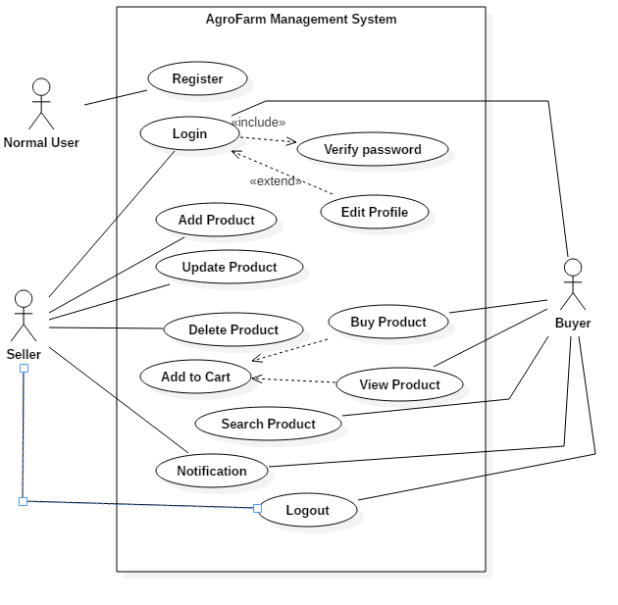

It shows the interaction between actor and the system with different functionality of the system. Following is the explanation of the use case diagram of AgroFarm Management System:

|  |  |  |  |  |
| --- | --- | --- | --- | --- |
| ID | Use Case Title | Summery | Alternative  Sequence | Actor |
| UC(01) | Register | Add the user and access the privilege. |  | Normal User |
| UC(02) | Login | Buyer and seller can only login if they are registered. | If wrong username or password is inserted there is the alert notification | Buyer, Seller  Admin |
| UC(03) | Add Product | To add new agricultural product available | Fill up field message will be displayed if not filled | Seller |
| UC(04) | Update Product | To update the product seller has added | Error in update message will be pop out. | Seller |
| UC(05) | Delete Product | To delete the product | Confirmation message will pop out to delete | Seller |
| UC(06) | Add to cart | Add the viewed product | You must login message will pop out | Buyer |
| UC(07) | Search Product | To search required product | Enter the valid name message will be valid | Buyer |
| UC(08) | Buy Product | To buy the product uploaded by seller | Confirmation message will pop out | Buyer |
| UC(09) | Update profile | To change the password username of user | Confirmation message will pop out | Buyer, seller |
| UC(10) | Logout | To logout the user from the system |  | Buyer, seller |

**2.7 System Architecture**

**2.1.1: NLA**

**‘Barter and Carter Pvt. Ltd. Nepal’** is an outsourcing company located at Chabahil, Kathmandu. The company is willing to develop a website for the farmer, which will ease the effort of the farmer and buyer. The owner of the company is asking for the development of the website for the service providing and as commercial product and earn some revenue. Here are the requirements.

Firstly, the user must be registered. Seller and the buyer are two user of the website and there is super user who will manage the website. Here the farmer can add, update and delete the products. Admin in this scenario will be able to control the user and give right privilege to the user. Here both users will be able to search the agricultural products and view details. Visitors can also be able to visit the website and look through the product. The buyer and seller should be able to see the notification of the product that has been added to the cart.

Nouns (Potential Classes) from the scenario.

Company, website, seller, buyer, owner, commercial product, revenue, user, agricultural product, cart, visitors

Some rules are applied to this classes to get the final candidate classes

Synonyms, redundant, irrelevant, repetitive and those not related to the scenario are removed.

Those noun that are used during future development are removed.

|  |  |
| --- | --- |
| **S.,N** | **Class** |
| 1. | Seller |
| 2. | Buyer |
| 3. | Visitors |
| 4. | Agricultural Product |

2.7.2 Initial Class Diagram

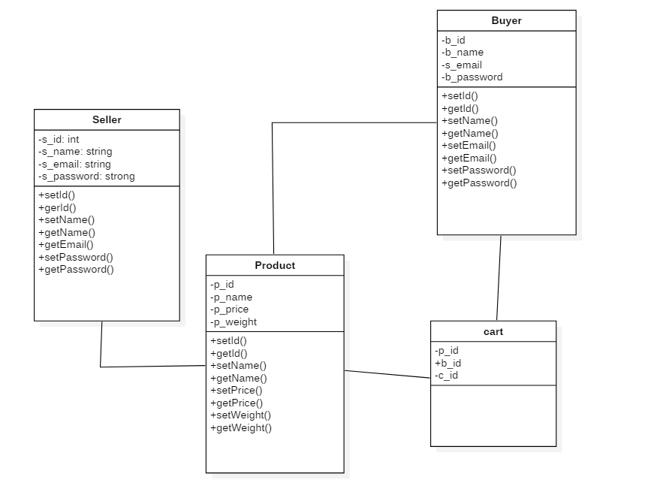

2.7.3 System architecture

Here the architecture used is 3-tier architecture for the project. This architecture holds user interface, business logic and data storage. They often used in applications as specific type of client server system. There are many benefits of using this architecture for the production as well as development environment team by modularizing the user interface, business logic and data storage layers.

