Agriculture Farm Management system

|  |
| --- |
|  |
| Module Name: Computing Project (CP)    By: **Upendra Pandey** To Module Teacher (**Sudeep Lal Bajimaya**)  NCC ID: 00176097  Batch: 23 ‘A’ |

**Softwarica College of IT & E-Commerce**

Table of Contents

Chapter 1 Introduction 2

1.1 Project Introduction 2

1.2 Justification for the project 2

I. Background of the project 2

II. Problem Statement 2

1.3 Description of the project 3

Features 3

1.4 Overview 3

Chapter 2 Scope of the project 4

2.1 Scope 4

2.2 Limitation 4

2.3 Amis 4

2.4 Objective 4

2.5 Overview of the scope 4

Chapter 3 Development Methodology 5

3.1 Methodology 5

3.2 Design Pattern 6

3.3 System Architecture 8

Chapter 4 Project Scheduling 9

4.1 Work breakdown system 9

4.2 Milestone 10

4.3 Scheduling / Gannt Chart 12

Chapter 5 Risk Management 14

Chapter 6 Configuration Management 16

Conclusion 17

# Chapter 1 Introduction

## 1.1 Project Introduction

The world is being digital and people are trying comfortable life. So, most of the products are sold online, Agricultural sector is also being online these days, Farmer want their product to be sold easily and the buyers want fresh product (vegetables, fruits seeds). The management system that is being developed is focused in same scenario. My project is to create an online purchase website that focuses on selling and buying agricultural products. In order to crate my project, I will be using a specific programming language which is PHP, MySQL as my database, JavaScript, bootstrap, jQuery.

## Justification for the project

### Background of the project

As the new project (management system) is being all the important a lot of research is to be done. Though a competitive market is not found in the agriculture field it is highly profitable and has great scope.

I will include various feature that will be unique and also include common feature of other management system and websites to make it more efficient. The project is online based where the farmers will be able to upload any agricultural products available for sale, buyers will be able to view and buy each product available for sale.

### Problem Statement

The agricultural sector has not been fully digitalized most of the people are unknown about the working mechanism so, the challenge will be focusing farmers and making the system as easy as possible so that they would not face any problem using the system. Some of them may need to be provided training in order to use it without any errors.

## Description of the project

### Features

Following features will be included on the system:

* **Login and Registration**

Users can login and register to the system or website.

* **Admin Control**

Admin will be able to control the user and the privilege to be provided.

* **Blog**

A blog page will be added to share the thoughts and the knowledge about the related sector.

* **Update**

User (seller) will be able to update the product and add new kind of product and also can update their personal information.

* **Delete**

User (seller) will be able to delete the product that are not found in their farm.

* **Reviewed Based System**

Buyer will be able to review the product they are buying and show that they are being satisfied.

## Overview

Beside those features various features are added to the system. The system will be easier to use as possible and will be user friendly, various features like subscription, search product will be added to reduce the problem of user. There will be navigation bar added so that it will be easier to navigate in each page. Different accessibility features will also be added to make it more responsive.

# Chapter 2 Scope of the project

## Scope

The scope of the project is to manage all the agricultural products provided by seller, so that the buyer can get the product easily and more efficiently and the result will be preview easily so that they can choose best for them.

## Limitation

Although the project is feasible there are some limitation of this management system. Some buyer may not appreciate the product. Some limitations are listed below:

1. In under developing country like Nepal there may not be availability of internet in rural areas which need to be access through internet being online.
2. Seller may not be familiar with the management system like this so they may feel difficult to use the system.
3. The review of the product may be inaccurate, which results the misconception of product.

## Amis

The main aim of the project is to make a product easily sold in the market. It will minimize the work force in the environment and increase the profit. Some of the aims are enlisted below:

1. To provide the easier navigation system to the user.
2. To provide the blog page where the experts will be discussing about the agricultural sector.
3. To provide the platform for digital marketing and to globally connect the people.

## Objective

The objective will be to provide a new type of management system in the market, so it can dominate over the market by taking the advantage of internet and digital marketing. It also provides platform to buyer to sell their product online and for the buyer to get all verified products. Other objectives are enlisted below:

1. To make purchase and sell power on agricultural products.
2. To fully utilize the digital marketing and maximize the profit on the sells of vegetables and fruits.
3. As the system is new it can be used to analyze the market of relatable product.

## Overview of the scope

The project in the universe cannot be limitation free so there are many limitations on the management system but the scope of the management system overtakes the limitation of the management system. The aim is to minimize the limitation of the management system and utilize the internet and digital marketing concept so that it could be benefit to each user either buyer or seller. These should be implemented with objectives in mind without going off-topic

# Chapter 3 Development Methodology

## Methodology

Waterfall model has been applied for this project. The waterfall project has various steps involved is sequential type. It is the methodology where previous step should be completed to get in new step. Each step has its own role and are crucial for the development.

The first step involves collecting all the requirements for the management system. In next step, those requirements are used to design a system. Next step involves implementing that is creating the management system, after which the testing is performed if the testing is successful the product is released. Final step involves the upgrade and maintenance of the management system.

**Advantages of Waterfall Model are given below:**

1. Simple and easy to understand and use,
2. Works well for smaller schemes where supplies are very well understood.
3. Easy to arrange tasks.

**Disadvantages of Waterfall Model are given below:**

1. High amounts of danger and doubt.
2. Not suitable for the projects where requirements are at a moderate to high risk of changing. So, risk and uncertainty are high with this process model.
3. Cannot accommodate changing requirement.

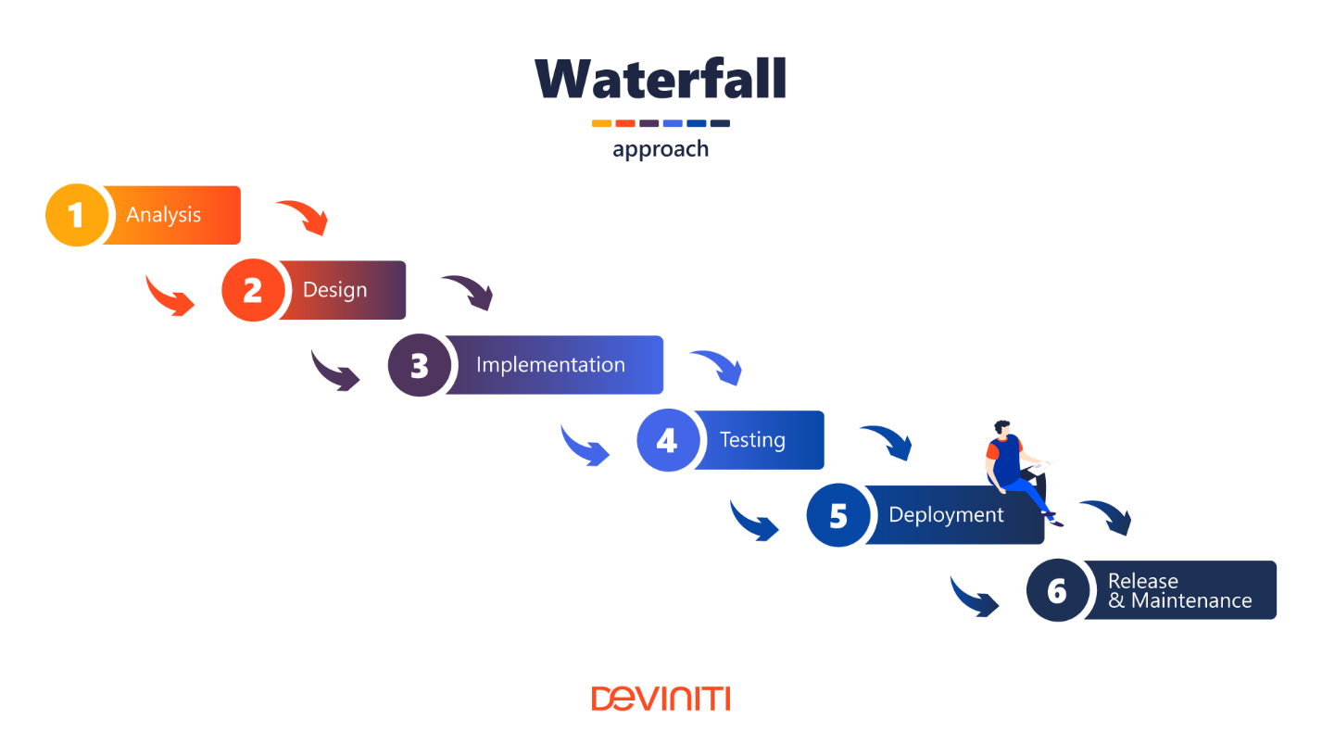

Figure 1: Software development life cycle

As the project is small scaled oriented and not complex, the methodology suitable for this project is Waterfall model.

## Design Pattern

The design pattern that will be used in this project is **Model View Controller (MVC)** design pattern. Most of the programming language nowadays use MVC pattern which is easy to understand and effective. MVC can be used for both web and desktop-based which is used by most of the programming language but not all.

**Model**: Model here represents an object. It can also have logic to update controller it its data changes.

**View:** Here the view represents the visualization of the data that model contains.

**Controller:** Controller acts both model and view. It controls the data flow into model objects and update the view whenever data changes.

**Advantages of using MVC pattern are:**

1. **MVC offers support for quick and parallel development**. So, developing web applications using the MVC model it is likely that one developer work on the view while the another can work on the controller
2. **MVC Web Application Supports Asynchronous Technique** which means that MVC application can be made to work even with PDF files, site that runs only on the specific browser, and also for desktop widgets.

**Disadvantages of using MVC pattern are:**

1. The complexity is high to develop the application using this pattern as they are each are isolates and don’t know what model view and controller are doing.
2. It is not suitable for the small application which has adverse effect in the application’s performance and architecture.

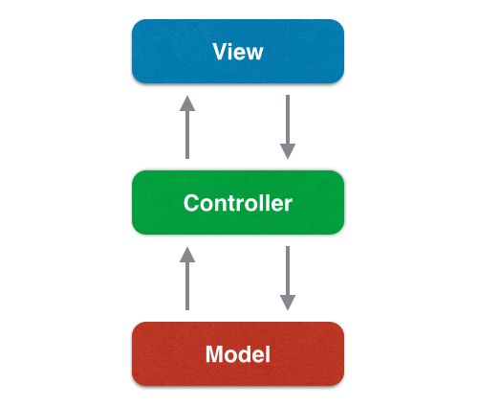

Figure 2: Design pattern used (MVC)

## System Architecture

An architecture is "the fundamental organization of a system, embodied in its components, their relationships to each other and the environment, and the principles governing its design and evolution.

It helps to explain a system view, behavior and its structure as it is conceptual design.

So, 3-tier architecture is used as shown below:

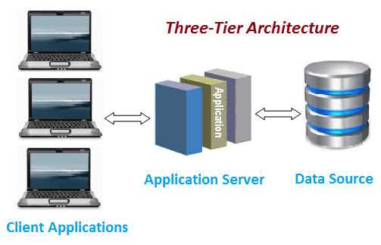

Figure 3: System Architecture (3- tier architecture)

# Chapter 4 Project Scheduling

## 4.1 Work breakdown system

Work breakdown is process where the project is divided from complex to simple management form, here we can understand and decide to continue the work according to their complex level of this project as given below:

## 2 Milestone

It is one of the important aspects that is required to be done in any project planning. It is also known as visible indicator of the project progress toward its objectives. It also helps the developer to understand the structure of the project.

|  |  |  |  |
| --- | --- | --- | --- |
| **Agriculture Farm Management System** | | | |
| **WBS number** | **Milestone** | **Date (2019)** | **Days** |
| **1** | **Proposal** | **(16 June – 1 July )2019** | **16 days** |
| 1.1 | Scope and objectives | 16 June- 19 June | 4 days |
| 1.2 | WBS, Milestone and Gantt Chart | 20 June – 23 June | 4 days |
| 1.3 | Risk Management | 24 June – 26 June | 3 days |
| 1.4 | Configuration Management | 27 June – 29 June | 3 days |
| 1.5 | Submission | 30 June – 1 July | 2 days |
| **2** | **Analysis** | **(2 July- 29 July) 2019** | **28 days** |
| 2.1 | Feasibility study | 2 July- 13 July | 12 days |
| 2.2 | Requirement Specification | 14 July – 26 July | 13 days |
| 2.3 | Use Case Diagram | 27 July – 29 July | 3 days |
| **3** | **Design** | **(30 July – 29 August) 2019** | **31 days** |
| 3.1 | Structural Model  [Class Diagram] | 30 July – 6 August | 8 days |
| 3.2 | Behavior Model | 7 August – 14 August | 8 days |
| 3.3 | Database design  [ER diagram]  [Data-Dictionary] | 15 August – 22 August | 8 days |
| 3.4 | User Interface (UI) Design | 23 August - 29 August | 7 days |
| **4** | **Coding** | **(30 August – 20 September) 2019** | **22 days** |
| 4.1 | Build Database | 30 August – 7 September | 9 days |
| 4.2 | Implementation of code | 8 September – 20 September | 13 days |
| **5** | **Testing** | **(21 September – 30 September) 2019** | **10 days** |
| 5.1 | Black Box Testing | 21 September- 23 September | 3 days |
| 5.2 | Unit Testing | 24 September – 27 September | 4 days |
| 5.3 | Validation Testing | 28 September- 30 September | 3 days |
| **6** | **Documentation** | **(1 October – 12 October) 2019** | **12 days** |
| 6.1 | User Manual | 1 October – 8 October | 8 days |
| 6.2 | Final Report | 9 October - 12 October | 4 days |

## 4.3 Scheduling / Gannt Chart

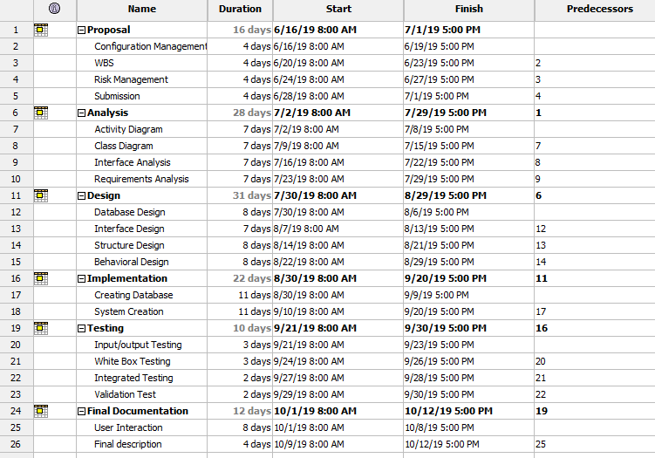

Figure 4: WBS in Project Libre

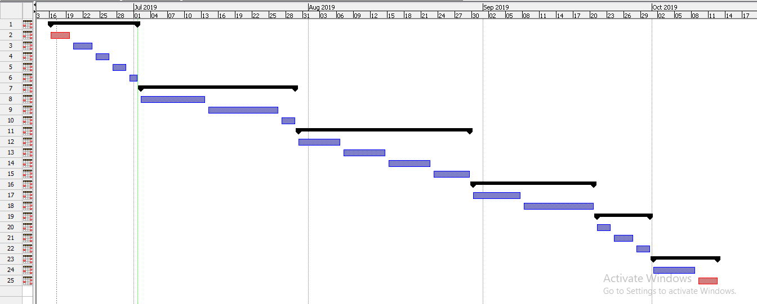

Figure 5: Gantt Chart

# Chapter 5 Risk Management

Risk management is the process of identifying, assessing and controlling threats to an organization’s investment and grossing which could stem from a wide variety of sources, including financial uncertainly, legal liabilities, strategic management errors, natural disaster or any kind of accidents, that could occur in future.

1. **Identify the Risk**

The risks are to be identified that might affect the management system or the project. So, different techniques are to be applied.

1. **Analyze the Risk**

After the identification of the risks, we need to understand its potential to affect management system or project goal and objectives with its likelihood and consequences.

1. **Evaluate or Rank the Risk:**

After analysis to the consequences and likelihood, we need to decide its acceptance whether it is serious enough to warrant treatment.

1. **Treat the Risk**

We need to access our highest ranked risk and set out the plan to treat these risks and has to decide to minimize the negative risks.

1. **Review the Risk**

This is the step where we take our risk register and use it to trace and review risks.

The impact on the system can be calculated by using following formulae

**Impact = Likelihood X Consequences**

|  |  |
| --- | --- |
| **Likelihood Table** | |
| **Likelihood** | **Value** |
| Low | 1 |
| Medium | 2 |
| High | 3 |

|  |  |
| --- | --- |
| **Risk Consequences Table** | |
| **Consequence** | **Value** |
| Very low | 1 |
| Low | 2 |
| Medium | 3 |
| High | 4 |
| Very high | 5 |

**Risk Management table:**

|  |  |  |  |  |  |
| --- | --- | --- | --- | --- | --- |
| **RID** | **Risk Name** | **Likelihood** | **Consequence** | **Impact** | **Solution** |
| 1 | Bug on the Code | 2 | 2 | 6 | Proper testing should be done before deployment. |
| 2 | Server failure | 1 | 5 | 5 | Backup should be done time to time |
| 3 | Untrained Developer | 1 | 5 | 5 | Proper training should be given. |
| 4 | Malware/ Virus | 2 | 5 | 10 | Antivirus and anti-malware software should be installed. |
| 5 | Strategy Risk | 2 | 5 | 10 | A well plan project should be implemented |
| 6 | External Factors | 1 | 3 | 3 | Proper safety measures for hazards. |

# Chapter 6 Configuration Management

Configuration management is governance and system engineering process for ensuring consistency among physical and logical assets in an operational environment.

It helps to classify documenting functional capabilities, individual configuration item and interdependencies. I will be keeping all the progress in the GitHub. I’ll also backup every change in my project development.

In order to access the file anytime from anywhere, here in GitHub, files and folders are managed in systematic way.

Link of my profile:

<https://github.com/Upendrapandey007/AgricultureFarmManagementSystem>

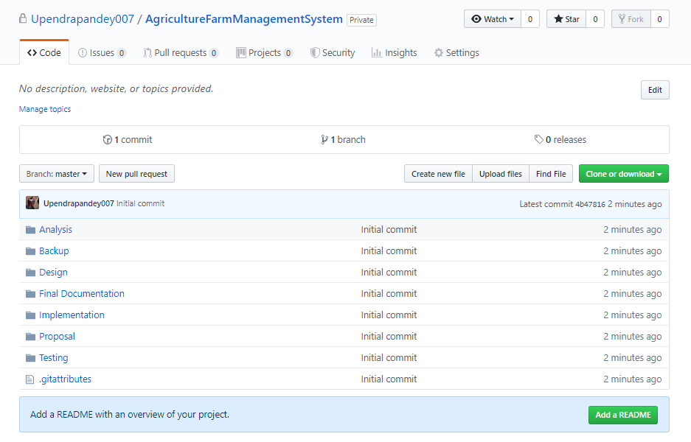

Figure 6: Configuration management (GitHub)

# Conclusion

After collection of information the management system will be ready which will be released in market and will be affordable for every farmer who will sell their product and costumer will buy the product from the seller.

The project will be completed using bracket as text editor, MySQL as database and Apache as Local server.