If Taxableincome =<25000
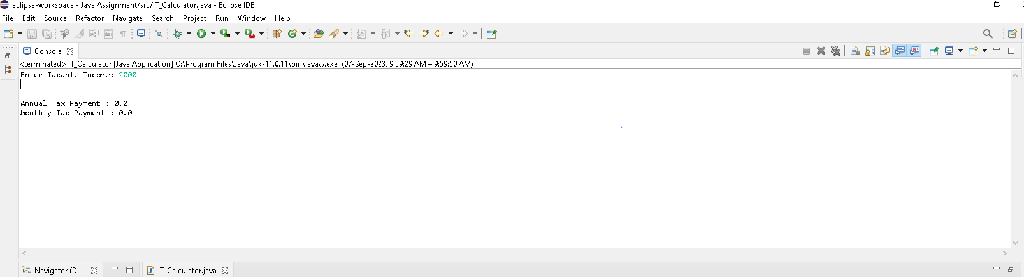
If Taxableincome =<50000

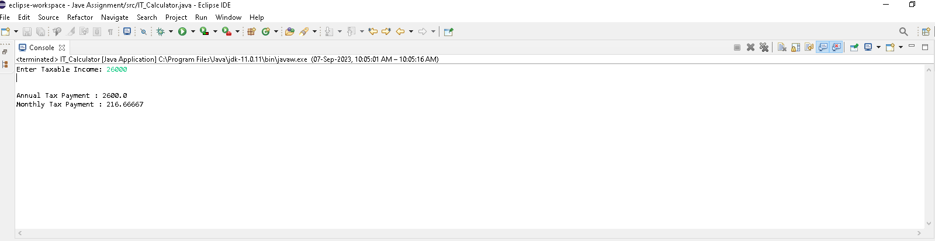

If Taxableincome <=75000

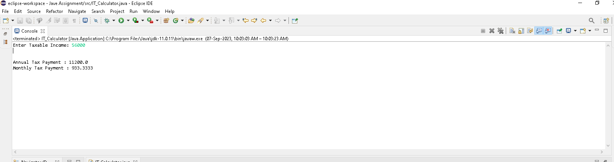
If Taxableincome >=75000

