# About the PDE

The PDE describes the **incompressible Navier–Stokes equations**—the fundamental equations governing the motion of viscous, incompressible fluids such as air or water. This PDE system is the mathematical foundation for simulating how incompressible fluids (like air or water) move around obstacles (such as buildings).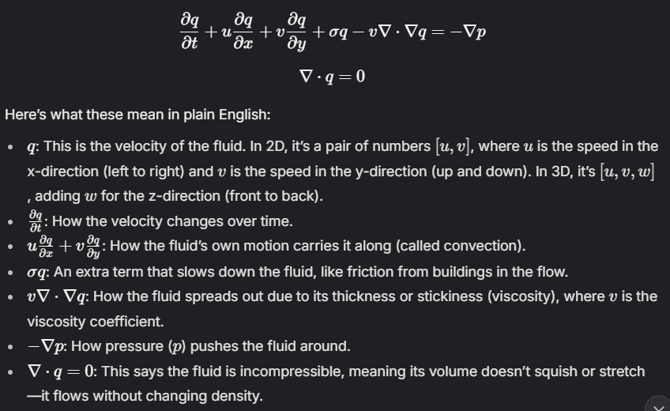

Applications

* **Urban airflow modeling**: Predicting wind patterns and pollutant dispersion in city environments.
* **Engineering design**: Simulating air or water flow around vehicles, buildings, or other structures.
* **Environmental science**: Studying weather, ocean currents, and climate phenomena.

**Conditions:**

**The air or water comes in from the left at 1 meter per second ( 𝑢 = − 1.0 m/s).**

**The space is a big grid (512 x 512 x 64 points), like a 3D map.**

**Buildings are added as obstacles that block or slow the air, modeled by the 𝜎 term.**

About the **𝜎 term**

This term causes the velocity q to decrease over time, proportional to its current magnitude. This isn't always present in the standard Navier-Stokes equations but can be added to model effects like flow through a porous medium (where friction dampens velocity) or other dissipative phenomena.

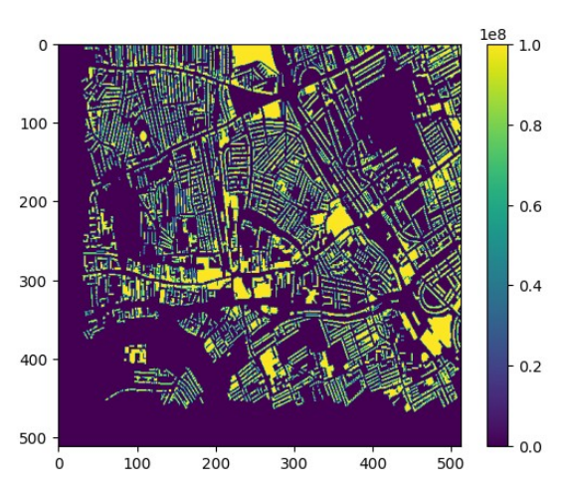

This is a map of the σ term at a specific height (z = 4). σ is huge (1e8) where buildings are, and 0 where there’s just air.

**Bright Yellow Areas** are buildings(darker shows high density), and **Dark Purple/Black Areas shows open spaces (streets, gaps between buildings) where the fluid is allowed to flow without this strong artificial damping.**

This plot verifies that the complex building geometry (loaded from "Mesh_buildings.npy")

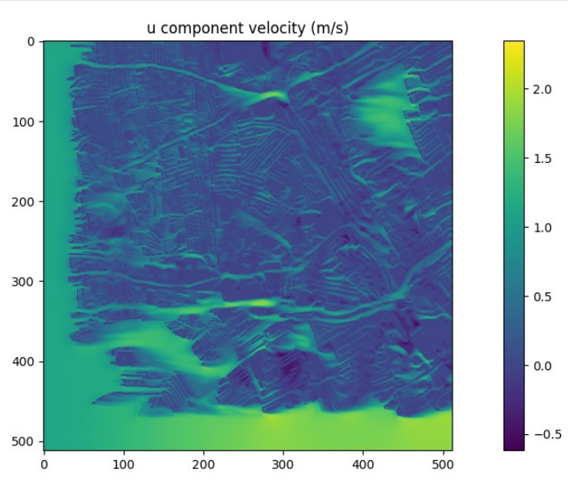

**What it shows**  
The horizontal (left-right) airflow velocity at height level z=4 after 500 simulation steps, plotted as -values_u.

**Key observations**

* **Color interpretation**:

|  |  |  |
| --- | --- | --- |
| Color Range | Actual Velocity | Flow Direction |
| ~2.0 m/s (yellow) | -2.0 m/s | Strong leftward |
| ~-0.5 m/s (purple) | +0.5 m/s | Rightward |
| ~0-0.5 m/s (green) | Near-zero | Stagnant/other directions |

* **Flow patterns**:
  + Accelerated leftward flow (yellow) in channels between buildings
  + Rightward flow (purple) in wake regions behind obstacles
  + Complex recirculation zones near building corners

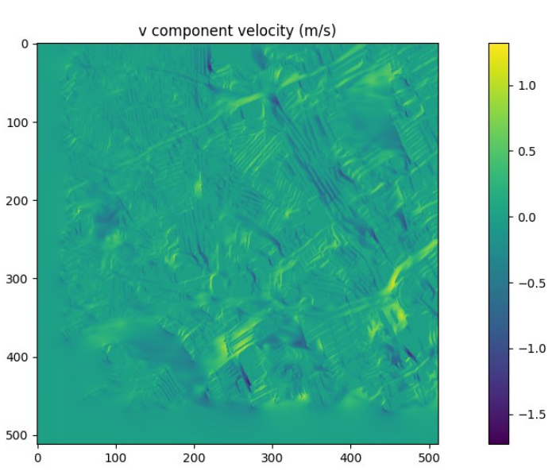

**What it shows  
Vertical (up-down) airflow velocity at the same height, plotted as -values_v****.**

**Key observations**

* **Color interpretation:**

|  |  |  |
| --- | --- | --- |
| **Color Range** | **Actual Velocity** | **Flow Direction** |
| **~1.0 m/s (yellow)** | **-1.0 m/s** | **Downward** |
| **~-1.5 m/s (purple)** | **+1.5 m/s** | **Upward** |

* **Flow patterns:**
  + **Strong upward currents (purple) along building windward faces**
  + **Downward motion (yellow) in leeward regions**
  + **Vortex formation visible in alternating color patterns**

**Combined Insights**

**These visualizations demonstrate how the AI4PDEs solver captures:**

1. **Flow acceleration through urban canyons**
2. **Wake formation behind obstacles**
3. **3D flow separation at building edges**
4. **Vertical mixing crucial for pollutant dispersion**