HW4

There is a bug in the strcpy.c code.

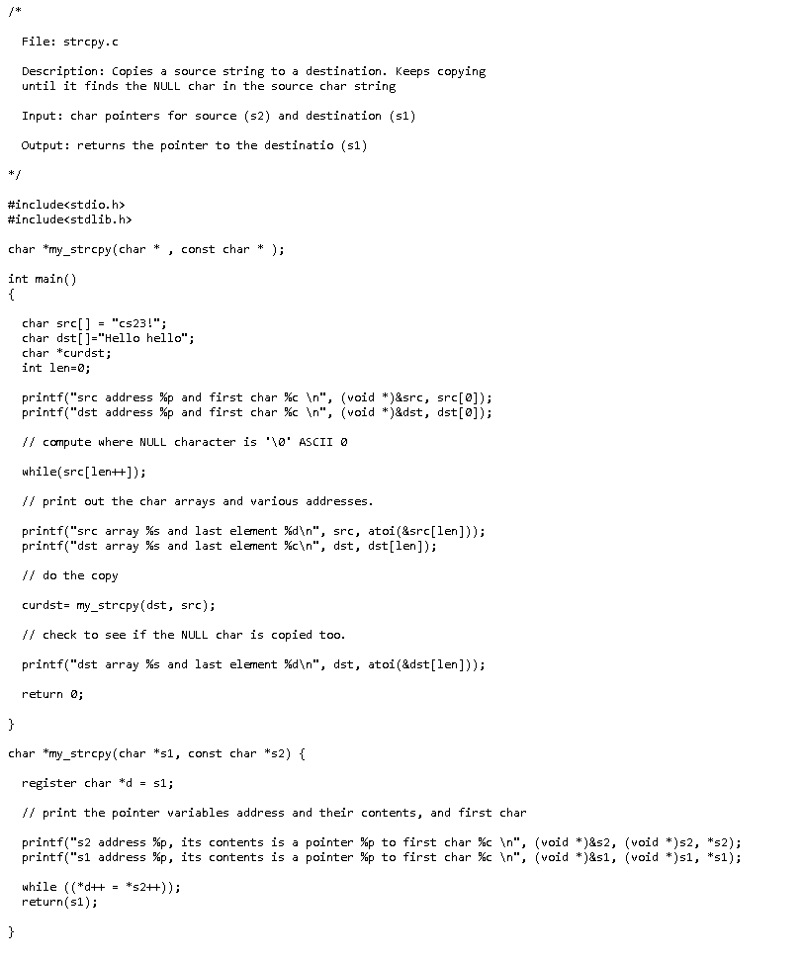

As we can see there’s a code that make two different character-type arrays copied.

To copy the array. We cannot use the normal way as variable does. We should use the pointer to point the arrays addresses. And the code up there show how to do a string-copy using pointer. But there’s a bug in the code. At the line of “While(src[len++])” , we know if you want the while loop can run successfully.

You need to set a condition. However, the while loop’s condition src[len] will cause a problem that the src array’s length doesn’t fit the dst array’s length. So, the code still can run, but it turns out result wrong.



The last element of dst array is not h.