A Leakage-Free Classical Pipeline for 5-Class SSVEP Decoding Under a 1.0-Second Constraint
Filter-Bank CSP and Filter-Bank CCA Fused via Shrinkage-LDA, with a Feature-Selection Ablation and a 5-Subject Cohort Evaluation
Tecnológico de Monterrey, School of Engineering and Sciences
Technical Report
Abstract
We present and validate a complete, leakage-free classical pipeline for decoding 5-class Steady-State Visually Evoked Potentials (SSVEP) from 1.0 s EEG windows recorded with 7 occipital-parietal electrodes at 250 Hz. Raw signals pass through zero-phase IIR conditioning, a dual-tier artifact-quality gate, and two complementary feature branches — Filter-Bank Common Spatial Patterns (FBCSP, m=1, p=50) and Filter-Bank Canonical Correlation Analysis (FBCCA, p=5) — fused into a 55-dimensional hybrid vector classified with Ledoit-Wolf Shrinkage Linear Discriminant Analysis (LDA). All spatial filters and scalers are fit strictly in-fold under Stratified 5-Fold cross-validation. On a representative subject the pipeline reaches 90.36% instantaneous (1.0 s) and 95.43% trial-smoothed (2.0 s) accuracy; across a 5-subject cohort the mean is 83.33%/87.57%. A feature-selection ablation shows dimensionality can be cut by over 60% with under 2 points of accuracy loss, confirming that Shrinkage-LDA's analytical regularization makes hard feature truncation optional rather than necessary. Results are discussed against the SSVEP visual-paradigm literature.
Keywords: SSVEP, brain–computer interface, FBCSP, FBCCA, shrinkage-LDA, feature selection

1. Introduction
Brain-Computer Interfaces (BCI) based on Steady-State Visually Evoked Potentials (SSVEP) are attractive for communication and navigation applications because they require little or no user training and support high information-transfer rates (Chailloux Peguero et al., 2023). Performance, however, depends jointly on the visual stimulation design and the detection algorithm applied to the EEG. Building on evidence that Filter-Bank Canonical Correlation Analysis (FBCCA) is the strongest training-free detector among CCA, FBCCA and Minimum Energy Combination across multiple visual paradigms (Chailloux Peguero et al., 2023), this work designs a hybrid classical pipeline that pairs FBCCA with a complementary spatial-filtering branch (FBCSP) and asks three questions: (i) which classical feature space and classifier combination is strongest under a strict 1.0 s decision budget; (ii) how much can the resulting feature space be compressed before accuracy degrades; and (iii) how consistent is performance across subjects.
The 5 target frequencies used here (24.0, 20.0, 15.0, 10.9091 and 8.5714 Hz) are deliberately non-harmonically related, following the same rationale used to avoid cross-talk between targets in the reference SSVEP literature. All code, thresholds and hyperparameters described below correspond exactly to the implemented pipeline; no step is illustrative only.

2. Materials and Methods
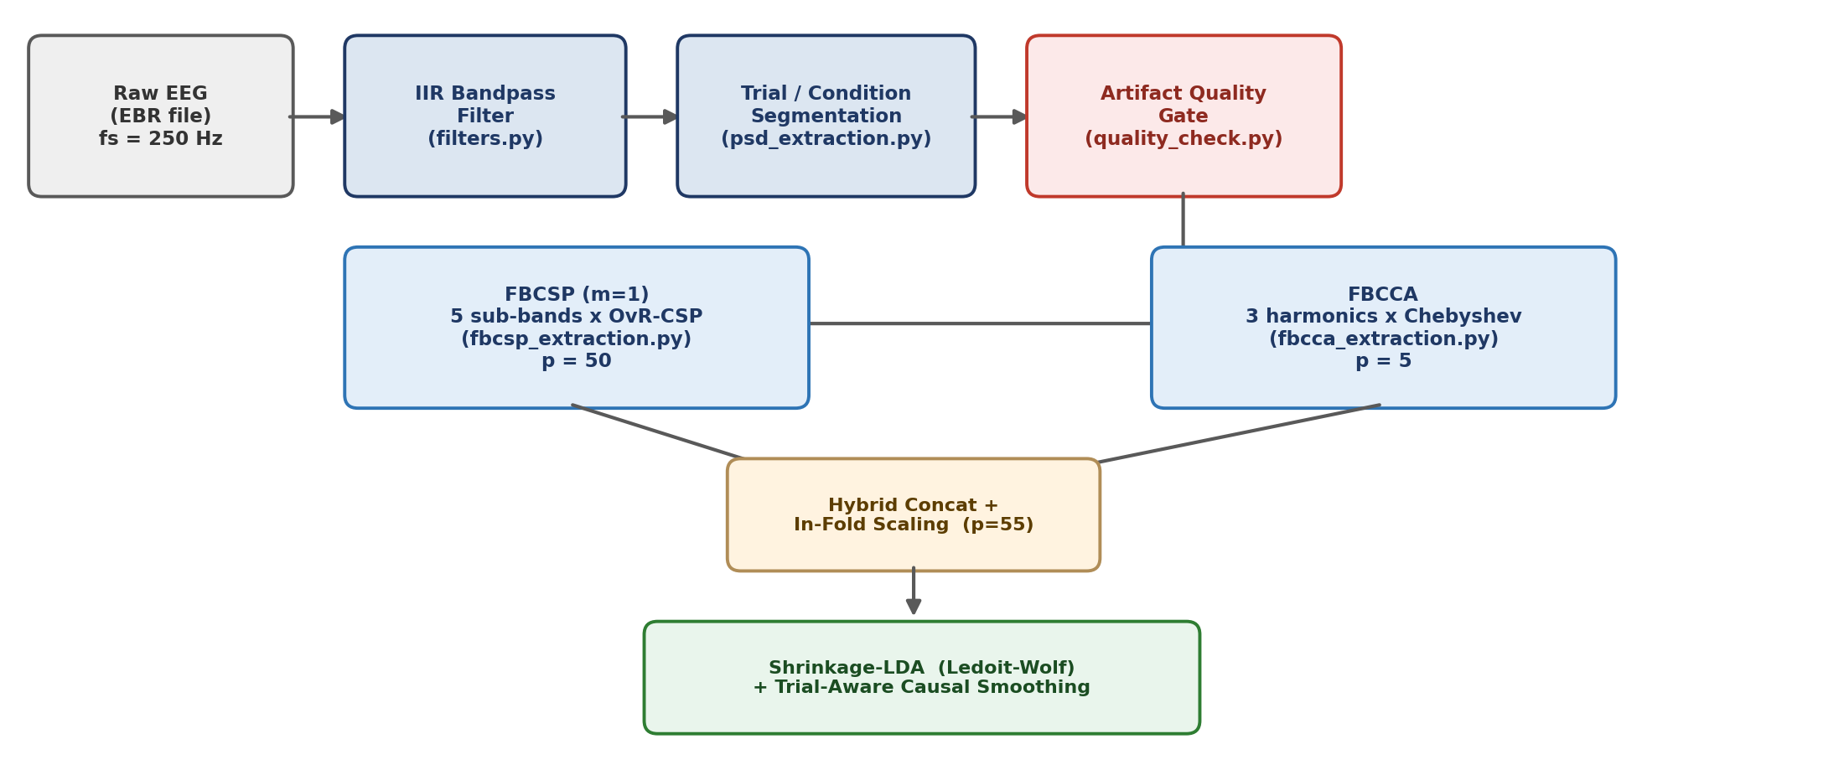
Figure 1. End-to-end pipeline: acquisition → IIR conditioning → trial segmentation → artifact gate → dual feature branches (FBCSP / FBCCA) → hybrid fusion with in-fold scaling → Shrinkage-LDA → causal smoothing.

2.1 Acquisition and Signal Conditioning
Each subject's raw recording (.ebr) is loaded together with its sampling rate and channel list; a configured subset of 7 scalp electrodes and a marker channel are extracted. Every channel is conditioned with a zero-phase Butterworth bandpass (1–60 Hz, order 4, scipy.signal.filtfilt), which removes drift and high-frequency noise while preserving the phase information that FBCCA later depends on. Trials are segmented from the marker channel into three epoch types — a 1.0 s pre-stimulus cue baseline, a 5.0 s stimulation epoch per target (101–105), and a fixation-cross rest epoch — and each stimulation epoch is sliced into 5 consecutive 1.0 s sub-windows, the unit on which every subsequent stage operates.

2.2 Artifact Quality Control
Two independent thresholds are applied sequentially. At the raw sub-window stage, a looser gate rejects segments with peak-to-peak amplitude above 200 µV or standard deviation outside [0.5, 60.0] µV. Immediately before each feature extractor runs, a tighter, conjunctive per-channel gate requires every one of the 7 channels to satisfy Vₚₚ ∈ [0.5, 120.0] µV and σ ∈ [0.1, 35.0] µV simultaneously; a single failing channel discards the whole multichannel window. Filtered windows and labels are re-indexed jointly to guarantee alignment. All three feature extractors share this exact gate, and the resulting clean-window masks and labels were verified to be identical across branches before hybrid fusion.

2.3 Feature Extraction
Filter-Bank CSP (FBCSP, m=1). Clean windows are bandpass-decomposed into 5 sub-bands (7–12, 13–17, 18–26, 27–36, 38–52 Hz). Within each sub-band, a One-vs-Rest multiclass CSP is fit on a trace-normalized covariance,
Σ_i = (W_i W_iᵀ)/Tr(W_i W_iᵀ),
and, per class, the generalized eigenproblem between the target and (target+rest) covariance is solved (Tikhonov-regularized, ε=10⁻⁶), keeping only the extreme eigenvector pair (m=1). Log-variance of the projected signal, normalized within-window, gives 5 classes × 2 filters × 5 sub-bands = 50 features.
Filter-Bank CCA (FBCCA). Sinusoidal references with N_{h}=3 harmonics are built for each of the 5 target frequencies. Each window is passed through 3 Chebyshev Type-I sub-band filters (low cutoffs 6/14/22 Hz) and canonical correlation is computed against each reference; sub-band scores are integrated with a power-law weight w(b)=b⁻¹·²⁵+0.25, giving one correlation prior per target (p=5) — an unsupervised, training-free signal that complements the supervised spatial features.
Both branches feed a 55-dimensional hybrid vector; a continuous/harmonic PSD representation (p=210 / p=32) was also implemented as a spectral baseline for comparison (Section 3.1).

2.4 Feature Selection
Given the p=55 hybrid space, two in-fold filter methods were evaluated on the 50 FBCSP columns (the 5 FBCCA priors are always retained): ANOVA F-score and mutual information, each ranking features on the training fold only before selecting the top-k. A physiologically motivated sub-band pruning heuristic (dropping the 38–52 Hz band) and a Sequential Forward Selection run were evaluated for comparison (Section 3.3).

2.5 Classification
The primary classifier is Linear Discriminant Analysis with Ledoit-Wolf analytical shrinkage (solver="lsqr", shrinkage="auto"), which regularizes the within-class scatter as
Σ_reg = (1−γ*)·S_w + γ*·ν·I_p ,
removing the need to hand-tune a shrinkage hyperparameter even as p approaches the per-fold sample size. Ten additional linear/discriminant models (Ridge, three penalized Logistic Regression variants, two SGD variants, standard LDA, an eigen-solver Shrinkage-LDA, and regularized QDA) were benchmarked alongside it; Shrinkage-LDA with the lsqr solver was consistently the strongest and is used throughout Section 3.

2.6 Evaluation Protocol
All reported numbers use Stratified 5-Fold cross-validation (random_state=42) with CSP filters and the StandardScaler fit strictly on the training fold — never on held-out data. Out-of-fold class probabilities are pooled across folds. Instantaneous accuracy is the per-window arg-max; a 2.0 s smoothed decision averages the current and immediately preceding probability vector, resetting every 5 sub-windows so no information crosses a trial boundary:
ȳⱼ = argmax_k { pⱼ(k) if j mod 5=0 ; avg(pⱼ₋₁(k), pⱼ(k)) otherwise }.

3. Results

3.1 Feature-Space and Model Selection
A cross-validated sweep across six feature spaces (continuous PSD p=210; harmonic PSD p=32; FBCCA p=5; harmonic PSD+FBCCA p=37; FBCSP p=50; FBCSP+FBCCA p=55) and the full model catalog (QDA excluded for high-dimensional rank failure) identified the FBCSP+FBCCA hybrid space with Shrinkage-LDA as the strongest configuration, clearly ahead of any single-domain space. A zero-training argmax on the raw FBCCA scores alone served as a lower-bound reference and was outperformed by every supervised configuration on the hybrid space.

3.2 Single-Subject Benchmark (Subject S03)
The winning configuration reached 90.36% instantaneous (1.0 s) and 95.43% smoothed (2.0 s) accuracy on Subject S03 (197 clean windows, 3 rejected). Figure 2 (left panel) shows perfect precision on the 24.0 Hz target; the two lowest, closely spaced frequencies (10.9091 and 8.5714 Hz) account for essentially all residual confusion, consistent with their reduced spectral separation at a 1–2 s analysis length.

3.3 Feature Selection Ablation
Selection Method | Dim. (p) | 1.0 s (%) | 2.0 s Smoothed (%)
Full baseline | 55 | 90.36 | 95.43
Sub-band pruning (drop 38–52 Hz) | 45 | 87.31 | 94.92
ANOVA F-score | 25 | 86.29 | 94.42
Mutual information | 25 | 87.82 | 93.40
Sequential forward selection | 20 | 84.77 | 93.40
Table 1. Ablation of the hybrid feature space (Subject S03). Even a 63.6% dimensionality cut (p=55→20) retains 93.40% smoothed accuracy, 2.0 points below baseline, reflecting Shrinkage-LDA's native regularization.

3.4 Multi-Subject Cohort (S01–S05)
The winning pipeline was applied unchanged, with subject-specific 5-fold CV, across all five subjects:
Subject | Clean Windows | Rejected | 1.0 s Acc. (%) | 2.0 s Smoothed (%)
S01 | 200 | 0 | 64.50 | 75.50
S02 | 196 | 3 | 66.33 | 71.94
S03 | 197 | 3 | 90.36 | 95.43
S04 | 197 | 1 | 98.98 | 98.48
S05 | 200 | 0 | 96.50 | 96.50
Mean | — | — | 83.33 | 87.57
Table 2. Per-subject clean windows, artifact rejection and accuracy. Cohort mean: 83.33% (1.0 s) / 87.57% (2.0 s smoothed).
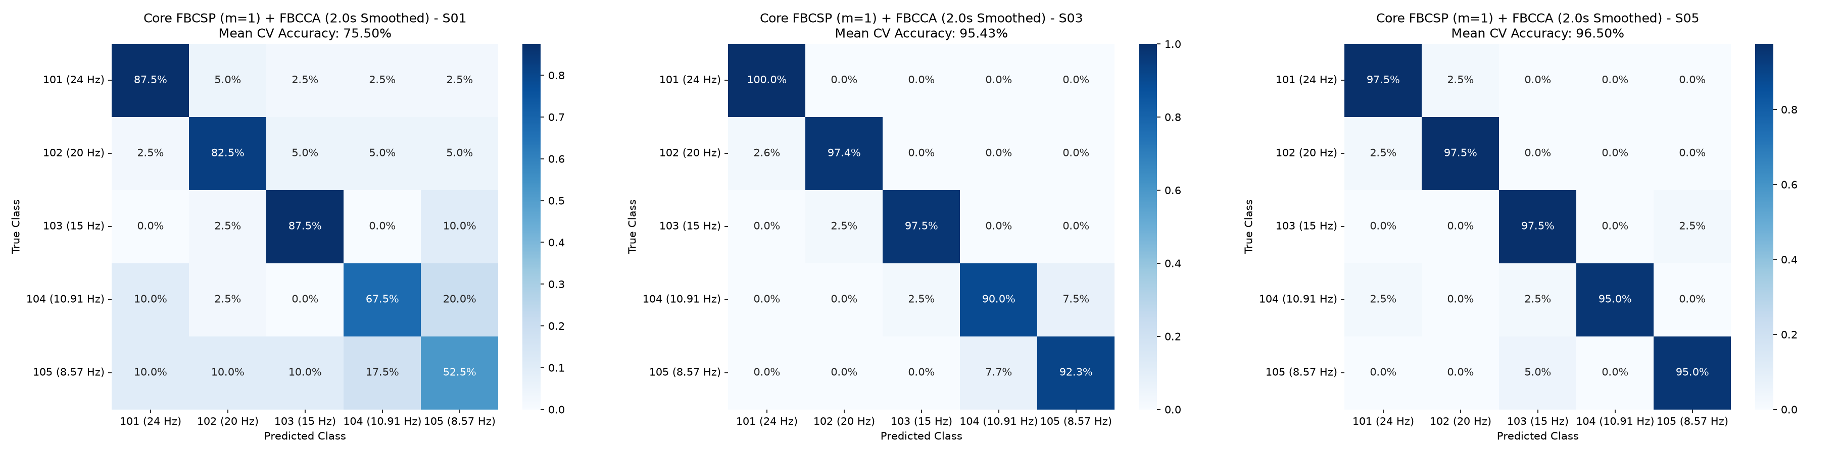
Figure 2. Normalized confusion matrices, 2.0 s smoothed. Left to right: S01 (attenuated responder, 75.50%), S03 (mid-tier, 95.43%), S05 (high responder, 96.50%). Confusion concentrates on the 8.5714/10.9091 Hz pair in every subject; S01 additionally shows appreciable spread across all classes.
The cohort separates into a high-responder tier (S03–S05, 95.4–98.5% smoothed) with well-separated occipital entrainment at all five frequencies, and an attenuated tier (S01–S02, 71.9–75.5% smoothed) consistent with the inter-subject variability (“BCI illiteracy”) reported broadly in the SSVEP literature; S01's zero rejected windows rule out a data-quality explanation. Smoothing recovers 11.0 points for the weakest responder (S01) versus essentially nothing for the strongest (S04, −0.50), i.e. temporal integration compensates specifically where instantaneous decisions are noisiest.

4. Discussion
These results agree with Chailloux Peguero et al. (2023) on three points: FBCCA is confirmed as a strong training-free detector, motivating its use as one of the two feature branches here; the lowest, closely spaced target frequencies are the hardest to separate in both studies, while widely spaced high frequencies (here, 24 Hz) are essentially always correct; and peak detection performance is reached within about the first second of stimulation in both studies, supporting a 1.0 s primary decision window with a 2.0 s smoothed option reserved for latency-tolerant use cases. The two studies differ in that the reference work isolates the effect of visual-paradigm design (On-Off vs. Checkerboard, rectangular vs. sinusoidal modulation), metadata not available in the recordings used here; capturing it in future sessions would allow a direct replication of that comparison on this cohort.
The feature-selection ablation additionally shows that Ledoit-Wolf shrinkage, not manual dimensionality reduction, is the operative regularizer in this pipeline: a 63.6% smaller feature vector costs only 2 accuracy points, so feature selection here is best framed as an optional efficiency lever for real-time deployment rather than a requirement for generalization.

5. Conclusion
- A leakage-free FBCSP (m=1) + FBCCA → Shrinkage-LDA pipeline reaches a 5-subject mean of 83.33% (1.0 s) / 87.57% (2.0 s smoothed) and should serve as the reference threshold before any deep-learning architecture is pursued.
- Hybrid spatial + correlation features consistently beat any single-domain representation (PSD, FBCSP, or FBCCA alone) under a 1.0 s decision budget.
- Dimensionality can be cut by >60% with <2 points of accuracy loss; feature selection is an efficiency choice, not a necessity, given Shrinkage-LDA's analytical regularization.
- Inter-subject variability, not model or feature choice, is the dominant source of residual error; future work should target subject-specific calibration for attenuated responders.

References
Chailloux Peguero, J. D., Hernández-Rojas, L. G., Mendoza-Montoya, O., Caraza, R., and Antelis, J. M. (2023). SSVEP detection assessment by combining visual stimuli paradigms and no-training detection methods. Frontiers in Neuroscience, 17:1142892. https://doi.org/10.3389/fnins.2023.1142892

