5.07 Assignment Instructions: Passwords

Instructions: Write a program to generate random passwords; the user should be able to select the character set and the length. Complete the Questions and Discovery section.
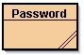
- Create a new project called 5.07 Password Generator in the Mod05 Assignments folder.
- Create a class called Password in the newly created project folder.
- Display a menu giving the user a choice of at least 4 different character sets to use to construct the password and the option to stop. (Note: Do not use the first range of punctuation symbols with ASCII values from 33-47). Ensure the user’s choice is valid.
- Allow the user to select the number of characters in the password. The minimum length allowed should be 6. Ensure the user’s choice is valid.
- Create a randomly generated password from the character set selected by the user and display it to the screen.
- The program should continue until the user wants to stop generating passwords.

Suggestions: Make an outline on paper, use pseudocode, or diagram logic sections with a flowchart. Would it be easier to write the 1st or the 4th menu option first?

Expected Output: The output of the program should resemble the following screen shot.

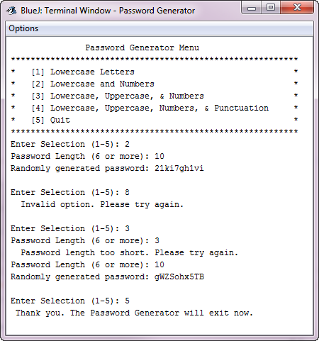
Some sample results from the program are shown below with their strength ratings determined by the password checker. Red or no bars is a "weak" strength, yellow bars indicate "medium", and green is "strong". Two green bars is "best".

Menu Selection | Password Length | Password | Strength
1 | 6 | mwpvys | weak
2 | 10 | 21ki7gh1vi | medium
3 | 12 | j4xUnj4E7Nkv | strong
4 | 14 | {C5lEak]\qQ0Ly | best

Questions and Discovery: Copy and paste the following information into a word processing document to submit along with your program. Answer the questions and fill-in the table. Remember never share your real passwords.

- Check the strength of two passwords of different length from each menu option with the password checker. Tabulate the strength of the passwords.
Menu Selection | Password Length | Password | Strength  (How long to Crack)
1 | 6 | npuuuv | 3 hours
1 | 12 | pgltesfnmcam | 4 centuries
2 | 6 | nc4o1e | 3 hours
2 | 12 | f6l5twzzvi9e | 4 centuries
3 | 6 | DguM0S | 3 hours
3 | 15 | kDPdlJq]YDYG213 | 3261 centuries
4 | 6 | vHsdl; | 3 hours
4 | 15 | m:;l*J^"6yE,;b5 | 3261 centuries

- Highlight each of the following that apply to you.
- Have you told anyone your password?
- Is your password written down somewhere?
- Are you still using the default password for any accounts (e.g. password, student, your user name, etc.)?
- Do you use the same password for multiple accounts?
- Is your password more than 6 months old?
- Does your password only contain letters?
- Is your password less than eight characters long?
- Does your password contain any recognizable words?
- Does your password contain the name of a pet, friend, or relative?

- Re-read the How to choose a better password and How Do I Create a Strong Password? articles. Write a short paragraph reflecting on what you have learned about passwords. In your opinion, what is the effectiveness of randomly generated passwords vs. memorable passwords? Will your practices with regarding generating passwords change? How?

Passwords are something that should be taken seriously, in a safety concern kind of way. They are essentially the key to your life, because everything is online and password protected. So, passwords should be kept a secret and only given out when necessary. Randomly generated passwords are the best because they have no connection to the person what so ever so it would be harder for someone else to guess is. On the other hand memorable passwords are easier for people to remember and easier to enter. No my passwords will stay the same because I am too far gone and stuck in my ways.

