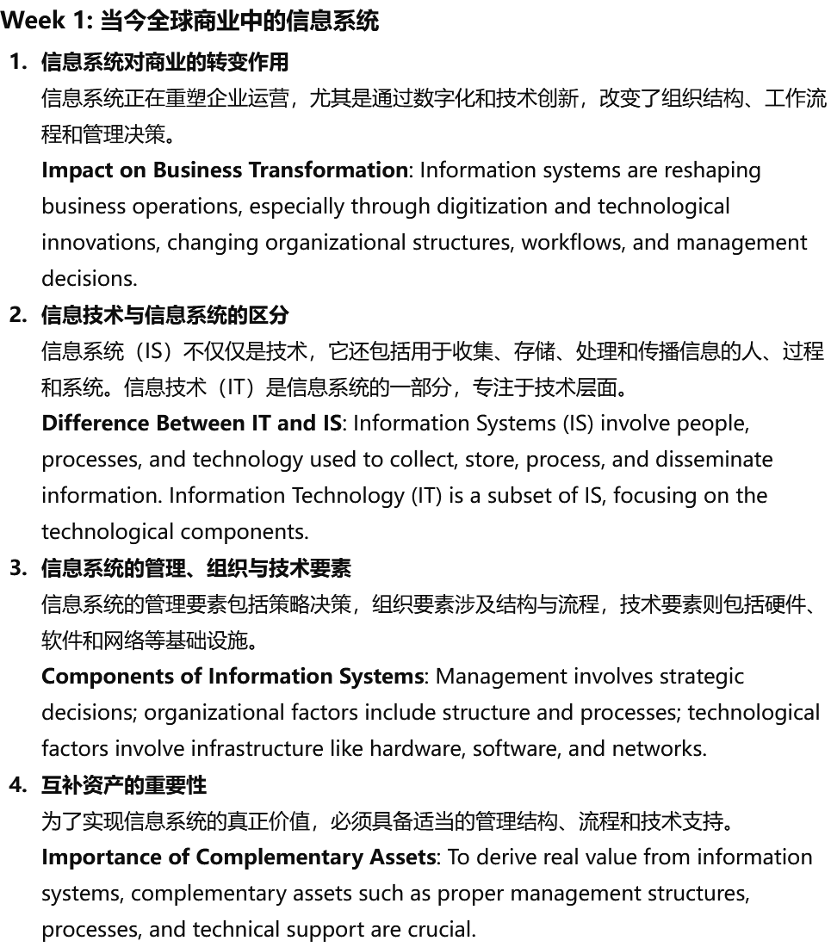
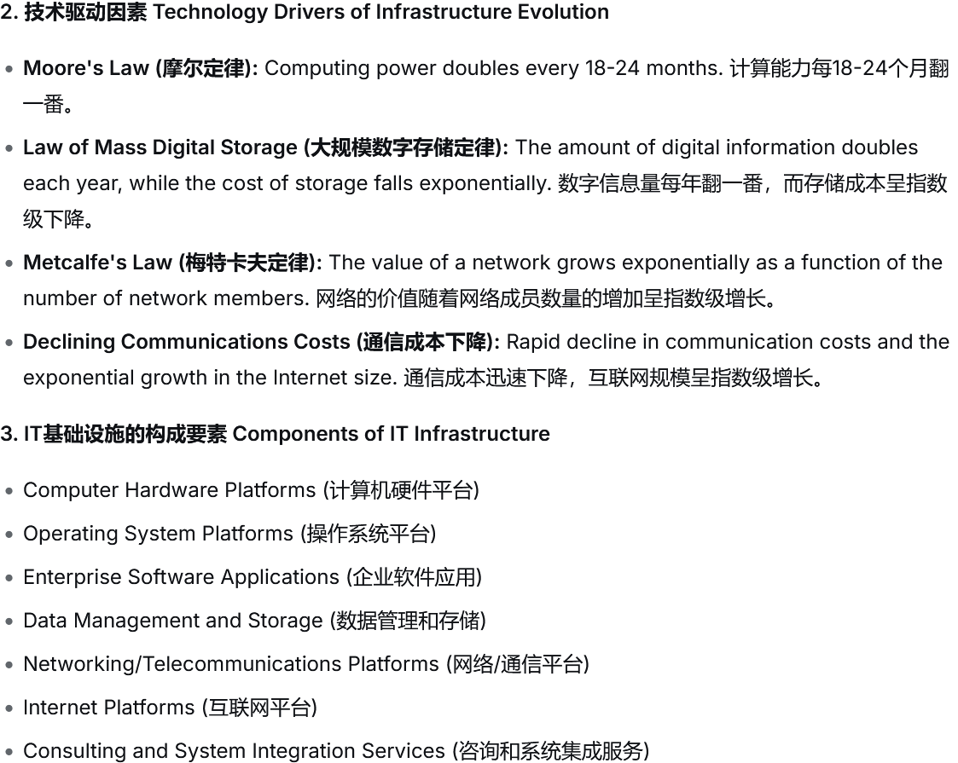

Week 5: IT基础设施与新兴技术
1.IT基础设施的构成要素
IT基础设施包括硬件、软件、存储设备、网络以及支持企业运营所需的管理服务等。
Components of IT Infrastructure: IT infrastructure includes hardware, software, storage devices, networks, and the management services required to support business operations.
2.云计算的应用与优势
通过云计算，企业可以减少资本支出，提升系统的灵活性和可扩展性，从而提高运营效率和客户服务。
Cloud Computing Applications and Benefits: Cloud computing allows businesses to reduce capital expenditures, enhance system flexibility and scalability, improving operational efficiency and customer service.
3.新兴技术对企业的影响
物联网、大数据和人工智能等新兴技术正在不断推动行业的创新，提供更精准的业务分析和预测能力。
Impact of Emerging Technologies on Business: Emerging technologies such as IoT, big data, and AI are continuously driving industry innovation, providing more accurate business analysis and forecasting capabilities.
4.IT基础设施的发展驱动力
计算能力的提升、存储成本的下降和网络技术的进步推动了IT基础设施的快速发展。
Drivers of IT Infrastructure Evolution: Advances in computing power, reductions in storage costs, and progress in networking technologies have driven rapid development in IT infrastructure.

