R32314015_YouShengxuan
2025.12.20

PART A:One-Way ANOVA Analysis

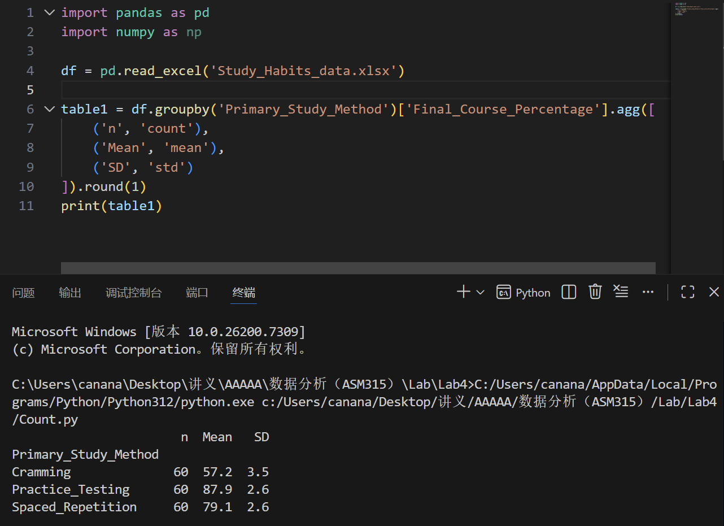
Descriptive Statistics (Table 1)

Six-Step Hypothesis Testing Procedure
Step 1: State Hypotheses

H₀: μ₁ = μ₂ = μ₃ (No difference in mean final percentage across study methods)
H₁: At least one mean differs
Step 2: Choose Test Statistic
One-way ANOVA F-statistic
Step 3: Select Significance Level
α = 0.05
Step 4: Compute Test Statistic
Using Pytho, the ANOVA table is obtained:
Step 5: Decision Rule
Reject H₀ if p < 0.05
Step 6: Conclusion
Since p < 0.001 < 0.05, we reject the null hypothesis. There is statistically significant evidence that at least one study method leads to a different mean final course percentage.

Part B: Chi-Square Test of Independence
Step 1: State Hypotheses
H₀: Study method and grade category are independent

H₁: Study method and grade category are associated

Step 2: Choose Test Statistic
Chi-square test statistic (χ²)
Step 3: Select Significance Level
α = 0.05
Step 4: Compute Test Statistic
χ² = 180.00, df = 4, p < 0.001
Expected frequencies all >5, meeting test assumption.
Step 5: Decision Rule
Reject H₀ if p < 0.05
Step 6: Conclusion
Since p < 0.001 < 0.05, we reject the null hypothesis. There is a statistically significant association between study method and final grade category.

Part C: Discussion Questions

1. Compare conclusions from ANOVA and Chi-square analyses
Both tests yielded statistically significant results (p < 0.001). The ANOVA showed that study method significantly affects mean numerical scores, while the Chi-square test showed that study method significantly affects the distribution of categorical grade outcomes. The conclusions are consistent: study method has a substantial impact on academic performance, whether measured continuously or categorically.

Explain why each test was appropriate for its respective research

question
ANOVA was appropriate for Research Question 1 because:
The dependent variable (Final_Course_Percentage) is continuous/interval.We compare means across three independent groupsThe research question asks about differences in average scores
Chi-square test was appropriate for Research Question 2 because:
Both variables (Primary_Study_Method and Grade_Category) are categorical. We examine association/independence between two nominal variables. The research question asks about relationship in frequency distributions.
3. Discuss limitations of the study and potential implications
Limitations:
Sampling: Single university sample limits generalizability
Design: Cross-sectional data cannot establish causality
Variables: Potential confounding factors not controlled
Mesurement: Self-reported study methods may be subject to bias
Simplification: Grade categories collapse continuous performance into broad groups
Potential Implications:
Educational Practice: Results suggest promoting spaced repetition and practice testing over cramming
Student Advising: Academic advisors can recommend evidence-based study strategies
Further Research: Randomized controlled trials could establish causal relationshipsCurriculum Design: Courses could incorporate structured practice testing components

