A B
MSE SKEW -1.6987 -0.7236
StatPlus SKEW -1.6718 -0.7119
MSE KURT 4.3330 -0.3165
StatPlus KURT 7.0458 2.6365

StatPlus uses these
Skew：
G₁ = [n / ( (n-1)(n-2) )] * Σ[ (Xi - X̄) / s ]³
Kurt：
G₂ = { [n(n+1) / ( (n-1)(n-2)(n-3) )] * Σ[ (Xi - X̄) / s ]⁴ } - [3(n-1)² / ( (n-2)(n-3) )]

Both skewness and kurtosis of data set A are close to zero, and the histogram is bell-shaped, indicating an approximately normal distribution. Data Set B has a high skewness and the histogram is biased, indicating that it deviates from a normal distribution

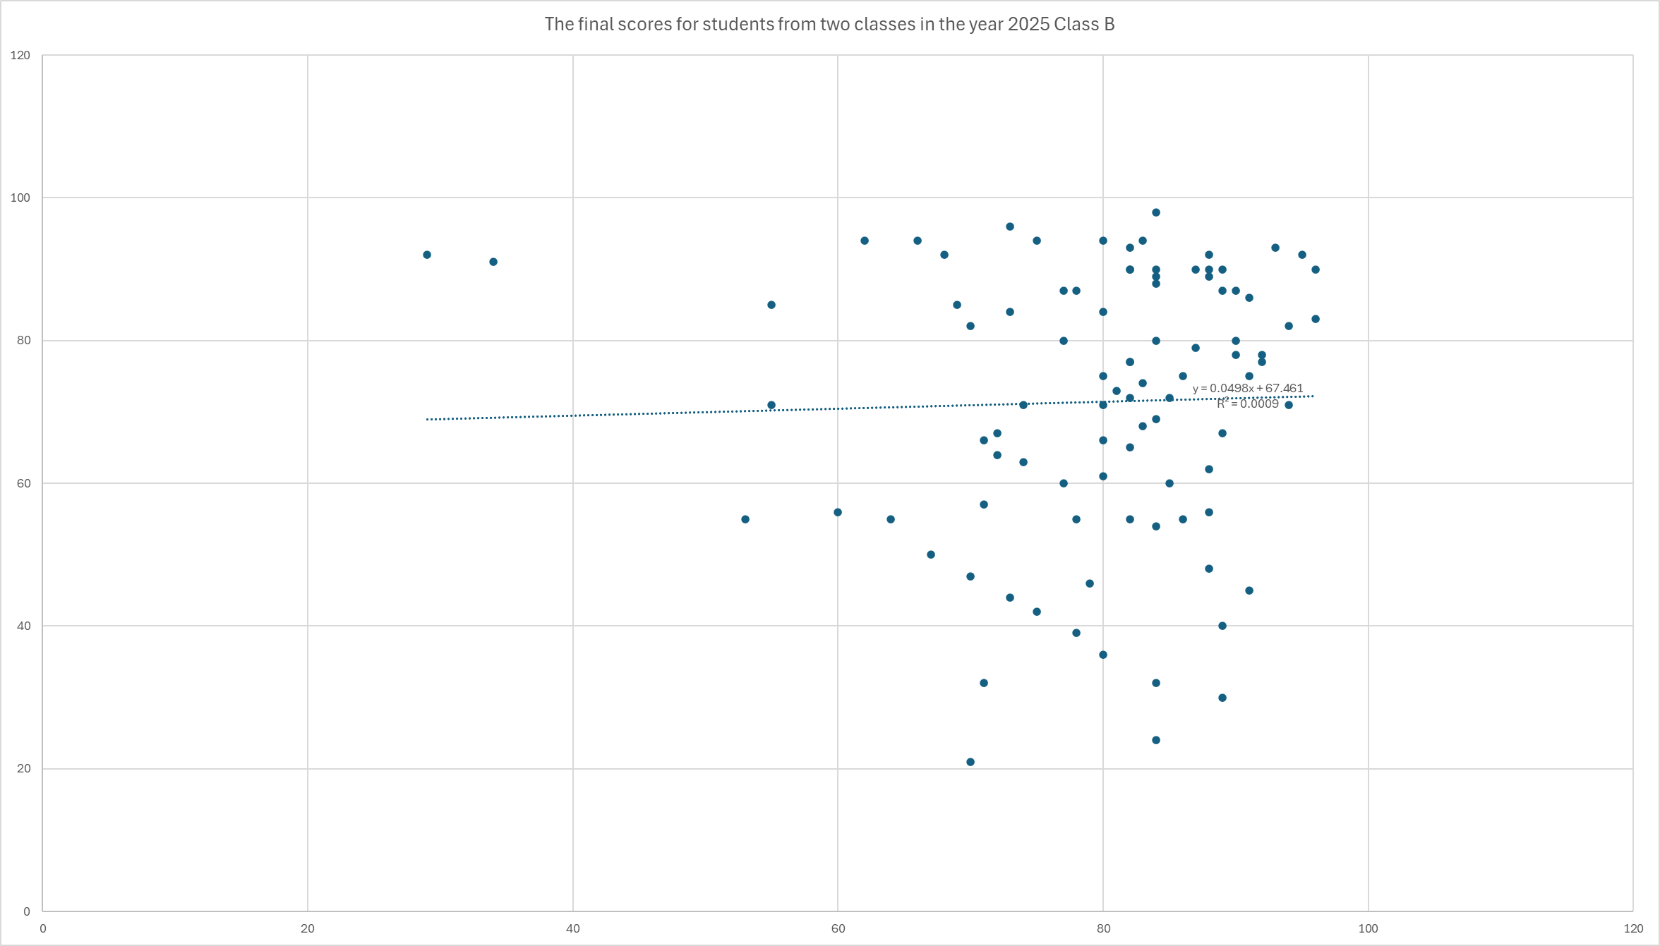
obey normal distribution

Based on the comprehensive analysis conducted in this lab, I believe that the normal probability plot is the most effective method for assessing normality. Its primary advantage lies in its ability to provide a direct and intuitive visual representation of how closely the data follows a normal distribution. Data points aligning closely along the straight reference line strongly suggest normality, while systematic deviations clearly indicate the nature and extent of the departure.
While descriptive statistics like skewness and kurtosis offer valuable numerical summaries, they can be significantly influenced by extreme values or outliers, potentially leading to misleading conclusions. A single outlier can drastically affect these measures. Similarly, graphical tools like histograms, though useful for visualizing shape, often involve a degree of subjective interpretation, especially with smaller sample sizes where bin choice can alter the apparent distribution.
Therefore, the normal probability plot strikes an optimal balance, combining visual clarity with objective assessment. It effectively mitigates the limitations of the other methods, making it the most reliable and informative technique for evaluating normality in a dataset.

