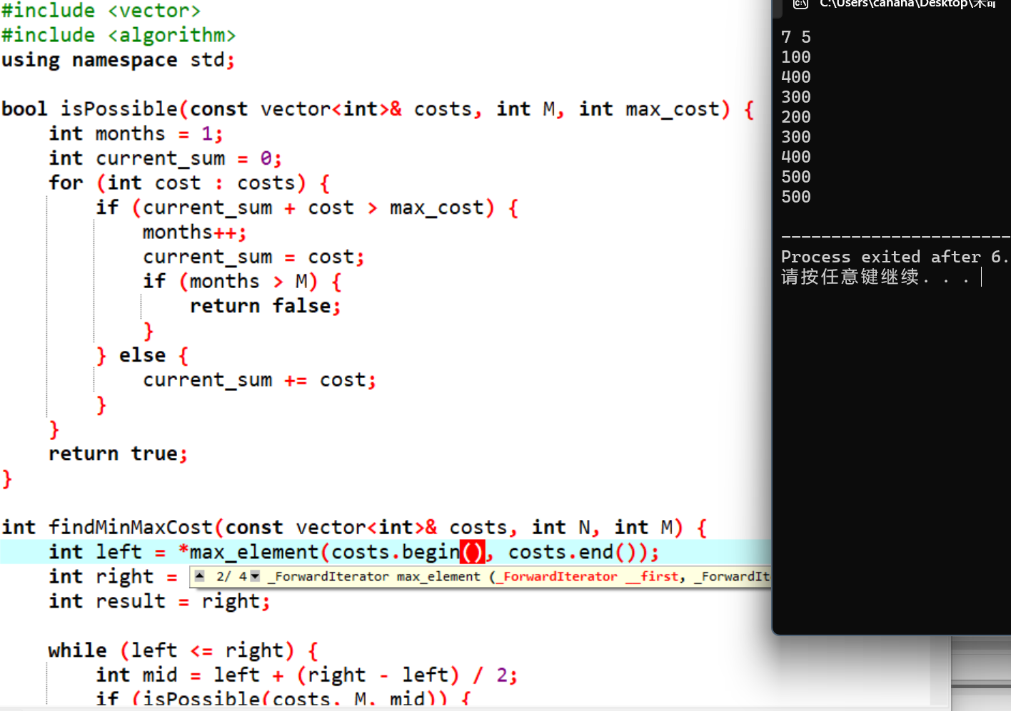
#include <iostream>
#include <vector>
#include <algorithm>
using namespace std;

bool isPossible(const vector<int>& costs, int M, int max_cost) {
int months = 1;
int current_sum = 0;
for (int cost : costs) {
if (current_sum + cost > max_cost) {
months++;
current_sum = cost;
if (months > M) {
return false;
}
} else {
current_sum += cost;
}
}
return true;
}

int findMinMaxCost(const vector<int>& costs, int N, int M) {
int left = *max_element(costs.begin(), costs.end());
int right = accumulate(costs.begin(), costs.end(), 0);
int result = right;

while (left <= right) {
int mid = left + (right - left) / 2;
if (isPossible(costs, M, mid)) {
result = mid;
right = mid - 1;
} else {
left = mid + 1;
}
}

return result;
}

int main() {
int N, M;
cin >> N >> M;
vector<int> costs(N);
for (int i = 0; i < N; ++i) {
cin >> costs[i];
}

int min_max_cost = findMinMaxCost(costs, N, M);
cout << min_max_cost << endl;

return 0;
}

