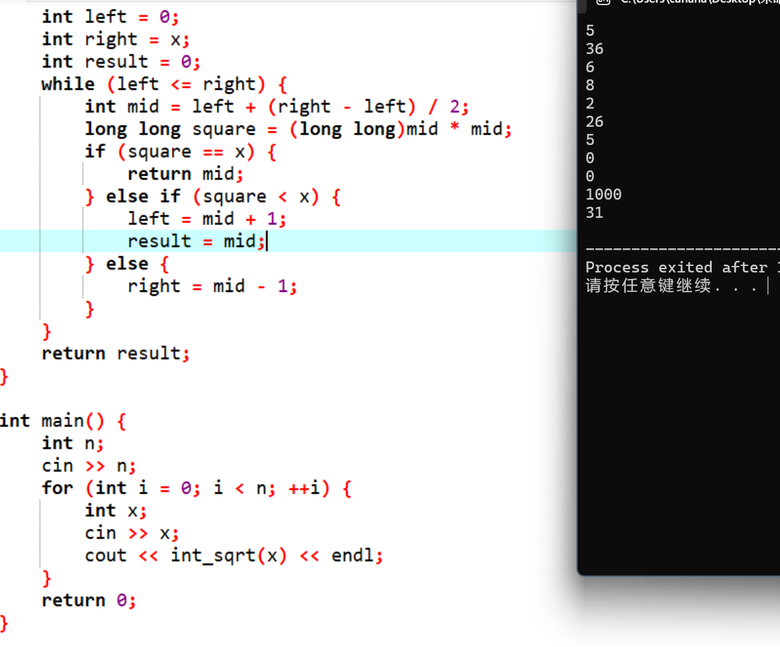
#include <iostream>
using namespace std;

int int_sqrt(int x) {
if (x == 0 || x == 1) {
return x;
}
int left = 0;
int right = x;
int result = 0;
while (left <= right) {
int mid = left + (right - left) / 2;
long long square = (long long)mid * mid;
if (square == x) {
return mid;
} else if (square < x) {
left = mid + 1;
result = mid;
} else {
right = mid - 1;
}
}
return result;
}

int main() {
int n;
cin >> n;
for (int i = 0; i < n; ++i) {
int x;
cin >> x;
cout << int_sqrt(x) << endl;
}
return 0;
}

