CSE 214 – Spring 2023
Recitation 10 (Graph) TA Version
1. [15 minutes] Graph Representations
Graph G:
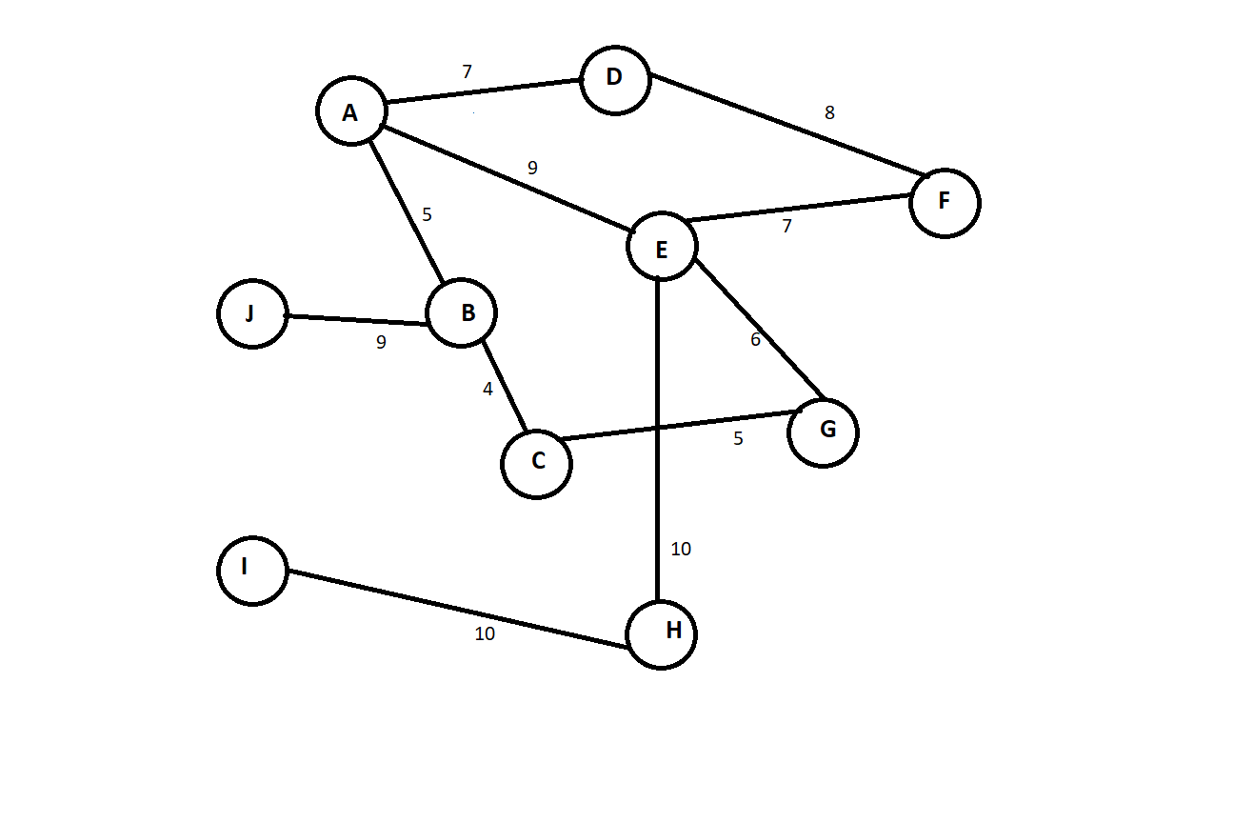
A) Write the adjacency matrix representation of the weights of the edges of Graph G, mark -1 for no connecting edge.
Graph G | A | B | C | D | E | F | G | H | I | J
A | -1 | 5 | -1 | 7 | 9 | -1 | -1 | -1 | -1 | -1
B | 5 | -1 | 4 | -1 | -1 | -1 | -1 | -1 | -1 | 9
C | -1 | 4 | -1 | -1 | -1 | -1 | 5 | -1 | -1 | -1
D | 7 | -1 | -1 | -1 | -1 | 8 | -1 | -1 | -1 | -1
E | 9 | -1 | -1 | -1 | -1 | 7 | 6 | 10 | -1 | -1
F | -1 | -1 | -1 | 8 | 7 | -1 | -1 | -1 | -1 | -1
G | -1 | -1 | 5 | -1 | 6 | -1 | -1 | -1 | -1 | -1
H | -1 | -1 | -1 | -1 | 10 | -1 | -1 | -1 | 10 | -1
I | -1 | -1 | -1 | -1 | -1 | -1 | -1 | 1- | -1 | -1
J | -1 | 9 | -1 | -1 | -1 | -1 | -1 | -1 | -1 | -1

CSE 214 – Spring 2023
Recitation 10 (Graph) TA Version
B) Construct the edge list for Graph G.
A: (B, 5) $→$ (D, 7) $→$ (E, 9)
B: (A, 5) $→$ (C, 4) $→$ (J, 9)
C: (B, 4) $→$ (G, 5)
D: (A, 7) $→$ (F, 8)
E: (A, 9) $→$ (F, 7) $→$ (G, 6) $→$ (H, 10)
F: (D, 8) $→$ (E, 7)
G: (C, 5) $→$ (E, 6)
H: (E, 10) $→$ (I, 10)
I: (H, 10)
J: (B, 9)

C) Given the following adjacency matrix, draw the corresponding unweighted directed graph.
Graph C | 1 | 2 | 3 | 4 | 5 | 6
1 | 0 | 1 | 1 | 0 | 0 | 0
2 | 0 | 0 | 0 | 1 | 0 | 0
3 | 1 | 0 | 0 | 0 | 0 | 0
4 | 0 | 0 | 0 | 0 | 1 | 1
5 | 0 | 0 | 0 | 0 | 0 | 0
6 | 1 | 0 | 0 | 0 | 1 | 0

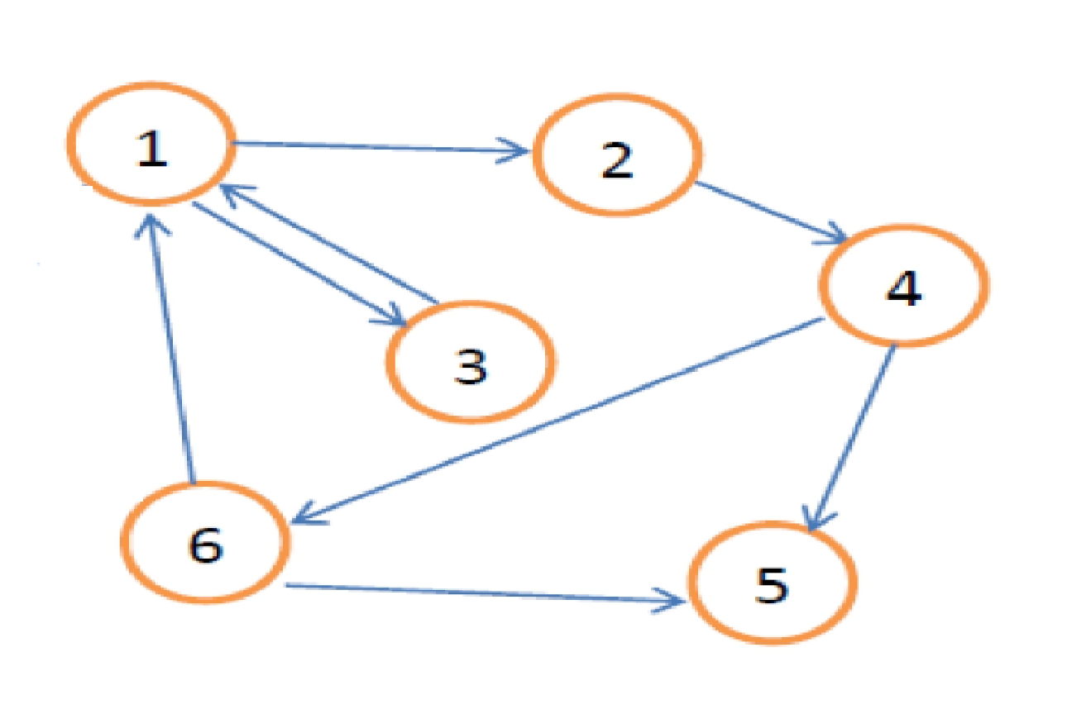

CSE 214 – Spring 2023
Recitation 10 (Graph) TA Version
2. [5 minutes] True/False
A) Given a graph with n vertices and m edges, the space complexity of an adjacency matrix is $O(nm).$
False, an adjacency matrix has n rows and n columns, so space complexity would be O$(n^{2})$.
B) For an undirected graph, the adjacency matrix is asymmetrical.
False, since connections are undirected, if A is connected to B, then B must be connected to A, and thus the adjacency matrix will be symmetrical.
C) It is faster to add or remove an edge on an adjacency matrix compared to an edge list.
True, we can check in $O(1)$ time if the edge exists using the adjacency matrix.
D) When representing a graph, an adjacency matrix is always more memory efficient than edge lists.
False, an edge list is the more memory efficient representation when the adjacency matrix is sparse.
E) Dijkstra’s shortest-path algorithm finds the path with the least number of edges from a source to every other vertex of a graph.
False, the algorithm finds the path of minimum total weight from a source node to every other node in the graph.

CSE 214 – Spring 2023
Recitation 10 (Graph) TA Version
3. [15 minutes] Graph Traversal
Graph T:
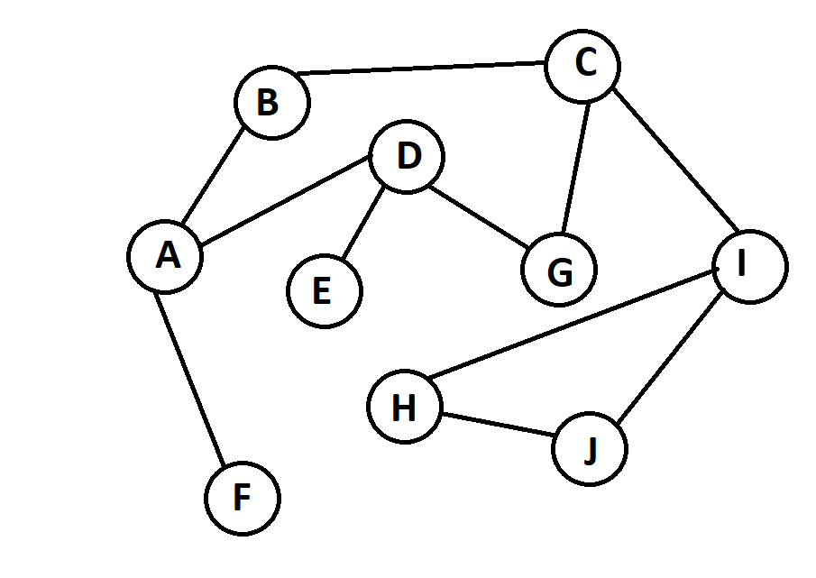
A) Perform breadth-first traversal on Graph T, begin with vertex A and vertex C.
Vertex A: A, B, D, F, C, E, G, I, H, J
Vertex C: C, B, G, I, A, D, H, J, F, E

B) Perform depth-first traversal on Graph T, begin with vertex D and vertex I.
Vertex D: D, A, B, C, G, I, H, J, F, E
Vertex I: I, C, B, A, D, E, G, F, H, J

CSE 214 – Spring 2023
Recitation 10 (Graph) TA Version
4. [10 minutes ] Dijkstra’s Shortest Path Algorithm given Graph D:
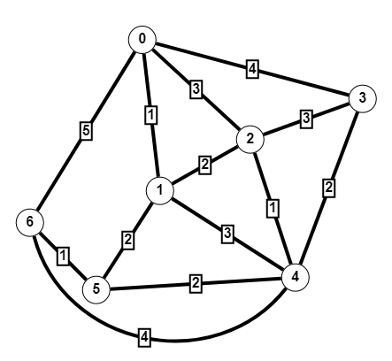
A) Simulate Dijkstra’s shortest path algorithm on Graph D with source vertex 6.
S | V-S | 0 | 1 | 2 | 3 | 4 | 5 | 6
{} | {0, 1, 2, 3, 4, 5, 6} | $$∞$$ | $$∞$$ | $$∞$$ | $$∞$$ | $$∞$$ | $$∞$$ | $$0$$
{6} | {0, 1, 2, 3, 4, 5} | $$5$$ | $$∞$$ | $$∞$$ | $$∞$$ | $$4$$ | $$1$$ | $$0$$
{6, 5} | {0, 1, 2, 3, 4} | $$5$$ | $$3$$ | $$∞$$ | $$∞$$ | $$3$$ | $$1$$ | $$0$$
{6, 5, 1} | {0, 2, 3, 4} | $$4$$ | $$3$$ | $$5$$ | $$∞$$ | $$3$$ | $$1$$ | $$0$$
{6, 5, 1, 4} | {0, 2, 3} | $$4$$ | $$3$$ | $$4$$ | $$5$$ | $$3$$ | $$1$$ | $$0$$
{6, 5, 1, 4, 0} | {2, 3} | $$4$$ | $$3$$ | $$4$$ | $$5$$ | $$3$$ | $$1$$ | $$0$$
{6, 5, 1, 4, 0, 2} | {3} | $$4$$ | $$3$$ | $$4$$ | $$5$$ | $$3$$ | $$1$$ | $$0$$

B) What is the shortest path from vertex 6 to vertex 3, and what is the total weight of that path?
Path: 6$→$5$→$4$→$3 Weight: 5
5. [10 minutes] Graph Traversal Application
Design an algorithm that returns true if there exists a path between two vertices in the graph.
boolean isReachable(Vertex src, Vertex dst)
{
// use breadth-first traversal to find a path from src to dst.
Queue<Vertex> bftQueue = new Queue<Vertex>();
src.visited = true;
bftQueue.enqueue(src);
Vertex curr;
while(!bftQueue.isEmpty())
{
curr = bftQueue.dequeue();
if(curr.equals(dst)) return true;
for(Vertex v : curr.getNeighbors())
{
if(!v.visited)
{
v.visited = true;
bftQueue.enqueue(v);
}
}
}
return false;
}

