CSE 214 – Spring 2023

Recitation 06 – Binary Trees

1. (5 minutes) Consider the following tree:
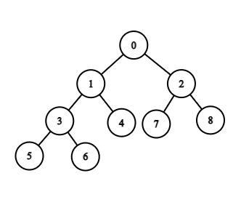
Pre: Current Node, Left Node, Right Node
In: Left Node, Current Node, Right Node
Post: Left Node, Right Node, Current Node
  - What is the in-order traversal of this tree?
5 3 6 1 4 0 7 2 8
  - What is the pre-order traversal of this tree?
0 1 3 5 6 4 2 7 8
  - What is the post-order traversal of this tree?
5 6 3 4 1 7 8 2 0

2. (5 minutes) Suppose we have the following results from performing a preorder traversal on a
binary search tree containing numeric keys
preorder: 45, 32, 11, 29, 64, 50
Construct a BST that is consistent with the above traversal
45
32 64
11 50
29
3. (5 minutes) Given the following traversals, construct the general binary tree and list the post-order traversal.
Inorder sequence: D B E A F C
Preorder sequence: A B D E C F
First listed in pre-order is the root of the tree. Everything to the left of the known root node in the in-order is known to be in the left subtree while everything to the right of the known root node is in the right subtree. Repeat this process for all subtrees that you come across.
A
/ \
/ \
B C
/ \ /
/ \ /
D E F
4. (10 minutes) Complete vs. Full Binary Trees
  - A complete binary tree is a binary tree in which every level of the tree has the maximum number of nodes possible except possibly the deepest level. Also, at the deepest level, the nodes are as far left as possible. What are the formulas for the maximum and minimum number of nodes and internal nodes in a complete binary tree of height h. Can you explain how you got the formulas?
Formulas can be derived from max # of nodes in complete binary tree of height h.
Formula for min # of nodes in a complete binary tree of height h: 2^h
Formula for max # of nodes in a complete binary tree of height h: 2^(h+1) - 1
Formula for min # of internal nodes in a complete binary tree of height h: 2^(h-1)
Formula for max # of internal nodes in a complete binary tree of height h: 2^h - 1
  - What is the minimum and maximum number of nodes in a complete binary tree with a height of 4?
Nodes: Min: 16 Max: 31
What is the minimum and maximum number of internal nodes(non-leaf nodes)?
Internal: min: 8 max: 15
(Ignore the number on each node, they don't necessarily represent the # of nodes.)
Minimum complete binary tree with a height of 4
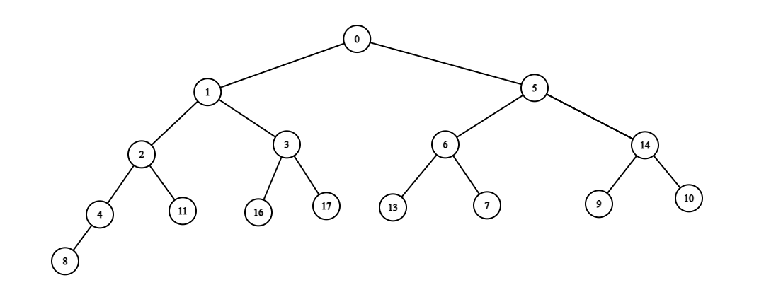
Maximum complete binary tree with a height of 4 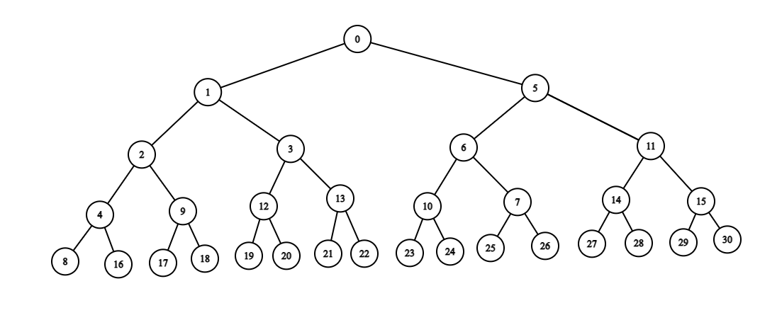
  - A full binary tree is a binary tree in which every non-leaf node has 2 children, and all leaves have the same depth. What is the minimum and maximum number of nodes in a full binary tree with a height of 4? What is the number of internal nodes(non-leaf nodes)? What is a full binary tree’s relation to a complete binary tree?
This is a maximum complete binary tree. Every full binary tree is a complete binary tree but not all complete binary trees are full binary trees.
31 nodes and 15 internal nodes

5. (15 minutes) Assume we have the following declared:
public class TreeNode {
int val;
TreeNode left;
TreeNode right;
TreeNode() {}
TreeNode(int val) { this.val = val; }
TreeNode(int val, TreeNode left, TreeNode right){
this.val = val;
this.left = left;
this.right = right;
}
}
Given a root node, write function(s) that allow us to validate whether the Tree is a valid BST
public boolean isValidBST(TreeNode root) {
if (root == null) return true;
return depthFirst(root, null, null);
}

private boolean depthFirst(TreeNode root, Integer min, Integer max) {
if (root == null) return true;

if ((min != null && root.val <= min) || max != null && root.val >= max) {
return false;
}

return dfs(root.left, min, root.val) && dfs(root.right, root.val, max);
}

Public boolean isValidBST(TreeNode root){
If (root == null) return true
If (root.left == null && root.right != null)
Return (root.val < right.val) && isValidBST(root.right)
If (root.left != null && root.right == null)
Return (root.val > left.val) && isValidBST(root.left)
If (root.left != null && root.right != null)
Return (root.val > left.val) && (root.val < right.val) && isValidBST(root.left) && isValidBST(root.right)

}//this is wrong!!!!

Public boolean isBST(TreeNode root){
If root == null || root.left == null && root.right == null return true;
If root.left == null && root.right != null
Return isBST(root.right) && root.val <root.right.getleftmostdata();
If root.left != null && root.right == null
Return isBST(root.left) && root.val >root.left.getleftmostdata();
If root.left != null && root.right != null
Return isBST(root.right) && root.val <root.right.getleftmostdata() && isBST(root.left) && root.val >root.left.getleftmostdata();
}//the correct version
6. (15 minutes) Assume we have the following declared:
public class TreeNode {
int val;
TreeNode left;
TreeNode right;
TreeNode{}
TreeNode(int val) { this.val = val; }
TreeNode(int val, TreeNode left, TreeNode right){
this.val = val;
this.left = left;
this.right = right;
}
}
Given a sorted array, write function(s) to convert that array into a BST (return the root node).
public TreeNode arrayToBST(int[] nums) {
return builder(nums, 0, nums.length - 1);
}

public TreeNode builder(int[] nums, int start, int end) {
if (start > end) {
return null;
}
int mid = (start + end) / 2;
TreeNode root = new TreeNode(nums[mid]);
root.left = builder(nums, start, mid - 1);
root.right = builder(nums, mid + 1, end);
return root;
}
}

