CSE214 Spring 2023

Recitation 7: More on Binary Trees (TA Version)

- Fill in the table below for a binary search tree:
Algorithm | Worst Case Complexity | Average Complexity
Search | O(n) | O(logn)
Insert | O(n) | O(logn)
Delete | O(n) | O(logn)

Give an example of a BST for which these worst case times could occur.
The worst case would occur when the binary search tree is a linked list.
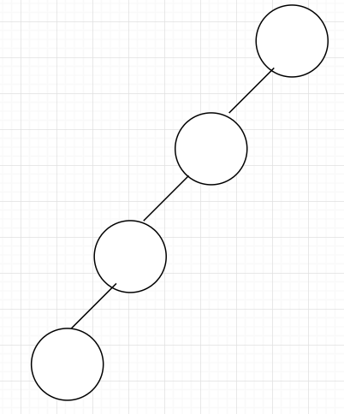

2. Given the following definition of a Node, write a method that searches a binary search tree for a node with a given target key.

public class Node {
int key;
Node left;
Node right;
public Node (int key, Node left, Node right){
this.key = key;
this.left = left;
this.right = right;
}
}

public Node search (Node root, int target){
// TODO
}

Answer starts here

public Node search (Node root, int target){
if (root == null) return null; // 1
if (root.key == target) return root; // 2
if (root.key > target) return search(root.left, target); // 3
else return search(root.right, target); // 4
}

1. Base case 1
2. Base case 2
3. If our current node’s key is greater than target, search the left subtree
4. Otherwise search the right subtree

Time Complexity: O(H) where H is the height of the tree.
This results in O(N) in the worst case, and O(log N) in the average case.

3. Given the following definition of a Node, write a method that takes the root of two binary trees and determines if they are the same tree. Two trees are the same if they have the identical structure and the nodes have the same key.

public class Node {
int key;
Node left;
Node right;
public Node (int key, Node left, Node right){
this.key = key;
this.left = left;
this.right = right;
}
}

public boolean isSameTree (Node tree1, Node tree2){
// TODO
}

Answer starts here

public boolean isSameTree (Node tree1, Node tree2){
if (tree1 == null && tree2 == null) return true; // 1
if (tree1 == null || tree2 == null) return false; // 2
if (tree1.key != tree2.key) return false; // 3
return isSameTree(tree1.left, tree2.left) && isSameTree(tree1.right, tree2.right); // 4
}

1. Base case 1: If two trees are null, they are the same
2. Base case 2: If only one of the trees are null, they are not the same
3. If the root of two trees do not have the same value, they are not the same.
4. Check if the left subtrees of both trees are the same and if the right subtrees of both trees are the same.

Time Complexity: O(n) where n is the total number of nodes in the tree because we only traverse the given tree once.

4. Given the following definition of a Node, write a method that takes the root of a binary tree and determines if it is symmetrical. Note: A symmetric tree is a tree that is symmetric around its center

public class Node {
int key;
Node left;
Node right;
public Node (int key, Node left, Node right){
this.key = key;
this.left = left;
this.right = right;
}
}

public boolean isSymmetric (Node root){
// TODO
}

Answer starts here

To check if a tree is symmetric, we can check if the left subtree is a mirror reflection of the right subtree. Two trees are a mirror reflection of each other if the two following conditions are true:
1. Their roots have the same key/value
2. For each tree, the left subtree is a mirror reflection of the right subtree of the other tree (The other case must be true. i.e., The right subtree must be a mirror reflection of the left subtree of the other tree)

public boolean isSymmetric (Node root){
return isMirror(root.left, root.right)
}

public boolean isMirror (Node tree1, Node tree2){
if (tree1 == null && tree2 == null) return true; // 1
if (tree1 == null || tree2 == null) return false; // 2
if (tree1.key != tree2.key) return false; // 3
return isMirror(tree1.left, tree2.right) && isMirror(tree1.right, tree2.left) // 4
}

Comments for the isMirror function.
1. Base case 1: If two subtrees are null, then they are mirrors of each other.
2. Base case 2: If only one subtree is null, then they are not mirrors.
3. Condition 1
4. Condition 2

Time Complexity: O(n) where n is the total number of nodes in the tree because we only traverse the given tree once.

5a. Draw the binary search tree that is created if the following numbers are inserted in the tree in the given order: [10, 48, 22, 13, 90, 27, 21, 45, 12].

10
\
48
/ \
22 90
/ \
13 27
/ \ \
12 21 45

5b. Draw the balanced BST containing the same numbers in part (a)

22
/ \
13 48
/ \ / \
10 21 27 90
\ \
12 45

6. If a node stores data up to 10 bytes and a reference requires 2 bytes, how much space would a full binary tree of height h take up? What about a full binary tree of height 2.

Number of leaf nodes: $2^{h}$
Number of internal nodes: $2^{h}-1$
Total number of Nodes: $2^{h+1}-1$
Number of references:$2\left(2^{h+1}-1\right)= 2^{h+2}-2$
Space for nodes: 10 * ($2^{h+1}-1$)
Space for references: 2*($2^{h+2}-2$)
Total Space: 10 * ($2^{h+1}-1$) + 2 * ($2^{h+2}-2$)
Plug in h=2 to the formula above to get 10*7 + 2*14 = 98

7. True or False
a) Every binary tree is either complete or full
FALSE: Binary tree with children only on one side, creating linked list type of tree
b) Every complete binary tree is also a full binary tree.
FALSE: Binary tree with leaves on the lowest level that are not left-aligned.
c) The maximum number of binary trees that can be formed with 3 nodes is 5 TRUE
a a a a a
/ \ / \ / \
B b b c b b
/ \ \ /
C c c c

8. Consider the two following trees. Which of the following is true?
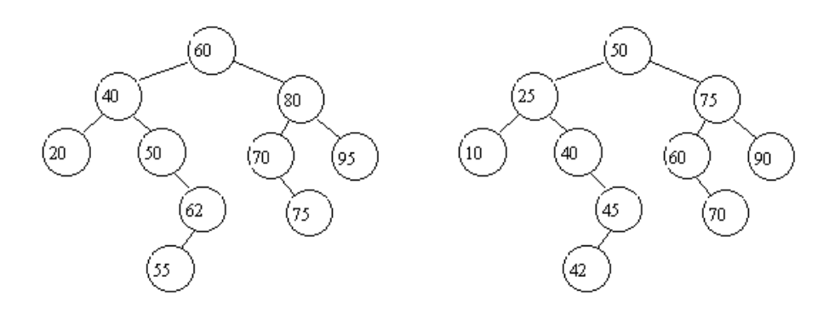

a) Both trees are binary search trees
b) Only the left tree is a binary search tree
c) Only the right tree is a binary search tree
d) Neither trees are binary search trees

The correct choice is c) only the right tree is a binary search tree. In the left tree, the node with value 62 makes the tree not a binary search tree because 62 is smaller than the root, 60.

