Recitation 8 Spring 2023 (TA Version)
Heaps, B-Trees, Red-Black Trees
1. [5 minutes] True/False
1. In a 2-3-4 Tree, insertion can be performed on any node so long as the other nodes are adjusted accordingly
FALSE – Insertion can only be performed on leaf nodes. Even if there are empty spaces on internal nodes, we don’t insert data there.
2. Deleting the highest priority element and reorganizing the heap will only take O(log n) time.
TRUE - Deleting the top element of the heap or the highest priority element, and then organizing the heap and returning the element has time complexity O(log N).
3. A red-black tree may have all red nodes.
FALSE – While we can have a red-black tree that has all black nodes if the root only has two leaf children, we cannot have an all red tree. The root must be black, therefore we cannot have an all red tree.

4. The following array is a max-heap:
Int maxHeap[] = {10,5,3,4,1};
TRUE - The greatest value is the root, which can be found at index 0. The left child, 5, is found at index 2*i+1 = 1, with i being the current node (in this case the root). The right child, 3, is found at index 2*i+2 = 2. The children of 5 are found at indexes 3 and 4, following the right and left children pattern. Thus, it is a correct max-heap.

2. [5 minutes] Short Answer
1. What are the steps for Depth-First Traversal in a Binary Tree?
At Node N,
- Recursively traverse the left subtree.
- Recursively traverse the right subtree.
- Visit the node N itself

2. Consider an R-B tree with a black height of 5. In any given path from root to leaf, give both the minimum and maximum amount of total nodes within the path (Root = 1 Node, Leaf = 1 Node).
Maximum is just the maximum height + 1
Minimum is least possible black height + 1
Minimum = 6, Maximum = 12.

3. [5 minutes] What is the max height of a Red-Black Tree with 6 nodes? Draw an example of this Red-Black Tree.
The maximum height is log(6+1) = ~2.8 = 2

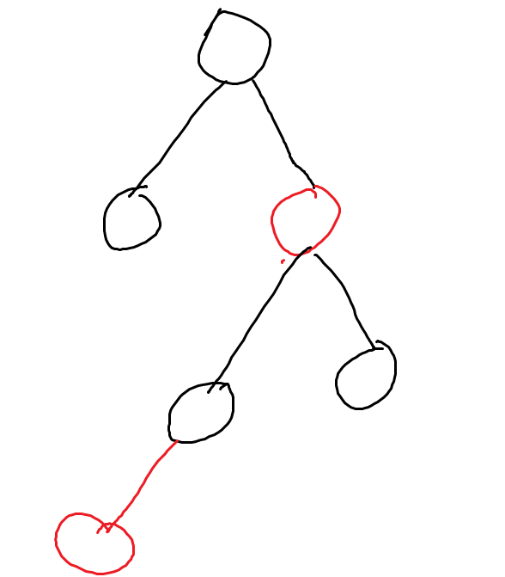
4. [7 minutes] Insert 2, 1, 4, 5, 9, 3, 6, 7 into an initially empty red-black tree
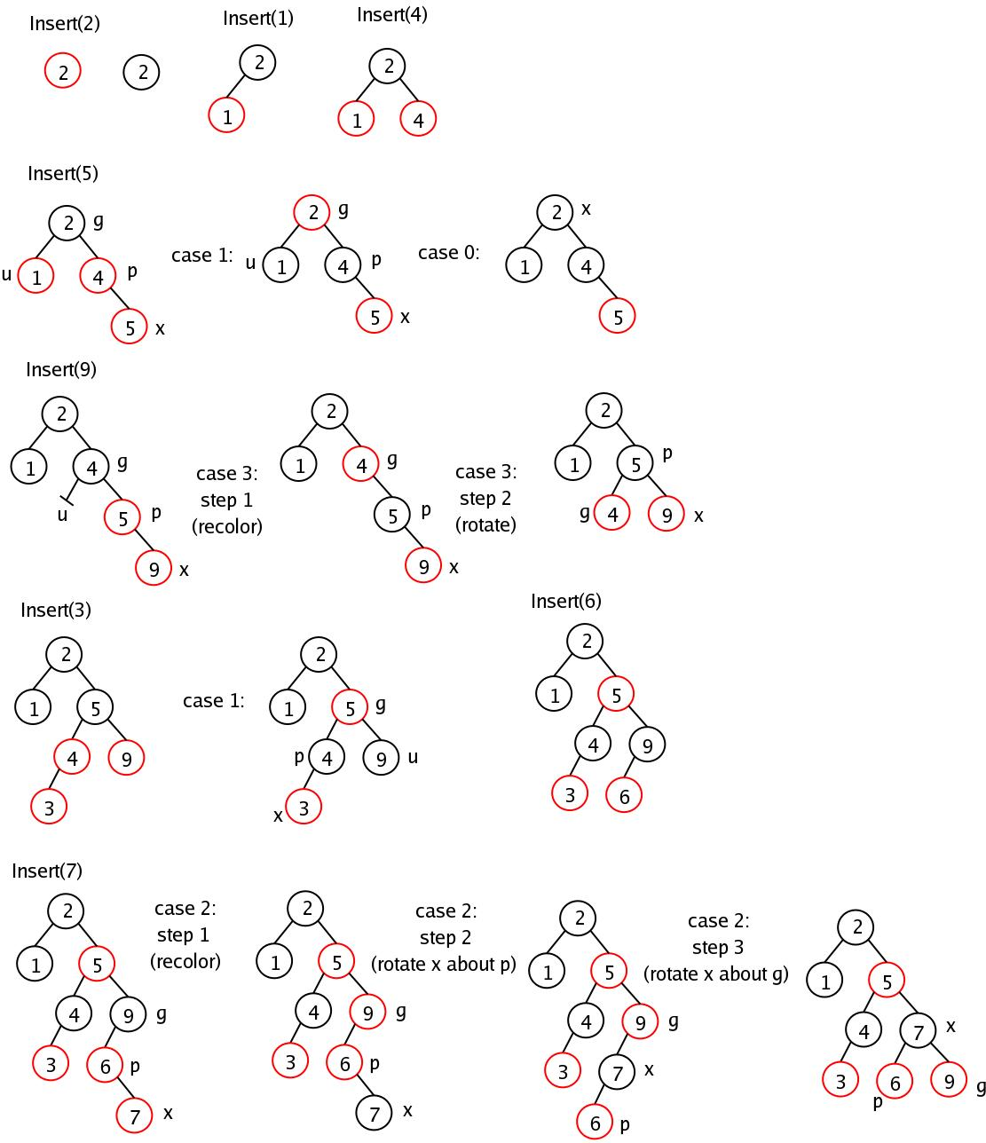

5. [15 minutes] Write a recursive function to check whether or not a given tree represents a max heap. You are permitted to use the following methods: getLeftChild(), getRightChild(), getData(). Use the following function declaration and assume the first call will pass in the root for the Node argument and -1 for the parentData argument.
public boolean isHeap(Node root, int parentData){
if(parentData == -1){
return (isHeap(root.getLeftChild(), root.getData()) &&
(isHeap(root.getRightChild(),root.getData());
}
if(root == null){
return true;
}
else if(root.getData() > parentData){
return false;
}
else{
return (isHeap(root.getLeftChild(), root.getData()) &&
(isHeap(root.getRightChild(),root.getData());
}
}
6. [5 minutes] Show what happens after removing 15 from this 2-3-4 tree. (change)
[15, 30]
/ | \
[10,11,13] [25] [50]

[13,30]
/ | \
[10,11] [25] [50]
7. [10 Minutes] Fill in the chart below with the worst-case time complexity for each of the following operations:

 | Search | Insert | Delete
B-Trees | O(log n) | O(log n) | O(log n)
AVL Tree | O(log n) | O(log n) | O(log n)
Red Black Tree | O(log n) | O(log n) | O(log n)
 | Peek | Push | Pop
Heap | O(1) | O(log n) | O(log n)

