1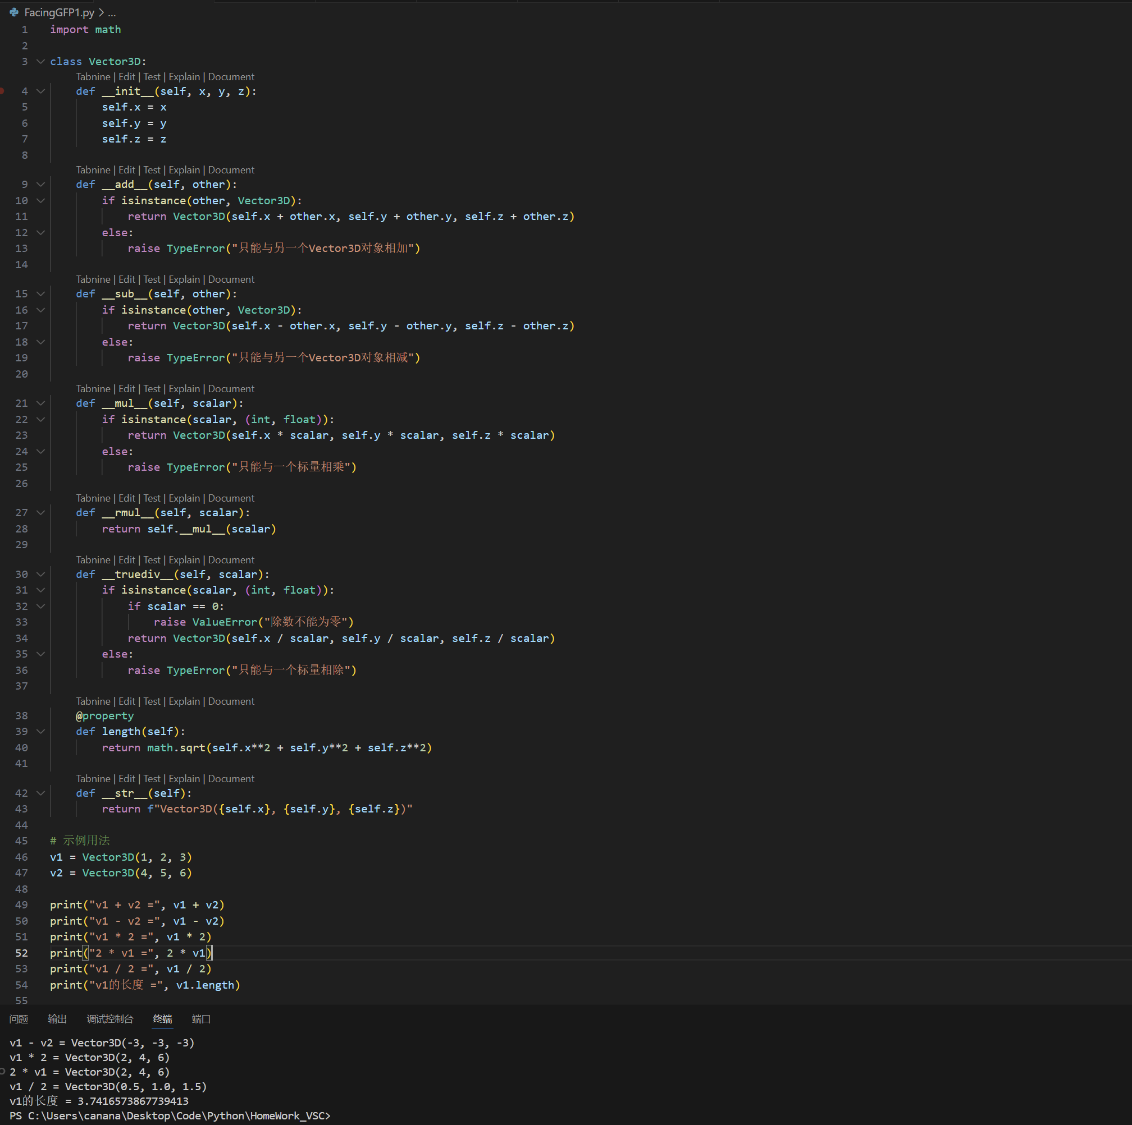
2.
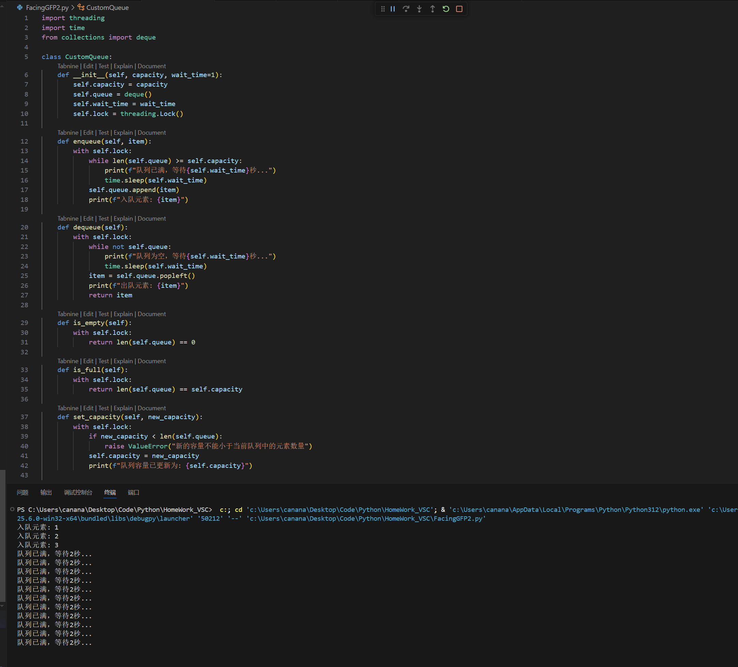

import threading
import time
from collections import deque

class CustomQueue:
def __init__(self, capacity, wait_time=1):
self.capacity = capacity
self.queue = deque()
self.wait_time = wait_time
self.lock = threading.Lock()
def enqueue(self, item):
with self.lock:
while len(self.queue) >= self.capacity:
print(f"队列已满，等待{self.wait_time}秒...")
time.sleep(self.wait_time)
self.queue.append(item)
print(f"入队元素: {item}")

def dequeue(self):
with self.lock:
while not self.queue:
print(f"队列为空，等待{self.wait_time}秒...")
time.sleep(self.wait_time)
item = self.queue.popleft()
print(f"出队元素: {item}")
return item
def is_empty(self):
with self.lock:
return len(self.queue) == 0
def is_full(self):
with self.lock:
return len(self.queue) == self.capacity
def set_capacity(self, new_capacity):
with self.lock:
if new_capacity < len(self.queue):
raise ValueError("新的容量不能小于当前队列中的元素数量")
self.capacity = new_capacity
print(f"队列容量已更新为: {self.capacity}")
def __len__(self):
with self.lock:
return len(self.queue)
def __str__(self):
with self.lock:
return f"CustomQueue({list(self.queue)}), 容量: {self.capacity}"
# 示例
if __name__ == "__main__":
queue = CustomQueue(capacity=3, wait_time=2)
# 创建入队线程
enqueue_thread = threading.Thread(target=queue.enqueue, args=(1,))
enqueue_thread2 = threading.Thread(target=queue.enqueue, args=(2,))
enqueue_thread3 = threading.Thread(target=queue.enqueue, args=(3,))
enqueue_thread4 = threading.Thread(target=queue.enqueue, args=(4,))
# 创建出队线程
dequeue_thread = threading.Thread(target=queue.dequeue)
dequeue_thread2 = threading.Thread(target=queue.dequeue)
# 启动线程
enqueue_thread.start()
enqueue_thread2.start()
enqueue_thread3.start()
enqueue_thread4.start()
dequeue_thread.start()
dequeue_thread2.start()

# 等待所有线程完成
enqueue_thread.join()
enqueue_thread2.join()
enqueue_thread3.join()
enqueue_thread4.join()
dequeue_thread.join()
dequeue_thread2.join()
print("当前队列状态:", queue)

