- From the figure on the right, which of the following statements is correct. ( B )
- The direction of electric field is from M to N.
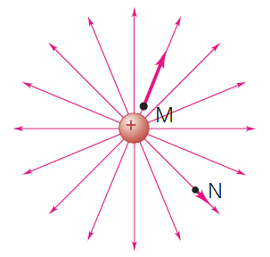
- The magnitude of electric field: E_{M}>E_{N}.
- The magnitude of electric field: E_{M}<E_{N}.
- None of the above is correct.

- Two charged parallel sheets in vacuum as shown in figure, the amount of charges is Q and the area of sheet is A, the magnitude of electric field between the two sheets is.

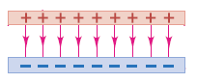
( $\frac{Q}{ε_{0}A}$ )
Electric charge is distributed uniformly along an infinitely long, thin wire. The charge per unit length is λ (assumed positive). The electric field E is. ( A )

- $\frac{λ}{2πε_{0}r}$ B. $\frac{λ}{2πε_{0}r^{2}}$ C.$\frac{λ}{4πε_{0}r^{2}}$ D.$0$
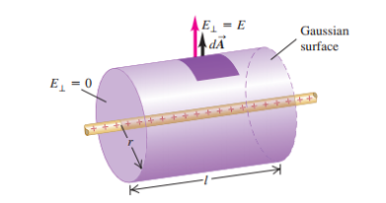
3. To find a relationship between at any point on the surface and the perpendicular component of the electric field at that point, we construct a Gaussiansurface in the form of a small cylinder. One end face, with arealies within the conductor and the other lies just outside. The electric field E1, E2 and E3 is respectively. ( C )
E2
E1
- 0, $\frac{σ}{2ε_{0}}$, 0 B. $\frac{σ}{2ε_{0}}$, 0, 0
C. $\frac{σ}{ε_{0}}$, 0, 0 D. 0, $\frac{σ}{ε_{0}}$, 0
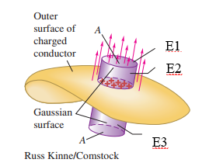
E3
4.There are two infinitely charged parallel sheets with different surface charge density as shown in figure, the magnitude of electric field of I region, II region.
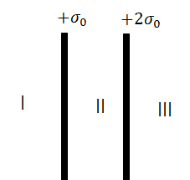
5.A disk with radius 0.2m is oriented with its normal unit vector $\hat{n}$at an angle of 30° to a uniform electric field $\overset{⃑}{E}$ with magnitude 3.0×10³ N/C, the electric flux through the disk. If you can tune the angle of the disk and uniform electric field, the maximum electric flux through the disk.
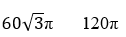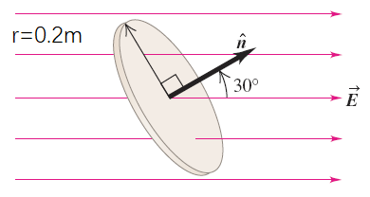
6.A ring-shaped conductor with radius a carries a total charge Q uniformly distributed around it. Find the electric field at a point P that lies on the axis of the ring at a distance x from its center.

We divide the ring into infinitesimal segments ds, the charge in a segment of length ds is dQ = λds.
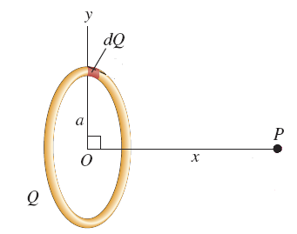
Hence the magnitude of this segment’s contribution $d\vec{E }$to the electric field at is
To find E_{x} we integrate this expression over the entire ring—that is, for s from 0 to 2πa (the circumference of the ring). The integrand has the same value for all points on the ring, so it can be taken out-side the integral. Hence we get

A small conducting spherical shell with inner radius a and outer radius b is concentric with a larger conducting spherical shell with inner radius c and outer radius d. the inner shell has total charge +3q, and the outer shell has charge +6q.
(1) Calculate the electric field (magnitude and direction) in terms of q and distance r from the common center of the two shells in the whole space.
(2) what is the total charge on the four surfaces of two shells.
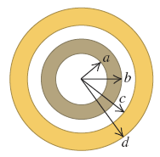
- (1)
The total charge on the inner surface of the inner shell:
Q=0
The total charge on the outer surface of the inner shell:
Q=3q
The total charge on the inner surface of the outer shell:
Q=-3q
The total charge on the outer surface of the outer shell:
Q=9q

