- Which of the following formula about magnetic field of a moving charge is correct?
( )
A. $\frac{μ_{0}}{4π}\frac{q\vec{v}×\hat{r}}{r^{2}}$ B. $\frac{μ_{0}}{4πε_{0}}\frac{q}{r^{2}}$ C. $\frac{μ_{0}}{4π}\frac{\vec{v}×\hat{r}}{r}$ D. $\frac{q}{4πε_{0}}\frac{\vec{v}×\hat{r}}{r}$
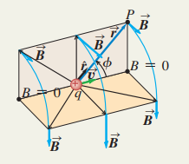
- Suppose the long solenoid in Figure has n turns per meter and cross-sectional area A. The current in its windings is increasing at dI/dt. Find the magnitude of the induced emf in the wire loop outside the solenoid.
( )
A. ${−μ}_{0}nAI$
B.${ −μ}_{0}nA\frac{dI}{dt}$
C. $nA\frac{dI}{dt}$
D.${−μ}_{0}A\frac{dI}{dt}$
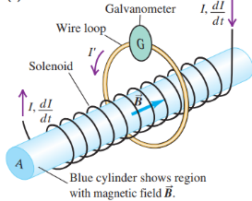
- An important experimental device that uses interference is the Michelson interferometer. If we now move the mirror M₂ slowly backward. The moved distance is y. The light wavelength used in this experimental device is λ. The number of fringes cross the crosshairs is
( )
A. 2y/λ B. y/λ
C. yλ D. 2yλ
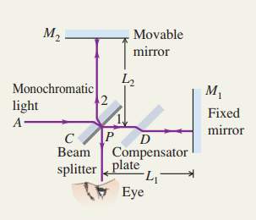
- The intensity of the light transmitted through the analyzer can be obtained by Malus’s law. An incident unpolarized light has intensity I₀. Find the intensities of this light transmitted by the first and second polarizers if the angle between the axes of the two filters is$ϕ$.
( )
A. (I₀/2)cos²$ϕ$ B. I₀ cos$ϕ$
C. (I₀/2) sin²$ϕ$ D. I₀ sin$ϕ$

- What cannot generate magnetic field below.
( )
A. moving charge B. current
C. magnet D. constant electrical field

- Sunlight reflects off the smooth surface of a swimming pool. For what angle of reflection $θ_{p}$is the reflected light completely polarized.
( )
A. arctan$\frac{n_{b}}{n_{a}}$ B. arcsin$\frac{n_{b}}{n_{a}}$
C. arctan$\frac{n_{a}}{n_{b}}$ D. arcsin$\frac{n_{a}}{n_{b}}$
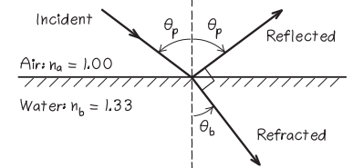
- Suppose the long of moving rod L, the velocity v, total resistance of the loop R and magnetic field B is given in Figure. Find the motional emf, the induced current, and the force acting on the rod.
( )
A. vBL, vBL/R, vB²L²
B. vBL, BL/R, vB²L²/R
C. vBL, vBL/R, vB²L²/R
D. vB, vBL/R, vB²L²/R
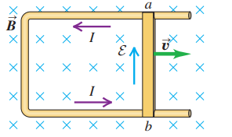

- The magnitude of magnetic field B at the center of circular loops is
( )
A. $\frac{μ_{0}I}{a}$ B. $\frac{μ_{0}I}{4a}$
C. $\frac{μ_{0}I}{2r^{2}}$ D. $\frac{μ_{0}I}{2a}$
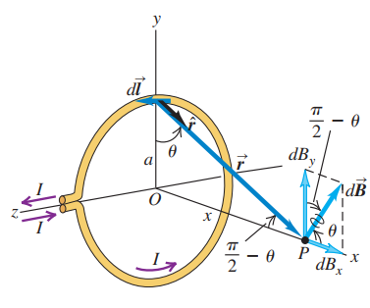
- Faraday’s law states that the induced emf in a closed loop equals the negative of the time rate of change of magnetic flux through the loop. Seen from Figure, which of the following statement is correct?
( )
A. When the magnet remains stationary, there is current in the coil.
B. No matter how the magnet moves, there is no current in the coil.
C. The magnet’s motion causes a changing magnetic field through the coil, inducing a current in the coil.
D. The movement of the magnet could not cause a changing magnetic field through the coil.
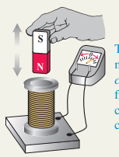

- Figure shows, in cross section, several conductors that carry currents through the plane. The currents have the magnitudes I₁, I₂ and I₃ and the directions shown. Four paths, labeled a, b, c and d, are shown. Each integral involves going around the path in the counterclockwise direction. The line integral $\oint{\vec{B}∙d\vec{l}}$for a, b, c and d path is
( )
A. 0, - μ₀I₁, μ₀(I₂ - I₁), μ₀(I₂ + I₃ - I₁)
B. 0, μ₀I₁, μ₀(I₁ - I₂), μ₀(I₁ - I₂ - I₃)
C. μ₀(I₁ + I₂ + I₃), μ₀I₁, μ₀(I₁ - I₂), μ₀(I₁ - I₂ - I₃)
D. μ₀(I₁ - I₂ - I₃), μ₀I₁, μ₀(I₁ - I₂), μ₀(I₁ - I₂ - I₃)
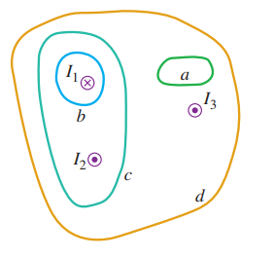

- A cylindrical conductor with radius R carries a current I. The current is uniformly distributed over the cross-sectional area of the conductor. The magnetic field as a function of the distance r from the conductor axis for points both inside (r < R) and outside (r > R) the conductor are and .
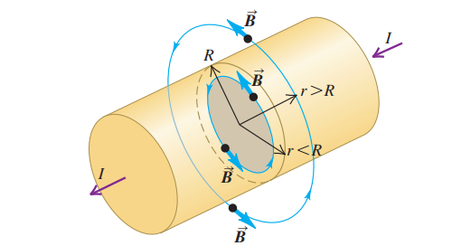

- Figure shows a doughnut-shaped toroidal solenoid, tightly wound with N turns of wire carrying a current I. In a practical solenoid, the turns would be much more closely spaced than they are in the Figure. The magnitude of the magnetic field at path 2 is , corresponding direction is (clockwise or counterclockwise).
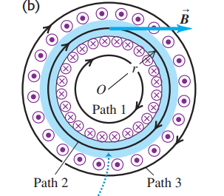
- The wavelength of a light is 808 nm in air. The wavelength of the light in water is . And the speed of the light in water is (The index of refraction in water is 1.33).
- Figure shows a two-slit interference experiment. If a thin glass sheet is added behind the slit S₁, the central bright fringe will move (up or down) . If the light source S move up, the central bright fringe will move (up or down) .
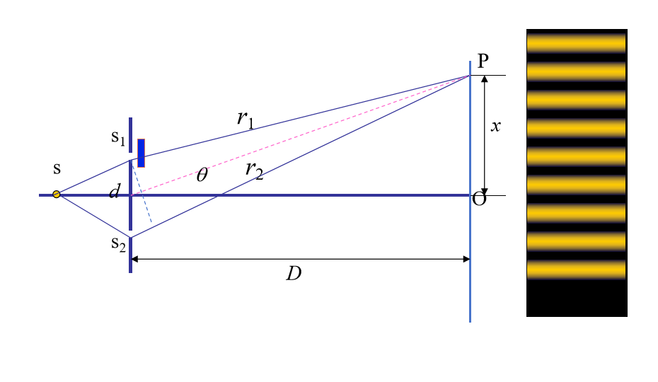
- A 100-loop circular wire coil with radius 4.00 cm is placed between the poles of a large electromagnet. The magnetic field is uniform and makes an angle of 60º with the plane of the coil; it decreases at 0.500 T/s. The magnitude of the induced emf is . If you viewed the coil from the left in Figure and looked in the direction of $\vec{A}$. The direction of the induced emf is (clockwise or counterclockwise).
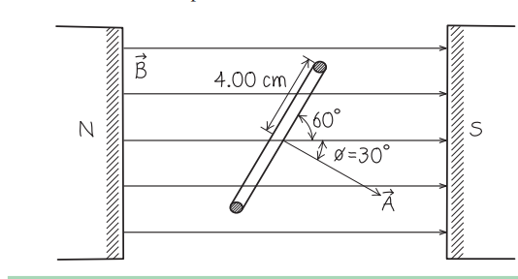

- A thin conductor wire ABCD with infinite length carries current I. BC section is bent into a semi-circular ring with a radius of R. CD section is perpendicular to the plane where the semicircle is located. The extension line of AB passes through points O (center of the circle) and C. Find the magnitude of magnetic field$\overset{⃑}{B}$ at point O?

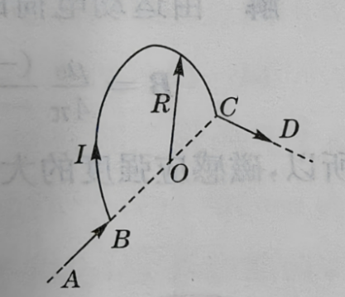

- A copper rod OP with a length of L rotate counterclockwise at angular velocity ω around its fixed end O in a uniform magnetic field. The copper rod is perpendicular to the magnetic field.
(a) Find the magnitude of the induced emf?
(b) Which point, O or P, is at higher potential?

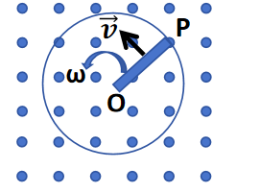

- The magnetic field at all points within a circular region of radius R, is uniform in space and directed into the plane of the page as shown in Figure. (The region could be a cross section inside the windings of a long, straight solenoid.) The magnetic field is increasing at a rate dB/dt. Point a is a distance r above the center of the region, point b is a distance r to the right of the center, and point c is at the center of the region.
(a) What are the magnitude and direction of electric field at points a, b, and c?
(b) What are the magnitude and direction of force on a stationary positive point charge q located at points a, b, and c?

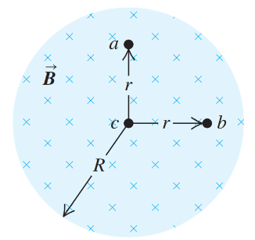

- The long, straight wire shown in Figure carries constant current I. A metal bar with length L is moving at constant velocity as shown in the Figure. Point a is a distance d from the wire.
(a) Calculate the emf induced in the bar.
(b) Which point, a or b, is at higher potential?

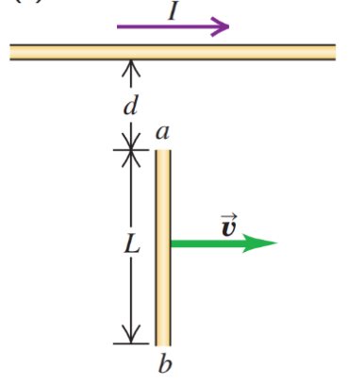

- Figure shows a two-slit interference experiment in which the slits are 0.200 mm apart. The wavelength of the light is 633 nm. The bright fringe m = 1 in the figure is 3.165 mm from the central fringe m = 0.
(a) Find the distance R between the screen and the slits.?
(b) If the wavelength of the light is 316.5 nm, find the distance between bright fringe m = 1 and the central fringe?

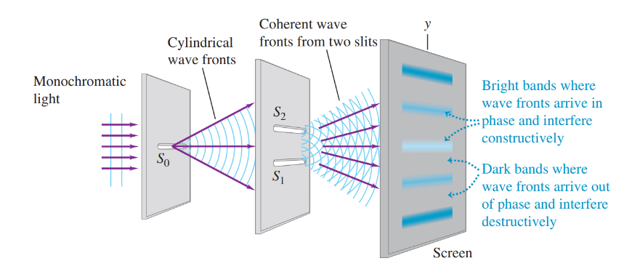
d=0.200 mm
m=0
m=-1
m=1
R=？

- Two beams of light with wavelength of λ₁ = 500 nm and λ₂ = 700 nm pass through a slit a = 0.200 mm wide. The diffraction pattern is observed on a screen x = 5.00 m away. Define the width of a bright fringe as the distance between the minima on either side.
(a) What is the width of the central bright fringe corresponding λ₁ = 500 nm?
(b) What is the width of the central bright fringe corresponding λ₂ = 700 nm?
(c) In the diffraction pattern, the bright fringe m = k₁ corresponding λ₁ = 500 nm and the bright fringe m = k₂ corresponding λ₂ = 700 nm are in the same position. Find the minimum k₁ and k₂ values (k₁ > 0 and k₂ > 0).
b
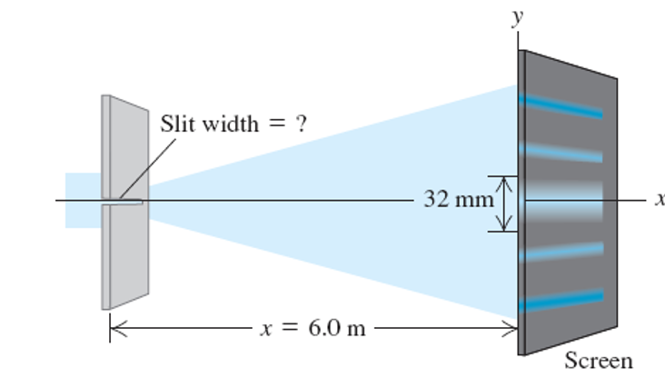
m=2
m=1
?
x = 5.00 m
d = 0.200 mm

