- Biot-Savart formula for calculating the magnetic field generated by a current-carrying conductor in the surrounding space, which of the following formula is correct. ( )
- $\frac{μ_{0}}{4π}\frac{Idl×\hat{r}}{r^{2}}$ B. $\frac{1}{4πε_{0}}\frac{Idl×\hat{r}}{r^{2}}$ C. $\frac{μ_{0}}{4π}\frac{Idl×\hat{r}}{r}$ D. $\frac{1}{4πε_{0}}\frac{Idl×\hat{r}}{r}$

- Which of the following statements about the source of the magnetic field is correct?
( )
- The magnetic field is generated by the moving charge.
- The magnetic field is generated by the stationary charge.
- The generation of a magnetic field has nothing to do with charge.
- None of the above.

3. A U-shaped conductor in a uniform magnetic field $\overset{⃑}{B}$ of 0.25 T perpendicular to the plane of the figure, directed into the page. A metal rod with length 1 m across two arms of the conductor, forming a circuit, and move the rod to the right with constant velocity 0.5 m/s. This induces an emf and a current, find the magnitude and direction of the resulting induced emf. ( )

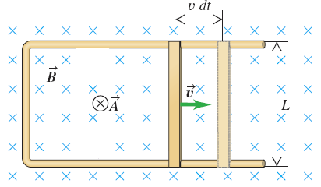

A. clockwise, 0.5 B. counterclockwise, 0.125
C. clockwise, 0.125 D. counterclockwise, 0.5

- Which of the following must not be met for the coherence of two waves:
( )
A. the same frequency B. constant phase relation
C. the same direction of polarization D. the same intensity

- A beam of unpolarized light of intensity I₀ passes through a series of ideal polarizing filters with their polarizing direction turned to various angles as shown in figure. What is the light intensity at points A and B?
( )
- I₀ and $\frac{I_{0}}{4}$ B. $\frac{I_{0}}{2}$ and $\frac{I_{0}}{4}$ C. I₀ and $\frac{I_{0}}{8}$ D. $\frac{I_{0}}{2}$ and $\frac{I_{0}}{8}$

- For monochromatic light and for a given pair of materials, a and b on opposite sides of the interface, the ratio of the sines of the angles θ_{a} and θ_{b}, where both angles are measured from the normal to the surface. If the two indexes of refraction n_{a}, n_{b} and θ_{a} was given, find the value of θ_{b}.
( )
A. arcsin ($\frac{n_{a}sinθ_{a}}{n_{b}}$) B. arcsin ($\frac{n_{b}sinθ_{a}}{n_{a}}$)
C. arccos ($\frac{n_{b}sinθ_{a}}{n_{a}}$) D. arccos ($\frac{n_{a}sinθ_{a}}{n_{b}}$)

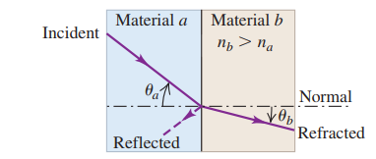
- Which of the following statements is correct, according to the sign direction of the induced emfs?
( )
A. The magnitude of magnetic field B is increasing.
B. The magnitude of magnetic field B is decreasing.
C. The magnitude of magnetic field B is unchanged.
D. None of the above.

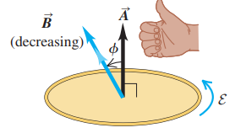

- Schematic diagram of an alternator is shown in Figure. A conducting loop rotates in a magnetic field, producing an emf. The magnetic flux is Φ_{B} = BAcosωt, the induced emf is
( )
A. ωBAsinωt B. ωBAcosωt
C. BAsinωt D. BAcosωt
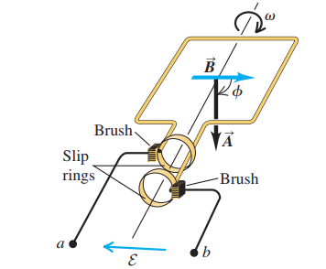
- Figure shows a two-slit interference experiment. If the slit S₀ moves up, which of the following statements is correct?
( )
- The central bright fringe will move up.
- The central bright fringe will move down.
- The central bright fringe will be unchanged.
- The central bright fringe will disappear.
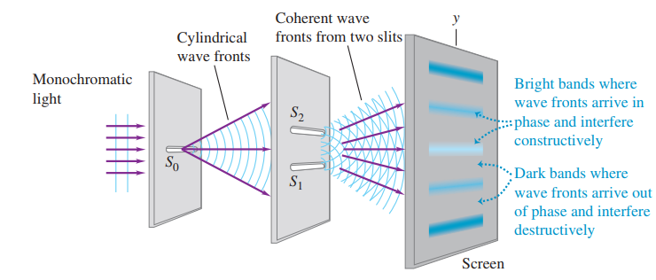

- Suppose the two glass plates in Figure are two microscope slides l long. At one end they are in contact; at the other end they are separated by a piece of paper h thick. Assume monochromatic light with a wavelength in air of λ₀. The successive interference dark fringes seen by reflection is at the position with the distance x from the line of contact. which of the following statements is correct?
( )

- x=m$\frac{lλ}{2h}$, m= 1,2,3.... The fringe at the line of contact is bright.
- x=m$\frac{lλ}{2h}$, m= 0,1,2,3.... The fringe at the line of contact is dark.
- x=m$\frac{lλ}{2}$, m= 0,1,2,3.... The fringe at the line of contact is bright.
- x=m$\frac{λ}{2h}$, m= 0,1,2,3.... The fringe at the line of contact is dark.
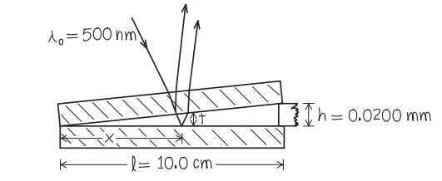
l

- The magnitude and direction of the magnetic field at point P are
and (inward or outward), respectively. Due to the current in the semicircular section of wire shown in the following figure.

- In the Michelson interference optical path, when the wavelength of monochromatic light is 500 nm and the movable mirror is moved by 5 μm, the change in the optical path difference between the two interference arms is . The interference fringes will move wavelength.
- The wavelength of the red light from a helium-neon laser λ₀ is 633 nm in air. The index of refraction of the aqueous humor n is 1.34. The light wavelength in the aqueous humor λ is . The speed of light in the aqueous humor v is (the speed of light in air is 3.00 ×10⁸ m/s).
- The single-slit diffraction pattern depends on the ratio of the slit width a to the wavelength λ. When the slit width a increase, the central peak become
(narrower or wider). When the shorter wavelength λ is selected, the central peak become (narrower or wider).
- The magnetic field between the poles of the electromagnet in Figure is uniform at any time, but its magnitude is increasing at the rate of 0.020T/s. The area of the conducting loop in the field is 120 cm² and the total circuit resistance, including the meter, is 5.0 Ω. The induced emf is and the induced current in the circuit is .

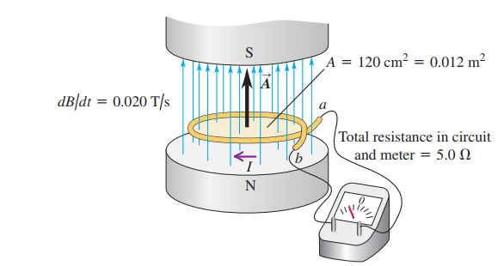

- A thin conductor rod of length 2a and current of I, find the magnitude of magnetic field $\overset{⃑}{B}$ at the distance x from its center.
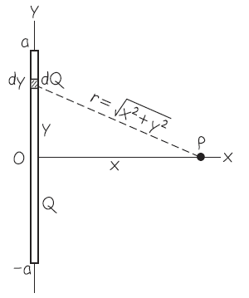

- Use Ampere’s law to find the magnetic field$\overset{⃑}{ B}$ at or near the center of such a solenoid if it has n turns per unit length and carries current I.
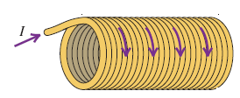

- A parallel-plate, air-filled capacitor is being charged as in Figure. The circular plates have radius 4.0 cm, and at a particular instant the conduction current in the wires is 0.28 A.
(a) what is the displacement current density j_{D} in the air space between the plates?
(b) what is the rate at which the electric field between the plate is charging?
(c) what is the induced magnetic field between the plates at a distance of 2.0 cm from the axis? (ε₀=8.85×10⁻¹² C²/N·m², μ₀=4π×10⁻⁷ N·s²/C²)

- Suppose the long solenoid in Figure has 500 turns per meter and cross-sectional area 4.0 cm². The current in its windings is increasing at 100 A/s.
- Find the magnitude of the induced emf in the wire loop outside the solenoid?
- Find the magnitude of the induced electric field within the wire loop if its radius is 2.0 cm?

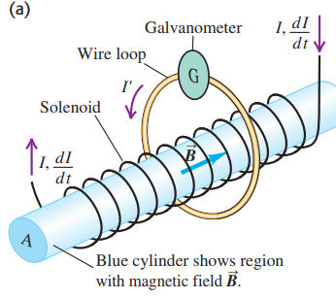

- Figure shows a two-slit interference experiment in which the slits are 0.200 mm apart and the screen is 1.00 m from the slits. The wavelength of the light is 633 nm.
(a) Find the spacing between adjacent bright fringe y?
(b) Find the spacing between m=3 bright fringe and the central fringe in the Figure y₃?
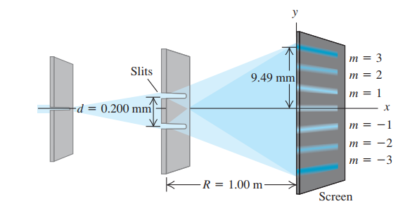
y₃
y

- Red light of wavelength 633 nm from a helium–neon laser passes through a slit a = 0.350 mm wide. The diffraction pattern is observed on a screen x=3.00 m away. Define the width of a bright fringe as the distance between the minima on either side.
(a) What is the width of the central bright fringe?
(b) What is the width of the first bright fringe ?
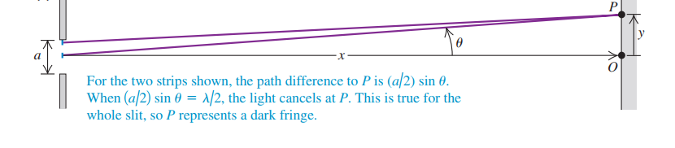
b

