- What are the three main purposes of an operating system?
操作系统的三个主要目的是什么？
Answer:
The three main purposes are:
• To provide an environment for a computer user to execute programs on computer hardware in a convenient and efficient manner.（provide an environment to run programs）
• To allocate the separate resources of the computer as needed to perform the required tasks. The allocation process should be as fair and efficient as possible.
(To manage the use of hardware)
• As a control program, it serves two major functions: (1) supervision of the execution of user programs to prevent errors and improper use of the computer, and (2) management of the operation and control of I/O devices.
(Supervision user and manage I/O device)
提供一个环境，让计算机用户能以方便高效的方式在硬件上执行程序；
按需分配计算机的各个资源，且分配过程应尽可能公平高效；
作为控制程序，两大功能是：(1) 监督用户程序执行，防止错误和不当使用；(2) 管理I/O设备的操作与控制.

此题考查操作系统的根本目标。资源管理和向用户提供扩展/虚拟机是核心思想。这些概念在第1.1节（什么是操作系统） 和第1.4节（操作系统概念） 中有详细阐述。

- How does the distinction(区别) between kernel mode and user mode function as a rudimentary form of protection (security)?
内核模式和用户模式如何作为一种基本的保护形式之间的区别?
Answer:
The distinction between kernel mode and user mode provides a rudimentary form of protection in the following manner. Certain instructions can be executed only when the CPU is in kernel mode. Similarly, hardware devices can be accessed only when the program is in kernel mode, and interrupts can be enabled or disabled only when the CPU is in kernel mode. Consequently, the CPU has very limited capability when executing in user mode, thereby enforcing protection of critical resources.
（some instruction can only be executed in kernel mode, in user mode CPU has been limited a lot）
内核态和用户态之间的区分通过以下方式提供了一种基础形式的保护：某些指令只能在CPU处于内核模式时执行。同样，硬件设备只能在程序处于内核模式时被访问，并且中断只能在内核模式下被启用或禁用。因此，CPU在用户模式下执行时能力非常有限，从而加强了对关键资源的保护。

此题核心知识点在第1.3.2节（双模式操作）。通过硬件支持的两种模式，将特权指令（如I/O操作、中断控制）限制在内核态执行，从而保护系统资源不受用户程序随意访问

- Some early computers protected the operating system by placing it in a memory partition that could not be modified by either the user job or the operating system itself. Describe possible difficulties that you think could arise with such a scheme.
一些早期计算机通过将操作系统置于一个用户作业和操作系统自身都无法修改的内存分区来保护它。描述你认为这种方案可能带来的困难。
Answer:
The data required by the operating system (passwords, access controls, accounting information, and so on) would have to be stored in or passed through unprotected memory and thus be accessible to unauthorized users.
(The date that system need can not be saved in those memory, its unprotected.)
操作系统所需的数据（密码、访问控制、记账信息等）将必须存储在未经保护的内存中或通过未经保护的内存传递，因此可能被未授权用户访问

此题与第1.5.2节（地址空间） 和内存保护概念相关。它指出了静态保护的缺陷：操作系统需要更新其内部数据（如计时器、缓存），若其所在内存完全不可写，将无法正常运行。

- Which of the following instructions should be privileged(特权)?
以下哪些指令应该是特权指令？
a. Set value of timer.
b. Read the clock.
c. Clear memory.
d. Issue a trap instruction.
e. Turn off interrupts.
f. Modify entries in device-status table.
g. Switch from user to kernel mode.
h. Access I/O device.
Answer:
The following operations need to be privileged: set value of timer, clear memory, turn off interrupts, modify entries in device-status table, access I/O device. The rest can be performed in user mode.
以下操作需要是特权操作：设置定时器值、清除内存、关闭中断、修改设备状态表项、访问I/O设备。其余的操作可以在用户模式下执行。

- Some CPUs provide for more than two modes of operation. What are two possible uses of these multiple modes?
一些CPU提供两种以上的操作模式。这些多种模式的两个可能用途是什么
Answer:
Although most systems only distinguish between user and kernel modes, some CPUs have supported multiple modes. Multiple modes could be used to provide a finer-grained security policy. For example, rather than distinguishing between just user and kernel mode, you could distinguish between different types of user mode. Perhaps users belonging to the same group could execute each other’s code. The machine would go into a specified mode when one of these users was running code. When the machine was in this mode, a member of the group could run code belonging to anyone else in the group.
Another possibility would be to provide different distinctions within kernel code. For example, a specific mode could allow USB device drivers to run. This would mean that USB devices could be serviced without having to switch to kernel mode, thereby essentially allowing USB device drivers to run in a quasi-user/kernel mode.
(Distinguish different users and the parts these users can use. Or anyway that allow some function of kernel mode can be used in user mode.)
尽管大多数系统只区分用户模式和内核模式，但一些CPU支持多种模式。多种模式可用于提供更细粒度的安全策略。例如，不仅可以区分用户模式和内核模式，还可以区分不同类型的用户模式。也许属于同一组的用户可以执行彼此的代码。当这些用户之一运行代码时，机器将进入指定模式。
另一种可能性是在内核代码内提供不同的区分。例如，一种特定模式可以允许USB设备驱动程序运行。这将意味着可以服务USB设备而无需切换到内核模式，从而实质上允许USB设备驱动程序在一种准用户/内核模式下运行。

此题拓展了双模式的概念。例如，现代CPU的环 结构（如Intel x86架构的Ring 0-3）就是一种多模式实现，为虚拟化等功能提供了支持。这属于第1.3.2节（双模式操作） 的延伸讨论

- What is the purpose of system calls?
系统调用的目的是什么
Answer:
System calls allow user-level processes to request services of the operating system.
(system calls allow processes request kernel mode ‘s service in user mode.)
系统调用允许 用户级 进程请求操作系统的服务。

系统调用是用户程序与操作系统内核交互的唯一接口。它实现了从用户态到内核态的受控切换。这是第1.4.1节（系统调用） 的核心内容。

- What is the purpose of system programs?
系统程序的目的是什么？
Answer:
System programs can be thought of as bundles of useful system calls. They provide basic functionality to users so that users do not need to write their own programs to solve common problems.
(They provide basic functionality for user to use)
系统程序可以被视为有用的系统调用的集合。它们为用户提供基本功能，使得用户无需编写自己的程序来解决常见问题。

系统程序（如Shell、编译器、文件工具）是操作系统提供给用户的实用工具，它们构建在系统调用之上，形成了用户眼中的“操作系统环境”。这在第1.6节（系统调用和系统程序的结构） 有描述

- What is the main advantage of the layered approach to system design? What are the disadvantages of the layered approach?
分层式系统设计的主要优点是什么？分层方法的缺点是什么？
Answer:
As in all cases of modular design, designing an operating system in a modular way has several advantages. The system is easier to debug and modify because changes affect only limited sections of the system rather than touching all sections. Information is kept only where it is needed and is accessible only within a defined and restricted area, so any bugs affecting that data must be limited to a specific module or layer. The primary disadvantage to the layered approach is the poor performance due to the overhead of traversing through the different layers to obtain a service provided by the operating system.
(Advantage: easy to design , different layers have no influence
Disadvantage: have poor performance)
与所有模块化设计的情况一样，以模块化方式设计操作系统有几个优点。系统更易于调试和修改，因为更改只影响系统的有限部分，而不是触及所有部分。信息只保存在需要它的地方，并且只能在定义和受限的区域内访问，因此任何影响该数据的错误必须限于特定的模块或层。
分层方法的主要缺点是由于需要通过不同的层来获取操作系统提供的服务而产生的开销，导致性能较差。

这是操作系统结构设计的经典问题。分层模型是Tanenbaum书中介绍的几种主要结构之一，在第1.7.2节（分层系统） 有详细讨论。

- How could a system be designed to allow a choice of operating systems from which to boot? What would the bootstrap program need to do?
如何设计一个系统以允许选择要启动的操作系统？引导程序需要做什么？
Answer:
Consider a system that would like to run both Windows and three different distributions of Linux (for example, RedHat, Debian, and Ubuntu). Each operating system will be stored on disk. During system boot, a special program (which we will call the boot manager) will determine which operating system to boot into. This means that rather than initially booting to an operating system, the boot manager will first run during system startup. It is this boot manager that is responsible for determining which system to boot into. Typically, boot managers must be stored at certain locations on the hard disk to be recognized during system startup. Boot managers often provide the user with a selection of systems to boot into; boot managers are also typically designed to boot into a default operating system if no choice is selected by the user.
(This system need to run first and have (almost) all the paths of OS in this computer, then it needs to provide possible choices of OS to user, and can start a default OS when no choice input)
考虑一个希望同时运行Windows和三种不同Linux发行版（例如，RedHat、Debian和Ubuntu）的系统。每个操作系统将存储在磁盘上。在系统启动期间，一个特殊的程序（我们称之为引导管理器）将决定启动到哪个操作系统。这意味着最初不是直接启动到操作系统，而是引导管理器在系统启动期间首先运行。正是这个引导管理器负责决定启动到哪个系统。通常，引导管理器必须存储在硬盘的某些特定位置才能被系统启动时识别。引导管理器通常向用户提供一个可供启动的系统选择；如果没有用户选择，引导管理器通常也被设计为启动到一个默认的操作系统。

此题涉及启动过程。引导管理器（如GRUB）是位于BIOS/UEFI和操作系统之间的一个特殊小程序。这个概念在第1.3.3节（启动计算机） 中被解释。

- Using the program shown below, explain what the output will be at LINE A.
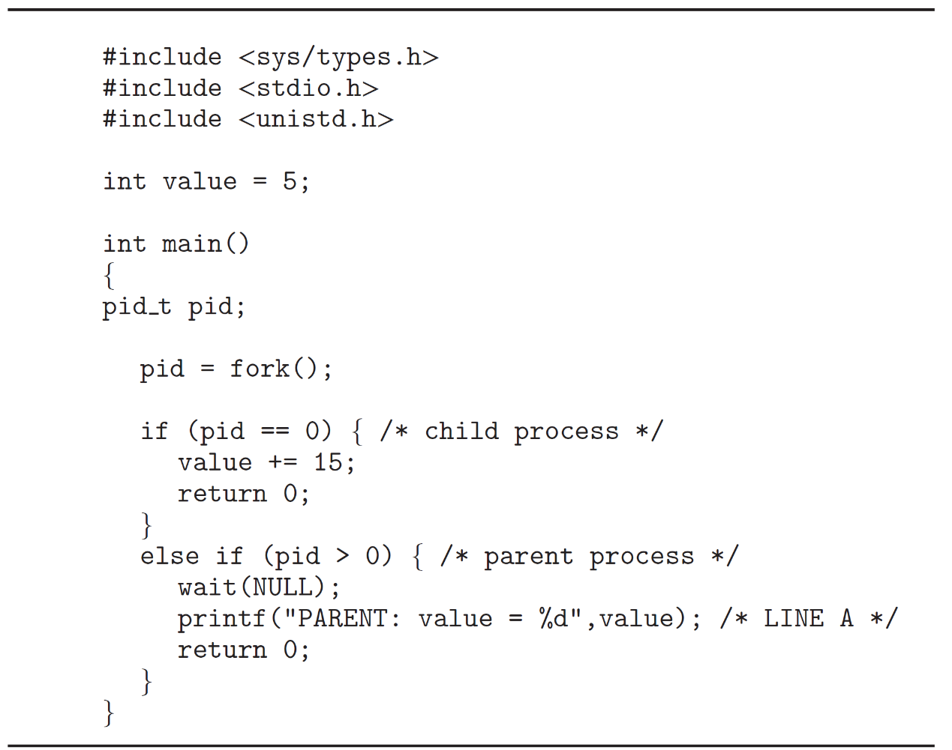
使用下面显示的程序，解释在A行的输出将是什么。

Answer:
The result is still 5, as the child updates its copy of value.When control
returns to the parent, its value remains at 5.
子进程在fork（）后复制了全局变量value到新地址的堆栈部分，但是pid是局部变量，只复制了存在，数值在子进程创建后才返回给父进程，因此在父进程中>0，子进程中为初始值0. 因此子进程中条件成立value（子）+15，父进程中不成立，value（父）不变，随后父进程执行输出为5.
结果仍然是5，因为子进程更新的是它自己的 value 副本。当控制权返回到父进程时，它的 value 值保持为5。

此题核心是理解fork()系统调用的语义——创建进程，并复制地址空间。子进程对变量的修改不影响父进程。这是第2.1.1节（进程模型） 和第2.2.3节（进程创建） 的核心内容。

- Including the initial parent process, how many processes are created by
the program shown below?
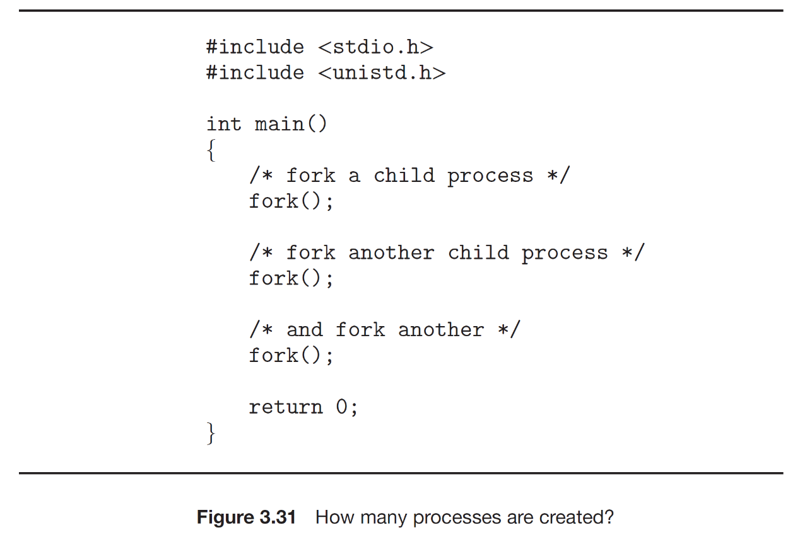
包括初始父进程，下面显示的程序创建了多少个进程？
8个，第一个fork创建一个子进程然后与父进程并行第二次调用fork创建了两个子进程，此时为四个，然后父进程与子进程（兄）与子进程（弟）与孙进程再创建了四个子进程，最终为8。

每次成功的fork()调用会使进程数翻倍。这是一个经典的fork()炸弹问题，考察对进程创建流程的理解。知识点源于第2.2.3节（进程创建）。
- Some computer systems provide multiple register sets. Describe what happens when a context switch occurs if the new context is already loaded into one of the register sets. What happens if the new context is in memory rather than in a register set and all the register sets are in use?
一些计算机系统提供多组寄存器。描述如果新上下文已经加载到其中一组寄存器中，当上下文切换发生时会发生什么。如果新上下文在内存中而不是在寄存器组中，并且所有寄存器组都在使用中，会发生什么？
Answer:
The CPU current-register-set pointer is changed to point to the set containing the new context, which takes very little time. If the context is in memory, one of the contexts in a register set must be chosen and be moved to memory, and the new context must be loaded from memory into the set. This process takes a little more time than on systems with one set of registers, depending on how a replacement victim is selected.
（these register set pointer is changed to point have new context. If in memory , one context in register sets need to move back to memory, then load the new context into register sets from memory）
CPU的当前寄存器组指针被改变为指向包含新上下文的寄存器组，这需要很少的时间。如果上下文在内存中，则必须选择一组寄存器中的某个上下文并将其移回内存，然后新上下文必须从内存加载到该寄存器组中。这个过程比只有一组寄存器的系统需要多一点时间，具体取决于选择哪个上下文作为替换牺牲者。

这是一个关于上下文切换性能优化的深入问题。它建立在第2.1.3节（进程实现） 中关于进程控制块和上下文切换的基本概念之上，并讨论了硬件特性如何影响切换开销。

- When a process creates a new process using the fork() operation, which of the following states is shared between the parent process and the child process?
当一个进程使用 fork() 操作创建一个新进程时，以下哪种状态在父进程和子进程之间是共享的？
a. Stack
b. Heap
c. Shared memory segments(共享内存段)
Answer:
Only the shared memory segments are shared between the parent process and the newly forked child process. Copies of the stack and the heap are made for the newly created process.
只有共享内存段在父进程和新fork出的子进程之间共享。栈和堆的副本是为新创建的进程制作的。

fork()后，子进程获得父进程地址空间的副本。栈和堆是私有的副本。只有共享内存段是真正共享的。这区分了进程间通信的不同机制，在第2.3.4节（共享内存） 有详细说明

- Provide three programming examples in which multithreading provides better performance than a single-threaded solution.
提供三个多线程能提供比单线程解决方案更好性能的编程例子。
Answer:
- A web server that services each request in a separate thread
一个Web服务器，在单独的线程中处理每个请求。
- A parallelized application such as matrix multiplication where various parts of the matrix can be worked on in parallel
一个并行化的应用程序，例如矩阵乘法，其中矩阵的各个部分可以并行处理。
- An interactive GUI program such as a debugger where one thread is used to monitor user input, another thread represents the running application, and a third thread monitors performance
一个交互式GUI程序，例如调试器，其中一个线程用于监视用户输入，另一个线程代表正在运行的应用程序，第三个线程监视性能。
- 大规模独立计算任务
（3D Rendering in Blender）
此题考查多线程的应用场景和优势：响应性、资源共享和并行性。这些例子和优势在第2.2.1节（线程的使用） 中有明确列举。

- Using Amdahl’s Law, calculate the speedup gain of an application that has a 60 percent parallel component for (a) two processing cores and (b) four processing cores.
使用Amdahl定律，计算一个具有60%并行组件的应用程序在 (a) 两个处理核心 和 (b) 四个处理核心 下的加速比增益。
Answer:
- With two processing cores we get a speedup of 1.42 times.
1/（（1-60%）+60%/2）=1/0.7=1.42
使用两个处理核心，我们得到1.42倍的加速比。

b. With four processing cores, we get a speedup of 1.82 times.
1/（（1-60%）+60%/4）=1/0.55=1.82
使用四个处理核心，我们得到1.82倍的加速比。

Amdahl定律量化了并行化对系统性能提升的限制。虽然公式可能在附录中，但其思想贯穿于讨论多核和并行处理的章节，如第2.2.4节（多核编程）。

- What are two differences between user-level threads and kernel-level threads? Under what circumstances is one type better than the other?
用户级线程和内核级线程之间的两个区别是什么？在什么情况下一种类型比另一种更好？
Answer:
- User-level threads are unknown by the kernel, whereas the kernel is aware of kernel threads.
(User-level threads isn’t run in kernel but kernel-level do)
用户级线程不被内核所知，而内核知道内核线程。
b. On systems using either many-to-one or many-to-many model mapping, user threads are scheduled by the thread library, and the kernel schedules kernel threads.
在使用多对一或多对多模型映射的系统上，用户线程由线程库调度，而内核调度内核线程。
c. Kernel threads need not be associated with a process, whereas every user thread belongs to a process. Kernel threads are generally more expensive to maintain than user threads, as they must be represented with a kernel data structure.
内核线程不需要与进程关联，而每个用户线程都属于一个进程。内核线程通常比用户线程维护成本更高，因为它们必须用内核数据结构表示。

这是第2.2.3节（在用户空间实现线程） 和第2.2.4节（在内核实现线程） 的核心对比内容，包括三种实现模型（多对一、一对一、多对多）及其优缺点。

- Describe the actions taken by a kernel to context-switch between kernel level threads.
描述内核在内核级线程之间进行上下文切换所采取的行动。
Answer:
Context switching between kernel threads typically requires saving the value of the CPU registers from the thread being switched out and restoring the CPU registers of the new thread being scheduled.
（save the register value and restore the value of new thread)
在内核线程之间进行上下文切换通常需要保存被换出线程的CPU寄存器值，并恢复被调度的新线程的CPU寄存器值。

内核级线程的上下文切换与进程上下文切换类似，但通常更轻量，因为它们在同一个地址空间内，不需要切换内存映射等。这基于第2.1.3节（进程实现） 的上下文切换概念，并应用于线程。

- What resources are used when a thread is created? How do they differ from those used when a process is created?
创建线程时使用哪些资源？它们与创建进程时使用的资源有何不同
Answer:
Because a thread is smaller than a process, thread creation typically uses fewer resources than process creation. Creating a process requires allocating a process control block (PCB), a rather large data structure. The PCB includes a memory map, a list of open files, and environment variables. Allocating and managing the memory map is typically the most time-consuming activity. Creating either a user thread or a kernel thread involves allocating a small data structure to hold a register set, stack, and priority.
(create a new thread requires a TCB[thread control block], and a new data structure.New thread can share some resource, have no need to new like process.)
因为线程比进程小，线程创建通常比进程创建使用更少的资源。创建进程需要分配进程控制块（PCB），这是一个相当庞大的数据结构。PCB包括内存映射、打开文件列表和环境变量。分配和管理内存映射通常是最耗时的活动。创建用户线程或内核线程都涉及分配一个小的数据结构来保存寄存器集、栈和优先级。

此题直接对比了进程和线程作为资源分配单位与调度单位的根本区别。这是第2.2.2节（经典线程模型） 的开篇重点。

- Assume that an operating system maps user-level threads to the kernel using the many-to-many model and that the mapping is done through LWPs. Furthermore, the system allows developers to create real-time threads for use in real-time systems. Is it necessary to bind a real-time thread to an LWP? Explain.
假设一个操作系统使用多对多模型将用户级线程映射到内核，并且该映射是通过LWP（轻量级进程）完成的。此外，该系统允许开发人员创建用于实时系统的实时线程。是否有必要将实时线程绑定到LWP？解释一下。
Answer:
Yes. Timing is crucial to real-time applications. If a thread is marked as real-time but is not bound to an LWP, the thread may have to wait to be attached to an LWP before running. Consider a situation in which a real-time thread is running (is attached to an LWP) and then proceeds to block (must perform I/O, has been preempted by a higher-priority real-time thread, is waiting for a mutual exclusion lock, etc.). While the real-time thread is blocked, the LWP it was attached to is assigned to another thread. When the real-time thread has been scheduled to run again, it must first wait to be attached to an LWP. By binding an LWP to a real-time thread, you are ensuring that the thread will be able to run with minimal delay once it is scheduled.
(Yes.If a thread is real-time but not bind to LWP, it may have to wait to be attached to an LWP before running)
是的。时序对实时应用至关重要。如果一个线程被标记为实时但未绑定到LWP，则该线程可能必须等待被附加到LWP才能运行。考虑一种情况：一个实时线程正在运行（已附加到LWP），然后继续阻塞（必须执行I/O，被更高优先级的实时线程抢占，正在等待互斥锁等）。当实时线程被阻塞时，它附加到的LWP被分配给另一个线程。当实时线程再次被调度运行时，它必须首先等待被附加到LWP。通过将LWP绑定到实时线程，您可以确保该线程一旦被调度，将能够以最小的延迟运行。

这是一个结合了线程实现模型（多对多） 和调度（特别是实时调度）的进阶问题。它强调了在复杂模型下保证可预测性 的重要性。知识点涉及第2.2.3节（混合实现） 和第2.4节（调度） 中关于优先级和实时系统的部分。

- ACPU-scheduling algorithm determines an order for the execution of its scheduled processes. Given n processes to be scheduled on one processor, how many different schedules are possible? Give a formula in terms of n.
一个CPU调度算法决定了其调度进程的执行顺序。给定n个进程在一个处理器上调度，有多少种不同的调度是可能的？给出一个关于n的公式。
Answer:
n! (n factorial = n × n – 1 × n – 2 × ... × 2 × 1).

这是一个排列组合问题，为理解不同调度算法的选择范围做铺垫。属于第2.4.1节（调度介绍） 的数学基础

- Explain the difference between preemptive and nonpreemptive scheduling.
解释抢占式和非抢占式调度的区别
Answer:
Preemptive scheduling allows a process to be interrupted in the midst of its execution, taking the CPU away and allocating it to another process. Nonpreemptive scheduling ensures that a process relinquishes control of the CPU only when it finishes with its current CPU burst.
(Preemptive scheduling allows process stop when it was running, instead running another process, nonpreemptive have to finish it first)
抢占式调度允许进程在其执行过程中被中断，剥夺CPU并将其分配给另一个进程。非抢占式调度确保进程仅在完成其当前的CPU执行后才放弃对CPU的控制权。

这是调度算法的一个基本分类标准。理解这一点对分析FCFS、SJF、优先级调度、RR等算法的行为至关重要。在第2.4.1节（调度介绍） 中定义。

- Suppose that the following processes arrive for execution at the times indicated. Each process will run for the amount of time listed. In answering the questions, use nonpreemptive scheduling, and base all decisions on the information you have at the time the decision must be made.
假设以下进程在指定的时间到达以待执行。每个进程将运行列出的时间量。在回答问题时，使用非抢占式调度，并且所有决策必须基于你在决策时必须掌握的信息。
Process Arrival Time Burst Time
P1 0.0 8
P2 0.4 4
P3 1.0 1
- What is the average turnaround time for these processes with the FCFS scheduling algorithm?
使用FCFS调度算法的平均周转时间是多少？ 答案：10.53
- What is the average turnaround time for these processes with the SJF scheduling algorithm?
使用SJF调度算法的平均周转时间是多少？ 答案：9.53 (8+8+1-1+8+1+4-0.4)/3
- The SJF algorithm is supposed to improve performance, but notice that we chose to run process P1 at time 0 because we did not know that two shorter processes would arrive soon. Compute what the average turnaround time will be if the CPU is left idle for the first 1 unit and then SJF scheduling is used. Remember that processes P1 and P2 are waiting during this idle time, so their waiting time may increase. This algorithm could be known as future-knowledge scheduling.
短作业优先（SJF）算法本应提高性能，但注意到我们在时间0时选择了运行进程P1，因为我们当时不知道很快会有两个更短的进程到达。 如果让CPU在最初的1个单位时间内保持空闲，然后使用SJF调度，计算平均周转时间将会是多少。请记住，在此空闲期间，进程P1和P2（以及其他已到达的进程）处于等待状态，因此它们的等待时间可能会增加。 这种算法可以被称为具有未来知识（或预见性）的调度。 答案：6.86 (1+0.6+1+1+4+1+4+8)/3

此题要求计算周转时间，是第2.4.3节（调度算法） 中先来先服务和最短作业优先算法的典型应用题。关键是要理解调度决策点和不同算法对进程等待时间的影响。

- Consider the following set of processes, with the length of the CPU burst
time given in milliseconds:
考虑以下进程集合，CPU执行时间长度以毫秒给出
Process Burst Time Priority
P1 2 2
P2 1 1
P3 8 4
P4 4 2
P5 5 3
The processes are assumed to have arrived in the order P1, P2, P3, P4, P5, all at time 0.
- Draw four Gantt charts that illustrate the execution of these processes using the following scheduling algorithms: FCFS, SJF, nonpreemptive priority (a larger priority number implies a higher priority), and RR (quantum = 2).
绘制四张甘特图，以说明使用以下调度算法的这些进程的执行情况：先来先服务（FCFS）、短作业优先（SJF）、非抢占式优先级（优先级数字越大意味着优先级越高）以及时间片轮转（RR）（时间片=2）
- What is the turnaround time of each process for each of the scheduling algorithms in part a?
在（调度算法应用场景的）a部分中，对于每种调度算法，每个进程的周转时间是多少？
- What is the waiting time of each process for each of these scheduling algorithms?
对于这些调度算法中的每一种，每个进程的等待时间是多少？
- Which of the algorithms results in the minimum average waiting time (over all processes)?
哪些（哪种）算法能使得（所有进程的）平均等待时间最小？

- The four Gantt charts: FCFS, SJF, nonpreemptive priority (a larger priority number implies a higher priority), and RR (quantum = 2).
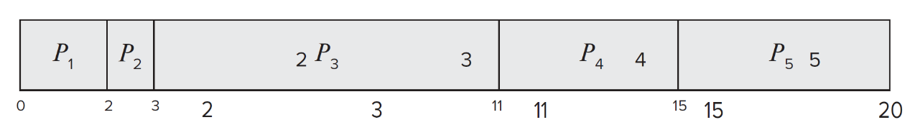
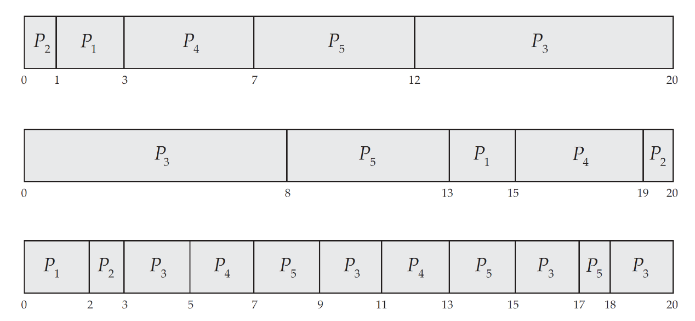
先来先服务（FCFS）、短作业优先（SJF）、非抢占式优先级（优先级数字越大意味着优先级越高）以及时间片轮转（RR）（时间片=2）
- Turnaround time:
周转时间
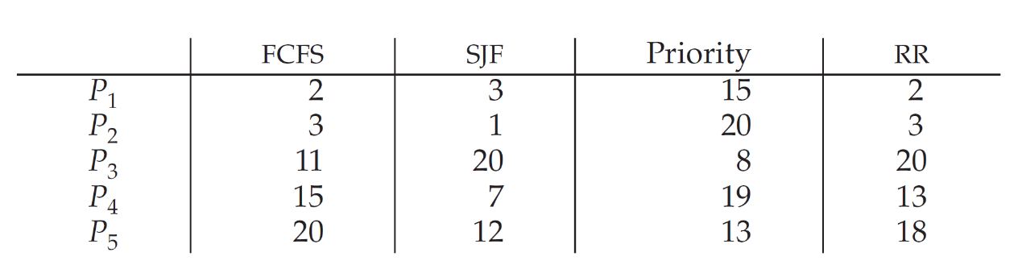
- Waiting time:
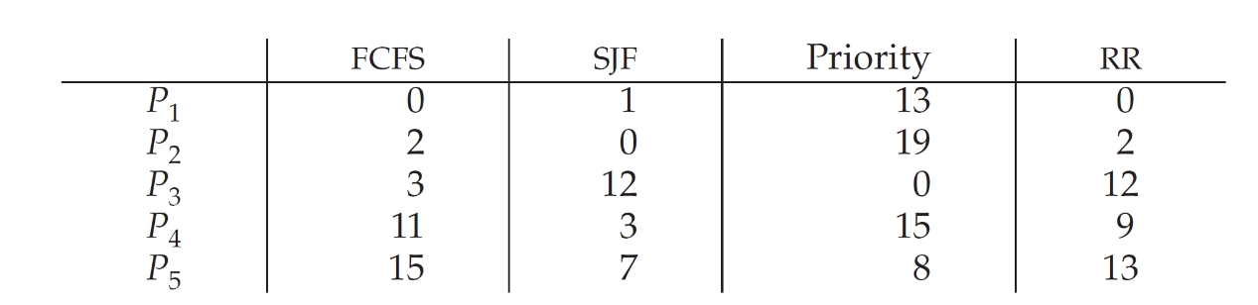
等待时间
d. SJF has the shortest wait time.
SJF算法有最短等待时间
- The following processes are being scheduled using a preemptive, roundrobin scheduling algorithm.
以下进程正在使用抢占式、轮转调度算法进行调度。
Process Priority Burst Arrival
P1 40 20 0
P2 30 25 25
P3 30 25 30
P4 35 15 60
P5 5 10 100
P6 10 10 105
Each process is assigned a numerical priority,with a higher number indicating a higher relative priority. In addition to the processes listed above, the system also has an idle task (which consumes no CPU resources and is identified as Pidle). This task has priority 0 and is scheduled whenever the system has no other available processes to run. The length of a time quantum is 10 units. If a process is preempted by a higher-priority process, the preempted process is placed at the end of the queue.
每个进程都被分配了一个数字优先级，数字越大表示相对优先级越高。除了上面列出的进程外，系统还有一个空闲任务（不消耗CPU资源，标识为Pidle）。该任务优先级为0，每当系统没有其他可用进程运行时，就会调度该任务。时间片长度为10个单位。如果一个进程被更高优先级的进程抢占，则被抢占的进程被放置在队列末尾。
- Show the scheduling order of the processes using a Gantt chart.
使用甘特图显示进程的调度顺序。
- What is the turnaround time for each process?
每个进程的周转时间是多少？
- What is the waiting time for each process?
每个进程的等待时间是多少？
d. What is the CPU utilization rate?
CPU利用率是多少？

Answer:
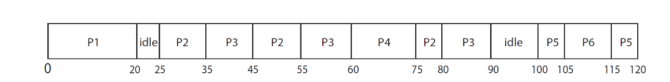
a. The Gantt chart:甘特图：
b. 每个进程的周转时间：P1: 20-0 - 20, P2: 80-25 = 55, P3: 90 - 30 = 60, P4: 75-60 = 15, P5:120-100 = 20, P6: 115-105 = 10
c. 每个进程的等待时间：P1: 0, p2: 40, P3: 35, P4: 0, P5: 10, P6: 0
d. CPU利用率：105/120 = 87.5 percent.

此题结合了优先级调度和时间片轮转，并引入了动态优先级（空闲任务）的概念。是比第23题更复杂的调度问题，综合考察了对第2.4.3节和第2.4.4节（多处理器调度和多级队列） 知识的掌握。

- What advantage is there in having different time-quantum sizes at different levels of a multilevel queueing system?
在多级队列系统的不同层级拥有不同时间片大小有什么优势？

Answer:
Processes that need more frequent servicing—for instance, interactive processes such as editors—can be in a queue with a small time quantum. Processes with no need for frequent servicing can be in a queue with a larger quantum, requiring fewer context switches to complete the processing and thus making more ef􀀀cient use of the computer.
(Processes that need more frequent servicing can be in a queue with a small time quantum,Processes with no need for frequent servicing can be in a queue with a larger quantum requiring fewer context switches)
需要更频繁服务的进程——例如，像编辑器这样的交互式进程——可以在一个具有小时间片的队列中。不需要频繁服务的进程可以在一个具有较大时间片的队列中，需要更少的上下文切换来完成处理，从而更有效地利用计算机。

这描述了多级反馈队列的设计哲学，旨在同时优化响应时间和CPU利用率。这是第2.4.4节（多级队列调度） 中的经典调度算法。

- The traditional UNIX scheduler enforces an inverse relationship between priority numbers and priorities: the higher the number, the lower the priority. The scheduler recalculates process priorities once per second using the following function:
传统UNIX调度器强制优先级数字和优先级之间成反比关系：数字越高，优先级越低。调度器每秒使用以下函数重新计算进程优先级一次：
Priority = (recent CPU usage / 2) + base
where base = 60 and recent CPU usage refers to a value indicating how often a process has used the CPU since priorities were last recalculated. Assume that recent CPU usage for process P1 is 40, for process P2 is 18, and for process P3 is 10. What will be the new priorities for these three processes when priorities are recalculated? Based on this information, does the traditional UNIX scheduler raise or lower the relative priority of a CPU-bound process?
其中，基准值为60，而近期CPU使用率指的是自上次重新计算优先级以来，某个进程使用CPU的频率。假设进程P1的近期CPU使用率为40，进程P2为18，进程P3为10。当优先级重新计算时，这三个进程的新优先级将分别是多少？基于这些信息，传统的UNIX调度器是会提高还是降低CPU绑定进程的相对优先级？

Answer:
The priorities assigned to the processes will be 80, 69, and 65, respectively.
分配给这些进程的优先级将分别是80、69和65。
The scheduler lowers the relative priority of CPU-bound processes.
调度器降低了CPU密集型进程的相对优先级。

此题展示了一个真实的、偏向I/O密集型进程的调度策略。通过惩罚近期CPU使用率高的进程，系统自然倾向于提高交互式进程的响应速度。这是第2.4.5节（传统UNIX调度） 中介绍的具体算法实例。

- In what way is an operating system like a government?
操作系统在哪些方面像一个政府？
A) It seldom functions correctly.
B) It creates an environment within which other programs can do useful work.
它创造了一个环境，在这个环境中其他程序可以做有用的工作。
C) It performs most useful functions by itself.
D) It is always concerned primarily with the individual's needs.
Ans: B
一个形象的比喻。操作系统本身不直接解决用户问题，而是管理和仲裁资源，使得应用程序能够有效运行。这呼应了第1.1节 关于操作系统作为资源管理者和扩展机的角色。

- Which of the following would lead you to believe that a given system is an SMP-type system?
以下哪项会让你认为一个给定系统是SMP型系统？
A) Each processor is assigned a specific task.
B) There is a boss–worker relationship between the processors.
C) Each processor performs all tasks within the operating system.
每个处理器执行操作系统内的所有任务。
D) None of the above
Ans: C
SMP是对称多处理的缩写。在SMP系统中，所有处理器是对等的，都可以运行操作系统内核和用户程序，没有主从之分。这是第1.2.2节（多处理器系统） 的关键概念。

- A ____ can be used to prevent a user program from never returning control to the operating system.
一个 ____ 可以用来防止用户程序从不将控制权返回给操作系统。
A) portal
B) program counter
C) firewall
D) timer
定时器
Ans: D
知识点说明： 定时器是硬件机制，可以在指定时间后产生中断，强制将CPU控制权交还给操作系统。这是实现进程调度和防止单个进程垄断CPU的基础。在第1.3.2节（双模式操作） 和第2章进程管理的调度部分都有提及。

