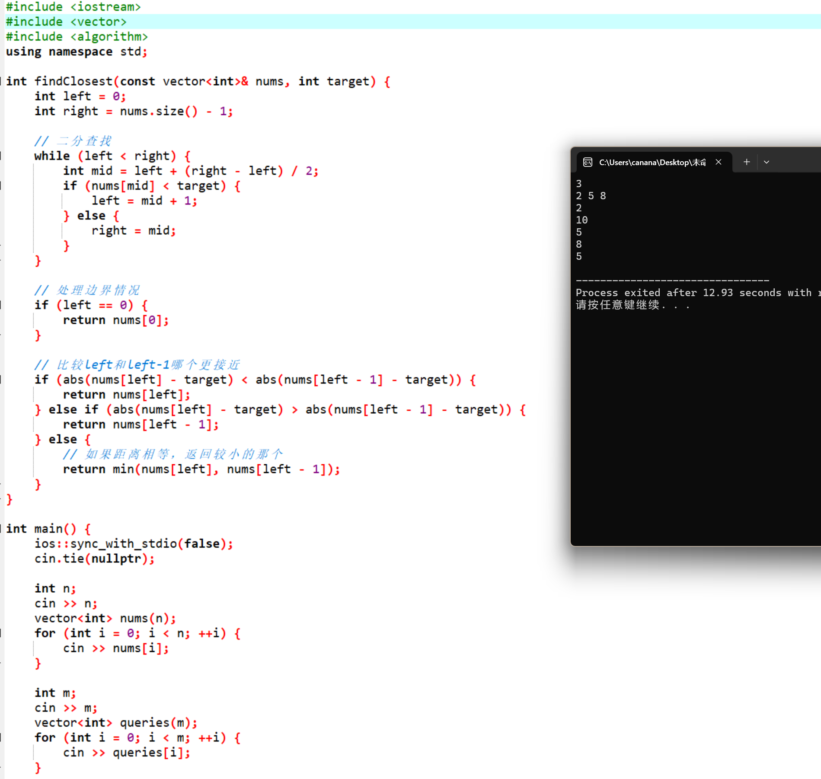
#include <iostream>
#include <vector>
#include <algorithm>
using namespace std;

int findClosest(const vector<int>& nums, int target) {
int left = 0;
int right = nums.size() - 1;

// 二分查找
while (left < right) {
int mid = left + (right - left) / 2;
if (nums[mid] < target) {
left = mid + 1;
} else {
right = mid;
}
}

// 处理边界情况
if (left == 0) {
return nums[0];
}

// 比较left和left-1哪个更接近
if (abs(nums[left] - target) < abs(nums[left - 1] - target)) {
return nums[left];
} else if (abs(nums[left] - target) > abs(nums[left - 1] - target)) {
return nums[left - 1];
} else {
// 如果距离相等，返回较小的那个
return min(nums[left], nums[left - 1]);
}
}

int main() {
ios::sync_with_stdio(false);
cin.tie(nullptr);

int n;
cin >> n;
vector<int> nums(n);
for (int i = 0; i < n; ++i) {
cin >> nums[i];
}

int m;
cin >> m;
vector<int> queries(m);
for (int i = 0; i < m; ++i) {
cin >> queries[i];
}

for (int query : queries) {
cout << findClosest(nums, query) << "\n";
}

return 0;
}

