A.1) Sketch the Task-Artifact Cycle
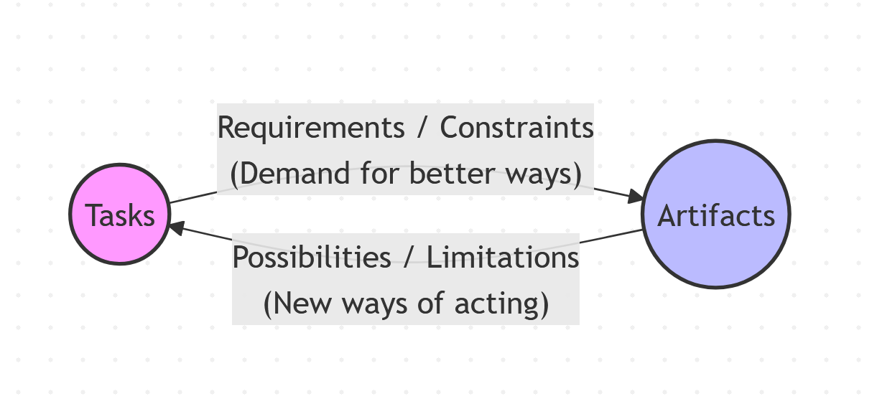Description:
The Task-Artifact Cycle illustrates that human tasks implicitly define the requirements for new artifacts. Once a new technology (artifact) is introduced to support a task, it inevitably changes the nature of the task itself. This creates a co-evolutionary loop: as the artifact opens new possibilities for action, users develop new needs and ways of working, which in turn drive the design of the next generation of artifacts.

A.2) Autonomous Driving: Task-Artifact Cycle
Discussion:
The primary needs articulated in driving are safety, efficiency, and the desire to reach a destination without the cognitive load of manual control. In response, autonomous driving artifacts (sensors, AI) are designed to replace human steering.
However, as the quote suggests, these artifacts do more than just respond; they transform the "driving" task into a "riding" task. This provides new possibilities: the car interior can evolve from a cockpit into a mobile office, a cinema, or a sleeping pod. As users adopt this technology, new human needs will emerge, such as the need for advanced in-car productivity tools, personalized entertainment interfaces, and higher levels of trust-based feedback from the vehicle. The artifact is no longer just a transport tool, but a multipurpose living space.

B.1) Personas
For a family home, I recommend creating the following four personas:
- The Tech-Savvy Parent: Uses the TV for streaming high-quality 4K movies and managing smart home integrations.
- The Non-Tech Senior: Primarily watches linear broadcast TV and values simplicity and large text.
- The Young Student : Uses the TV for educational YouTube content and casual gaming.
- The Busy Professional: Uses the TV for quick news updates, fitness videos, and casting content from her phone.

B.2) Tasks
- Searching for a specific movie/show title.
- Switching between HDMI inputs (e.g., Gaming Console vs. Cable).
- Adjusting volume and audio settings.
- Browsing recommendations on streaming apps (Netflix/YouTube).
- Casting or mirroring a smartphone screen.
- Using voice commands to find content.
- Updating system software or apps.
- Configuring Parental Controls/Profiles.
- Adjusting picture settings (Brightness/Game Mode).
- Accessing a "Watch Later" or "Favorites" list.

B.3) Task Frequency Analysis
Task / Persona | Mark (Parent) | Joe (Senior) | Lily (Child) | Sarah (Pro)
1. Search Content | 0.9 | 0.3 | 0.8 | 0.6
2. Switch Inputs | 0.8 | 0.1 | 0.7 | 0.2
3. Adjust Volume | 1.0 | 1.0 | 0.9 | 1.0
4. Browse Apps | 0.9 | 0.2 | 0.9 | 0.7
5. Screen Casting | 0.6 | 0.0 | 0.4 | 0.8
6. Voice Commands | 0.7 | 0.1 | 0.8 | 0.5
7. System Updates | 0.2 | 0.0 | 0.1 | 0.1
8. Parental Controls | 0.5 | 0.0 | 0.1 | 0.2
9. Picture Settings | 0.4 | 0.1 | 0.2 | 0.2
10. Favorites List | 0.8 | 0.4 | 0.7 | 0.6
Design Recommendations:
The design should prioritize a "Multi-User Profile" system to cater to diverse needs. For seniors like Joe, a "Simplified Mode" with high contrast and linear TV priority is essential. For power users like Mark and Sarah, a robust global search and voice control should be central. The interface must balance "discoverability" for new content with "efficiency" for frequent tasks like volume and input switching, which are used by everyone.

