- The rest energy E of an object with rest mass m is given by Einstein’s famous equation E=mc², where c=$2.997924×{10}^{8}$ m/s is the speed of light in vacuum. Find E for an electron for which (to three significant figures) m=$9.11×{10}^{−31}$kg, The SI unit for E is the joule: 1J = 1$kg∙m^{2}/s^{2}$. So the rest energy E is ( )

(A). $8.187659×{10}^{−14}$ J (B). $8.19×{10}^{−14}$ J
(C). $8.2×{10}^{−14}$ J (D). $9×{10}^{−14}$ J
B

- A light rope is tied to the ceiling of the elevator, and a heavy object is tied to its lower end. When the elevator rises with acceleration a₁, the tension in the rope is equal to half of the maximum tension that the rope bears. How much acceleration the elevator rises when the rope is just pulled off. （ ）
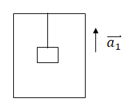

(A). 2a₁ (B). 2(a₁+g)
(C). 2a₁+g (D). a₁+g

C

- A hemispherical bowl with a smooth inner surface with a radius of 10cm, rotates around its symmetry axis OC at a uniform angular velocity ω. It is known that a small ball P placed on the inner surface of the bowl is stationary relative to the bowl, and its position is 4cm above the bottom of the bowl. It can be inferred from this that the angular velocity of the bowl rotation is. （ ）
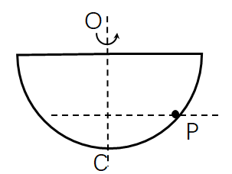

(A). 10rad/s (B). 13rad/s
(C). 17rad/s (D). 18rad/s

B

- A mass point with a mass of m=0.5kg moves in the Oxy coordinate plane, and its motion equation is x=5t, y=0.5t² (SI), during the period from t=2s to t=4s, the external force acts on the mass point Work is: （ ）

(A). 1.5J (B). 3J
(C). 4.5J (D). -1.5J
B

- As shown in the figure, a small ball with a mass of m, from a high H position on a smooth track from rest to a circular ring, if H is high enough, the difference in force of the ball exerted by the ring when the ball is at the highest point and the lowest point of the ring is exactly the weight of the ball （ ）
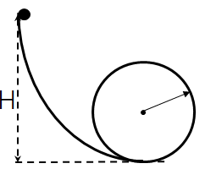
(A). 2 times the weight of ball (B). 4 times the weight of ball
(C). 6 times the weight of ball (D). 8 times the weight of ball
C

- As shown in the figure, there is a light spring sandwiched between objects A and B with masses m₁ and m₂ placed on a smooth horizontal table. First, squeeze A and B to make the spring in a compressed state, and then remove the external force. Then in the process of A and B being bounced. （ ）
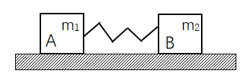
(A). The momentum of the system is conserved, but the mechanical energy is not.
(B). The momentum of the system is conserved, but the mechanical energy is also conserved.
(C). The momentum of the system is not conserved, but the mechanical energy is conserved.
(D). The momentum of the system and the mechanical energy are both not conserved.

B

11. An object with a mass of m is placed in the elevator, and the elevator drops h at a uniform acceleration of $\frac{1}{2}$g. In this process, the work done by the elevator on the object is 。

12. Under the combined action of two constant forces, the displacement of a particle is $∆\overset{⃑}{r}=3\overset{⃑}{i}+8\overset{⃑}{j}$ (SI), during this process, the kinetic energy increment is 24J, and one constant force is known to be $\overset{⃑}{F}=12\overset{⃑}{i}−3\overset{⃑}{j}$ (SI), the work done by another constant force is 。

13. A particle with a mass of m moves in a straight line along the x-axis, and the force received is $\overset{⃑}{F}=F_{0}cosωt\overset{⃑}{i}$ (SI). At t=0, the position coordinate of the mass point is x₀, and the initial velocity is ${\overset{⃑}{v}}_{0}=0$, then the relationship between the position coordinates of the particle and time is 。

14. On a rotating gear, a tooth tip P moves along a circle with a radius of R, and its path s changes with time as $S=v_{0}t+\frac{1}{2}bt^{2}$, where v₀ and b are both positive constants, then The acceleration of the tooth tip P at time t is: 。

15. A piece of wood has a mass of 45kg and drifts downwards at a constant speed of 8km/h. A 10kg bird flies upwards at a speed of 8km/h. It attempts to land on this piece of wood, but when it is unstable, It leaves the wood at a speed of 2km/h relative to the wood, and flies upwards, ignoring the friction of water. The final speed of the wood is 。

16. A small ball with mass m, at a horizontal speed ${\overset{⃑}{v}}_{0}$ and a static diagonal wedge with mass M on a smooth table, will bounce vertically after a complete elastic collision, then the height of the ball rising after the collision h= 。
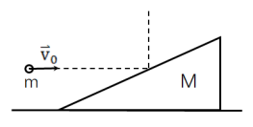

17. A bullet with a velocity of 700m/s, after piercing a wooden board, the velocity drops to 500m/s. If it continues to pass through a second piece of wood with the same thickness and resistance as the first piece, the speed of the bullet will be reduced to 。（Air resistance is negligible）

11. $−\frac{1}{2}mgh或\frac{1}{2}mgh$ 12. 12J 13. $\frac{F_{0}}{mω^{2}}\left(1−cosωt\right)+x_{0}$ 14. $\sqrt{b^{2}+{(v_{0}+bt)}^{4}/R^{2}}$ 15. 5.45km/h 16. $\frac{M−m}{2Mg}v_{0}^{2}$ 17. 100m/s

A, B, and C are three objects with a mass of M. B and C are placed on a smooth horizontal table with a 0.4m string between the two. They were originally loose, and B and C were leaning together. The other side of B is connected to A with a string that crosses the fixed pulley on the side of the table (as shown in the picture). The mass of the pulley and the rope and the friction on the axle are negligible. The rope cannot be stretched.
Question:
(1) After A and B start, how long does it take for C to start to move?
(2) What is the speed when C starts to move? ( g= 10m/s²)
(1)
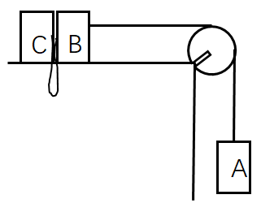
$M_{A}g−T=M_{A}a$
$T=M_{B}a$

$a=\frac{Mg}{M_{A}+M_{B}}=\frac{1}{2}g$

$l=\frac{1}{2}at^{2}=\frac{gt^{4}}{4}\underset{⇒}{}t=0.4s$

(2)

$v_{1}=at=\frac{1}{2}gt=2.0 m/s$
$M_{A}v_{2}−M_{A}v_{1}=−T_{AB}∙τ$ (because $M_{A}≪T_{AB}$)
$$M_{B}v_{2}−M_{B}v_{1}=T_{AB}∙τ−T_{BC}∙τ$$
$$M_{C}v_{2}−0=T_{BC}∙τ$$

$$\left(M_{A}+M_{B}+M_{C}\right)v_{2}=\left(M_{A}+M_{B}\right)v_{1}$$
Find, $v_{2}=\frac{2}{3}v_{1}=1.33m/s$

There is a smooth split-shaped object on a smooth plane, its mass is M, the angle of the inclined plane is α, and an object with mass m is placed on the inclined plane, as shown in the figure, Find:
(1) How much horizontal force F must be applied to M to keep m stationary relative to M?
(2) If there is no external force, find the acceleration of m relative to M, and the acceleration of m and M relative to the ground.
