SBIAHU AMS 310 Fall 2025

Homework #1 Due September 26

- The following are ages of 62 people who live in a certain neighborhood:
2, 5, 6, 12, 14, 15, 15, 16, 18, 19, 20, 22, 23, 25, 27, 28, 30, 32, 33, 35, 36, 36, 37, 38, 39, 40, 40, 41, 42, 43, 43, 44, 44, 45, 45, 46, 47, 47, 48, 49, 50, 51, 56, 57, 58, 59, 59, 60, 62, 63, 65, 65, 67, 69, 71, 75, 78, 80, 82, 84, 90, 96
- Display the data in a frequency table.
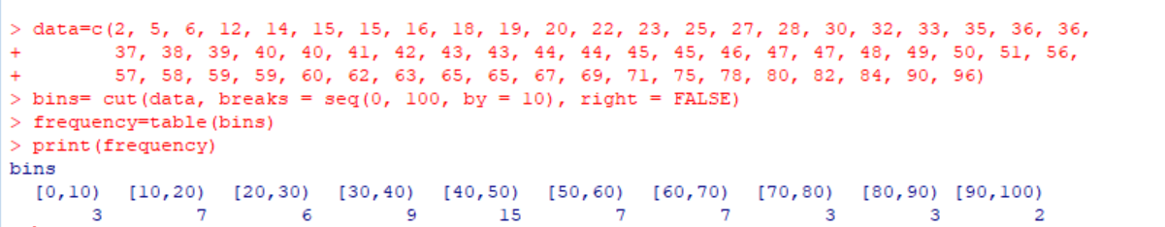
- Display the data in a histogram.
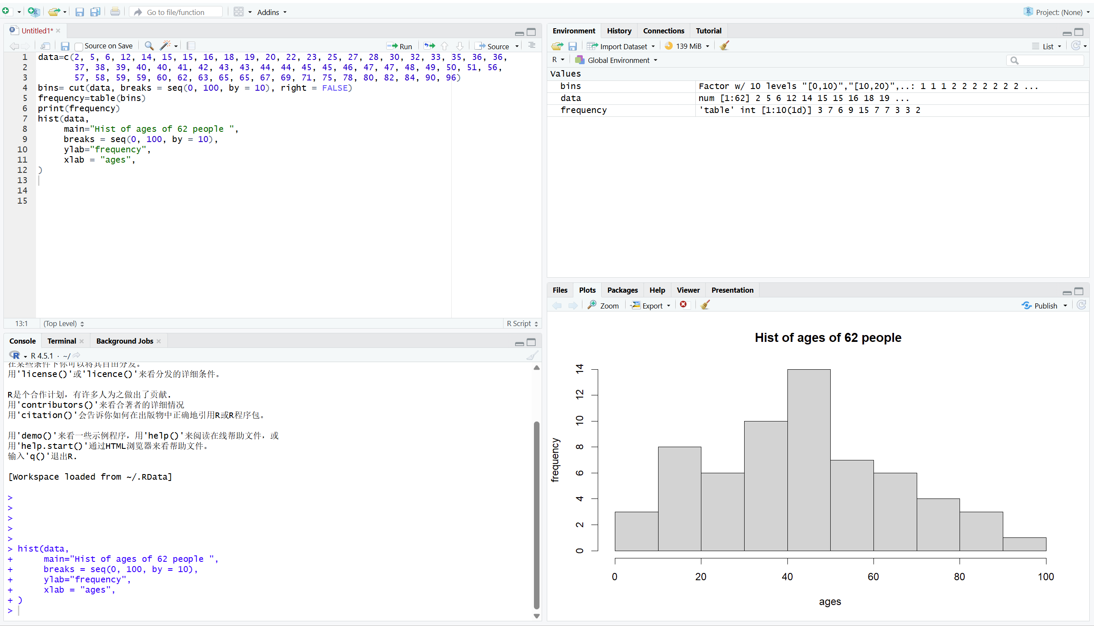

- Describe the shape of the distribution
- Display the data using a stem-and-leaf plot. 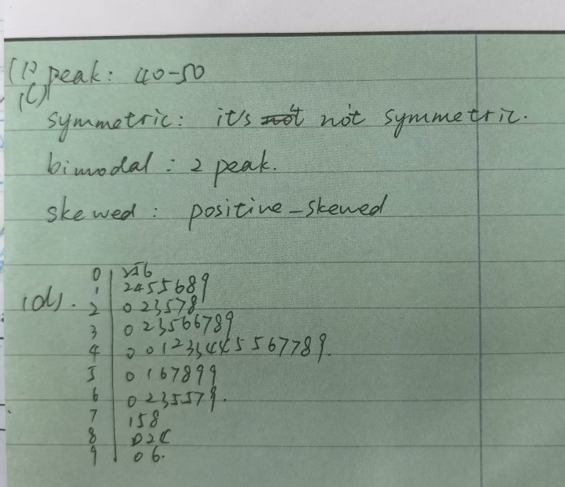

- The following figure shows a histogram of 56 observations generated by R.

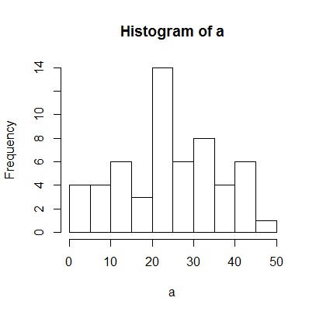
Each class interval includes the left endpoint but not the right.

- Find the relative frequency of each interval.

- Find the class interval containing the median.
- Describe the shape of the distribution.
- Which of the following can be the sample mean?
(i) 16.50 (ii) 24.64 (iii) 33.50 (iv) 46.00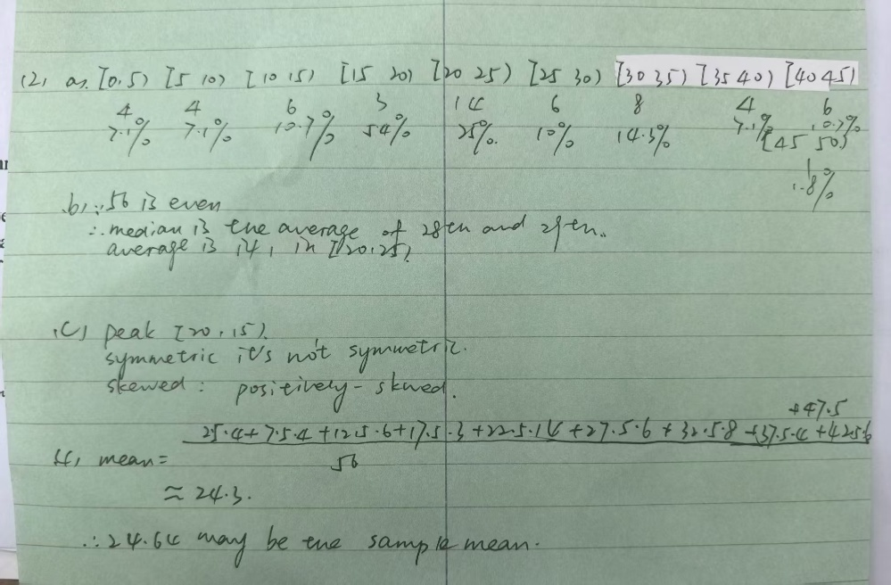

3. Following are the weights of weights of young goats, in pounds:

56, 32, 60, 59, 74, 65, 44, 51, 58, 51, 66, 49
- Illustrate the observations with a frequency table.
- Illustrate the observations with a histogram.
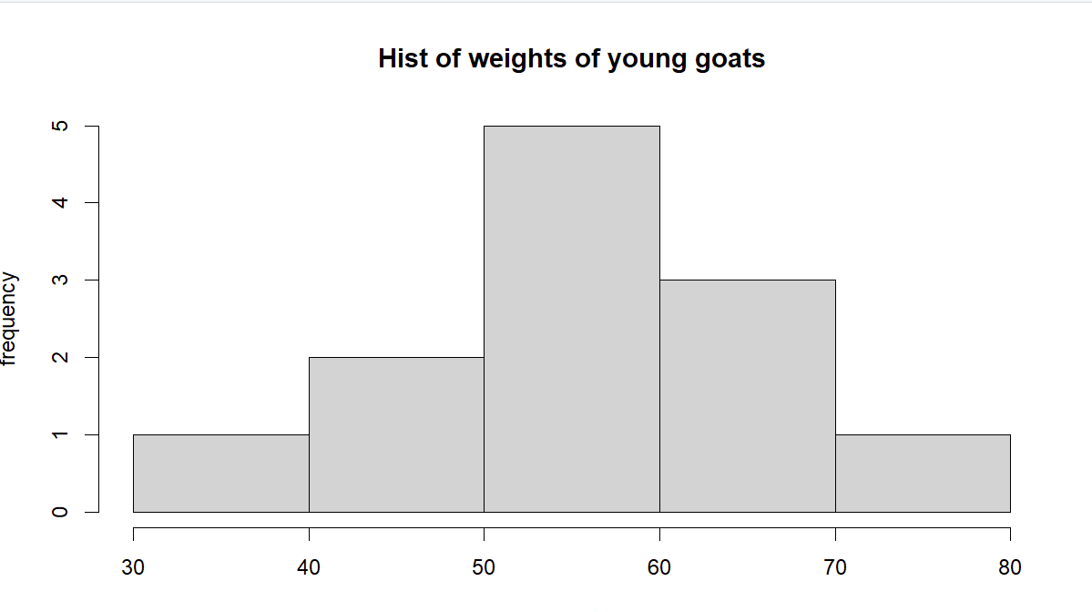
- Compute the sample mean and the sample variance.

- What proportion of the measurements lie in the interval $\overline{x}±2s$? 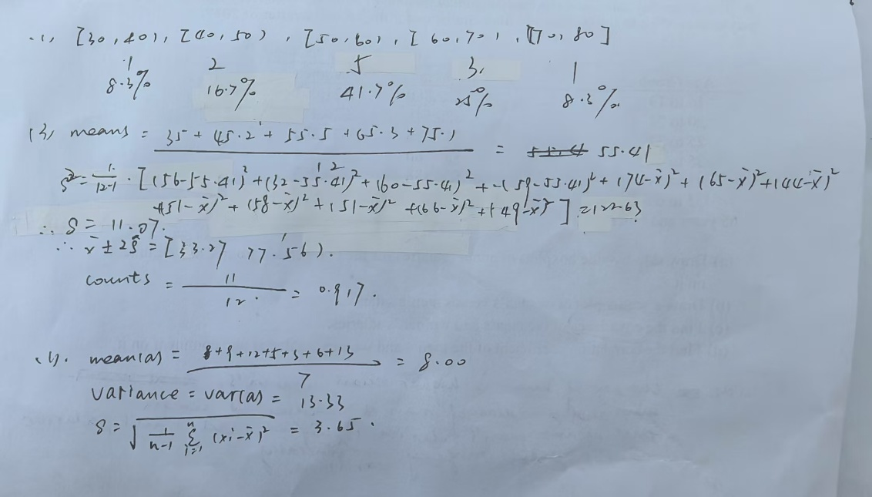

4. Cathy has obtained a sample mean of students: {9, 8, 12, 5, 3, 6, 13}.
- Find the sample mean.
- Find the sample standard deviation
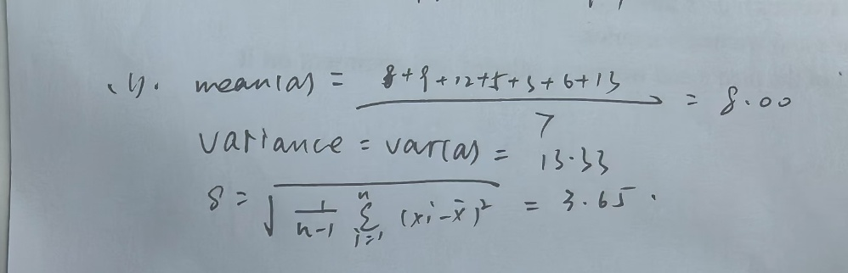.

5. The weights (in pounds) of six people are: d. Compute the following sample statistics for the given weights:
- median
- 70th percentile
- mean
- variance and standard deviation
- range

- 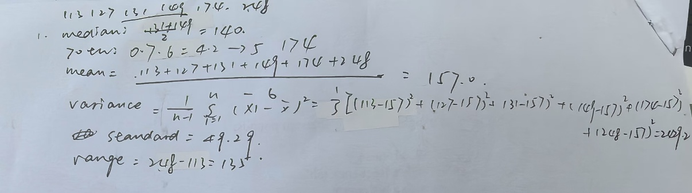

6. The following stem-and-leaf plot shows scores on a statistics final exam:
2 | 9
3 | 38
4 | 3688
5 | 116
6 | 14678
7 | 7889
8 | 234556699
9 | 001347
10 | 0

- Compute the sample median and quartiles.
如下图
- Compute the sample mean and sample variance.
如下图
- Compute the 66th percentile.

- If grade B was given to the students with scores between the 36th percentile and the 72nd percentile (inclusive), find the number of students who received B’s.
- How many students obtained scores above the 80th percentile?
- Compute the sample range and the interquartile range.
- Construct a boxplot.
- Find outliers, if there are any. 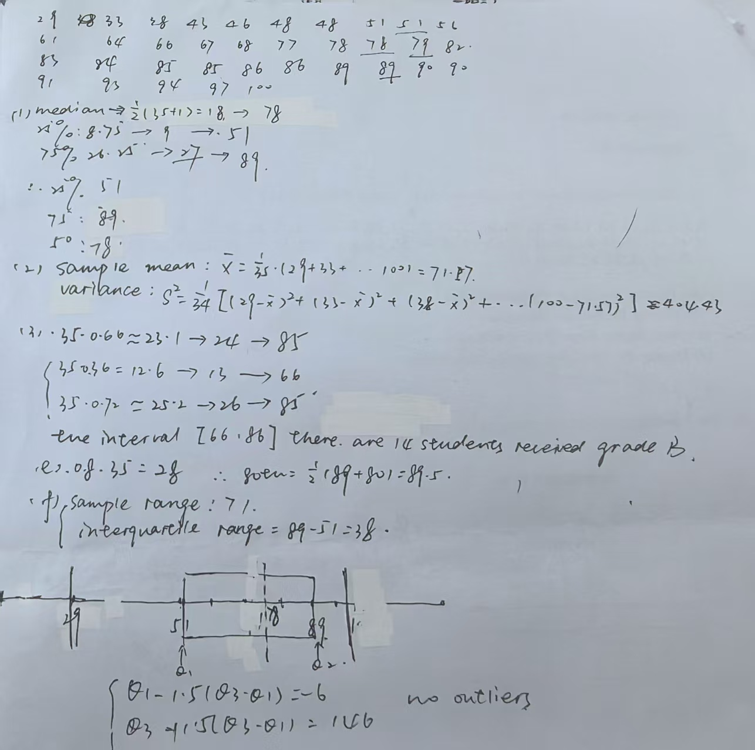

7. Octane levels for various gasoline blends are given below:

  - 84.2 86.9 87.7 91.7 88.8 95.3 93.5 94.3 88.1 90.2 91.4 91.3 93.9
- Construct a stem-and-leaf plot by using the tens digit as the stem.
- Construct a stem-and-leaf plot by using the first two digits (tens and ones digits) as the stem.
- Which of the above stem-and-leaf plots describes the distribution more efficiently?
- Draw a dot diagram.
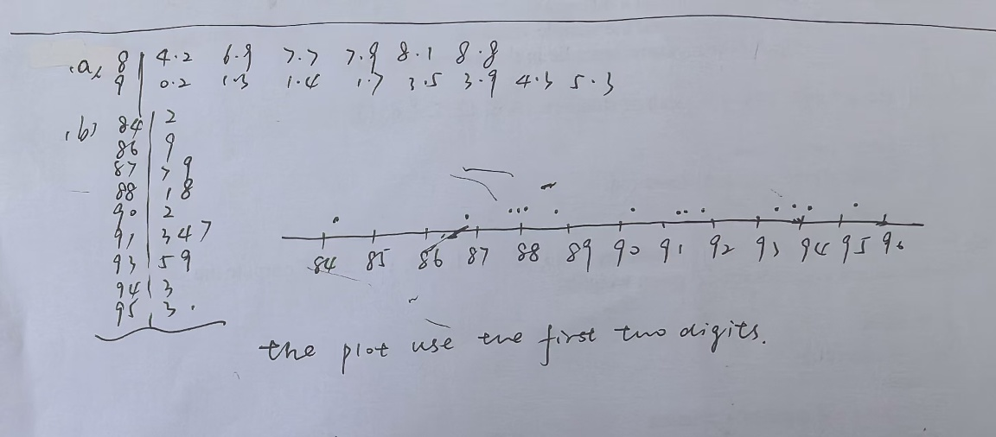

8. The following are amounts of total snow falls (in inches) in different northeastern cities in the United States in a certain year.

24 39 7 48 16 29 34 20 43 18 12 19 22 27 29 10 37 16 23 32

- Construct a stem-and-leaf plot.
- Compute the sample mean and standard deviation.
- Compute the sample median and quartiles.
- Construct a boxplot.
- Are there outliers?
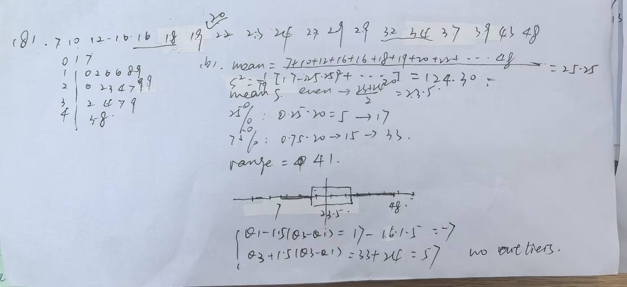

9. The following data show the median annual income of Americans at every age bracket by gender according to the Bureau of Labor Statistics for the second quarter of 2017.

 |  | Annual Salary
Age Group |  | Men | Women
16 to 19 |  | $22,880 | $21,008
20 to 24 |  | $28,548 | $26,416
25 to 34 |  | $43,056 | $37,804
35 to 44 |  | $55,380 | $45,604
45 to 54 |  | $56,888 | $44,252
55 to 64 |  | $55,016 | $45,188
65 years and older |  | $52,260 | $41,600
- Draw side-by-side boxplots of annual salaries for the two gender groups, and comment on it. 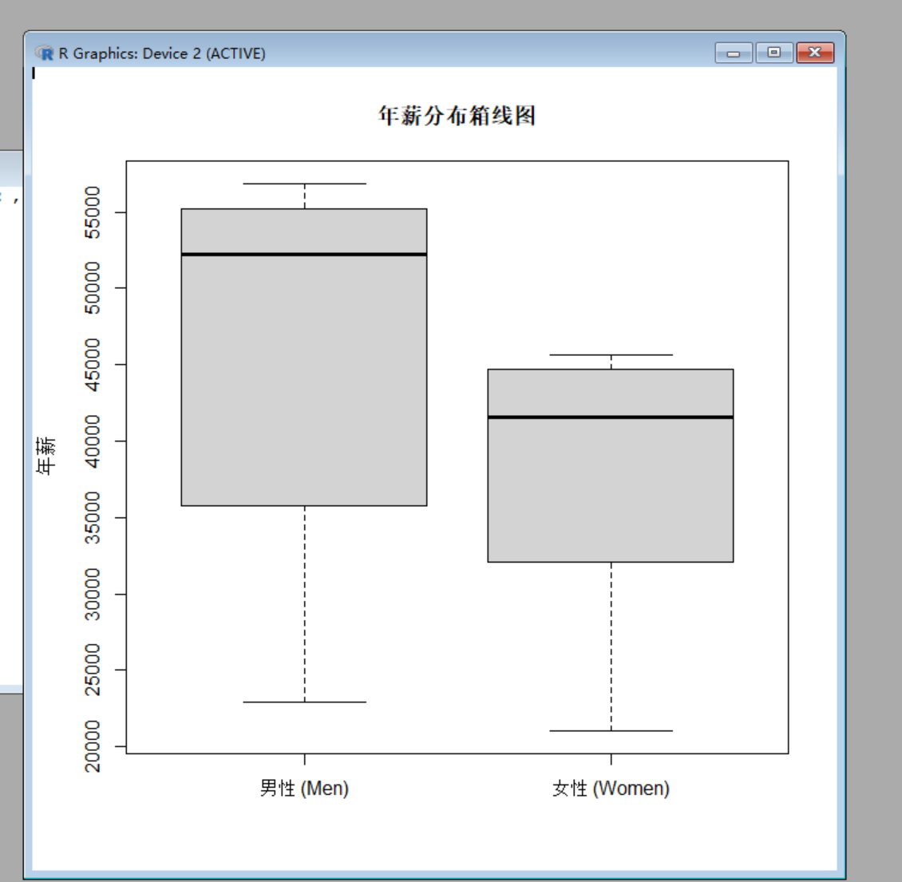
- Draw a scatter plot of women’s versus men’s salaries.
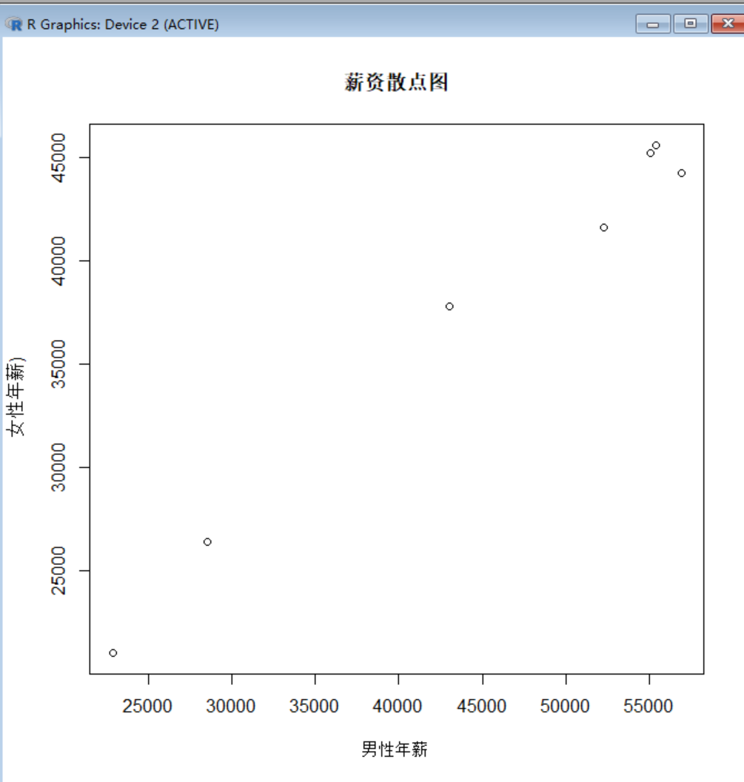
- Find the covariance of the men’s and women’s salaries.
- Find the correlation coefficient of the men’s and women’s salaries and comment on it.
