SBIAHU AMS 310 Fall 2025

Homework #3 Due October 17

1. Let $X$ be a random variable with cdf

$$F\left(x\right)=\left\{\begin{matrix}\begin{matrix}0, & x<-2 \\ 1/8, & -2≤x<-1 \\ 3/8, & -1≤x<0\end{matrix} \\ \begin{matrix}5/8, & 0≤x<1 \\ 7/8, & 1≤x<2 \\ 1 & x≥2\end{matrix}\end{matrix}\right.$$

- Find the probability distribution of $X.$
- Find the expected value and standard deviation of $X.$
- Find the 70th percentile$.$
- Find $P(-1≤X≤1)$.
- 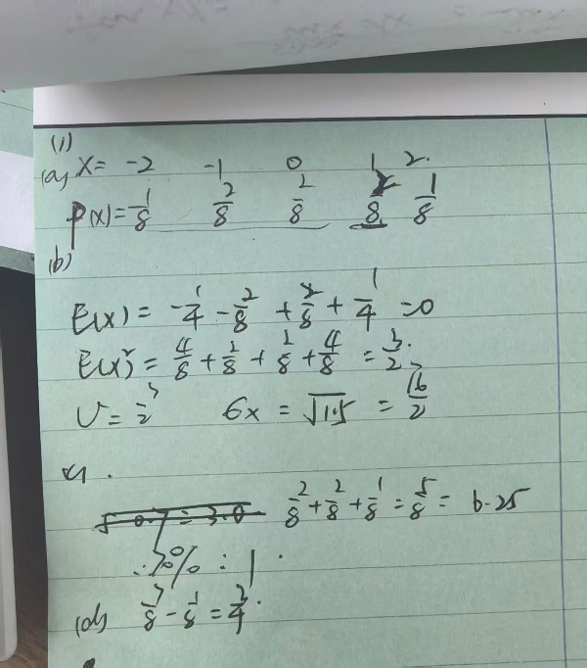

2. You are told that $E\left(X\right)=1$, $Var\left(X^{2}\right)=4$, and $E\left(X^{4}\right)=20.$ What is $Var\left(X\right)$?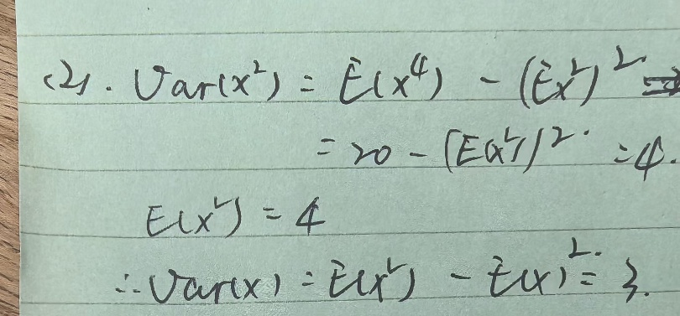
3. Let $X$ have a binomial distribution with $n=5$ and $p=0.2$.

- Find $P(X=1).$
- Find $P\left(X<3\right)$.
- Find the mean of $X.$
- Find the standard deviation of $X.$
- 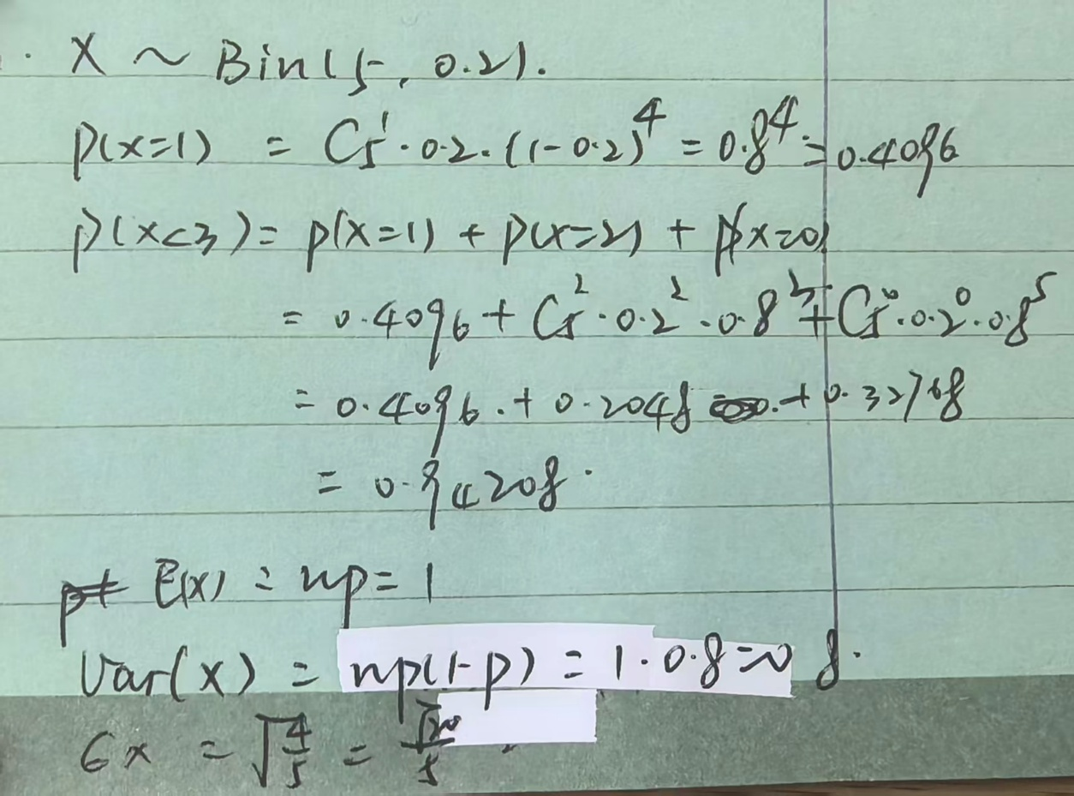

4. Let $X$ have probability distribution
$$f\left(x\right)=\frac{2!}{x!\left(2-x\right)!}{\left(\frac{1}{5}\right)}^{x}{\left(\frac{4}{5}\right)}^{2-x}, x=0, 1, 2.$$

- Find the cdf $F\left(x\right)$ of $X.$
- Find the probability that $X$ is odd.
- Find $E\left(X\right)$.
- Find Var($X).$
- 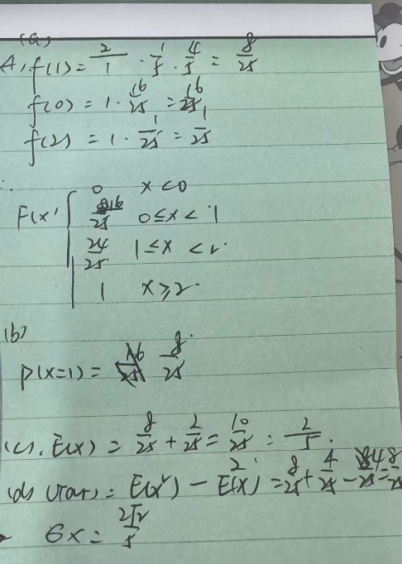

5. Two dice are tossed. Let $X$ be the random variable that shows the maximum of the two tosses.

- Find the distribution of $X.$
- Find $P\left(X≤3\right).$
- Find $E\left(X\right).$
- 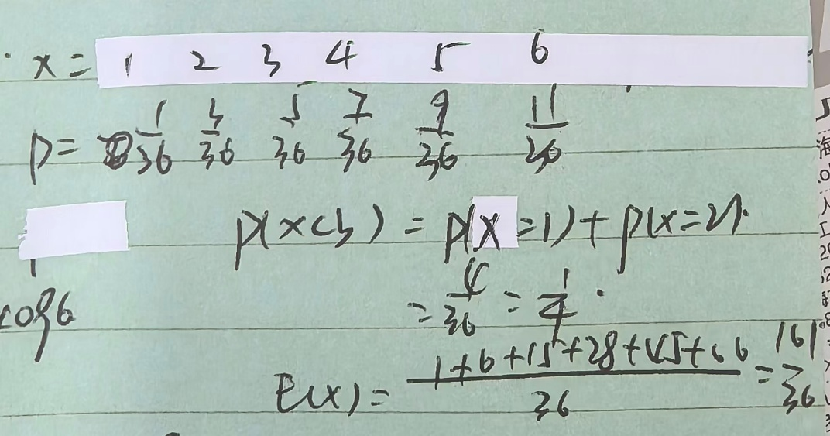

6. The school newspaper of a college has ten reporters. Three of the reporters are male students and the other seven are female students.

- If you randomly select four reporters to work on an article about the 50-year anniversary of the school, in how many ways two of the chosen reporters are males?
- What is the probability that at least two male students are selected among the 4 reporters chosen in part (a)?
- 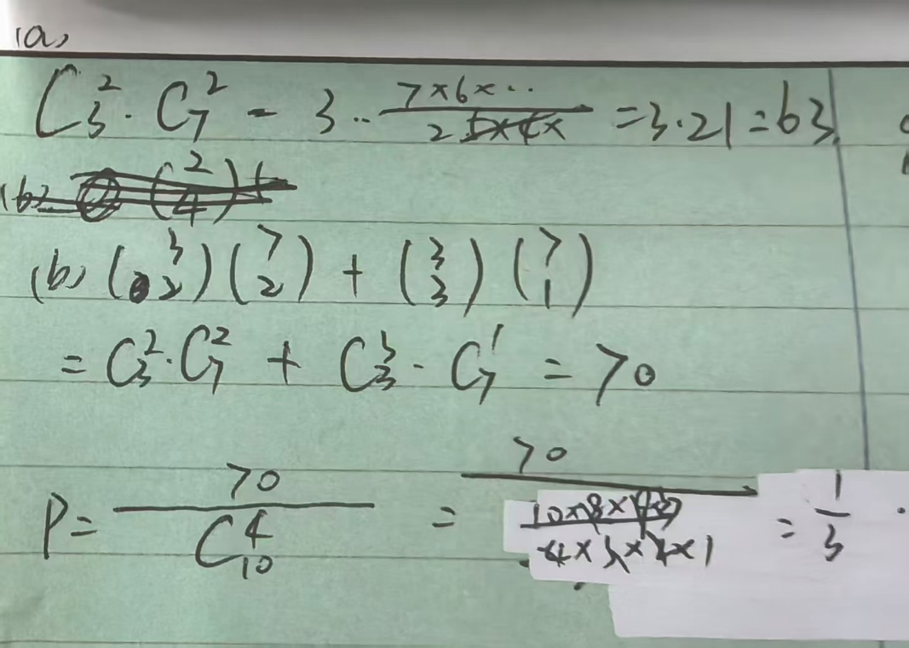

7. A certain online site has four visitors in three minutes on average. Let a Poisson random variable $X$ denote the number of visitors per minute to this site.

- Find the probability that this site gets two visitors in a minute.
- Find the probability that this site gets at least two visitors in a minute.
- 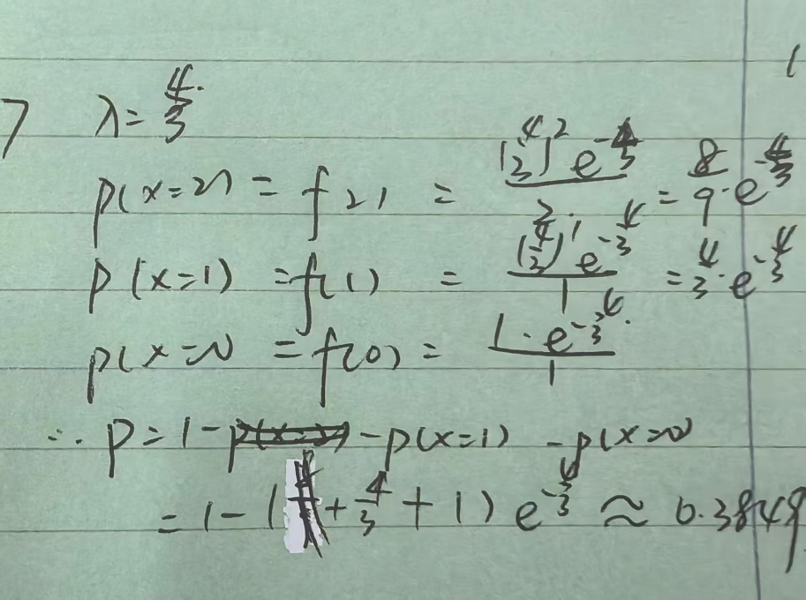

8. A certain drug causes liver damage in 0.5% of patients. Suppose the drug is to be tested on 100 patients. Answer the following questions.

- Find an approximate probability that none of these patients will experience liver damage.
- Find an approximate probability that 1 of these patients will experience liver damage.
- Find an approximate probability that 2 or more of these patients will experience liver damage.
- Find the exact probabilities of the above three questions and compare them with the approximate probabilities.
- 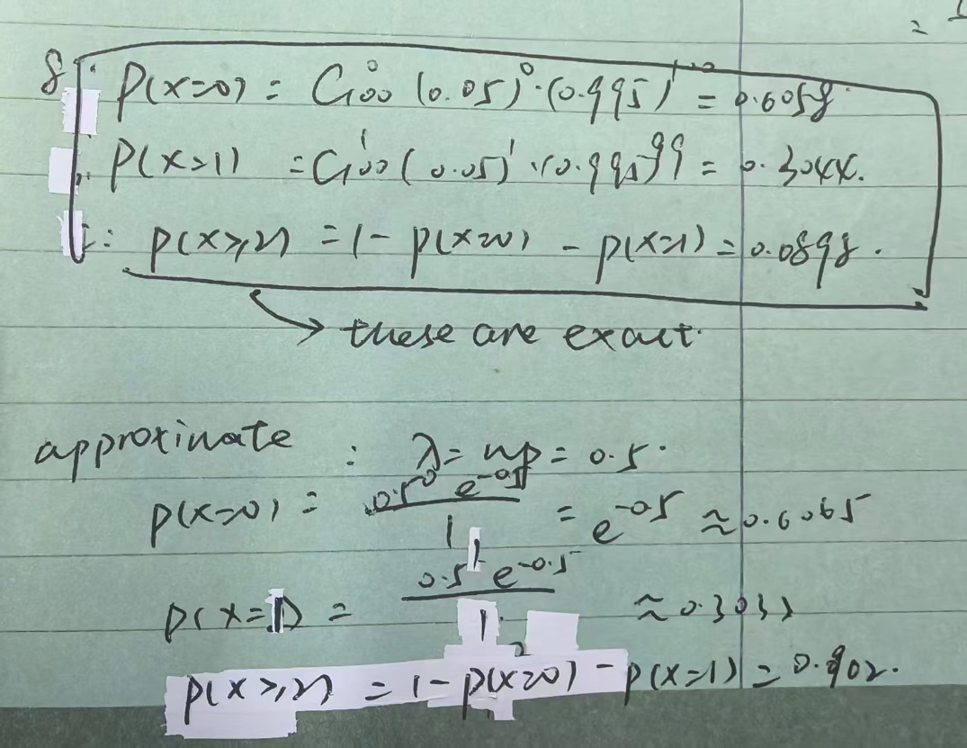

9. An apartment seeker in Manhattan estimates that 10% of the available apartments in her price range are in acceptable condition. Furthermore, she has time to look at only one apartment every weekend.

- How many weeks should this person expect to spend for apartment hunting?
- What is the probability that she will find an acceptable apartment in the first two weekends that she looks?
- What is the probability that it will take more than 4 months (17 weeks) to find an acceptable apartment? 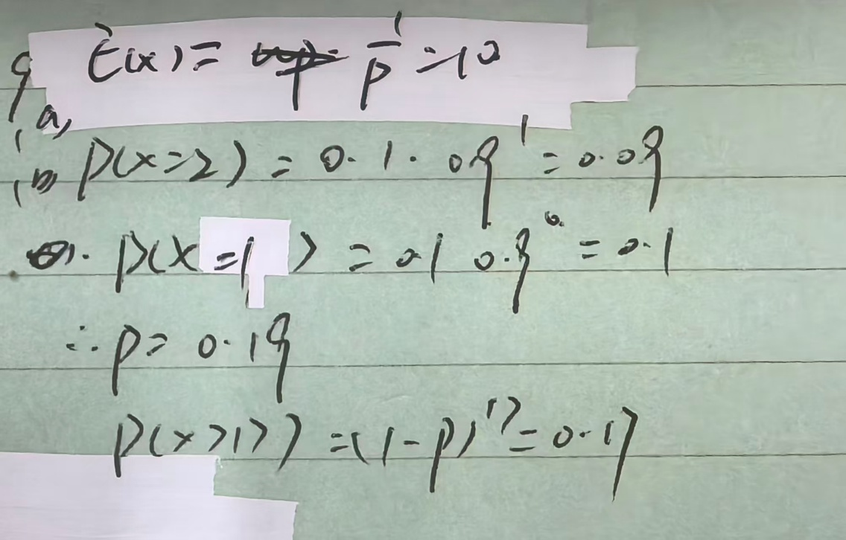

10. When a fair die is flipped 72,000 times, find the lower bound of the probability that the number 5 occurs between 11,500 and 12,500 times.
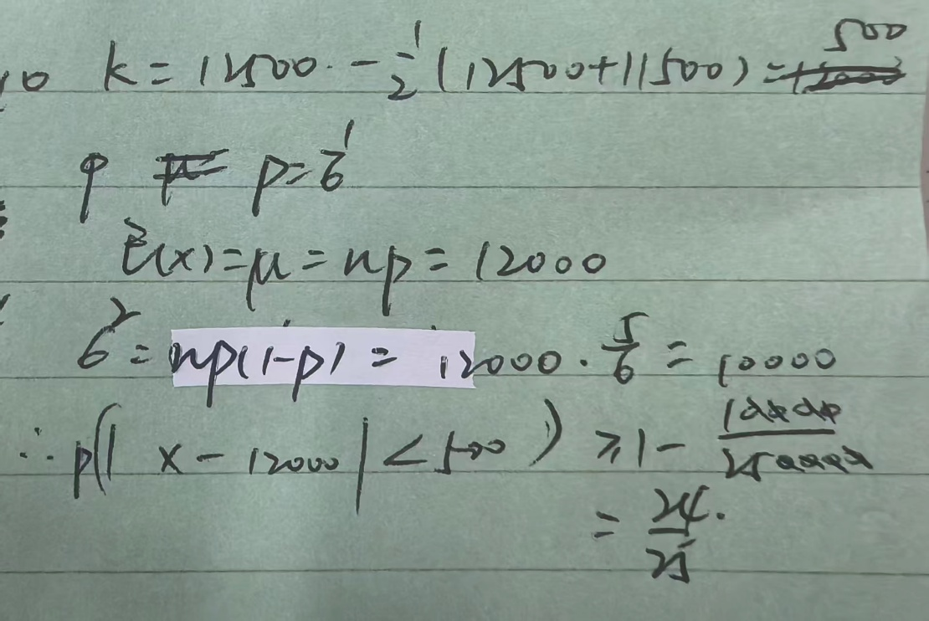

11. In a certain town, 30% of the eligible voters prefer the candidate from a conservative party, 20% prefer the candidate from a liberal party, and the remaining 50% have no preference in a presidential election. If you randomly sample 10 eligible voters, what is the probability that 3 will prefer the candidate from the conservative party, 2 will prefer the candidate from the liberal party, and the remaining 5 will have no preference?
