Stony Brook Institute at Anhui University
Grade Major Name AHU ID No.

------------------------------装---------------------------------------------订----------------------------------------线----------------------------------------

Seat No.:
2024 Spring Semester
Principles of Digital Media Technology Final Exam
(Closed-book Exam Duration: 120 minutes)
Section | I | II | III | IV | Total score
Score
Grader

Score
I. Blank Fillings (12 items, 2 points each)

- The International Telecommunication Union Telecommunication Standardization Sector (ITU-T) divides media into Perception medium, , Presentation medium, Storage medium, Transmission medium.
- The auditory frequency range of humans is typically from Hz to Hz.
- In 2005, the Ministry of Science and Technology of China formulated the "2005 China Digital Media Technology Development White Paper," which defines digital media as digitized content works that are distributed to end users for consumption through a comprehensive service system, with as the primary distribution medium.
- The digitization process of images mainly involves three steps: , , and .
- ‌The ability of human vision to perceive depth is primarily based on the principle of
between the two eyes.
- The two commercial game engines currently dominating the market share are Unreal Engine and .
- The color represented by the RGB (255 255 0) is .
- The png format file structure defines that the maximum depth of grayscale images can reach 16 bits, and the maximum depth of color images can reach bits.
- In the publishing and printing industry, the color model used is .
- The Nyquist–Shannon sampling theorem states that to restore the original signal without distortion from the sampled signal, the sampling frequency should be greater than the highest frequency of the signal.
- According to the persistence of vision characteristics of the human eyes, movies usually play at a rate of fps.
- If the plaintext(明文) is "China," its ciphertext（密文） according to the Caesar cipher(凯撒密码，k=3) is .
Score
II. Multiple Choices (10 items, 2 points each)

13. Which of the following transformations does not belong to frequency domain enhancement processing? ( )
A. Fourier Transform
B. Discrete Cosine Transform
C. Wavelet Transform
D. Changing Pixel Intensity Values
14. Which of the following is not one of the three attributes of color? ( )
A. Sharpness/Clarity
B. Chroma/Hue
C. Saturation/Purity
D. Brightness/Luminance
15. Which of the following is not a primary application of computer graphics? ( )
A. Virtual Reality
B. Computer-Aided Design (CAD) Drawing
C. Scientific Computing Visualization
D. Portrait Beautification (人像美化)
16. Which type of problem in data mining does the following analysis belong to: Upon studying sales records, a supermarket finds that customers who purchase milk are very likely to also purchase bread? ( )
A. Classification Analysis
B. Clustering Analysis
C. Natural Language Processing
D. Association Analysis
17. Which of the following biometric recognition technologies has the highest accuracy? ( )
A. Iris Recognition（虹膜）
B. Face Recognition
C. Fingerprint Recognition
D. Voice Recognition
18. Which of the following studies does not fall under the field of computer vision? ( )
A. 3D Rendering (渲染)Based on Ray Tracing
B. Stereoscopic Vision
C. Camera Calibration
D. 3D Reconstruction
19. Digital media technology has evolved through the development stages from 2C to 4C, where 2C stands for Computing and ( )
A. Communication
B. Consuming
C. Content
D. Computer
20. Which of the following is not an essential component of a speech synthesis system? ( )
A. Prosody (韵律)Processing
B. Language Model Training
C. Unit Synthesis and Concatenation
D. Speech Processing
21. (Multiple-Answers Questions) The characteristics of bitmap images are ( )
A. amplification distortion
B. large file volume
C. good color performance
D. amplification without distortion
22. (Multiple-Answers Questions) The main steps of the SIFT algorithm include ( )
A. Scale-space extrema detection
B. Accurate determination of keypoint locations
C. Determination of keypoint orientations
D. Keypoint descriptor calculation
III. Calculations and Proofs
Score
23.(6 points) How much MB of storage space does it take to record a 3-minutes sound signal with standard CD format? If we want to transmit this audio file over the network, considering the bandwidth limitation, which allows a maximum of 1 MB of data per second, how long will it take to transmit this audio file? (write the calculation formula and steps).

24. (8 points) ① Suppose there is an image with a total of n=64×64 pixels and its histogram is as shown in the figure. Perform histogram equalization（直方图均衡化） on the image, write down the process of equalization, and draw the histogram after equalization.
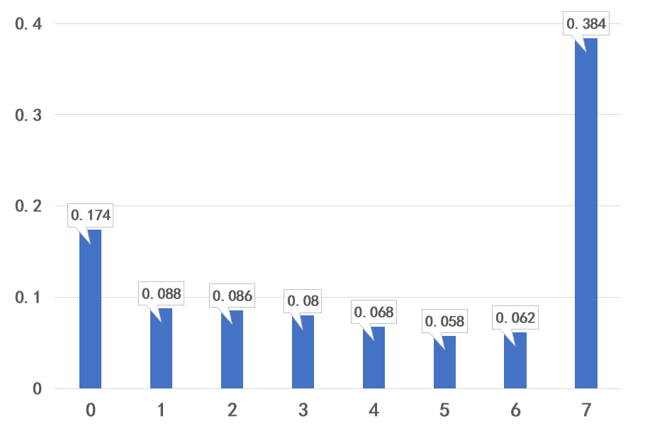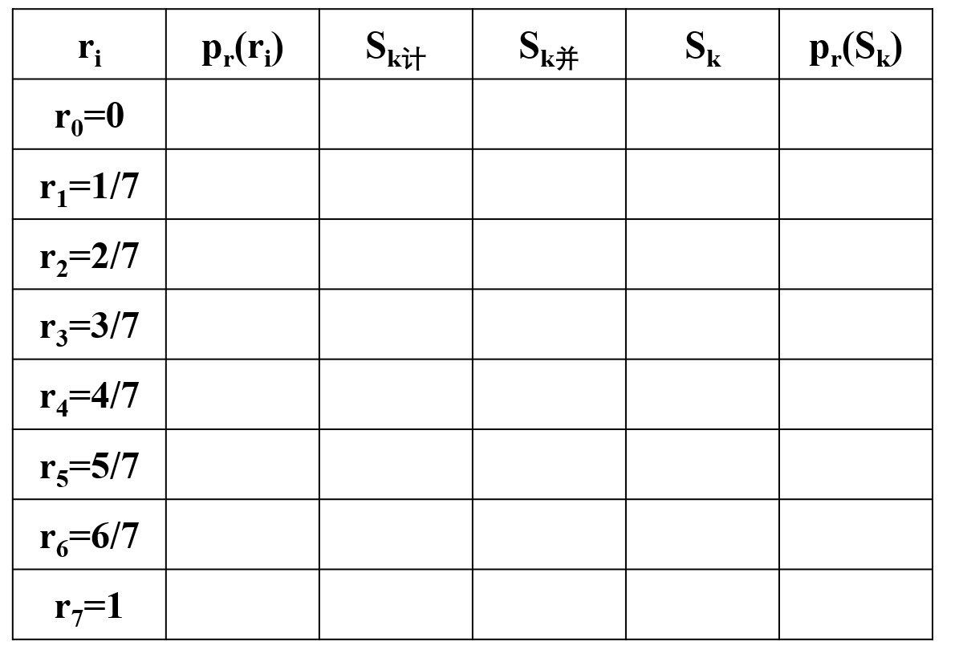

② If the grayscale values of 8 consecutive pixels in the original image are 0, 1, 2, 3, 4, 5, 6, 7 respectively, what are their grayscale values after equalization?

IV. Comprehensive Analysis Problem
Score

25. (6 points) Please list common video encoding standards and their typical applications?

26. (6 points) What are the main steps of facial recognition?

27. (6 points) Describe the concept, main components, and functions of a game engine.

28. (6 points) Explain the differences between classification algorithms and clustering algorithms.

29. (7 points) What are the main types of redundancy in digital media? Please provide examples.

30. (6 points) Describe the differences between symmetric encryption systems and asymmetric encryption systems, and provide examples of typical algorithms for each.

31. (5 points) Fill in the correct letters in the inter-frame predictive coding flowchart.
