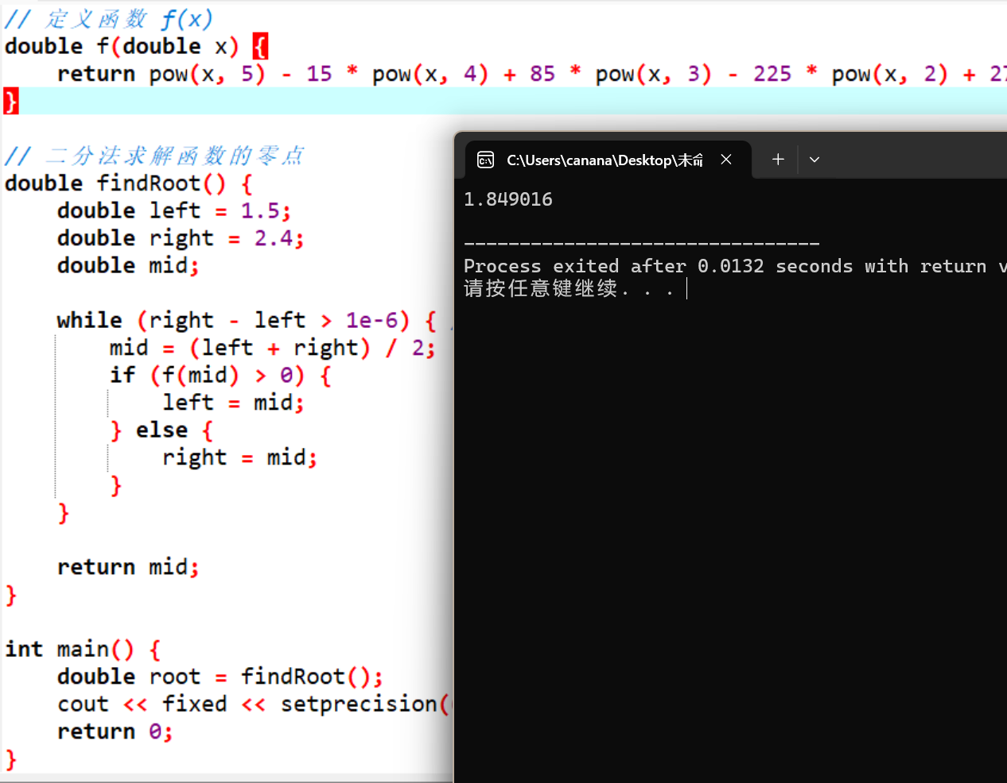
#include <iostream>
#include <cmath>
#include <iomanip>
using namespace std;

// 定义函数 f(x)
double f(double x) {
return pow(x, 5) - 15 * pow(x, 4) + 85 * pow(x, 3) - 225 * pow(x, 2) + 274 * x - 121;
}

// 二分法求解函数的零点
double findRoot() {
double left = 1.5;
double right = 2.4;
double mid;

while (right - left > 1e-6) { // 精度控制到1e-6
mid = (left + right) / 2;
if (f(mid) > 0) {
left = mid;
} else {
right = mid;
}
}

return mid;
}

int main() {
double root = findRoot();
cout << fixed << setprecision(6) << root << endl;
return 0;
}

