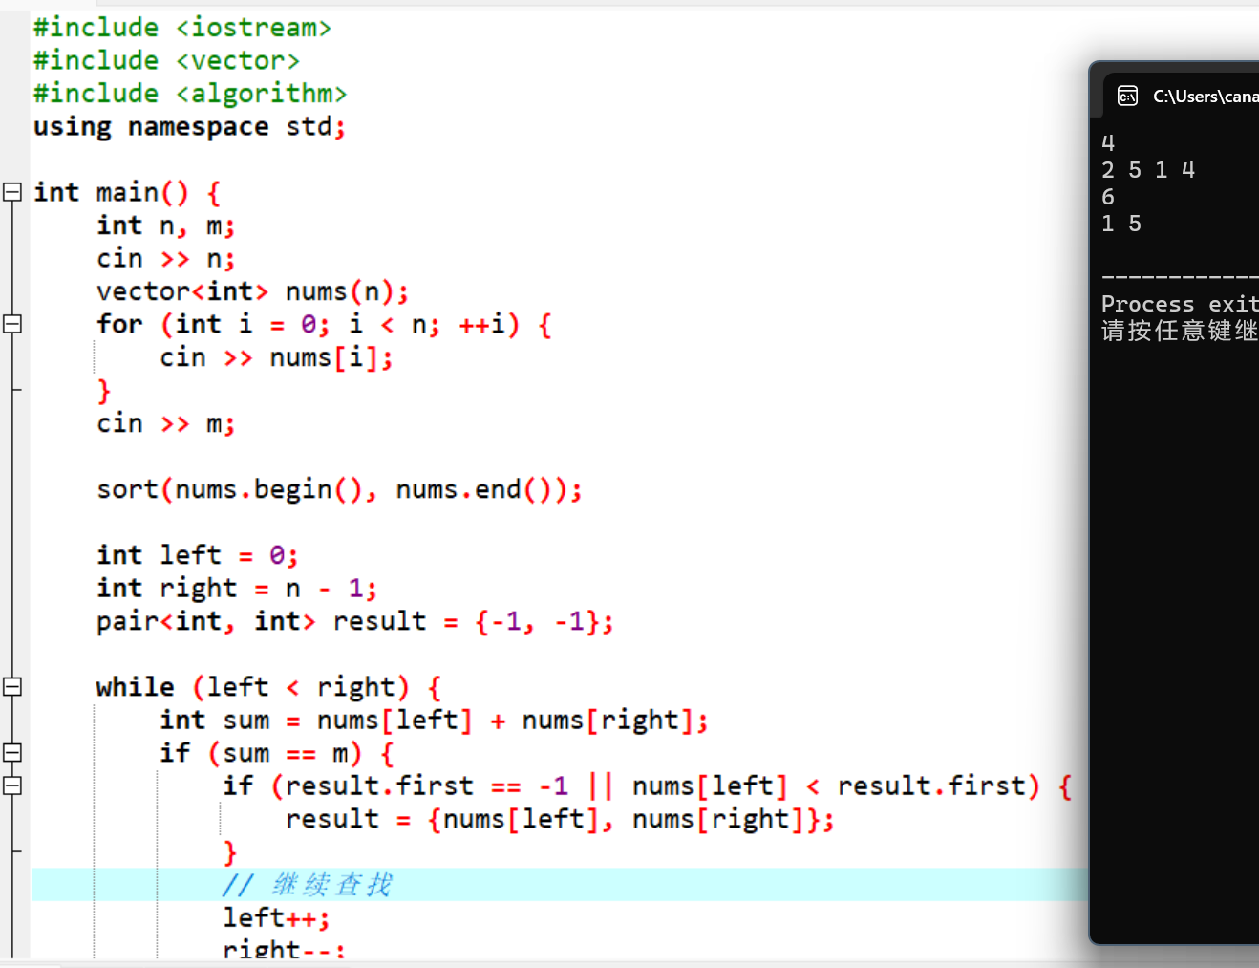
#include <iostream>
#include <vector>
#include <algorithm>
using namespace std;

int main() {
int n, m;
cin >> n;
vector<int> nums(n);
for (int i = 0; i < n; ++i) {
cin >> nums[i];
}
cin >> m;

sort(nums.begin(), nums.end());

int left = 0;
int right = n - 1;
pair<int, int> result = {-1, -1};

while (left < right) {
int sum = nums[left] + nums[right];
if (sum == m) {
if (result.first == -1 || nums[left] < result.first) {
result = {nums[left], nums[right]};
}
// 继续查找
left++;
right--;
} else if (sum < m) {
left++;
} else {
right--;
}
}

if (result.first != -1) {
cout << result.first << " " << result.second << endl;
} else {
cout << "No" << endl;
}

return 0;
}

