学号R32314013 专业 数字媒体技术 姓名郑嘉乐
实验日期2024.5.23教师签字 成绩
安徽大学纽约石溪学院数字逻辑实验报告

【实验名称】组合逻辑电路设计
（Design of Combinational Logic Circuit）
【实验目的】
1. 熟悉实验箱；
2. 掌握组合逻辑电路的一般设计方法；
3. 掌握组合逻辑电路的测试方法。
1. Become familiar with the experimental kit.
2. Master the general design methods of combinational logic circuits.
3. Master the testing methods of combinational logic circuits.

【实验原理】
组合逻辑电路设计就是按照具体逻辑命题 的要求设计出适合的组合电路。根据实验 提供的集成电路芯片搭建电路并测试，实 现该设计的功能。
组合逻辑电路设计一般步骤：
1. 对给定事件进行逻辑定义、确定输入输出变量；
2. 将设计需求转换为真值表；
3. 将真值表转换为逻辑表达式并进行化简或转换；
4. 根据逻辑表达式画出逻辑电路图。
The design of a combinational logic circuit involves creating a suitable circuit layout according to the specific requirements of a logical proposition. Circuit construction and testing are carried out using the integrated circuit chips provided by the experiment to realize the functionality of the design.

Typical steps in the design of a combinational logic circuit include:
1. Logically defining the given event and determining the input and output variables;
2. Converting the design requirements into a truth table;
3. Transforming the truth table into logical expressions and simplifying or converting them;
4. Drawing the logic circuit diagram based on the logical expressions.

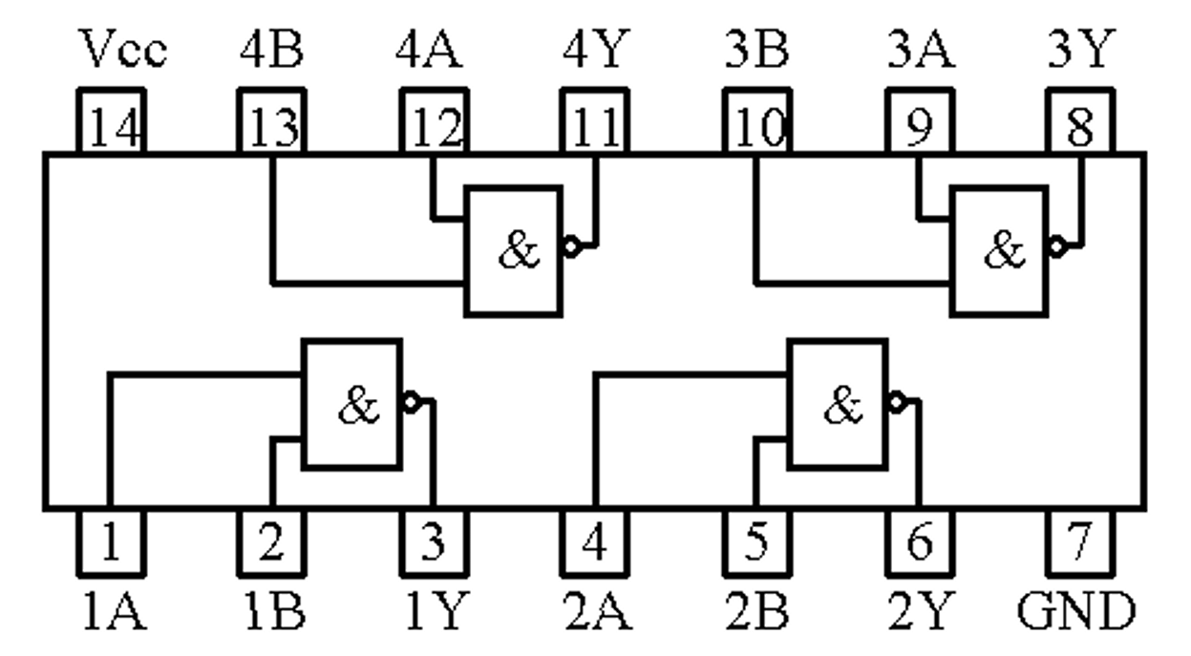
Fig 1- 1 Quadruple 2-Input NAND Gates 74LS00 pinout

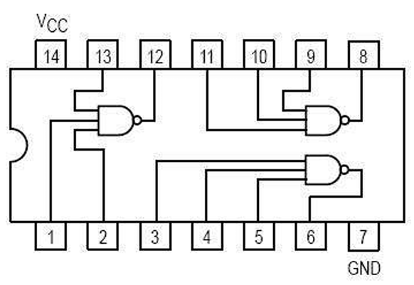
Fig 1- 2 Triple 3-Input NAND Gates 74LS10 pinout

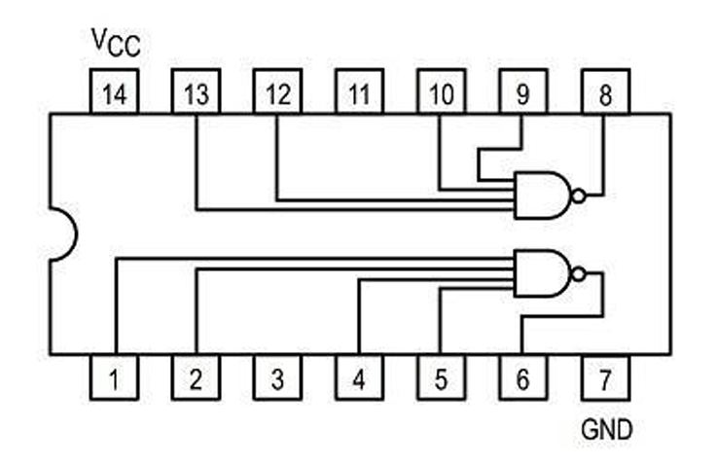
Fig 1- 3 Dual 4-Input NAND Gates 74LS20 pinout

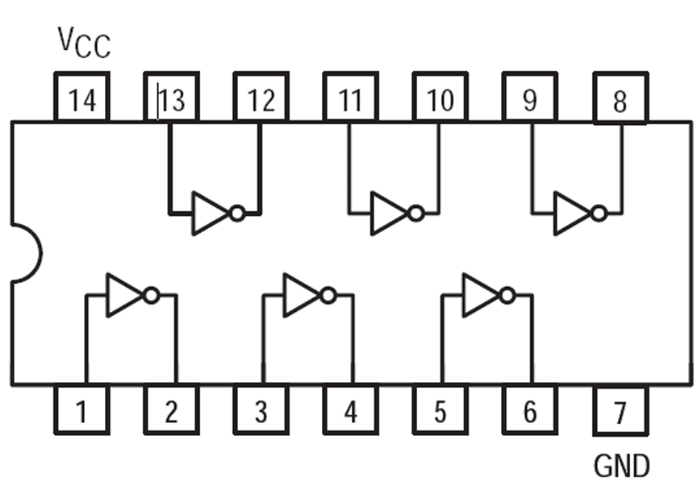
Fig 1- 4 Hex Inverters 74LS04 pinout

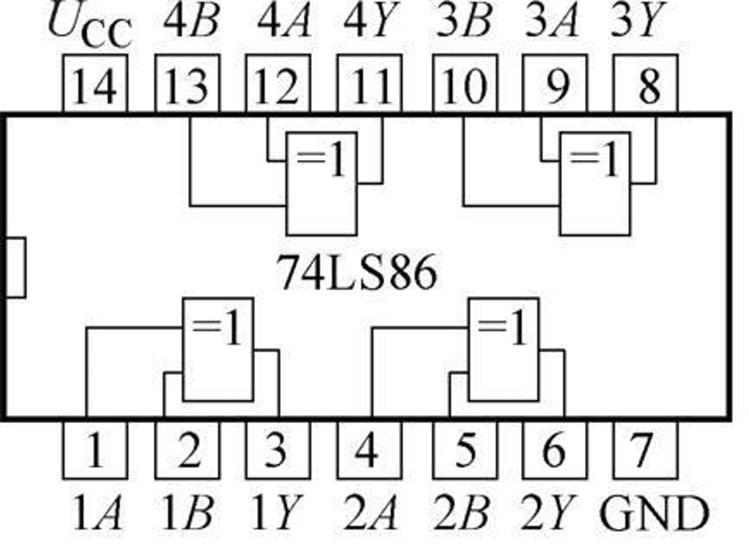
Fig 1- 5 Quadruple 2-Input XOR Gates 74LS86 pinout

【实验内容】
1. 设计一个电路实现3人多数表决器。
2. 设计一个电路实现1位2进制全加器。
1. Design a circuit to implement a 3-person majority vote decision-maker.
2. Design a circuit to implement a 1-bit binary full adder.

【实验分析及设计】
- 3-person majority vote decision-maker.
A | B | C | F
0 | 0 | 0 | 0
0 | 0 | 1 | 0
0 | 1 | 0 | 0
1 | 0 | 0 | 0
0 | 1 | 1 | 1
1 | 0 | 1 | 1
1 | 1 | 0 | 1
1 | 1 | 1 | 1
Table 1- 1 The truth table of 3-person majority vote decision-maker.

Thus, we have
$$F=\overline{A}BC+A\overline{B}C+AB\overline{C}+ABC=\overline{\overline{AB}⋅\overline{AC}⋅\overline{BC}}$$
My group uses one 74LS00 and one 74LS20 to build this.
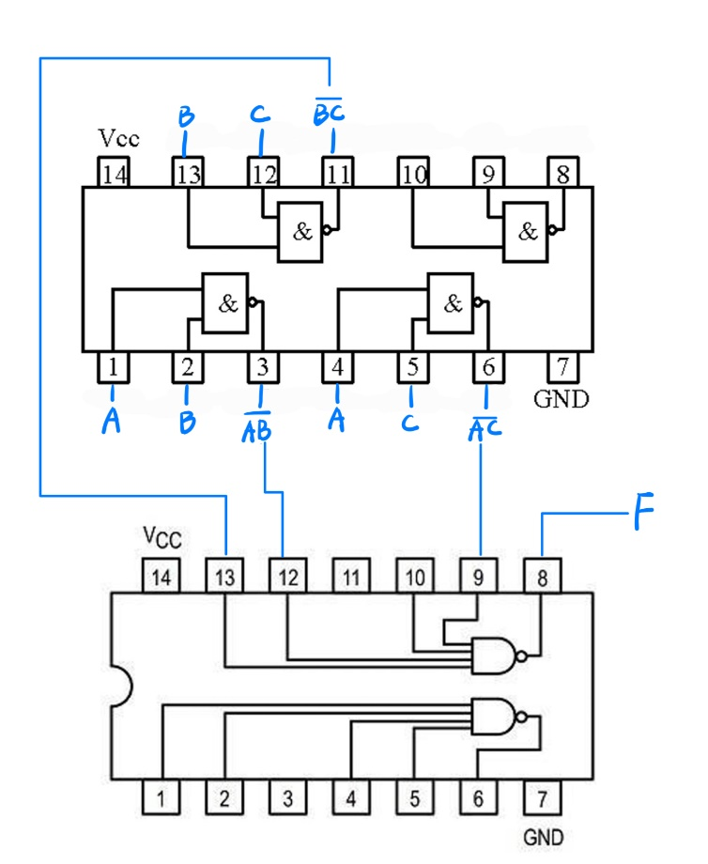

- 1-bit binary full adder.
A | B | CI | S | CO
0 | 0 | 0 | 0 | 0
0 | 0 | 1 | 1 | 0
0 | 1 | 0 | 1 | 0
0 | 1 | 1 | 0 | 1
1 | 0 | 0 | 1 | 0
1 | 0 | 1 | 0 | 1
1 | 1 | 0 | 0 | 1
1 | 1 | 1 | 1 | 1
Table 1- 2 The truth table of 1-bit binary full adder.

Thus, we have
$$S=\overline{A}\overline{B}CI+\overline{A}B\overline{CI}+A\overline{B}\overline{CI}+ABCI=A⊕B⊕CI$$
$$CO=\overline{A}BCI+A\overline{B}CI+AB=\overline{\overline{\left(A⨁B\right)∙CI}∙\overline{AB}}$$
My group uses one 74LS00 and one 74LS86 to build this.
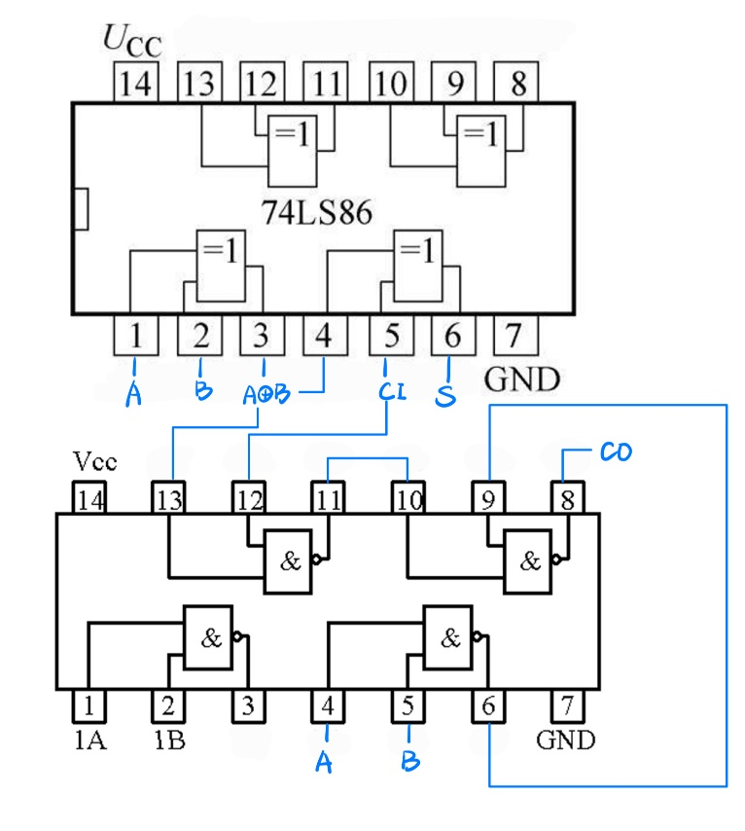

【小结或讨论】
实验很简单，弄明白公式的转换和芯片的原理后，剩下就只剩接线的方法问题。接线需要有条理，不然容易很乱。一个好的方法是先接电源和接地导线，再讲公式分块来接，会有条理很多。
实验中74LS86芯片极大的提高了效率，没有该芯片当然也可以实现实验的功能，但是会繁琐很多。

The experiment is quite simple. After understanding the transformation of the formula and the principle of the chip, what remains is the method of wiring. The wiring needs to be organized, otherwise it can get very messy. A good method is to first connect the power and ground wires, and then connect the formula in blocks, which will be much more organized.
The 74LS86 chip greatly improved efficiency in the experiment. It is possible to achieve the function of the experiment without this chip, but it would be much more cumbersome.

