ISE333 User Interface Development (Design)
期中考试卷整理版（含答案）
依据课堂讲解投影照片逐题转录；含图像题素材、已展示答案与识别置信标注
使用说明：本文件只整理照片中可辨认或可由同页答案/课程材料可靠补全的题目。对受彩色噪点、遮挡或截边影响的内容，以“[不清]”标记；由课程知识推断而非直接可见的答案，明确标注“推断”。未出现在照片中的题目编号保留但不虚构。

题目覆盖概览
部分 | 照片中可整理内容 | 状态
I. 选择题 | I.2–I.11、I.14–I.15；I.8局部文字不清 | 大部分可恢复
II. 填空/匹配 | II.1交互风格、II.2 FPIDP、II.3设计框架 | 可恢复，含图示
III. | 未在已上传照片中发现可辨认题干 | 保留缺口，不补造
IV. 分析与计算 | IV.1、IV.2、IV.3三角形像素覆盖计算 | 可完整恢复，含图示

I. Multiple-choice Questions / 选择题
I.1 未在照片中拍到题干或答案。
识别说明：缺失：不根据课程内容虚构题目。
I.2 The three-level organization of UID knowledge does not contain _______.
A. UID Guidelines
B. UID Principles
C. UID Theories
D. UID Laws
答案：D. UID Laws 〔识别说明：已由投影答案明确显示〕
I.3 Which of the following things do not belong to usability motivations?
A. Consumer electronics, e-commerce, and social media
B. Professional environments and sociotechnical (“socially-technical fused”) systems
C. Fully-automated industrial manufacturing and agricultural production
D. Exploratory, creative, and collaborative interfaces
答案：C. Fully-automated industrial manufacturing and agricultural production 〔识别说明：已由投影答案明确显示〕
I.4 ______ can be loosely defined as the outcome or the process of creating specifications for synthetic artifacts, such as products, services, and processes?
A. Deployment
B. Design
C. Integration & testing
D. Maintenance
答案：B. Design 〔识别说明：已由投影答案明确显示〕
I.5 Which of the following statement is wrong?
A. The interdisciplinary science of human-computer interaction (HCI) involves experimental psychology.
B. Although life-changing shifts were made possible, researchers and UIDers rarely harnessed technology to serve human needs.
C. Experts in human factors or ergonomics have contributed to UID.
D. Knowledge in the context of UID is not purely management-style knowledge.
答案：B. 〔识别说明：已由投影答案明确显示；投影注释：Researchers and UIDers did harness technology to serve human needs a lot.〕
I.6 Which of the following statement is not related to operational characteristics of the UID process?
A. Design is a dynamic process and cannot be adequately represented statically.
B. The design process is unpredictable and radically transformational, involving the development of partial and interim solutions that may ultimately play no role in the final outcome.
C. Design intrinsically involves discovery of new goals.
D. The design process is hierarchical and can be organized in a strictly top-down way.
答案：D. 〔识别说明：已由投影答案明确显示〕
I.7 ______ do not belong to the requirements analysis of the FPIDP?
A. Budget requirements
B. Functional requirements
C. Non-functional requirements
D. User experience (UX) requirements
答案：A. Budget requirements 〔识别说明：已由投影答案明确显示〕
I.8 Which of the following statement is wrong?
A. [前半句受严重噪点影响；可辨部分：… stairs / branches / handrails / infrastructure / administration hall / languages can be regarded as UI in their respective systems (“existing environments”).]
B. Food is one domain in which the core technology had not changed, but it was the UI that made a difference / enhanced the influence of the domain.
C. UIDers have accumulated a wealth of experience and researchers have produced a growing body of empirical evidence and theories, all of which can be organized into three levels.
D. Among the three levels of UID knowledge, theories are at the lowest level.
答案：D. 〔识别说明：答案在投影中可见；A、B个别词受噪点遮挡，按可见文字转录。〕
I.9 For UIs dedicated to professional environments, the two usability measures _______ and rate of errors by users are normally cared more than the others?
A. Time to learn
B. Retention over time
C. Speed of performance
D. Subjective satisfaction
答案：C. Speed of performance 〔识别说明：已由投影答案明确显示〕
I.10 Which of the following statement is wrong?
A. UIs are very much synthetic and they are artifacts that decidedly do not occur in nature.
B. Early computer applications were designed by programmers to be highly functional for the programmers themselves as well as non-technical audience for computers.
C. The current generation of users are less dedicated to the technology itself, but are more oriented toward their professional or recreational needs.
D. Although science and technology have been progressing rapidly in modern era, we are still far from having a “Tech Brain”.
答案：B. 〔识别说明：已由投影答案明确显示〕
I.11 Which of the following is related to group/community diversity?
A. Diverse cognitive abilities
B. Personality differences
C. Cultural & national differences
D. Variations in physical abilities
答案：C. Cultural & national differences 〔识别说明：基于课程“Group/Community Diversity”内容推断；照片未显示该题答案行。〕
I.12–I.13 未发现足够完整且可唯一确认的题干照片。
识别说明：缺失：避免将重复投影页误判为新题。
I.14 Which of the following statement is not true about use cases?
A. The use case is a concept from software engineering, intended for writing functional requirements.
B. They are formalized scenarios that capture operations between the actor and the system in a step-by-step manner.
C. The set of UI functionalities should simply be a sum of its use cases and no functionality should be implemented that does not explicitly support at least one use case.
D. Use cases do not give any recipe for evaluation of the UI system.
答案：D. 〔识别说明：已由投影答案明确显示〕
I.15 ______ do not belong to principles of UID?
A. Follow a high-level widely applicable framework
B. Determine users’ skill levels
C. Identify the tasks and choose an interaction style
D. Ensure human control while increasing automation
答案：A. Follow a high-level widely applicable framework 〔识别说明：已由投影答案明确显示〕

II. Fill-in / Matching Questions
II.1 [4 pts] UI interaction styles include direct manipulation, navigation (menu selection), form fill-in, natural language, and command language. Given the following UI illustrations, fill their corresponding interaction styles respectively.
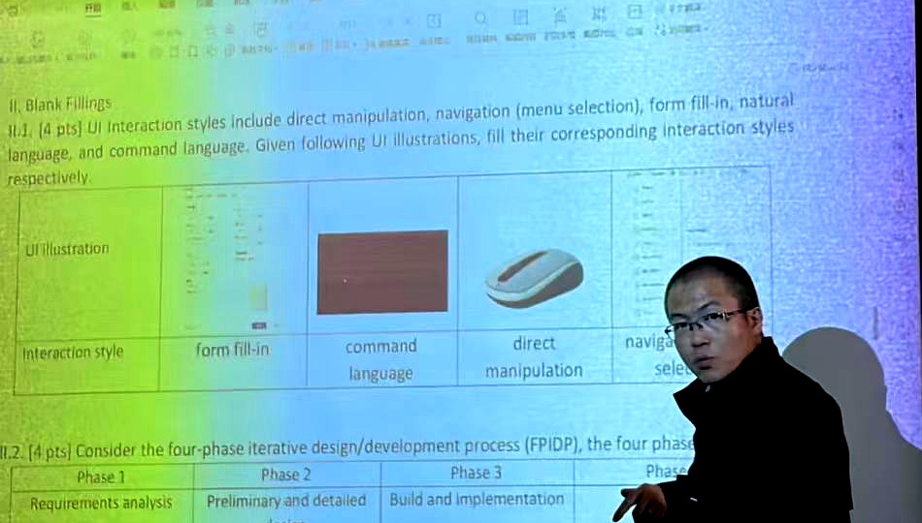
答案：依图从左到右：form fill-in；command language；direct manipulation；navigation (menu selection)。 〔识别说明：投影答案行可见；第4格因人物遮挡，但“naviga… sele…”与课程五种交互风格可唯一确认。〕
II.2 [4 pts] Consider the four-phase iterative design/development process (FPIDP), the four phases are:
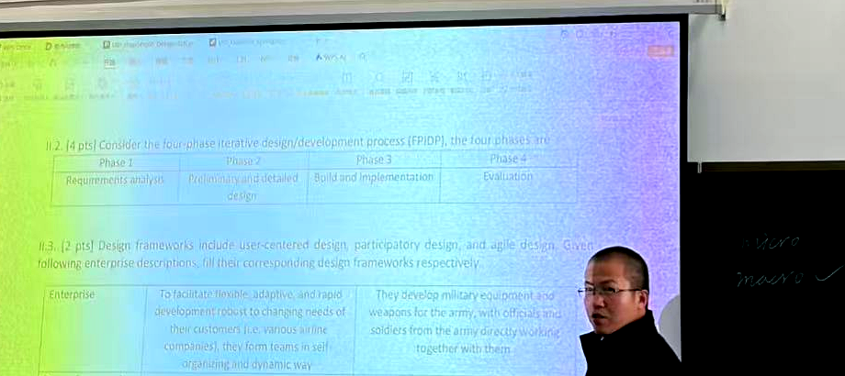
答案：Phase 1: Requirements analysis；Phase 2: Preliminary and detailed design；Phase 3: Build and implementation；Phase 4: Evaluation。 〔识别说明：投影表格可辨认；由课程设计流程内容复核。〕
II.3 [2 pts] Design frameworks include user-centered design, participatory design, and agile design. Given the following enterprise descriptions, fill their corresponding design frameworks respectively.
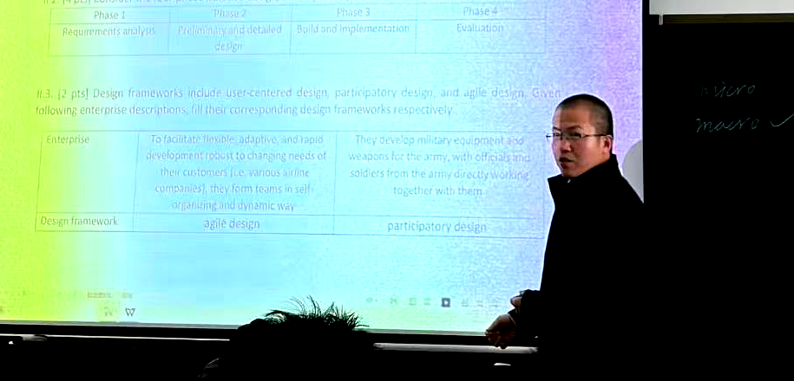
答案：左列企业：agile design；右列企业：participatory design。 〔识别说明：投影答案行可见；企业描述中局部词受拍摄噪点影响，不影响匹配答案。〕

III. [Not captured / 未拍到]
已上传图片中未找到第 III 部分的可辨题干或答案，因此本整理版不编造该部分内容。

IV. Analytical Computations and Clarifications / 分析计算题
IV.1 [5 pts] A director observes that the actual project duration needed to achieve 99% project objective is always about five times the open-loop period. Estimate the OL error rate of the company’s working system? Show details.
答案：OL error rate: E^5 = 1 − 99% = 0.01 ⇒ E = 0.01^(1/5) = 39.81%. 〔识别说明：已由投影答案明确显示。〕
IV.2 [5 pts] (Following IV.1.) The director also observes that both the PDD error rate and the BI error rate are about 10%. Estimate the RA error rate? Show details.
答案：E = (1 + R)(1 + D)(1 + I) − 1 ⇒ R = (1 + E)/((1 + D)(1 + I)) − 1 = (1 + 0.3981)/(1.1 × 1.1) − 1 = 15.55%. 〔识别说明：已由投影答案明确显示。〕
IV.3 Given a triangle with its shape characterized by the illustrated corner points A, B, and C. For visualization in a graphical UI, A, B, and C should be located at the pixel (500,400), the pixel (200,100), and the pixel (600,100) respectively. (1) For pixels internal to the triangle, their pixel value should be 0 (black). (2) For pixels external to the triangle, their pixel value should be 255 (white). (3) For a boundary pixel (partially internal and partially external to the triangle), its pixel value should be a weighted average according to the areas of its black and white parts: pixel value = (black area ratio)×(black value) + (white area ratio)×(white value).
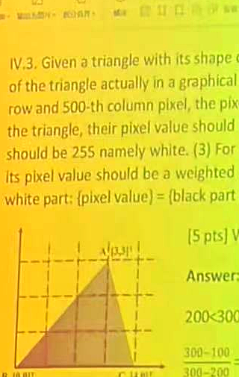
IV.3-a [5 pts] What is the pixel value of the pixel (300,300)? Show details.
答案：255. Since 200 < 300 < 500, (300,300) lies horizontally between B and A. Compare slopes: (300−100)/(300−200) = 2 > (400−100)/(500−200) = 1, so (300,300) is above edge AB and external to the triangle. 〔识别说明：已由投影答案明确显示。〕
IV.3-b [5 pts] What is the pixel value of the pixel (500,200)? Show details.
答案：0. B and C have y = 100, so BC is horizontal; 100 < 200, hence (500,200) is above BC. Also (200−100)/(500−200) = 1/3 < (400−100)/(500−200) = 1, so it is below AB. Therefore it is inside the triangle. 〔识别说明：已由投影答案明确显示。〕
IV.3-c [5 pts] What is the pixel value of the pixel (550,250)? Show details.
答案：128. (250−100)/(550−500) = 3 = (400−100)/(600−500) = 3, so the center of the pixel square is exactly on edge AC. By geometric symmetry, black and white areas are each 0.5: 0.5×0 + 0.5×255 = 127.5, rounded to 128. 〔识别说明：已由投影答案明确显示；投影特别说明：image pixel values are integers。〕

答案速览 / Answer Key
题号 | 答案 | 题号 | 答案
I.2 | D | I.3 | C
I.4 | B | I.5 | B
I.6 | D | I.7 | A
I.8 | D | I.9 | C
I.10 | B | I.11 | C（推断）
I.14 | D | I.15 | A
II.1 | Form fill-in / Command language / Direct manipulation / Navigation | II.2 | Requirements analysis / Preliminary & detailed design / Build & implementation / Evaluation
II.3 | Agile design / Participatory design | IV.1 | 39.81%
IV.2 | 15.55% | IV.3 | (300,300)=255; (500,200)=0; (550,250)=128

识别与推断说明
• 本整理版以课堂投影照片为主，保留原英文题干，不对照片缺失的题目进行填造。
• 含“推断”字样的仅有 I.11，其选项与课程 Universal Usability 中的 “Group/Community Diversity” 对应关系明确；其余答案均在投影页中显示。
• I.8 的 A、B 选项局部受到彩色噪点与人物遮挡影响，已保留可识别内容并标注不确定处。
• 题目中的关键视觉内容已作为图像附入：交互风格示例、FPIDP 阶段表、设计框架匹配表、三角形像素覆盖示意。

