CSE 331 Spring 2026
Homework 1

SEED Labs - MD5 Collision Attack Lab

Acknowledgement:
I confirm that this submission, including all code and figures, is entirely my own work.

Full Name: 尤晟喧
Student ID: R32314015
Date: 2025.3.16

2.1 Task 1: Generating Two Different Files with the Same MD5 Hash
All questions in the homework should be answered in English.
– Question 1. If the length of your prefix file is not multiple of 64, what is going to happen?
Answer:When the prefix file length is not a multiple of 64 bytes, md5collgen automatically adds padding (null bytes) to fill up to the nearest 64-byte boundary before appending the 128-byte collision data.

– Question 2. Create a prefix file with exactly 64 bytes, and run the collision tool again, and see what happens.
Answer:When the prefix is exactly 64 bytes (one MD5 block), no padding is needed, and the collision data (128 bytes) is appended directly after the prefix.

– Question 3. Are the data (128 bytes) generated by md5collgen completely different for the two output files? Please identify all the bytes that are different.
Answer: No, the 128 bytes of collision data are NOT completely different. Only 8 bytes differ between out1.bin and out2.bin in the collision region.

Offset (hex) | Offset (dec) | out1.bin | out2.bin
0x52 | 18 | 0xdb | 0x5b
0x6e | 46 | 0x21 | 0xa1
0x77 | 55 | 0x91 | 0x11
0x92 | 82 | 0xfc | 0x7c
0xa6 | 102 | 0xa2 | 0x22
0xb7 | 119 | 0xe3 | 0x63

Screenshots for task 1(Replace the three screenshots below with your own screenshots):
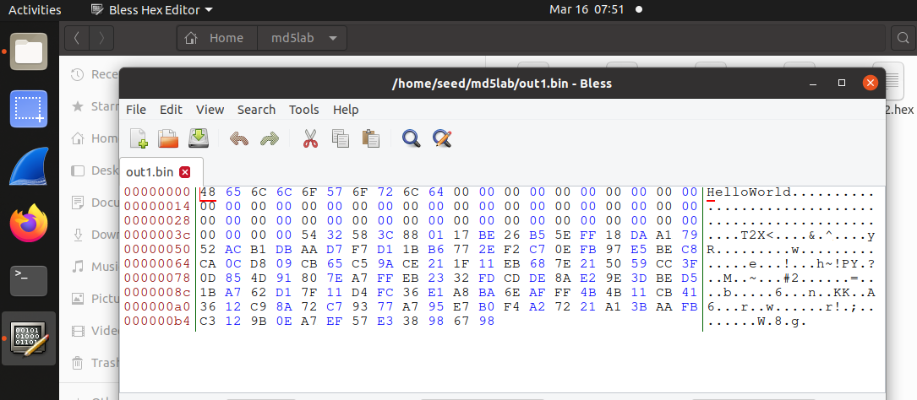

Figure 1 Contents of out1.bin
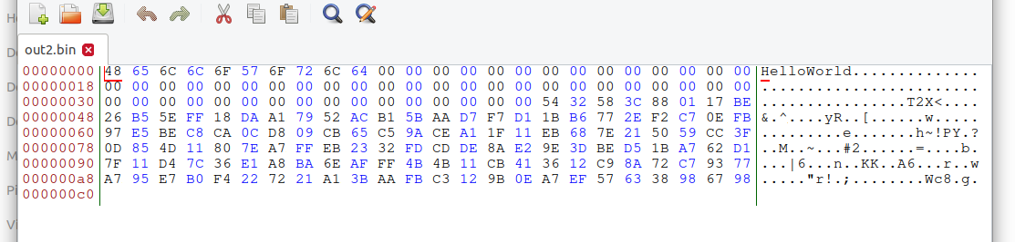

Figure 2 Content of out2.bin
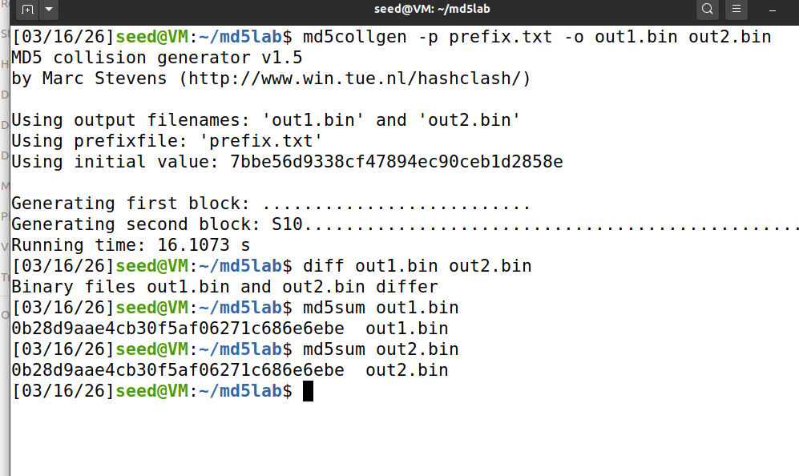
Figure 3 Terminal log showing that out1.bin and out2.bin are different files, yet have the same md5 hashcode
Note: All three of your screenshots for 2.1 should be on this page only. Your screenshots of the terminal window should show the entire window. Do not take pictures with your phone!

2.2 Task 2: Understanding MD5’s Property
“If inputs M and N have the same hash, adding the same suffix T to them will result in two outputs that have the same hash value.”
– Question 4. Explain how you demonstrate that the property above holds for MD5. Keep your answer short and precise.
Answer:
# Start with MD5 collision pair (out1.bin ≠ out2.bin, but MD5(out1) = MD5(out2))
# Add identical suffix to both:
cat out1.bin > out1_suffix.bin && echo "SUFFIX" >> out1_suffix.bin
cat out2.bin > out2_suffix.bin && echo "SUFFIX" >> out2_suffix.bin
# Result:
# - out1_suffix.bin ≠ out2_suffix.bin (files still differ)
# - MD5(out1_suffix) = MD5(out2_suffix) = 0bf8e434c9e5a546c20c297ce8c5ea8a

No screenshots are needed for this task.
2.3 Task 3: Generating Two Executable Files with the Same MD5 Hash
Look at the Figure 3 in the lab manual, and answer the following questions:
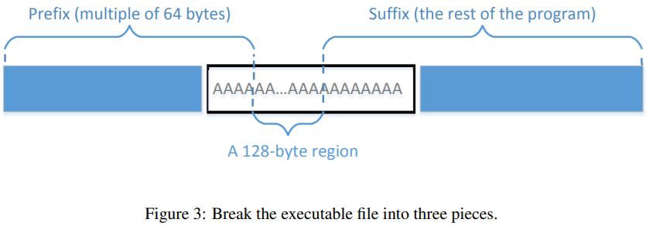
– Question 5. How long is your executable file? (exact number of bytes in decimal)
Answer: 256 bytes
– Question 6. How long is your prefix? (exact number of bytes in decimal)
Answer: 128 bytes
– Question 7. After compiling you C code and generating the executable file, what instructions did you run to generate two different 128-byte regions for the prefix?
Answer: Used ‘dd’ to generate two different 128-byte random prefixes.

No screenshots are needed for this task.
2.4 Task 4: Making the Two Programs Behave Differently
Look at the Figure 4 in the lab manual, and answer the following questions:
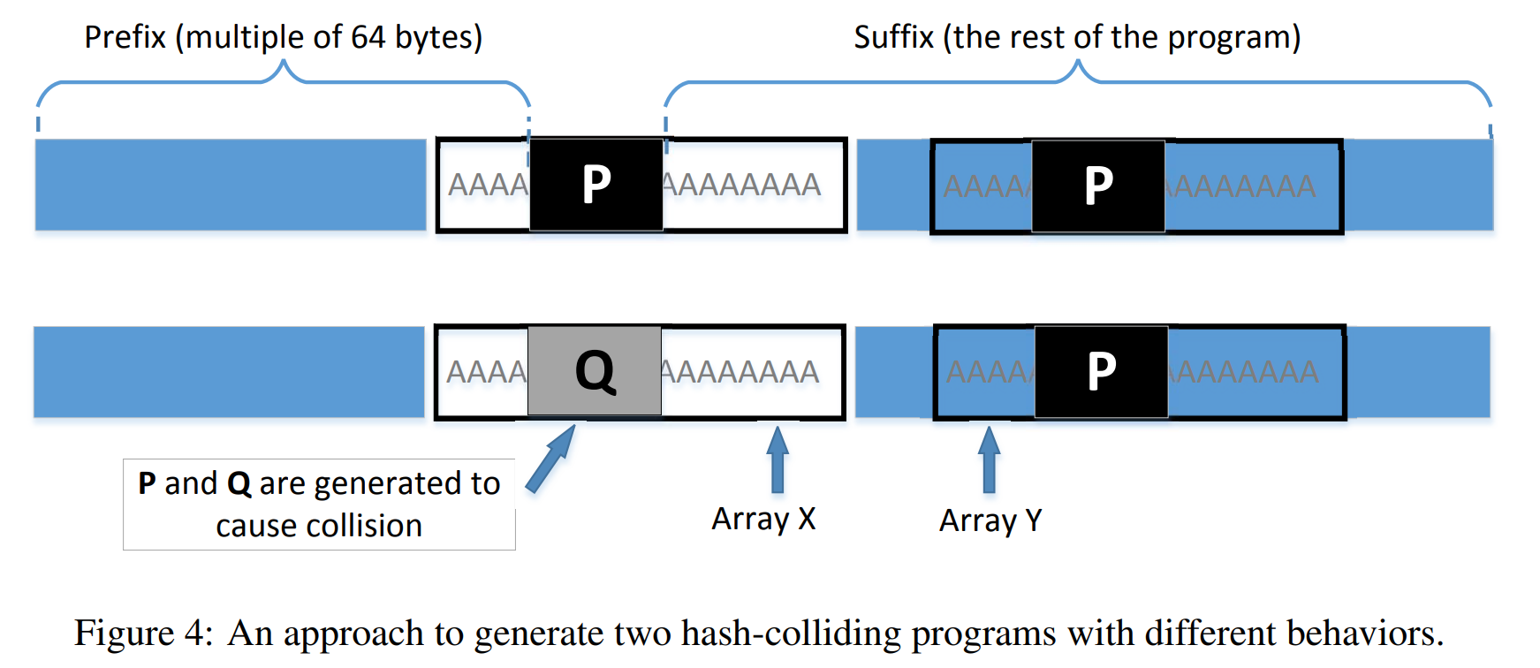
– Question 8. How long is your new executable file? (exact number of bytes in decimal)
Answer: 17000
– Question 9. How long is your prefix? (exact number of bytes in decimal)
Answer: 12288 byte
– Question 10. What is the starting address of P in the entire executable file? (Hexadecimal, can be read from Bless or HxD or other hex editors)
Answer: 0x3000

Screenshots for task 4(Replace the three screenshots below with your own screenshots):
Again, look at Figure 4 in the lab manual. The first screenshot should show P and P in the first executable.
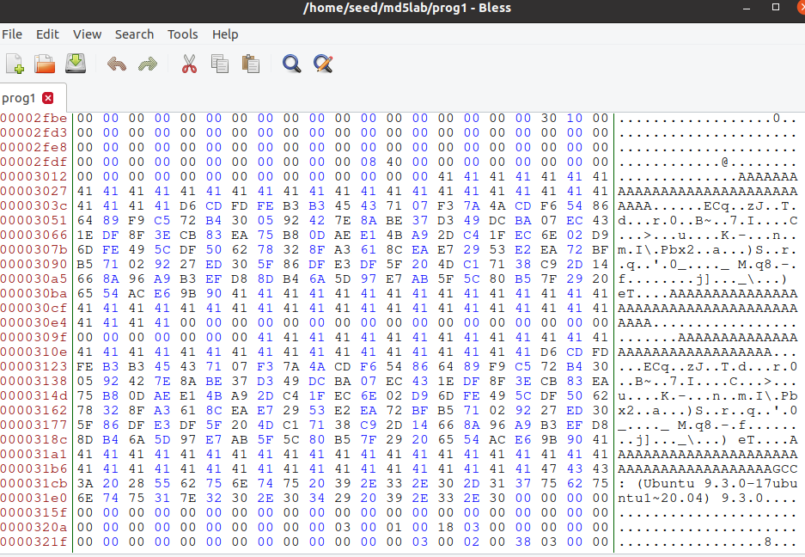
Figure 4 Contents of first executable, showing array X and Y contents, they both contain P

The second screenshot should show P and Q in the second executable. Mark at least one difference between P and Q.
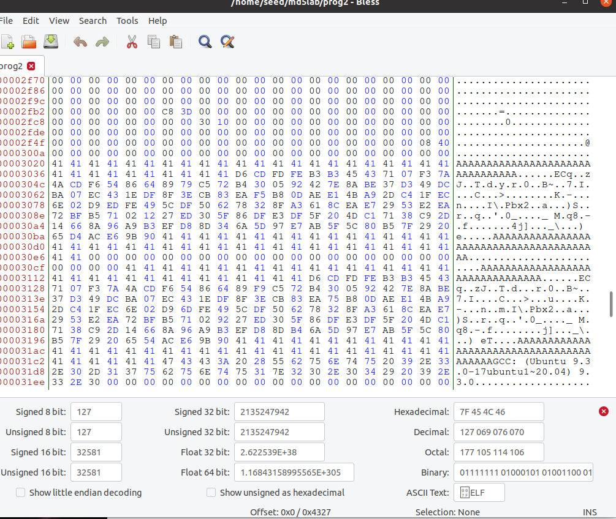
Figure 5 Contents of second executable, showing array X and Y contents, X contains Q, Y contains P

The third screenshot should show that the md5sum for both executables are the same, but their output results are different.
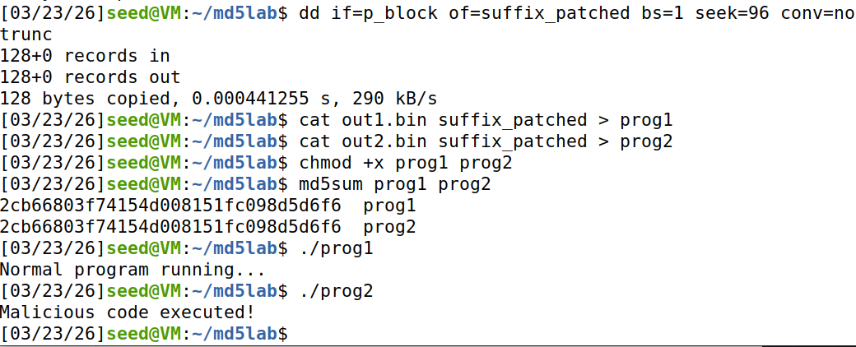
Figure 6 Terminal log showing that run1 and run2 have the same md5sum, but different outputs.
There’s amazing that these two prog actually having same MD5 but they have diff output

3 Submission
Convert the finished template to pdf and upload it together with three files in one zip package:
1. The source code file in step 2.4.
2. The first executable in step 2.4(contains P and P).
3. The second executable in step 2.4(contains P and Q).
Do not upload any other files.

# 1. 重新切割前缀 (12352字节)
head -c 12352 task4.out > prefix
# 2. 生成碰撞文件 (这会产生 out1.bin 和 out2.bin)
md5collgen -p prefix -o out1.bin out2.bin
# 3. 提取碰撞块 P (out1.bin 的最后 128 字节)
tail -c 128 out1.bin > p_block
# 4. 提取原始后缀
tail -c +12481 task4.out > suffix_orig
# 5. 准备 32 字节的 'A' (0x41) 来填充 Y 的前 32 位，确保与 X 对齐
printf '\x41%.0s' {1..32} > a_pad
# 6. 开始给后缀打补丁
cp suffix_orig suffix_patched
# 将 'A' 写入 Y 的起始位置 (Offset 64)
dd if=a_pad of=suffix_patched bs=1 seek=64 conv=notrunc
# 将 P 块写入 Y 的对应位置 (Offset 96)
dd if=p_block of=suffix_patched bs=1 seek=96 conv=notrunc
# 7. 合成两个程序
cat out1.bin suffix_patched > prog1
cat out2.bin suffix_patched > prog2
By these steps I finally finished 2.4 .Damn! I’ve thinking for a long time to think out the problem is that I have no P_block in Array_Y in two program ,so every time X is diff with Y. Haha , how stupid!

