CSE 331 Spring 2026
Homework 6

SEED Labs
Buffer Overflow Attack Lab
(Server Version)

Acknowledgement:
I confirm that this submission, including all code and figures, is entirely my own work.

Full Name: ____尤晟喧_____
Student ID: ____R32314015_____
Date: _____2026.05.20_________

Complete this template based on the manual provided. Answer in English. (Homework_6_Manual_Buffer_Overflow_Server.pdf, available in English and Chinese).
3 Task 1: Get Familiar with the Shellcode
– Question 1. Show your modified shellcode to delete a file. You just need to modify the snippet below.
# The * in this line serves as the position marker *
"rm -iv Readme.md *"
"AAAAAAAA" # Placeholder for argv[0] --> "/bin/bash"
"BBBBBBBB" # Placeholder for argv[1] --> "-c"
"CCCCCCCC" # Placeholder for argv[2] --> the command string
"DDDDDDDD" # Placeholder for argv[3] --> NULL

Screenshot for Task 1 (Replace the screenshot below with your own screenshot):
Show your screenshot of removing a file. Its name should match your code above. You can use either 32-bit or 64-bit version.
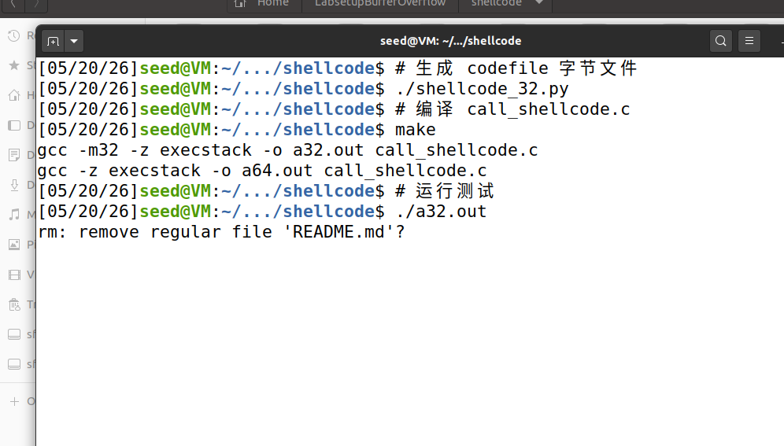
Figure 1 Using shellcode to remove a file

4 Task 2: Level-1 Attack
4.1 Server
Screenshot for Task 2 4.1 (Replace the screenshot below with your own screenshot):
Show your screenshot of the messages printed out by the target container.
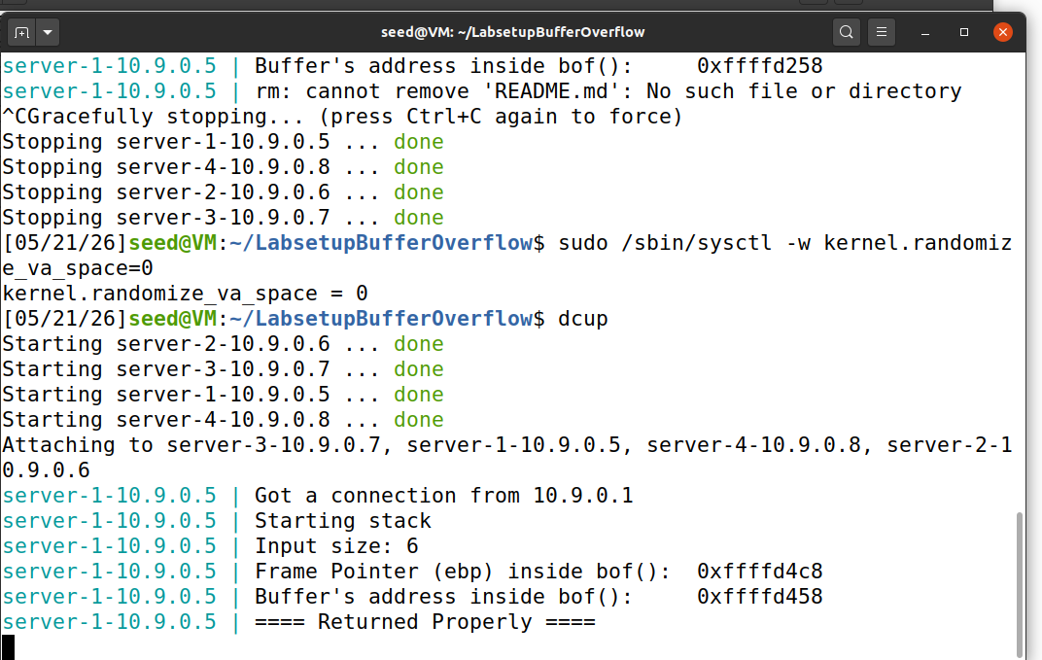
Figure 2 Messages printed out by the target container, after receiving echo hello

4.2 Writing Exploit Code and Launching Attack
– Question 2. What are your start, ret, and offset variables? Fill in the blank below.
start = 381
ret = 0xffffd52c
offset = 116
– Question 3. Explain how you determined the value of ret and offset.
Answer:
offset = ebp地址 - 缓冲区地址 + 4
start = 517 - len(shellcode)
ret = 缓冲区地址 + 偏移量

Screenshot for Task 2 4.2 (Replace the screenshot below with your own screenshot):
Show your screenshot of getting the reverse shell on the target server 10.9.0.5.
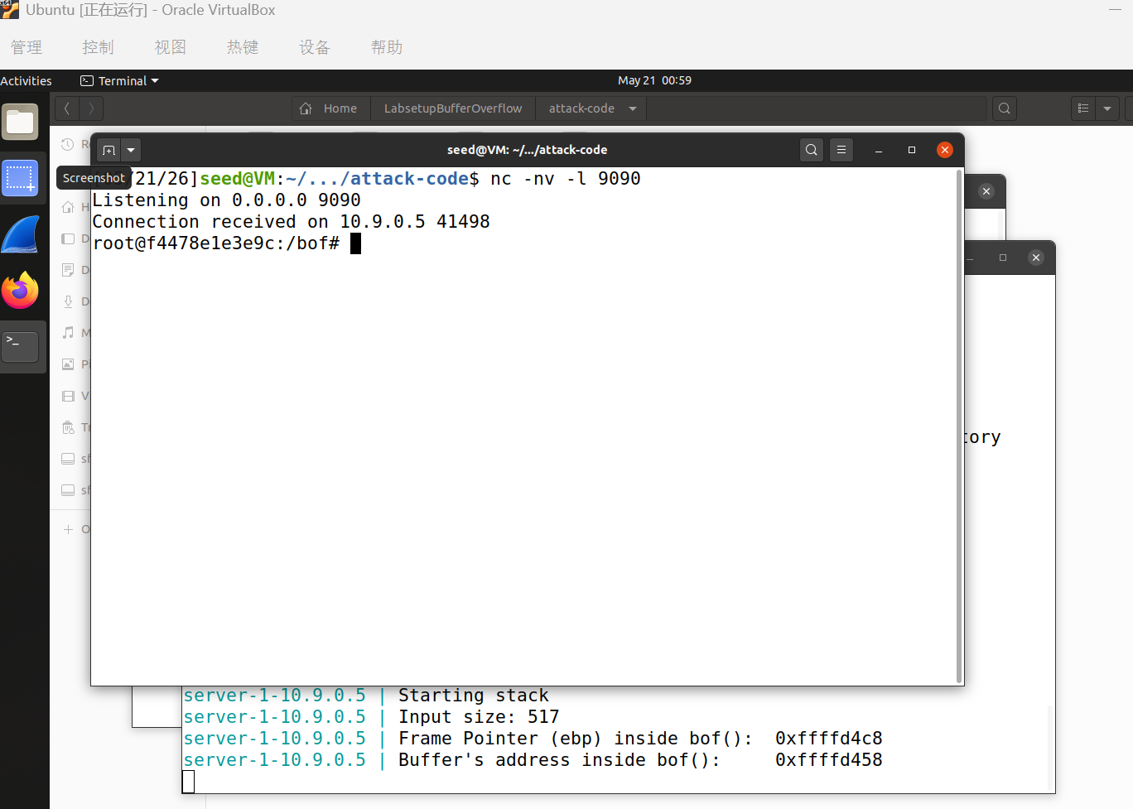
Figure 3 Reverse shell on the target server 10.9.0.5

5 Task 3: Level-2 Attack
– Question 4. What are your start, ret, and offset variables? Fill in the blank below.
start =381
ret = 0xffffd2c4
offset: 196(Answer separately if needed)
– Question 5. Explain how you determined the value of ret and offset.
Answer:
The server prints the buffer address before the overflow occurs. By checking Docker logs (docker logs server-2-10.9.0.6), I obtained the buffer address (e.g., 0xffffd198). The return address was set to buffer_addr + 300, which points safely into the NOP sled region of the payload (between offset 200 and 380), well before the shellcode at offset 381. The +300 offset provides tolerance for minor stack address variations caused by the randomized environment variable.

Screenshot for Task 3 (Replace the screenshot below with your own screenshot):
Show your screenshot of getting the reverse shell on the target server 10.9.0.6.
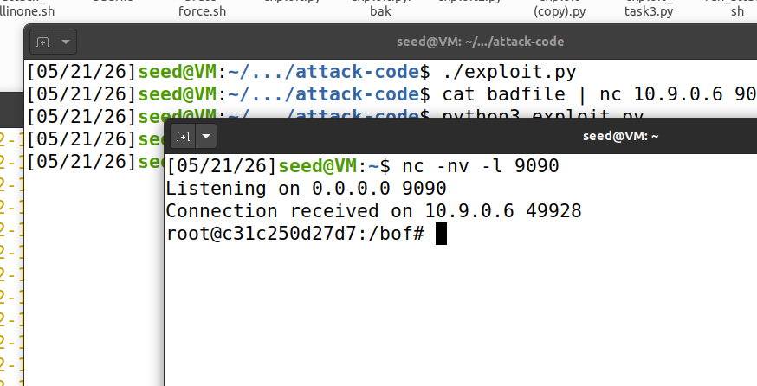
Figure 4 Reverse shell on the target server 10.9.0.6

6 Task 4: Level-3 Attack
– Question 6. What are your start, ret, and offset variables? Fill in the blank below.
start = 0
ret = 0x00007fffffffe0c0
offset = 216
– Question 7. Explain how you determined the value of start, ret and offset.
Answer:
64bit addresses (e.g. 0x00007fff...) contain null bytes. strcpy stops at the first 0x00. The return address at offset 216 has nulls at bytes 6–7, so only 222 bytes of payload are copied. Shellcode is placed at offset 0 to ensure it's fully copied before strcpy truncation.
Obtained from docker logs server-3-10.9.0.7. Points to buffer start (= shellcode start). Lower 6 bytes (c0 e0 ff ff ff 7f) have no nulls, so strcpy copies them onto the saved return address; upper 2 bytes (00 00) remain as-is on the stack, forming the complete 64-bit address.
Screenshot for Task 4 (Replace the screenshot below with your own screenshot):
Show your screenshot of getting the reverse shell on the target server 10.9.0.7.
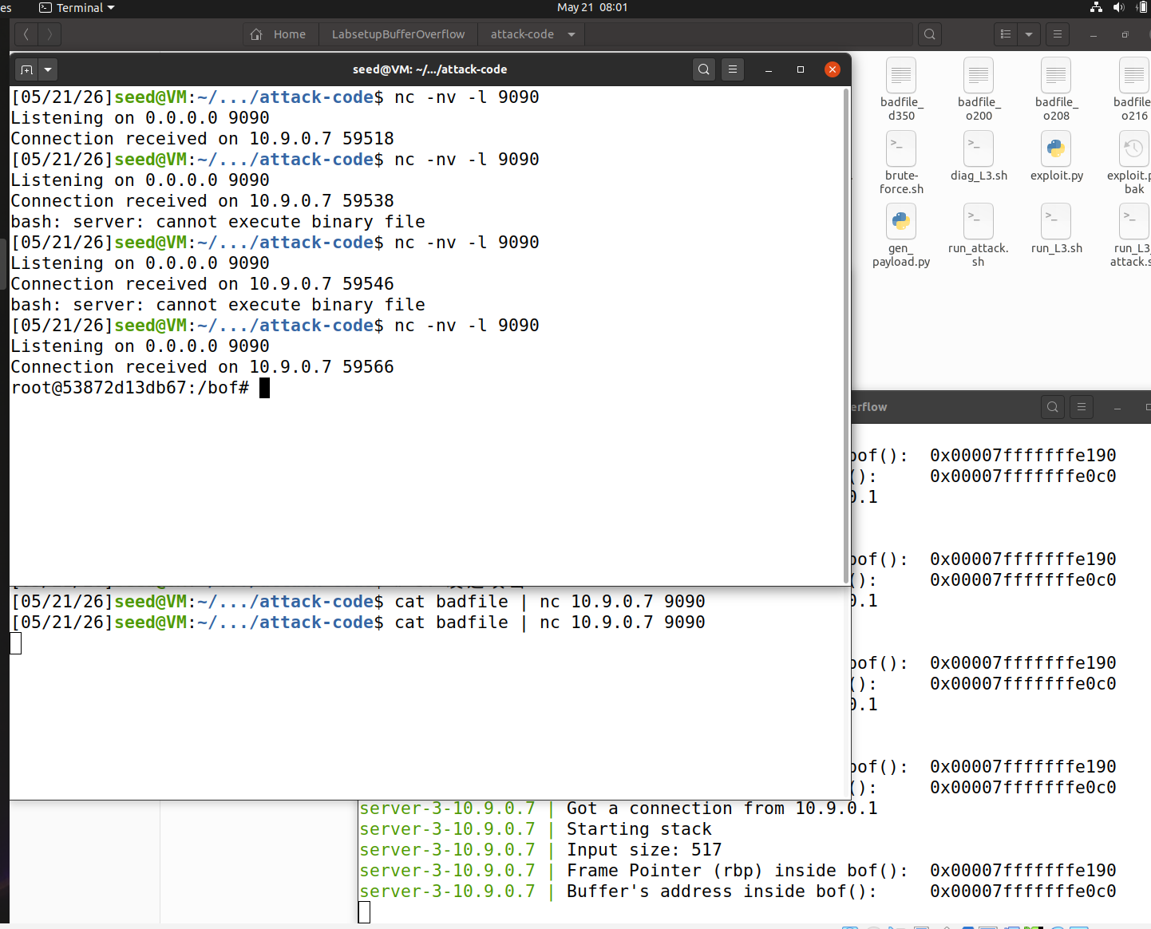
Figure 5 Reverse shell on the target server 10.9.0.7
7 Task 5: Level-4 Attack
– Question 8. What are your start, ret, and offset variables? Fill in the blank below.
start = 200
ret = 0x7fffffffe688
offset = 104
– Question 9. Explain how you determined the value of start, ret and offset.
Answer: For L4, offset was set to 104 by disassembling stack-L4 with objdump, where buffer sits at RBP-0x60 and the return address at RBP+8, giving 96+8=104. Since BUF_SIZE=80 makes offset=104 smaller than the 165-byte shellcode, placing the shellcode at the payload start would cause the return address at payload[104:111] to overwrite shellcode data, so start was moved to 200 to keep the shellcode safe. For ret, I computed the address of str in main's frame — which remains intact because the overflow cannot reach it past the 1000-byte dummy_buffer — by tracing the stack frame chain from the server-printed bof frame pointer up through dummy_function and main, yielding str = main_RBP - 0x210 = 0x7fffffffe5c0; ret was then set to str + 200 = 0x7fffffffe688, pointing directly to the uncorrupted shellcode.
Screenshot for Task 5 (Replace the screenshot below with your own screenshot):
Show your screenshot of getting the reverse shell on the target server 10.9.0.8.
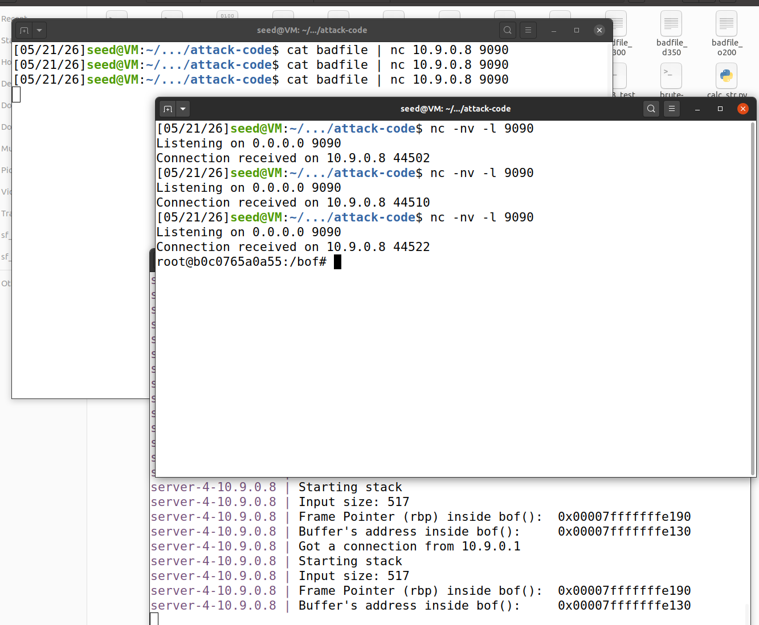
Figure 6 Reverse shell on the target server 10.9.0.8

8 Task 6: Experimenting with the Address Randomization
Screenshot for Task 6 (Replace the screenshot below with your own screenshot):
Show your screenshot of the messages printed by the target container. The messages should show the result of ASLR.
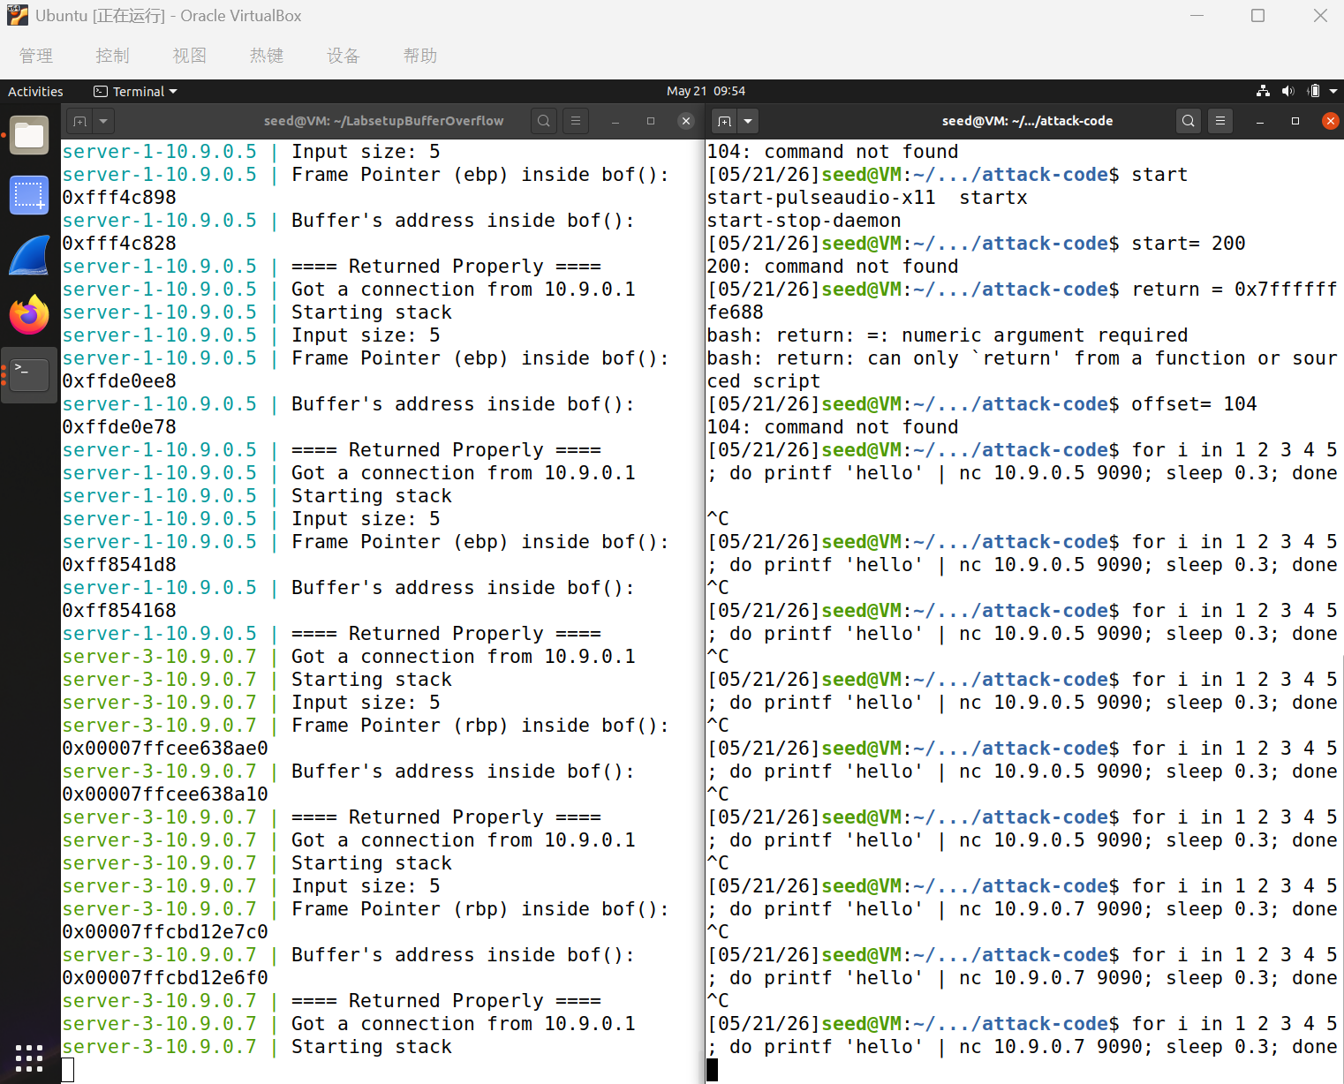
Figure 7 Messages showing the result of ASLR
– Question 10. From your observation of the messages, explain why ASLR makes the buffer-overflow attack more difficult.
Answer:## Q10: Why does ASLR make buffer overflow attacks more difficult?

ASLR randomizes the stack base address on each execution, so the buffer address changes every time. With ASLR=2, the buffer address varied by gigabytes across connections (e.g., `0xffde6228` → `0xfff51138`). Without a fixed address, the hardcoded return address in the exploit becomes invalid — it points to a random, unpredictable location instead of the shellcode. The attacker must either leak the address at runtime or brute-force a vast address space, making exploitation impractical.

You don’t need to complete Defeating the 32-bit randomization, as it is mostly luck-based.

9 Task 7: Experimenting with Other Countermeasures
9.1 Task 7.a: Turn on the StackGuard Protection
Screenshot for Task 7.a (Replace the screenshot below with your own screenshot):
Show your screenshot containing the result of turning on the StackGuard Protection.
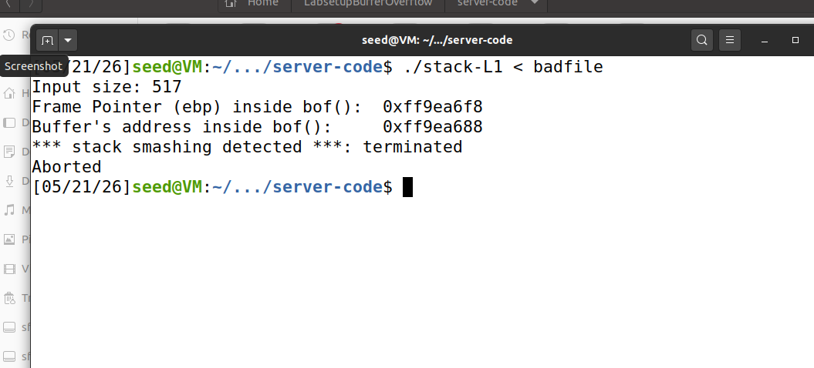
Figure 8 Result of turning on the StackGuard Protection
– Question 11. Explain your observations for this task.
Answer:
When StackGuard is enabled, the compiler inserts a random canary value between the buffer and the return address. Overflowing the buffer corrupts the canary. Before returning, bof() checks the canary — if modified, the program aborts with "stack smashing detected", preventing the attacker from hijacking control flow.

9.1 Task 7.b: Turn on the StackGuard Protection
Screenshot for Task 7.b (Replace the screenshot below with your own screenshot):
Show your screenshot containing the result of turning on the Non-executable Stack Protection.
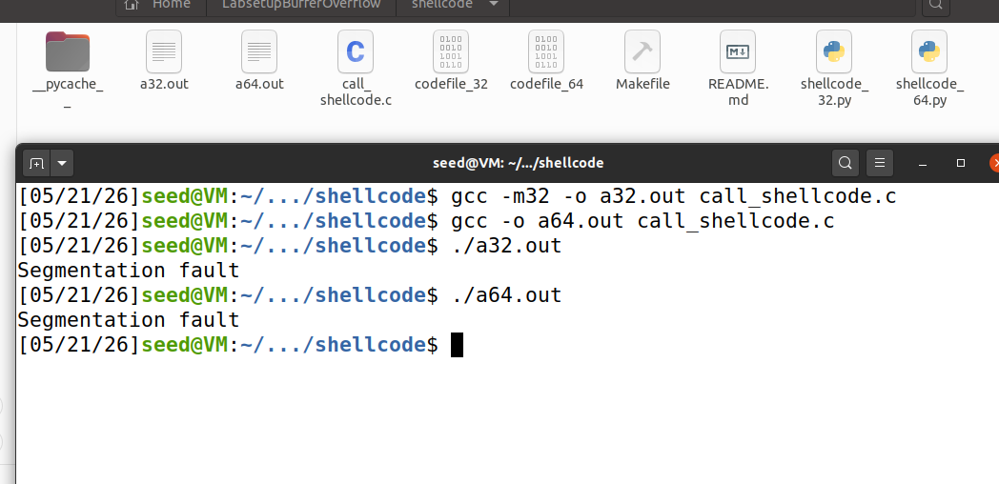
Figure 9 Result of turning on the Non-executable Stack Protection
– Question 12. Explain your observations for this task.
Answer:
The NX (Non-Executable) bit marks the stack memory as read/write only, without execute permission. When the exploit overwrites the return address to point to shellcode placed on the stack, the CPU detects an attempt to execute instructions from a non-executable memory region and raises a segmentation fault. The buffer overflow still corrupts the return address, but the shellcode never runs because the hardware refuses to fetch instructions from the stack.

10 Submission
Convert the finished template to PDF and upload. Do not upload .docx or any other files.

