CSE 331 Spring 2026
Homework 7

SEED Labs
Race Condition Vulnerability Lab

Acknowledgement:
I confirm that this submission, including all code and figures, is entirely my own work.

Full Name: _________
Student ID: _________
Date: ______________

Complete this template based on the manual provided. Answer in English. (Homework_7_Manual_Race_Condition.pdf, available in English and Chinese).
3 Task 1: Choosing Our Target
Screenshot for Task 1 (Replace the screenshots below with your own screenshots):
Show your screenshot of the end of /etc/passwd file, with the magic value. You can use other text editors.
Figure 1 Magic value at the end of the /etc/passwd file
– Question 1. Please report whether you can log into the test account without typing a password, and check whether you have the root privilege.
Answer:

Also, show your screenshot of logging into the test account, and show root privilege status.
Figure 2 Logging into the test account and showing root privilege status
4 Task 2: Launching the Race Condition Attack
4.1 Task 2.A: Simulating a Slow Machine
– Question 2. What did you do before running the vulp program? Provide instructions (if any).
Answer:

– Question 3. What did you enter when the vulp program is reading user input?
Answer:
– Question 4. What did you do during the 10 seconds sleep time? Provide instructions (if any).
Answer:

Screenshot for Task 2.A (Replace the screenshot below with your own screenshot):
Show your screenshot of the messages printed out by executing ls -ld /tmp/XYZ command, both BEFORE and AFTER executing the vulp program.
Figure 3 Messages printed out by the ls -ld /tmp/XYZ instruction, before and after executing vulp program

4.2 Task 2.C: An Improved Attack Method
– Question 5. The lab manual says “The following program first makes two symbolic links /tmp/XYZ and /tmp/ABC, and then using the renameat2 system call to atomically switch them.” What does “atomically” mean in the context of this task? Why is it needed?
Answer:

– Question 6. Show your target_process.sh file below. You need to modify the original file; show your modification in red color.
#!/bin/bash
CHECK_FILE="ls -l /etc/passwd"
old=$($CHECK_FILE)
new=$($CHECK_FILE)
while [ "$old" == "$new" ]
do
echo "hello" | ./vulp
new=$($CHECK_FILE)
done
echo "STOP... The passwd file has been changed"

Screenshot for Task 2.C (Replace the screenshot below with your own screenshot):
Show your screenshot of the messages printed out by executing the .sh file. Only show the last part, where you successfully performed the attack.
Figure 4 Messages printed out by executing the .sh file, showing only the last part, where the attack is successful

5.1 Task 3.A: Applying the Principle of Least Privilege
– Question 7. Show your modified vulp source code for this task below. You need to modify the original file; show your modification in red color.
#include <stdio.h>
#include <stdlib.h>
#include <string.h>
#include <unistd.h>

int main()
{
char* fn = "/tmp/XYZ";
char buffer[60];
FILE* fp;
uid_t real_uid = getuid();
uid_t eff_uid = geteuid();

/* get user input */
scanf("%50s", buffer);
if (!access(fn, W_OK)) {

fp = fopen(fn, "a+");
if (!fp) {
perror("Open failed");
exit(1);
}
fwrite("\n", sizeof(char), 1, fp);
fwrite(buffer, sizeof(char), strlen(buffer), fp);
fclose(fp);

} else {
printf("No permission \n");
}

return 0;
}

– Question 8. After using seteuid system to modify the vulp program, you should see something like the image below when you attempt the attack. Provide explanation and replace the screenshot below with your own screenshot.
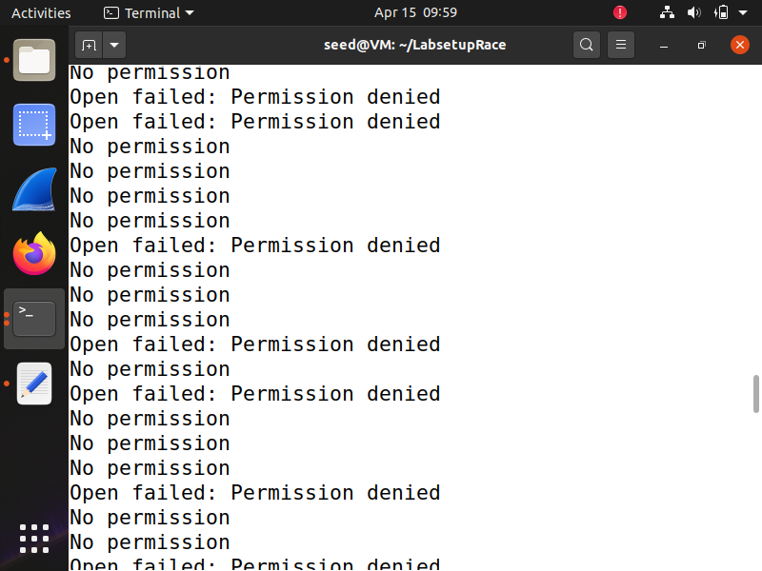
Answer:

5.2 Task 3.B: Using Ubuntu’s Built-in Scheme
Note: You can search for relevant information to answer Questions 9 and 10.
– Question 9. Do you see similar results as in Task 3.A? (Yes or no would be fine)
Answer:
– Question 10. How does this protection scheme work? What are the limitations of this scheme?
Answer:

6 Submission
Convert the finished template to PDF and upload. Do not upload .docx or any other files.

