ISE 333: User Interface Development (Design)
Technical Report
An Intelligent Navigation UI
Spring 2026 | Instructor: Hao Li
School | Stony Brook University
Main entry script | main.m
Implementation language | MATLAB programmatic GUI with basic uicontrols and graphics
Map asset | MapForUI.jpg, 1404 x 803 pixels
Coordinate scale | 1 pixel represents 1.7 meters; real-world origin is the map lower-left corner
Group information | Group leader: You Shengxuan (R32314015); members 2-5: TBD.

Submission note
The interface is launched by running main.m. After launch, map loading, inspection, IV management, measurement, rotation, skeleton extraction, street view, and path planning are all controlled through the GUI.

1. UID Idea and Design Strategy
The project implements a campus navigation UI for intelligent vehicles. The UI treats the campus map as the primary work surface: users click directly on the map, receive real-world coordinates, and manipulate IV, distance, trajectory, skeleton, local-view, and path-planning tasks through grouped controls.
- Direct manipulation: the map, IVs, trajectories, skeletons, and paths remain continuously visible while the user works.
- Consistency: similar tasks follow the same sequence: select a mode, click the map, read feedback, and observe the updated visualization.
- Immediate feedback: the coordinate label, operation log, IV report list, error dialogs, and redrawn graphics show the result of each action.
- Error prevention and recovery: IV loading validates road legality; invalid locations show an error without changing existing IVs.
- Small vocabulary: controls use concrete terms such as Add IV, Remove IV, Distance, Trajectory, Rotate, Local, Path Plan, and Street View.

2. System Model

2.1 Coordinate Model
The source image is displayed in a real-world coordinate system. The lower-left map corner is (0, 0), the X axis grows to the right, and the Y axis grows upward. The conversion is:
X = pixel_x * 1.7; Y = (image_height - pixel_y) * 1.7

2.2 Road Model
Only modeled roads are navigable. The implementation uses manually traced road corridors in map pixel coordinates, stored in RoadModelDataPx.m, with explicit width for each segment. The road corridors support IV legality checks and automatic IV orientation; path planning is performed on a dense 4 px navigable road grid with a custom A* search, avoiding MATLAB graph/shortestpath built-ins.
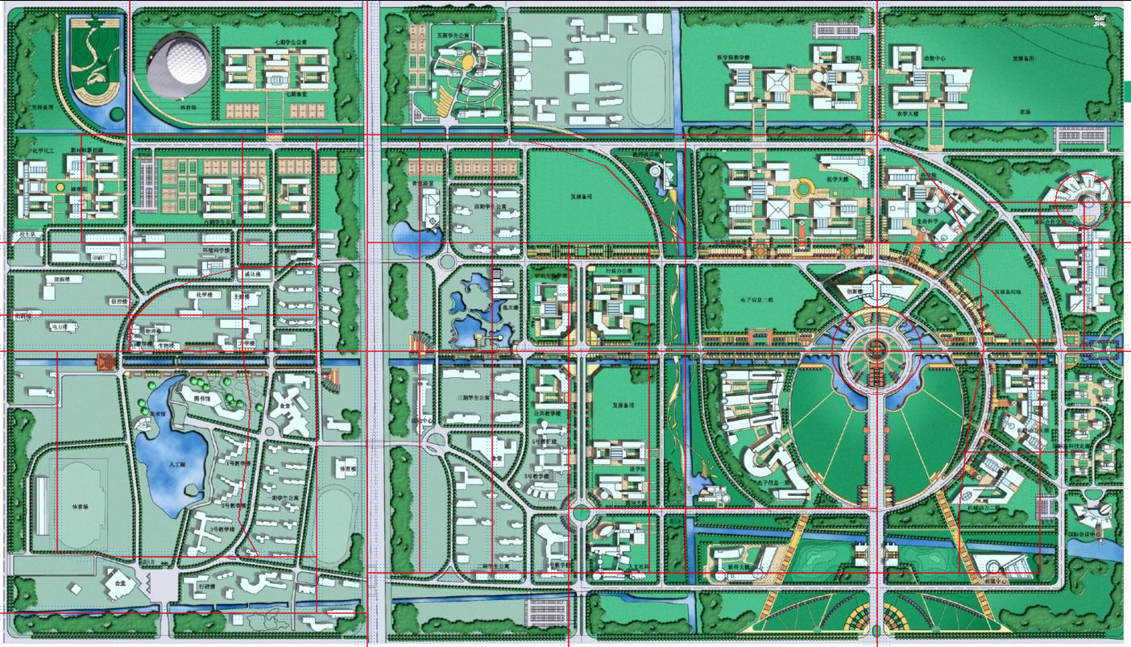
Figure 1. Corrected road corridor model and sampled 4 px navigable grid overlaid on the provided campus map.

2.3 IV Model
Each intelligent vehicle is represented as an 8 meter by 3 meter rectangle in real-world coordinates. A user-controlled visualization scale changes only the display size, not the coordinate system. Orientation is either entered manually in degrees or automatically aligned to the nearest road segment.

3. How to Run and Use the UI
- Unzip the MATLAB scripts package and keep MapForUI.jpg in the same folder as main.m.
- Open MATLAB, set the current folder to the unzipped project folder, and run main.m.
- Use the GUI controls only after launch. The MATLAB command line is not needed for later operations.
- Use Inspect mode for ordinary coordinate reading, or select a task mode before clicking the map.
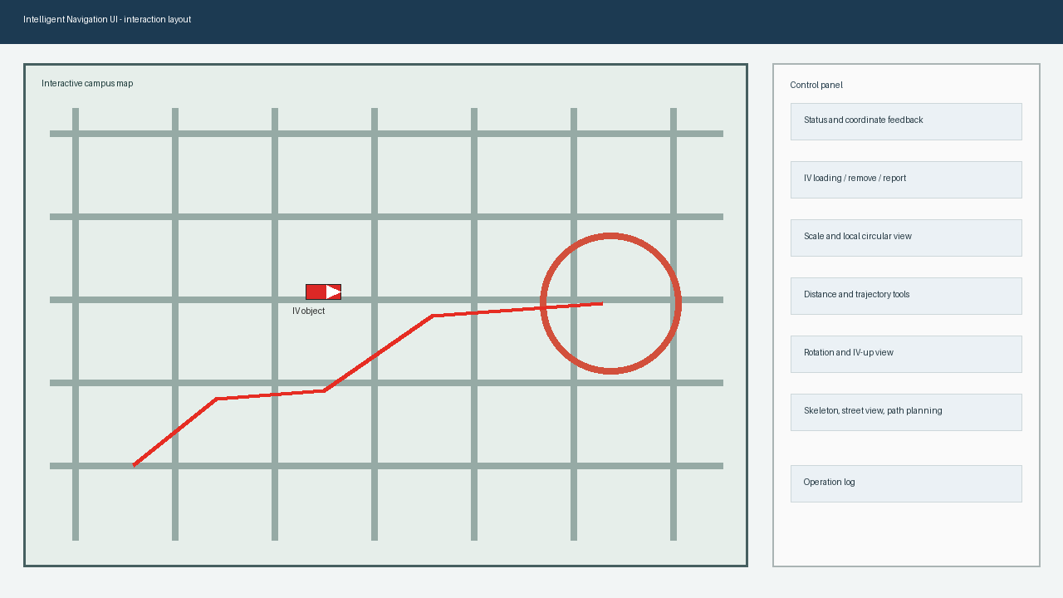
Figure 2. UI layout rationale: large map workspace, grouped control panel, status feedback, and operation log.

4. Functional Coverage
Requirement | User operation | Implementation evidence
Launch by main script | Run main.m. | main.m adds the project folder to path and calls RunIntelligentNavigationUI.
Load map | Press Load Map. | MapForUI.jpg is loaded with imread and displayed in metric axes.
Click coordinate | Click any point on the map in Inspect mode. | The coordinate label reports real-world X and Y in meters.
Load IV | Press Add IV by Click, then click a road. | Nearest road validation checks whether the click falls inside road width.
Invalid IV point | Click outside modeled road while adding IV. | The UI shows an error dialog and leaves existing IVs unchanged.
Adjust IV orientation | Use IV angle or Auto align road before loading. | Manual angle or nearest road segment angle is applied to the IV rectangle.
Remove IV | Select IV in popup, press Remove IV. | Only the selected IV is deleted; other IVs remain.
Report IV positions | Press Report IVs. | The report list shows all IV IDs, X/Y positions, orientation, and scale.
Two-point distance | Press 2-Point Distance and click two map points. | Euclidean real-world distance is displayed in the log.
Trajectory length | Press Trajectory Start, click sequence, press Trajectory Finish. | Polyline length is accumulated from clicked real-world points.
Rotate map | Enter Rotate deg and press Apply. | The map and all overlays are redrawn with the specified rotation.

5. Optional Requirements and Group Assignment
OR item | Scope | Assigned member | Delivered behavior
OR 1 | Road skeleton extraction | TBD Member 2 | Extract Skeleton mode lets users click road points; the skeleton and approximate attached road band can be visualized.
OR 2 | Scale and local visualization | TBD Member 3 | IV scale changes the rectangle size; Local view masks the map strictly to a circle centered on a selected IV with user-entered radius.
OR 3 | Automatic IV orientation and IV-up view | TBD Member 4 | Auto align road sets IV orientation from the closest road segment; IV Up rotates the map so the selected IV heads upward.
OR 4 | Virtual street view generation | TBD Member 5 | Street View mode generates a simplified road-facing scene for a clicked road point and displays snapped coordinates and heading.
OR 5 | Path planning | You Shengxuan (R32314015) - group leader / integration lead | Path Plan mode accepts two arbitrary map points, snaps them to closest road points, computes a shortest road path with a custom A* search on a dense 4 px navigable grid, and visualizes it.

Before final submission, replace TBD Member 2-5 with actual group member names and IDs. You Shengxuan (R32314015) is the confirmed group leader and integration lead.

6. Design Details by Task

6.1 Map Interaction
The map is the center of interaction. Every click is transformed from display coordinates back into the unrotated metric map coordinate frame before any task logic runs. This keeps coordinate reporting, IV placement, distance measurement, and path planning consistent even after map rotation.

6.2 IV Loading and Road Legality
When the user clicks to load an IV, the UI projects the clicked point onto every traced road-corridor segment and finds the closest segment. The selected point is valid only when the distance to that segment is within half of the corridor width. A valid IV is snapped to the closest road point so the visual result is clean and predictable.

6.3 Path Planning
Path planning uses the traced road corridors plus a dense 4 px navigable grid. Two arbitrary clicked map points are snapped to their closest road points, then to nearby grid nodes. A custom A* procedure computes the shortest grid path, and the UI visualizes the result on the map. This improves fidelity on curves and intersections while still avoiding MATLAB graph or shortestpath functions.

6.4 Local Circular View
Local visualization creates a circular mask in real-world coordinates. Pixels outside the specified radius are blanked, and the axes are limited to the selected IV center plus/minus the exact radius. This keeps the displayed local map consistent with the requested range.

7. Submission File List
File | Purpose
main.m | Main script required by the project. Run this file to launch the UI.
UI implementation | RunIntelligentNavigationUI.m contains UI creation, callbacks, IV logic, measurement, optional functions, and custom shortest path code; RoadModelDataPx.m stores the shared traced road-corridor model.
Map asset | MapForUI.jpg is the required map asset used by the UI.
Technical report | Technical_Report_Intelligent_Navigation_UI.docx is this report.
MATLAB scripts ZIP | IntelligentNavigationUI_MatlabScripts.zip packages the MATLAB scripts and map asset for email submission.

8. Verification Checklist
Check | Status | Evidence
Main script exists | Pass | main.m is present and calls the UI entry function.
No ad hoc configuration | Pass | The startup script uses its own folder path and the map is packaged with the code.
No advanced graph/image built-ins | Pass | Road checking, rotation, 4 px grid construction, and A* shortest path are implemented explicitly.
Basic requirements covered | Pass | All required UI operations are represented in controls and callbacks.
Optional requirements covered | Pass with TBD placeholders for members 2-5 | All five optional UI functions have code paths; OR5/integration is assigned to the group leader.

9. Remaining Fill-in Before Email
- Replace TBD Member 2-5 placeholders with actual names and student IDs.
- Group leader confirmed: You Shengxuan (R32314015). Confirm whether he sends the final email to Prof. Li.
- Attach the packaged MATLAB scripts zip and this technical report to the submission email.
- Watch for Prof. Li acknowledgement of reception, as requested in the project specification.

