**INTRODUCTION**

The lifestyles of different countries are shaped by a myriad of factors, including culture, work ethics, education systems, healthcare, and social norms. Germany and Australia, both developed nations, exemplify unique approaches to living, influenced by their historical contexts and societal values. Germany, located in the heart of Europe, is renowned for its rich cultural heritage, strong economy, and emphasis on order and efficiency. In contrast, Australia, known for its diverse landscapes and laid-back lifestyle, embraces multiculturalism and prioritizes outdoor living.

**Culture and Social Life**

Germany:

* **Cultural Diversity:** Germany has a rich cultural heritage, with numerous festivals (like Oktoberfest), a strong emphasis on classical music, and a variety of regional traditions.
* **Social Norms:** Germans value punctuality, orderliness, and direct communication. Relationships can be more formal initially, with a gradual shift to familiarity.

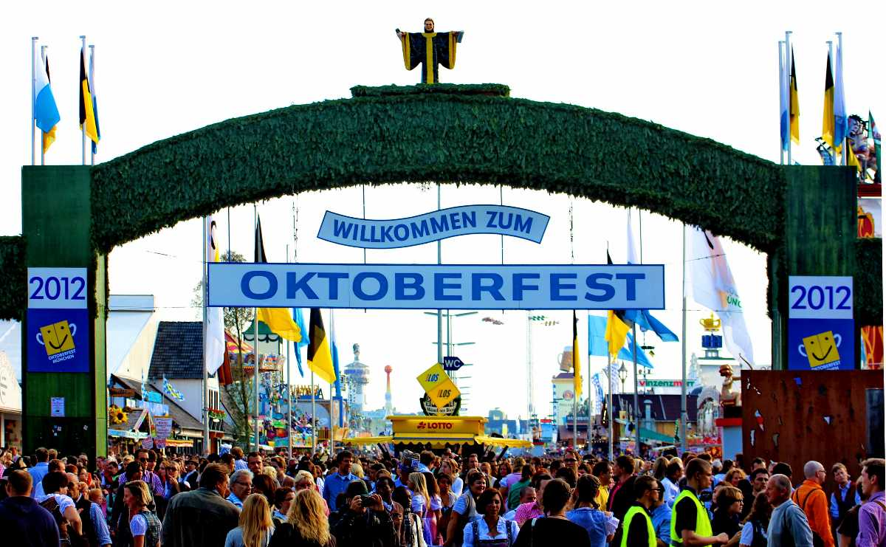

Australia:

* **Cultural Diversity:** Australia is known for its multicultural society, celebrating various cultures through festivals, food, and community events.
* **Social Norms:** Australians are generally informal and laid-back, often using first names even in professional settings. The concept of "mateship" is central to social interactions.

**Education System**

Germany:

* **Structure:** Education is highly valued, with a strong emphasis on vocational training. The system includes Hauptschule, Realschule, and Gymnasium pathways, leading to diverse career opportunities.
* **University Education:** Tuition fees at public universities are low, making higher education accessible.

Australia:

* **Structure:** Education is compulsory until the age of 16 or 17, depending on the state. The system includes primary, secondary, and tertiary education.
* **University Education:** Higher education can be expensive, but there are various scholarships and financial aid options available.

**Healthcare**

Germany:

* **System:** Germany has a universal healthcare system that is primarily funded through statutory health insurance. It offers high-quality medical care and a wide range of services.
* **Access:** Healthcare access is generally efficient, with a strong focus on preventive care.

Australia:

* **System:** Australia also has a universal healthcare system known as Medicare, which provides access to a range of medical services, though private health insurance is also common.
* **Access:** Australians enjoy good access to healthcare services, but wait times can vary.

**Cost of Living**

Germany

* **Housing:** Costs can vary significantly between cities. Major cities like Munich and Frankfurt are more expensive, while smaller towns are more affordable.
* **General Costs:** Daily expenses, including groceries and transportation, are generally reasonable, although utilities can be high.

Australia:

* **Housing:** Major cities like Sydney and Melbourne have high housing costs. Regional areas tend to be more affordable.
* **General Costs:** Overall, Australia is known for a higher cost of living compared to Germany, especially in housing and dining out.

**Conclusion**

In summary, Germany and Australia offer contrasting lifestyles shaped by their cultural values, work practices, education systems, healthcare, and living costs. Understanding these differences can provide valuable insights into the unique characteristics of each country’s way of life. This comparison can help readers appreciate the diversity and complexity of lifestyles in these two nations.