MASCoT AI
MArket SCanning Tool
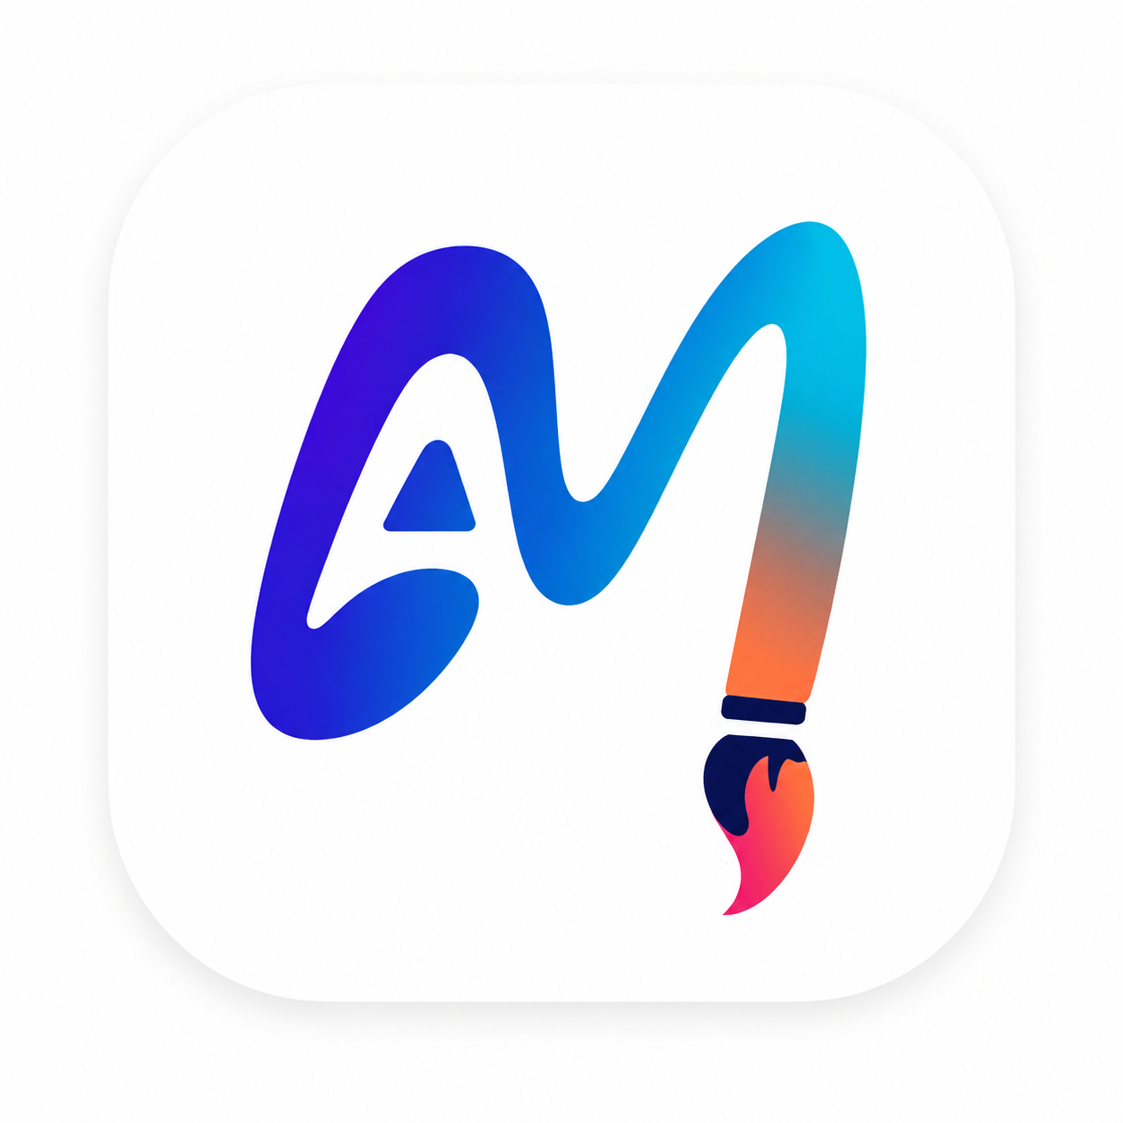
Market Scanning & Lead Discovery Agent for the Paint Industry
Phase 2: Design, Build & Go-to-Market
Team Member ID | Team Member Name
bitsom_pm_2601920 | Saanvi Behele
bitsom_pm_2601911 | Arockia Praveen Kumar
bitsom_pm_2601907 | Khushbu Borkar
bitsom_pm_2601762 | Nupur Tomar
bitsom_pm_2601916 | Bharadwaja Sarma Uppala

Index | Table of Contents

Index | Section | Page No
Q1 | Outline the Design Thinking Process | 3
Q2 | Build User Personas | 4
Q3 | Build User Stories | 6
Q4 | Design & Development: Build vs. Outsource | 6
Q5 | Team Roles, Responsibilities & Tech Choices | 7
Q6 | MVP, Prioritisation, Testing & AI Integration | 7
Q7 | Project Plan, Methodology & Jira Board | 9
Q8 | Ethical Considerations | 12
Q9 | Lean Model Canvas | 13
Q10 | Segmentation, Targeting & Positioning (STP) | 14
Q11 | Brand the Product | 15
Q12 | The 7Ms for the New Product | 15
Q13 | Product Launch, End-to-End Strategy | 16
Q14 | Channel Strategy | 17
Q15 | Channel Mix, Ownership & Omnichannel Rationale | 20
Q16 | User Flow & User Journey | 23
Q17 | Customer Service Strategy | 25
Q18 | Increasing CLV & Renewal Rates | 25
Q19 | Growth Hacks & Loops | 26
Q20 | Wireframes, MVP Demo & PRD | 27
E1 | Experimental Task, Real User Interviews (JTBD) | 35
E2 | Experimental Task, One Real Action, Two Channels | 36
E3 | Experimental Task, Renewal Objection Interviews | 37
E4 | Experimental Task, Business Owner Interviews | 38

Q1 | Outline the Design Thinking Process

Problem Statement
How might we design an AI-powered agent for the paints and coatings industry that automatically curates and delivers timely, project-driven company insights, sourced from financial data, construction activity, tenders, news, and social signals, to sales representatives before client meetings, so they can identify paint demand opportunities, tailor product recommendations (decorative, waterproofing, industrial coatings), and significantly reduce manual research time while increasing sales rates?

Stage | Guiding Question | Our Answer
Empathize | Who are we building for? | B2B Sales Reps, B2B Business Heads, Sales Managers, and Marketing Teams at organised paint companies.
Define / Ideate | What are we building? | An AI tool which helps in finding and analysing the market to find the potential leads.
Empathize | Why are we building it? | To remove manual multi-source research, aggregate financial/news/social signals, keep a paint-industry focus for reliability, deliver one summarised report per prospect, remove market-targeting ambiguity, and track client project pipelines.
Prototype / Test | How are we building it? | Initial prototype will include an AI agent that performs market scanning along with report generation and consumer’s financial details.
Why we are building it, in detail
- No manual research across multiple sources
- Aggregates financial, news, and social-media signals
- Paint-industry focus gives higher data reliability
- Single summarised report per prospect
- Removes ambiguity on which markets to target
- Tracks client future plans via project-pipeline data
So that the user can find demand opportunities, tailor product recommendations, and reduce the manual research needed to find potential leads.

Q2 | Build User Personas

Four personas anchor the design process: two primary front-line sales roles who use MASCoT AI daily, and two secondary leadership roles who sponsor adoption and expansion.
Primary Persona 1, Field Sales Representative
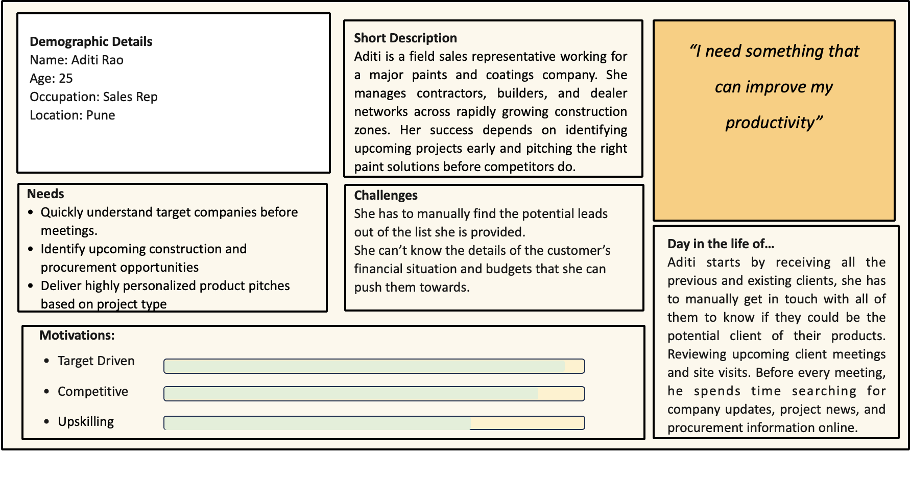
Aditi Rao · Sales Representative · Pune
Primary Persona 2, Regional Sales Manager
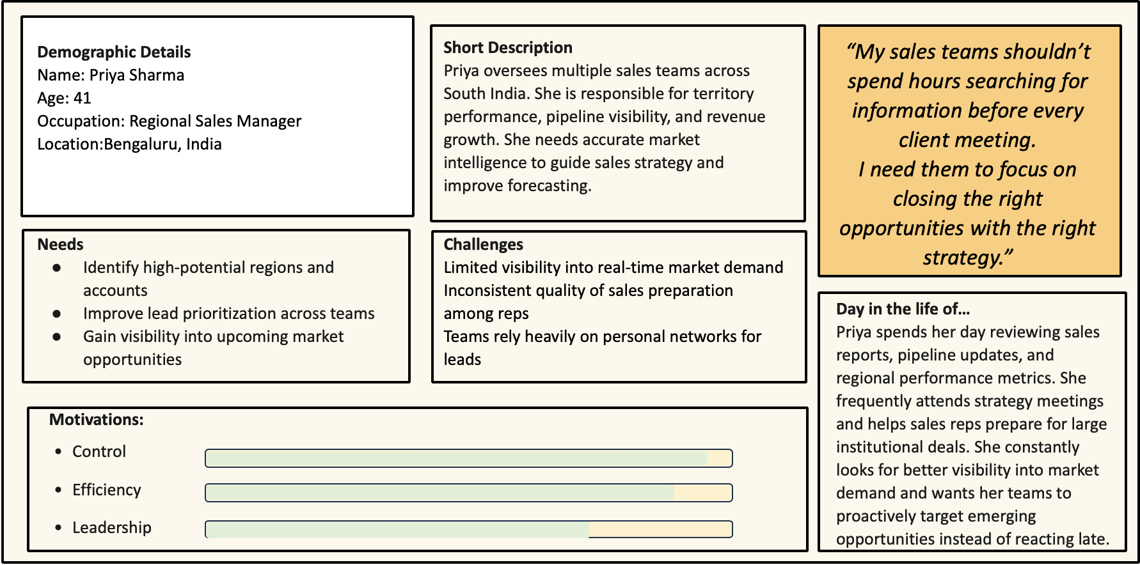
Priya Sharma · Regional Sales Manager · Bengaluru

Secondary Persona 1, Head of Strategic Business Development
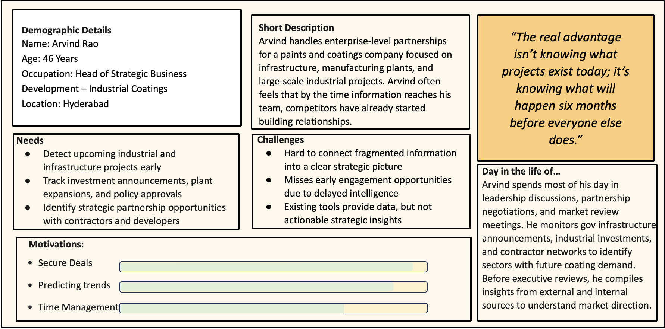
Arvind Rao · Head of Strategic Business Development (Industrial Coatings) · Hyderabad
Secondary Persona 2, Business Development Head
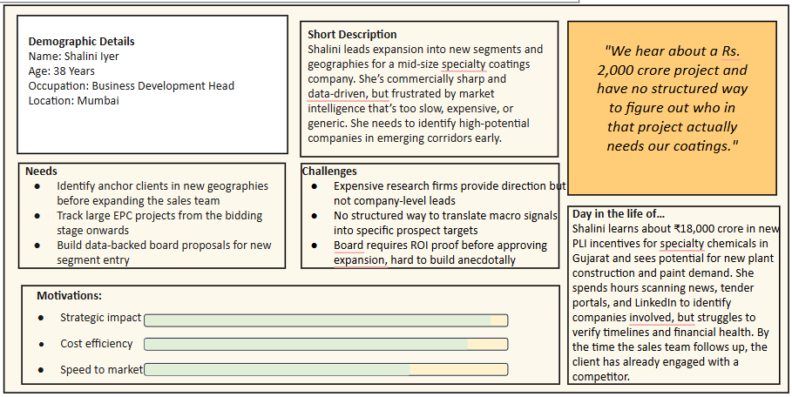
Shalini Iyer · Business Development Head · Mumbai

Q3 | Build User Stories

User Type | User Story | Priority
Sales Rep | As a Sales Rep, I want to do the market research so that I can find the potential lead. | Must Have
Sales Rep | As a Sales Rep, I want to understand the client’s financial scenario so that I can create the best pitch. | Must Have
Sales Manager | As a Sales Manger, I want to make myself ready to connect with clients so that we can acquire the clients. | Should Have
Sales Manager | As a Sales Manger, I want to have a reminder and summary prior to meeting so that I am aligned to the goals of the meeting. | Could Have

Q4 | Design and Development: Build vs. Outsource

Will you handle design and development internally or outsource? Why?

Component | Decision | Pros | Cons
UI/UX | Build internally | When developed internally we get the flexibility to modify the UI/UX as per the requirements. | The cost of modification of the design is higher when outsourced as compared to when developed inhouse.
Architecture | Build internally | Primary IP so this cannot be outsourced. Handing over core logic to third parties risks leaks, replication, or legal dependency on external code. Gives flexibility of modifying as per requirements. Gives ease of scalability. | Need to invest a lot of time and effort. Can be challenging if expertise is limited within the team.
Backend | Build internally | Data/Stats/Metrics can be kept securely within the company. Overhead cost of development along with the infrastructure resources can be constrained. | Need to invest a significant amount of time and effort. Encryption of data at rest and in transit should be handled cautiously
Agentic model (LLM) | Purchase (PAYG) | Easily use the LLM which is deployed on the cloud on the local server.. | Training or even fine tuning a model requires massive computing power, specialized hardware, and vast amounts of memory.
Tools used by LLM | Purchase | Buying ready tools off the shelf is cost effective and can be easily integrated. | Customization is difficult to implement.
Governance / Security | Mitigation (hybrid) | Gives the flexibility of making terms internally and getting implemented externally. | Dependency on external software increases the cost.
Payment Gateway | Purchase | Buying ready tools off the shelf is cost-effective and can be easily integrated. Secured payment, monitoring of the transactions | Transactional charges.

Q5 | Team Roles, Responsibilities & Tech Choices
•What are the tech capabilities in your company? How will it help in your tech choices?

Team Member | Role | Responsibility
Saanvi Behele | AI & Backend Developer | AI model development, prompt engineering, backend development, API integration, and application containerisation.
Bharadwaja Sarma Uppala | Backend & Database Developer | Backend development, database design and management, authentication, data integration, and API implementation.
Kushboo Borkar | UI/UX Designers | User research, wireframing, prototyping, interface design, and improving overall user experience.
Arockia Praveen Kumar | UI/UX Designers
Nupur Tomar | Technical Writer & Moderator | Project documentation, sprint documentation, user guides, presentation preparation, meeting coordination, and stakeholder communication.
Entire Team | QA & Testing | Unit testing, integration testing, User Acceptance Testing (UAT), bug fixing, and regression testing throughout the development lifecycle.

How this shapes our tech choices
Because core development, AI and backend expertise already exist in-house, the team retains ownership of architecture and backend, while buying in ready-made LLM and payment infrastructure rather than building these from scratch.

Q6 | MVP, Prioritisation, Testing & AI Integration

•What features will the MVP of your product have?
MVP Feature Set
- Industry-level market scanning for paint leads
- Automated company insights report per prospect
- Client financial & order-history reports
How would you prioritise the features for your product?
Feature Prioritisation, MoSCoW
MoSCoW was chosen because it is easy to apply without prior usage data and is an appropriate starting framework for a pre-launch product.
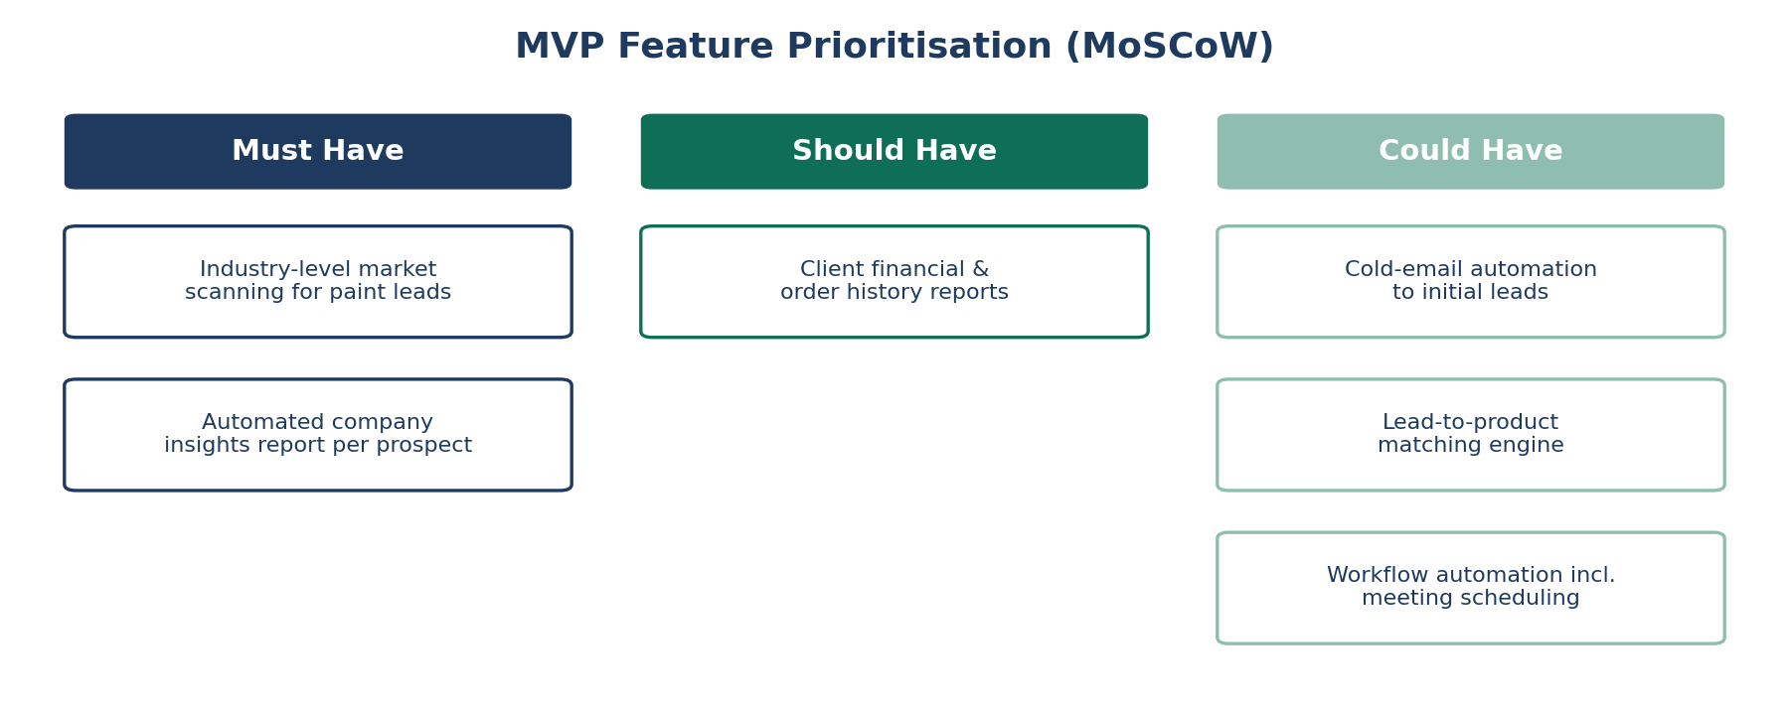
MVP feature prioritisation using the MoSCoW framework
•How would you test your product and feature prior to deployment?
Testing Strategy Prior to Deployment
- Extensive unit test cases
- Regression testing
- User Acceptance Testing (UAT)
- A/B testing
•How will you integrate AI/GenAI and agentic AI?
AI / GenAI / Agentic AI Integration
- AI will be used for scanning the market and finding potential leads as per the product described by the user
- Generated summaries/reports
- Agentic tools used: web crawler, auto-mailing, auto call-scheduling

Q7 | Project Plan, Methodology & Jira Board

•Create a sample project plan
Introduction
Following the product discovery and design thinking phases, our team established a clear understanding of the target users, their pain points, and the core value proposition of MASCoT AI. Based on these insights, the team defined a Minimum Viable Product (MVP) that focuses on validating the most critical assumptions with minimum development effort and cost. The MVP is designed to demonstrate the core capabilities of MASCoT AI, including industry-specific market scanning, AI-generated company insights, and financial analysis reports, while intentionally excluding advanced features that are not essential for initial user validation. This approach enables rapid iteration based on user feedback while minimising technical complexity and development risk.
To ensure timely delivery within the available resources, the project will follow an Agile methodology over an eight-week development period. The plan emphasises iterative development, continuous testing, and frequent stakeholder feedback, allowing the team to progressively build, validate, and refine the solution. Given the objective of creating a proof-of-concept with an almost zero budget, the implementation relies primarily on open-source technologies, free-tier cloud services, and pay-as-you-go AI APIs wherever necessary. The following project plan outlines the development schedule, resource allocation, estimated budget, and risk mitigation strategy for building the MASCoT AI MVP.
Project Plan (8 Weeks)
Week | What (Deliverables) | How (Activities) | Resources | Cost
Week 1 | Project Planning & Requirement Finalization | Finalize user stories, prioritize MVP using MoSCoW, create Jira board, define architecture | PM, Entire Team | ₹0
Week 2 | UI/UX & Database Design | Wireframes in Figma, database schema, API design, development setup | UI/UX Designer, Backend Developer | ₹0 (Free Figma)
Week 3 | Backend Development | Build authentication, product input forms, report APIs, database integration | Backend Developer | ₹0
Week 4 | AI Agent Development | Integrate web search, news scraping, company summary generation, prompt engineering | AI Developer | ₹500–₹1,000
Week 5 | Frontend Development | Dashboard, report viewer, login, product management screens | Frontend Developer | ₹0
Week 6 | Integration Sprint | Connect frontend, backend and AI agent, end-to-end workflow testing | Full Team | ₹0
Week 7 | Testing & UAT | Unit testing, bug fixing, user acceptance testing with classmates/mentors | QA (Team Members) | ₹0
Week 8 | Deployment & Product Demo | Deploy on free cloud, documentation, presentation and demo | Entire Team | ₹0–₹500

Agile Sprint Schedule
Sprint | Duration | Deliverables
Sprint 1 | Week 1–2 | Requirements, UI, Architecture, Database
Sprint 2 | Week 3–4 | Backend APIs, AI Agent, Authentication
Sprint 3 | Week 5–6 | Frontend, Integration, Complete MVP
Sprint 4 | Week 7–8 | Testing, Deployment, Demo
Risk Response Plan
Risk | Probability | Impact | Mitigation
AI API cost exceeds budget | Medium | High | Use free-tier APIs, cache responses, limit token usage
Delay in AI integration | Medium | High | Develop backend independently using mock responses
Web scraping failures | Medium | Medium | Use multiple free data sources and fallback datasets
Team availability | High | Medium | Daily stand-ups and task reassignment
Deployment issues | Low | Medium | Test locally before deploying to free cloud services
Expected Outcome
At the end of 8 weeks, the team will have:
- A functional web application
- AI-powered market scanning for paint industry prospects
- Automated company insight reports
- Deployed MVP with documentation and presentation
- Development completed within a minimal budget (~₹2,000) using Agile methodology and free/open-source technologies
Product Launch Timeline (Go-to-Market)
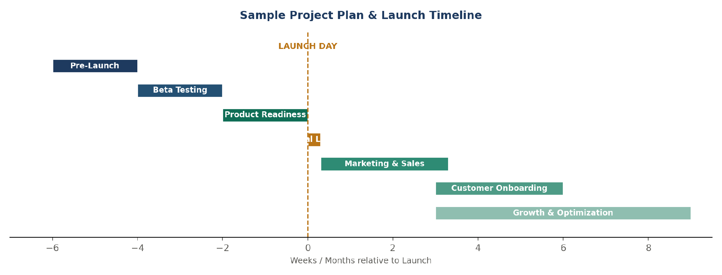
End-to-end launch plan from pre-launch through growth & optimisation

Phase | Timeline | Goal
1. Pre-Launch | Weeks -6 to -4 | Branding, website, MVP completion, waitlist
2. Beta Testing | Weeks -4 to -2 | Pilot with 10–15 paint manufacturers, collect feedback
3. Product Readiness | Weeks -2 to 0 | Refine product, train sales and support teams (if present)
4. Official Launch | Launch Day | Webinar, live demo, pilot programs in select paint companies with demos on how to use and benefits
5. Marketing & Sales | Months 1–3 | LinkedIn campaigns, email outreach, demos, free trials, expos/summits/conferences, ads, sponsored results
6. Customer Onboarding | Ongoing | Dedicated onboarding, customer success, support
7. Growth & Optimisation | Ongoing | Track KPIs, improve AI models, expand features

•What methodology will you use? Why
Methodology, Agile (Scrum)
We have chosen the Agile Scrum methodology for developing the MASCoT AI MVP because it gives us the flexibility to build, test, and improve the product step by step. Since this is an AI-based solution, requirements and ideas may evolve as we receive feedback and test different features. Agile allows us to make these changes without affecting the overall project timeline.
The project will be completed over 8 weeks, divided into four two-week sprints. At the end of each sprint, the team will review the progress, test the completed features, and plan the next set of tasks. This helps us identify issues early and continuously improve the product.
Why Agile?
- It allows us to develop the MVP in small, manageable stages instead of building everything at once
- We can quickly incorporate feedback from mentors and potential users during development
- Testing happens throughout the project, helping us identify and fix issues early
- Our team members can work on different modules simultaneously while staying aligned through regular discussions
- Since we are working with a limited budget and timeline, Agile helps us focus on the most important features first and deliver a working MVP within eight weeks
Overall, Agile is the most suitable approach for our project because it supports continuous improvement, encourages teamwork, and helps us deliver a functional product within the available time and resources.
•Create a board in Jira and attach screenshot
Jira Board
This is a board of sprint 3 from our entire plan
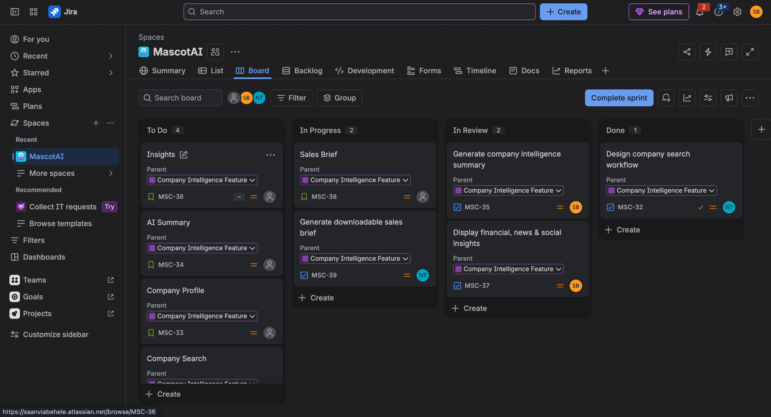
MASCoT AI, Jira Board (MascotAI project space)

Q8 | Ethical Considerations

•What are some ethical considerations for your product?
We are validating the sources to handle the hallucinations and biased output.
- We are validating the sources to handle the hallucinations and biased output.
- Data privacy: masking the user's sensitive details before sending them to the cloud-based AI agent
- The tool is having the transparency feature which provides the user with the background actions done by the agent.
- The episodic memory is only stored in the internal memory rather than the model’s database which creates security towards the information shared with the model.
- The data citations are mentioned in the output to verify the source of the information

Q9 | Lean Model Canvas

•Use the default template and make Lean Model Canva

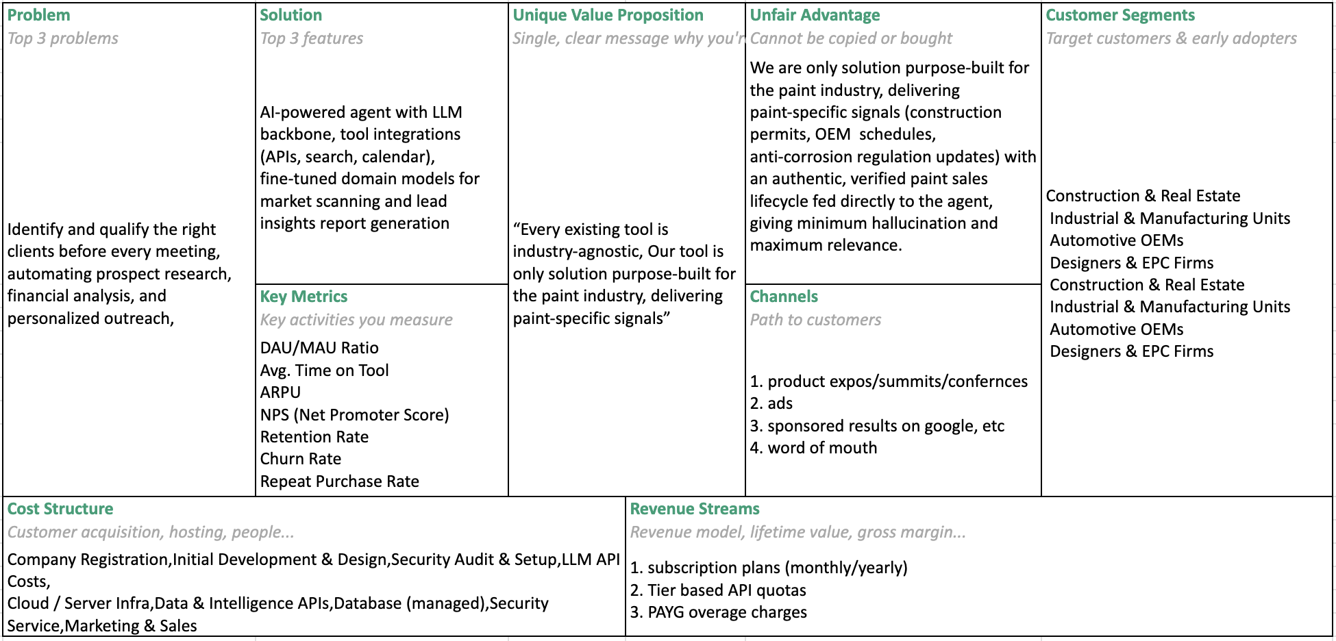
MASCoT AI, Lean Model Canvas

Q10 | Segmentation, Targeting & Positioning (STP)
•Outline the STP from your new product (not required for the feature)
Segmentation
Basis | Segments
By industry type | Construction & Real Estate; Industrial & Manufacturing Units; Automotive OEMs; Designers & EPC Firms
By company size | Large paint manufacturers (e.g., Asian Paints, Berger); medium/regional paint brands
By needs/behaviour | Paint distributors; construction chemical companies needing market intelligence
Targeting
The initial focus is medium and large B2B paint manufacturers in India with dedicated sales teams that struggle to identify high-potential construction projects. They need timely insight into construction permits, OEM production schedules, anti-corrosion regulation updates, and other industry-specific signals to spot opportunities and prepare for engagements. This segment is first because it combines the highest willingness to pay with the clearest, most measurable pain: time lost to manual research.
Positioning
The only AI-powered sales intelligence platform purpose-built for the paint industry, delivering verified, paint-specific market signals instead of generic business intelligence. Unlike industry-agnostic tools, MASCoT AI provides authentic, highly relevant insights across a paint-specific sales lifecycle, enabling more accurate recommendations, reduced AI hallucinations, and better-informed sales decisions.

Q11 | Brand the Product
- (sub) Brand the product

Element | Detail
Brand name | MASCOT Ai (Market Analysis, Sales, and Customer Outreach Tool)
Tagline | “Purpose-built intelligence for the paint industry” / “Intelligence that paints opportunities”
Brand values | Trustworthy, Intelligent, Industry-Specific, Reliable

Q12 | The 7Ms for the New Product
- What are the 7Ms for your new product?

M | Detail
Mission | Phase 1: create market awareness. Phase 2: improve lead generation.
Market | Geographic: cities across India. Demographic: paint manufacturers, distributors and sales departments. Behavioural: stakeholders searching for new projects and opportunities; CRM users; frequent travellers; industry-news followers; multi-channel communicators.
Media | Digital channels: LinkedIn, Google, blogs, ZOHO in-app ads.
Message | “Never miss your next big paint sales opportunity.” Supporting lines: spot opportunities before competitors; turn hours of research into minutes; walk into every meeting prepared.
Money | ~10% of the product budget allocated to marketing.
Moment | Post-Monsoon Maintenance & Festive Quarter (Sept–Jan): factory shutdowns, shipyard maintenance, automotive ramp-up, plus rain-backlog and festive-driven demand. Also start of the financial year/quarter and LinkedIn working hours.
Metrics | Impressions & reach, CTR, follower growth, conversion rate, ARPU, retention rate, churn rate, repeat purchase rate.

Q13 | Product Launch, End-to-End Strategy

- How will you launch the product? Write the complete end to end strategy and mode around it. Fully functional Plan of a product Launch.

Phase | Timeline | Goal
Pre-Launch | Weeks -6 to -4 | Branding, website, MVP completion, waitlist
Beta Testing | Weeks -4 to -2 | Pilot with 10-15 paint manufacturers, collect feedback
Product Readiness | Weeks -2 to 0 | Refine product, train sales and support teams (if present)
Official Launch | Launch Day | Webinar, live demo, pilot programs in some targeted and selected paint companies with demos on how to use and pros about the agent
Marketing & Sales | Months 1–3 | LinkedIn campaigns, email outreach, demos, free trials, product expos/summits/conferences, ads, sponsored results on google, word of mouth
Customer Onboarding | Ongoing | Dedicated onboarding, customer success, support
Growth & Optimization | Ongoing | Track KPIs, improve AI models, expand features

The launch follows the seven-phase project plan above: pre-launch branding and MVP completion, beta testing, product readiness, an official launch event, a three-month marketing and sales push, ongoing onboarding, and continuous growth optimization.
The Product Launch in 60 Seconds
60-second pitch
MASCoT AI is an AI-powered sales intelligence agent built only for the paints and coatings industry. Instead of reps spending hours researching prospects across news, tenders and financial filings, MASCoT AI scans it all automatically and delivers one clear report per prospect before every client meeting. We launch with a free-report tier for individual reps, expand to full sales teams once managers see the time saved and deals won, and scale into enterprise licences with paint majors as trust builds. In short: we help paint sales teams find the right opportunity, understand the client before they walk in, and close faster.

Q14 | Channel Strategy

•Design the channel strategy for your product?
MASCoT AI operates as a product-led growth business with a high-touch enterprise layer. The channel strategy has three distinct stages, each with dedicated channels, tactics and owners.
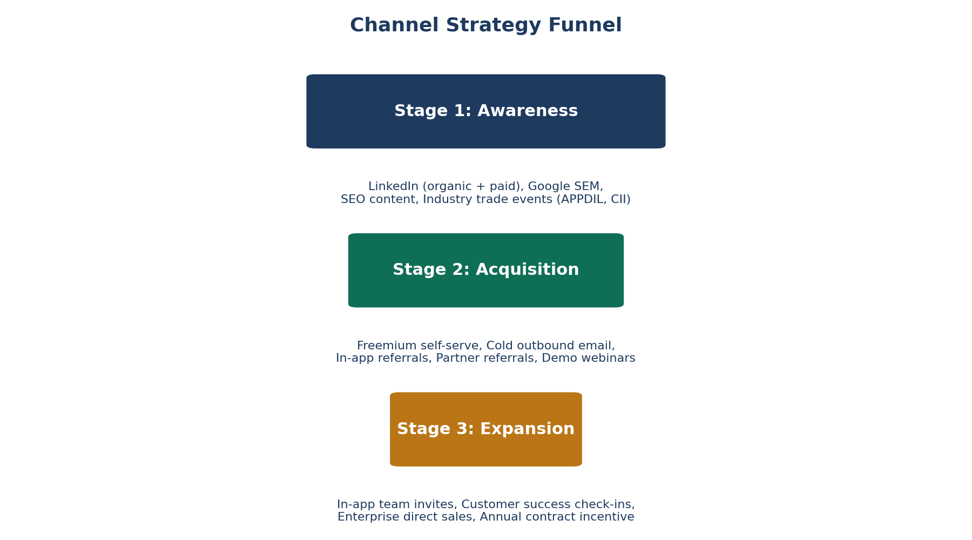
Three-stage channel funnel: Awareness → Acquisition → Expansion
Stage 1: Awareness
The goal of awareness channels is to put MASCoT AI in front of sales managers, business development heads, and senior sales reps at organised Indian paint companies. These are not impulse buyers, they discover tools through peers, industry events, and content that speaks directly to their daily problems.
Channel | Type | Tactic | Target Audience
LinkedIn Organic Content | Online, Owned | Weekly posts on paint sales productivity, AI for B2B sales, and market intelligence. Short-form case studies and “did you know” posts about construction pipeline data. | Sales managers, BD heads, marketing managers at paint companies
LinkedIn Paid (Sponsored Posts) | Online, Paid | Targeted ads by job title (sales officer, area sales manager), company size (500+ employees), and industry (paints & coatings, construction). CTA: “Get 5 free prospect reports.” | Same as organic, with lookalike audience expansion
Google Search Ads (SEM) | Online, Paid | Capture high-intent searches: “paint sales lead generation tool”, “construction project leads India", and “B2B sales intelligence India”. Low volume, high conversion intent. | Sales reps actively searching for a solution
SEO Content (Blog) | Online, Owned | Long-form articles: “How to find construction projects before competitors" and “Top 10 signals that a company needs industrial paint”. Ranks for industry-specific search terms. | Any paint sales professional searching for guidance
Industry Trade Events | Offline, Owned | Booth presence and live demos at APPDIL conferences, CII painting & coatings summits, and construction expos. Founder-led demos targeting sales directors. | Senior decision-makers; enterprise account targets
Stage 2: Acquisition
Once a prospect is aware of MASCoT AI, the acquisition layer converts them from a visitor to an active user. The dominant motion is self-serve, product-led: the product itself is the salesperson.
Channel | Type | Tactic | Conversion Mechanism
Freemium Self-Serve (5 free reports) | Online, Owned | No credit card required. Rep signs up, enters their paint products and territory, and runs their first search within 3 minutes. Value is immediate. | Free trial exhaustion triggers upgrade prompt. TTFV under 10 minutes.
Cold Outbound Email | Online, Owned | Personalised emails to Sales Heads and Area Sales Managers at top 200 organised paint companies. Offer: “Free 14-day team pilot for your 5 reps.” | Direct conversion to team pilot. Founder makes first call.
In-app Referral Programme | Online, Owned | Existing users can refer a colleague and both receive 10 extra free report credits. Viral loop within paint company teams. | Rep-to-rep organic spread within the same company.
Partner Referral Channel | Offline & Online, Partnership | Paint distributors and ERP vendors (e.g., Tally, ZOHO CRM partners) refer MASCoT AI to their paint company clients in exchange for a referral fee. | Pre-qualified leads from trusted ecosystem partners.
Demo Webinars (monthly) | Online, Owned | Live 30-minute product demos hosted on Zoom, promoted via LinkedIn and email. No pitch, pure value demo. Recording shared post-event. | Attendees offered extended free trial post-demo.

Stage 3: Expansion
Expansion channels convert individual paid users into team licences and enterprise organisation deals, where revenue multiplies without proportionally increasing acquisition cost.

Channel | Type | Tactic | Target
In-app Team Invite Flow | Online, Owned | A paid rep can invite teammates directly from the dashboard. Manager gets a notification with usage stats showing how the rep is using the tool. | Individual seats to team of 5–20 seats
Customer Success Check-in | Offline & Online, Owned | Monthly check-in call with pilot companies at Week 4. Present usage data, ROI proof, and an upgrade proposal to the Sales Director. | Team pilot to enterprise org. licence
Enterprise Direct Sales | Offline, Owned | Founder-led outreach to the top 20 paint companies by revenue (Asian Paints, Berger, Kansai Nerolac, and Shalimar). Customised demo and business case presentation. | Rs 10L–50L annual org. licence
Annual Contract Incentive | Online & Offline, Owned | Monthly subscribers are offered a 20% discount on switching to annual billing. Locks in retention and improves cash flow. | Monthly to annual plan upgrade

Q15 | Channel Mix, Ownership & Omnichannel Rationale

•What mix of online/offline and owned vs franchised are you considering?
Online/Offline Mix & Ownership
Decision
70% Online, 30% Offline. 100% Owned. No franchising.
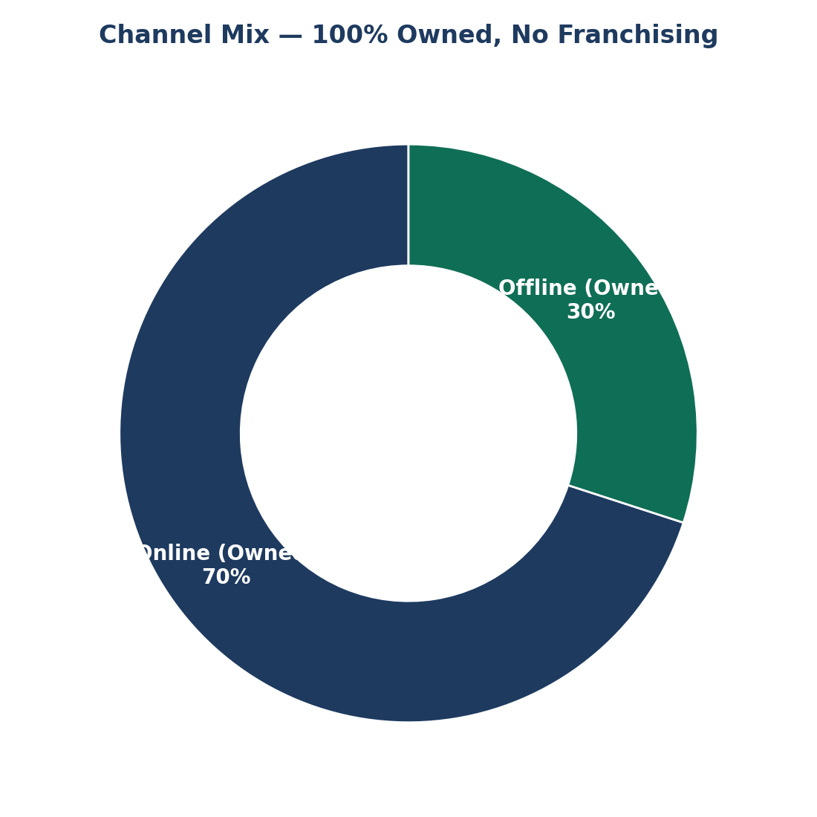
Owned channel mix, no franchise/reseller model this phase
All channels are owned and operated directly, preserving brand consistency, pricing control, and relationship quality during product-market fit.
Online Channels (70%) | Offline Channels (30%)
Owned Online:  • Product website and freemium sign-up flow  • LinkedIn organic content (3 posts per week)  • SEO blog (2 articles per month)  • Monthly product demo webinar  • Email nurture sequences (onboarding, upgrade, re-engagement)  • In-app referral programme  • In-app team invite and expansion flow  Paid Online:  • LinkedIn Sponsored Posts (targeted by job title and company)  • Google Search Ads (high-intent paint sales keywords)  Budget: 10% of monthly revenue reinvested into paid acquisition once the freemium conversion rate exceeds 12%. | Owned Offline:  • Industry trade event booth presence (APPDIL, CII, 2–3 events per year)  • Founder-led enterprise direct sales calls and demos  • Customer success check-in calls (Month 1 and Month 3 for all pilot companies)  • Field visits to top-10 target enterprise accounts in Year 1  Partnership Channels (Offline + Online):  • Industry association co-marketing (APPDIL, CPMA newsletters and webinars)  • Paint distributor referral network  • ERP and CRM partner referrals (ZOHO, Tally dealer network)  No revenue share with partners in Phase 1. Referral credits only. A revenue share model was introduced in Phase 2 when ARR exceeded Rs 1 Cr.

Why no franchising?
Franchising or reseller models require a mature, documented sales process, consistent product quality, and enough market validation to train third parties. MASCoT AI is in the product-market-fit stage. Introducing a franchise channel at this stage would:
(1) dilute brand and pricing control,
(2) create a support burden from channels the team cannot supervise, and
(3) slow the direct feedback loop with customers, the most critical input at this stage.
Franchising will be reconsidered after Series A when entering Tier-2 city markets where direct presence is not economically viable.
Purely Online or Omnichannel?
MASCoT AI will not be purely online. While the primary acquisition motion is digital and self-serve, a purely online strategy would fail to capture the enterprise deals that represent 60–70% of potential ARR. Here is why omnichannel is essential and what each layer does:
Layer | Mode | Why It Is Necessary for MASCoT AI
Self-serve acquisition | Purely online | The individual rep or small team signs up, tries the freemium tier, and upgrades without speaking to anyone. This is the most scalable and cost-efficient motion. Must work entirely online.
SME team conversion | Online + occasional call | A sales manager at a 50-person paint company evaluates MASCoT AI for a team of 10 reps. One 30-minute video demo closes this deal. Online discovery, one offline touchpoint.
Enterprise acquisition | High-touch offline | A Sales Director at Berger Paints or Kansai Nerolac will not buy a software tool for 50+ reps from a website. They need a live product demo, a security and data privacy review, a customised pricing proposal, and a reference customer call, 4–6 offline touchpoints over 6–8 weeks.
Industry trust-building | Offline only | The paint industry in India is relationship-driven. Being present at APPDIL events, speaking at CII webinars, and being recommended by CPMA gives MASCoT AI credibility that no amount of LinkedIn ads can replicate. This offline trust directly accelerates online conversions.
Onboarding and retention | Hybrid | Freemium users are onboarded entirely via in-app flows and email. Enterprise users receive a dedicated 1-hour onboarding call, then ongoing monthly check-ins. Both modes are necessary.

If We Were Purely Online | With Omnichannel
• We would capture individual reps and small teams well  • We would miss every enterprise deal (60–70% of potential revenue)  • We would have no presence at industry events where sales directors gather  • We would rely entirely on digital trust signals, which take 12–18 months to build in B2B India  • Customer success and retention for large accounts would be purely reactive | • Self-serve handles 80% of leads with near-zero cost per acquisition  • Offline enterprise motion closes 20% of leads that represent 70% of revenue  • Industry presence builds brand credibility that reduces paid acquisition cost over time  • Customer success touchpoints reduce churn for high-value accounts  • The two motions reinforce each other: enterprise logos make online ads more credible

•How will you ensure parity between channels?
Ensuring Channel Parity
Channel parity means a rep who self-signed online, a rep onboarded by the enterprise sales team, and a rep whose company bought an organisation licence all receive the same product experience, data quality, and feature access. Without active management, channels diverge, the enterprise gets extra features, sales teams promise things the product does not deliver, and the rep experience varies by how they entered.
Parity Mechanism | What It Ensures | How It Is Implemented
1. Unified product layer | All channels feed into the same web application and codebase. No separate enterprise version. | A single React frontend and Node.js backend serve all users. Feature differentiation is handled by usage-limit flags in the database, not by code branching.
2. Standardised onboarding flow | Whether a rep self-signs or is onboarded by the sales team, they complete the same 3-step setup: enter paint products, set territory, run first search. | In-app onboarding checklist is mandatory for all users including enterprise. Sales team completes it together with the user during the first call, not on their behalf.
3. Public pricing transparency | All pricing tiers and limits are publicly listed on the website. Enterprise discounts are volume-based, not secret. | Pricing page is public. Enterprise deals get per-seat discounts for volume (e.g. 50+ seats), but the base price-per-seat never undercuts what any individual buyer sees.
4. Simultaneous feature releases | New features ship to all users at the same time. Enterprise accounts do not get permanent exclusive access to features. | All releases use feature flags: internal team first, then 10% rollout, then 100%. Enterprise early-access betas are opt-in and time-limited (2-week preview), not permanent exclusives.
5. Support tier by subscription level, not channel | Support quality scales with subscription tier, not with how the user signed up. A self-serve Pro user gets the same support SLA as an enterprise-acquired Pro user. | Freemium: documentation and in-app chatbot. Pro seat: email support, 48-hour SLA. Enterprise org: dedicated success manager, 4-hour SLA on critical issues.

Q16 | User Flow & User Journey
•Create a user flow and user journey
User Flow
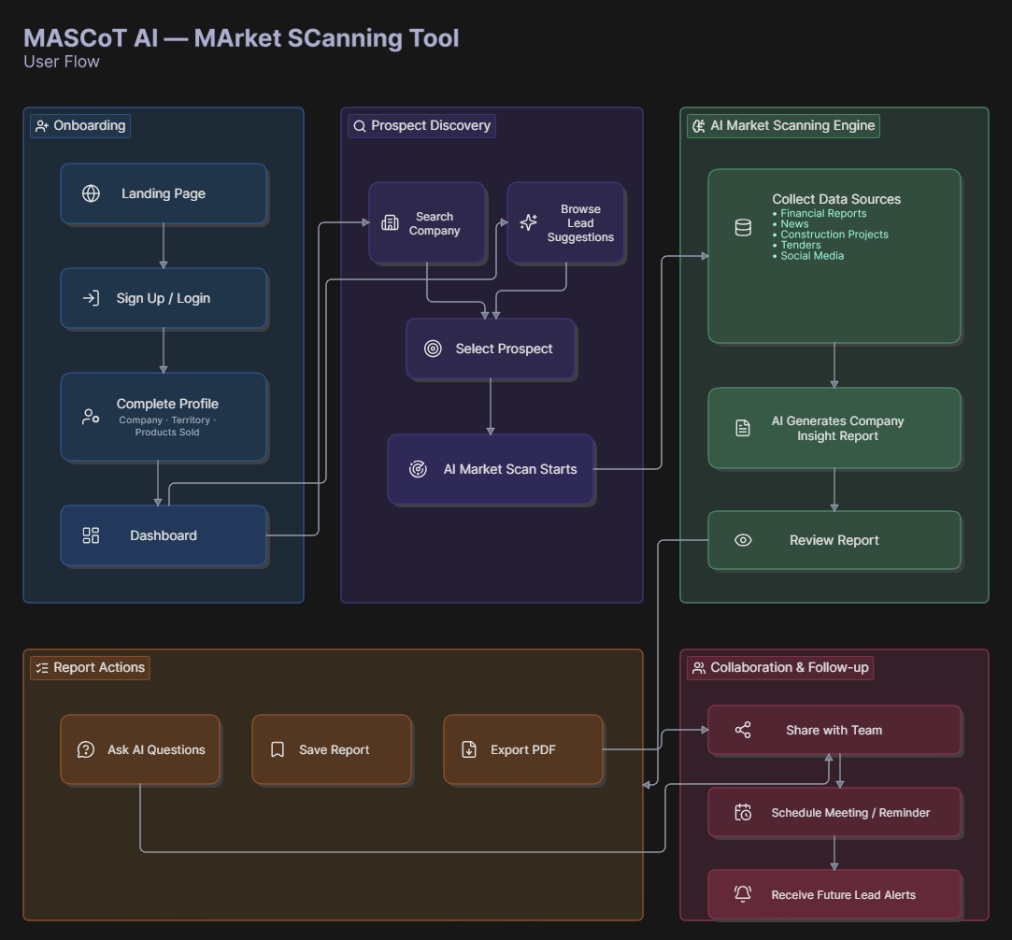
MASCoT AI, User Flow: Onboarding → Prospect Discovery → AI Market Scanning Engine → Report Actions → Collaboration & Follow-up

User Journey 1: User Registration
 | Action 1 | Action 2 | Action 3 | Action 4
User action | Open Webapp | Enter Email ID | OTP Verification | Password Setting
Touchpoints | Website link | Registration Page | Mail ID, Reg. Page | Registration Page
Sentiment | “Want to find paint-market details” | “Trying to log in” | “Is the OTP typed right?” | “Have to remember the password”
Emotion | Delighted | Neutral | Frustrated | Neutral
Opportunity | Create easy click search option in website | Make sure the mail id is in the right format | Auto OTP pop-up on mobile | Enforce strong password
User Journey 2: Add Product Details
 | Action 1 | Action 2 | Action 3 | Action 4 | Action 5
User action | Login | Product Details | Describe product | Images | Review
Touchpoints | Login Page | Menu, Detail Page | Product Page | Gallery/Camera | Product Page
Sentiment | “Enter the app” | “Where to add details?” | “Enter product features” | “Include images” | “Review before publishing”
Emotion | Delighted | Neutral | Frustrated | Delighted | Satisfied
Opportunity | Keep credentials in cache for ease of login | Ensuring that the page is found easily | Make sure it is restricted on word count | Restrict the image format and size | Keep review on one page
User Journey 3: View Market Research Analysis
 | Action 1 | Action 2 | Action 3 | Action 4 | Action 5
User action | Initiate lead meeting | Open insights dashboard | Review AI company brief | Ask AI for changes | Download / share brief
Touchpoints | Calendar / CRM | Dashboard | Company Report | Chat interface | PDF export
Sentiment | “Need to prep quickly” | “Hope this helps” | “Now I get their business” | “Needs a final touch” | “Ready for the meeting”
Emotion | Motivated | Expectant | Comprehension | Satisfied | Confident
Opportunity | CRM integration | — | Collect news/financials/social | Maximise context length | —

Q17 | Customer Service Strategy

Guiding principle
No dedicated customer-service hires yet. Support is founder- and team-led with heavy automation and self-service, focused on deflection, empowering users to resolve issues independently rather than expanding headcount.
Design the customer service strategy for your product?
Onboarding (does most support work for free)
- A single onboarding checklist screen walks the user through Registration → Product Details → first report
- One short Loom/screen-recording walkthrough, reusable across users
- Good onboarding prevents tickets rather than handling them after the fact
Support Channels (cheapest viable)
- A ‘Report an issue’ button opening a pre-filled email/Google Form, instead of paid live chat
- A single static FAQ page, sufficient at this stage
- No phone line or priority tier until there are paying enterprise customers

Q18 | Increasing CLV & Renewal Rates

What steps will you take to increase CLV and renewal rates?
The revenue model combines subscription and PAYG: each seat is a monthly subscription plus usage fees from heavy users. Value grows by keeping seats subscribed longer and earning more from usage.
Make ROI visible and attributable
Each rep gets a dashboard showing reports made, time saved and leads converted; this rolls up into a team view for the managers and business heads who decide on renewals, turning revenue-per-user and retention into the customer's own story.
Expand within the account before renewal
Since pricing is per seat, value grows mainly by adding seats. Begin with a pilot team, expand to the full sales team, then managers and marketing, timed around the Sept–Jan demand peak. PAYG usage doubles as an upsell signal: a rep hitting limits is a natural upgrade opportunity.
Reduce switching-cost anxiety by owning data history
Every report, flagged insight and client history accumulates inside MASCoT AI, becoming a personal CRM-like asset reps don't want to lose, a natural retention moat the product actively reminds users of.
Metrics Tracked
- Retention Rate & Churn Rate, how many customers stay vs. leave
- Repeat Purchase Rate, how often users buy extra credit packs
- ARPU Trend, accounts spending more over time signal stronger renewal likelihood

Q19 | Growth Hacks & Loops

What growth hacks/loops will you consider?
Rather than chasing consumer-style virality, growth spreads through the paint industry's own networks. When one sales rep starts using the tool, their teammates often follow. When one EPC firm adopts it on a project, it’s easier to roll it out across their other projects. And when a distributor sees value, they can pass it along to both contractors and manufacturers.
Loop | How It Works
1. Seat-Expansion (strongest) | When one sales rep wins a deal using MASCoT, they share the success with their manager. The manager sees proof in the dashboard and decides to add more reps.  In other words, one rep’s win convinces the boss to roll it out to the whole team.
2. Report-Sharing | Reps already share meeting briefs as PDFs. If those PDFs carry a small “Made with MASCoT” tag, anyone who receives them (like a colleague or manager) gets exposed to the tool.  In other words,every shared report is like an ad for MASCoT.
3. Data Network Effect (moat) | Every deal closed and every insight flagged makes MASCoT smarter for the next user in the paint industry.  In simple terms: The more teams use it, the sharper and more useful it gets for everyone.
4. Content / Community | We already scan construction activity and tenders. By turning a slice of that into a free weekly “Paint Industry Pulse” newsletter or LinkedIn post, we attract the right audience before they ever pay.  Like, we can share free industry updates to build trust and visibility among future customers.
5. Referral (tied to PAYG) | Heavy users who hit their usage limits are our best advocates. If they bring in a colleague or distributor, we reward them with extra credits or discounts.  For example, Power users get perks for bringing others on board.

Q20 | Wireframes, MVP Demo & PRD

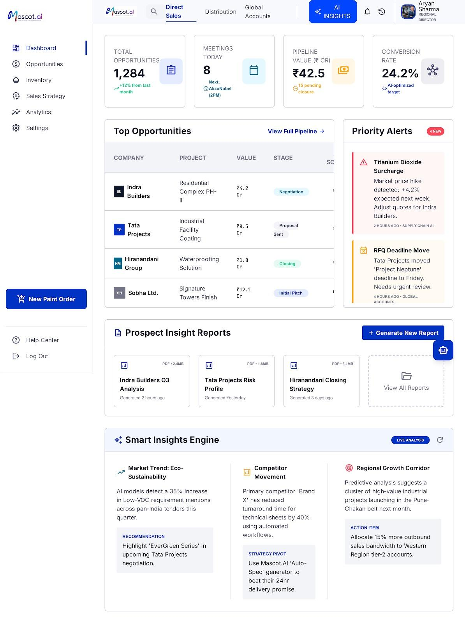

Wireframes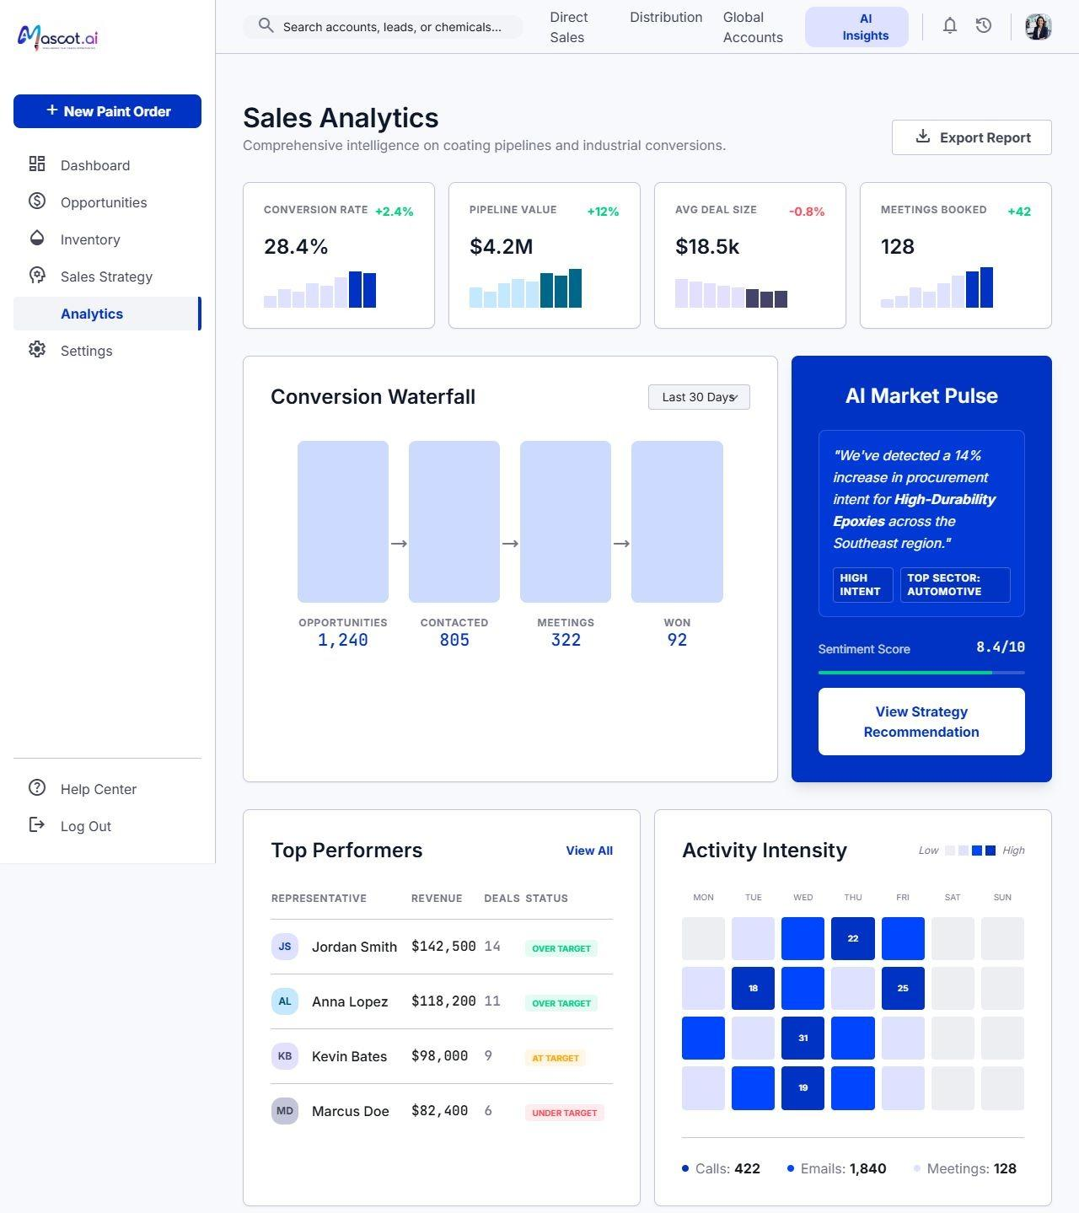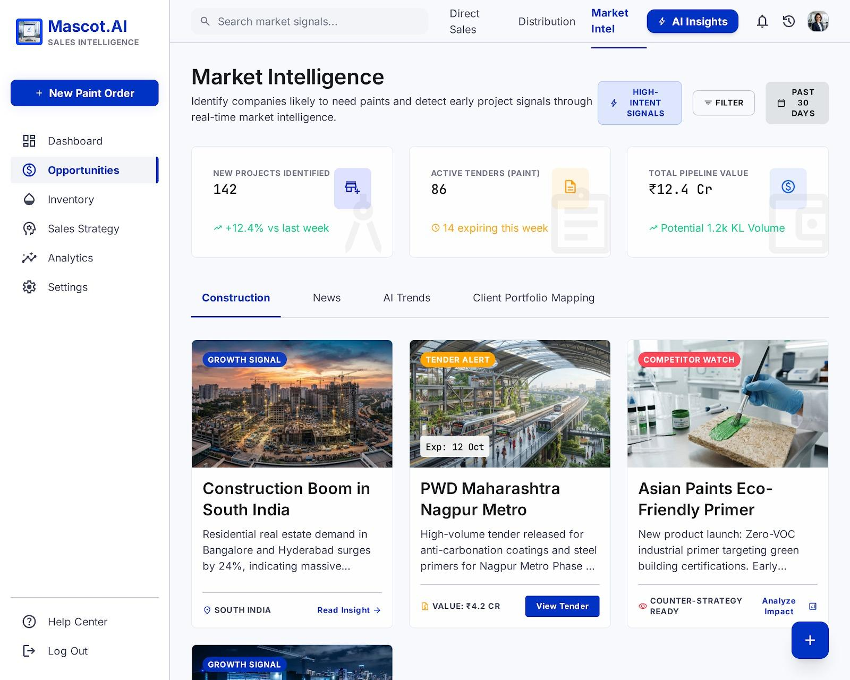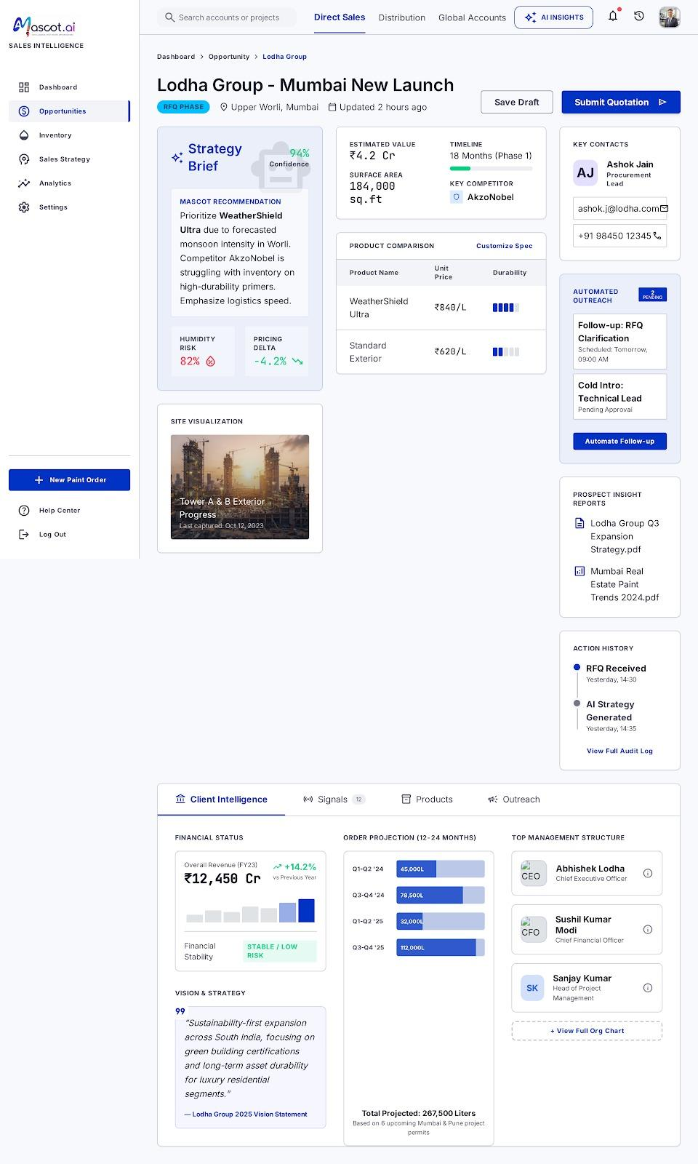
MVP Build & Demo

https://drive.google.com/file/d/1jEgG_lLFeDm_LWhST79jA-J4dXsfMKMS/view?usp=drive_link

Product Requirements Document (PRD)
MASCoT: Market Research & Lead Generation Platform
1. Executive Summary
MASCoT (Market Analysis & Sales Competitive Operations Tool) is an AI-powered market research and lead-generation platform designed for sales organisations, business development teams, and market analysts in the paint industry. It combines real-time market intelligence, opportunity identification, competitive analysis, and AI-driven insights to accelerate deal closure and revenue growth.
2. Product Overview
2.1 Vision
Empowering sales teams with actionable market intelligence and qualified leads through an integrated platform that combines AI-driven insights, competitive analysis, and opportunity scoring.
2.2 Mission
Reduce sales cycle time, increase conversion rates, and provide data-driven insights that enable smarter prospecting and negotiation strategies.
2.3 Core Platforms
- Direct Sales: Opportunity pipeline management and deal tracking
- Market Research: Real-time market trends, competitor analysis, and industry insights
- Distribution: Channel partner management and multi-tier sales tracking
- Global Accounts: Enterprise-level account management and relationship tracking
- AI Insights Engine: AI-powered analytics, market trend predictions, and actionable recommendations
3. Problem Statement
Sales teams today face several critical challenges:
- Information Fragmentation: Sales data scattered across multiple systems (CRM, email, spreadsheets and Google search)
- Lead Quality Issues: Difficulty distinguishing high-value prospects from low-intent leads
- Slow Market Insights: Inability to quickly identify emerging market trends and competitive threats
- Inefficient Pipeline Management: Manual tracking of opportunities across multiple stages
- Poor Sales Predictability: Lack of AI-driven forecasting and probability scoring
- Competitive Blind Spots: Limited visibility into competitor moves and market shifts
4. Product Solution
MASCoT provides a unified platform that integrates market research, lead generation, opportunity management, and AI-powered insights into a single dashboard.
4.1 Key Value Propositions
- Real-time Market Intelligence: AI models detect market trends, pricing changes, and competitive movements
- AI-Optimised Lead Scoring: Automatic scoring of prospects based on engagement patterns and fit metrics
- Integrated Opportunity Pipeline: Unified view of all sales opportunities with real-time status updates
- Actionable Insights: Predictive analytics suggest next best actions and risk factors
- Smart Alerts: Priority-based notifications for critical opportunities and market events
- Compliance & Reporting: Built-in audit trails and customisable reports for stakeholder visibility
5. Key Features & Functionality
5.1 Dashboard & Analytics
- Total Opportunities: Real-time count with month-over-month growth metrics
- Meetings Scheduled: Track upcoming customer interactions with next touchpoint dates
- Pipeline Value: Aggregate value of all active opportunities with closure probability
- Conversion Rate: Automated calculation with AI-optimised targets
- Top Opportunities Table: Sortable, filterable list of high-value prospects with stage tracking
5.2 Priority Alerts System
- Market Price Changes: Real-time notifications when commodity prices or service rates fluctuate
- RFQ Deadline Alerts: Urgent notifications when bid deadlines approach
- Competitive Threats: Alerts when competitors enter a target market
- Custom Triggers: Users can set personalised alert conditions
5.3 Prospect Insight Reports
- Pre-generated PDF reports on target companies and decision-makers
- Quarterly analysis of prospect financial health and market position
- Risk profiling based on historical data and predictive models
- Closing strategy recommendations based on similar past deals
- One-click report generation and email distribution
5.4 Smart Insights Engine
- Market Trend Analysis: Identify emerging opportunities in target verticals
- Competitor Movement Tracking: Monitor competitor pricing, new product launches, and market positioning
- Regional Growth Corridors: Predictive analysis of geographic markets with high-value project concentrations
- Strategy Pivots: AI-recommended tactical adjustments based on market shifts
- Action Items: Specific, prioritised recommendations for sales and business development teams
6. Target Users & Personas
6.1 Primary User Personas
Persona | Needs
Sales Director / Regional Director | Owns pipeline targets; needs visibility into all ongoing opportunities and team performance
Sales Executive / Account Manager | Manages individual opportunities; needs lead scoring and prospect insights
Business Development Manager | Identifies new markets and partnerships; needs market trend analysis
Sales Operations | Manages reporting and forecasting; needs automated data aggregation
Executive Leadership | Requires dashboard visibility for strategic decision-making
7. Key User Stories
ID | Story
US-1 | As a Sales Director, I want to see all opportunities in one dashboard, so that I can quickly identify pipeline gaps and prioritise my team's efforts.
US-2 | As a Sales Executive, I want AI-scored leads ranked by probability, so that I can focus on high-conversion prospects first.
US-3 | As a Business Development Manager, I want real-time alerts on competitor movements, so that I can adjust our go-to-market strategy immediately.
US-4 | As an Operations Manager, I want automated monthly reports on pipeline health, so that I can reduce manual reporting time by 80%.
US-5 | As an Executive, I want predictive revenue forecasts, so that I can make confident business decisions with data-driven insights.
8. Core User Interface Components
8.1 Left Sidebar Navigation
- Dashboard, Main metrics and overview
- Opportunities, Pipeline management
- Inventory, Market/resource tracking
- Sales Strategy, Strategic planning tools
- Analytics, Advanced reporting
- Settings, System configuration
8.2 Top Navigation Bar
- Module Selector (Direct Sales, Distribution, Global Accounts)
- Search Functionality
- AI Insights Toggle (Live Analysis)
- Notifications / Alerts
- User Profile & Settings
8.3 Core Dashboard Widgets
- Total Opportunities Card, Key metric with growth indicator
- Meetings Today Card, Upcoming interactions
- Pipeline Value Card, Total opportunity value with closure rate
- Conversion Rate Card, AI-optimised target benchmark
- Top Opportunities Table, Sortable, paginated list
- Priority Alerts Panel, Time-stamped urgent notifications
- Prospect Reports Section, PDF report library
- Smart Insights Engine, Market trend analysis and recommendations
9. Technical Requirements
9.1 Architecture
- Frontend: React-based responsive web application with real-time updates
- Backend: Microservices architecture with API Gateway pattern
- Database: PostgreSQL for transactional data, Redis for caching
- AI/ML: Custom-trained models for lead scoring and trend prediction
- Integration: REST APIs for CRM, email, calendar, and data-warehouse connectors
9.2 Performance Requirements
Requirement | Target
Dashboard load time | < 2 seconds
Search results | < 1 second
Report generation | < 5 seconds
API response time | < 500ms (p95)
System uptime | 99.5%
9.3 Integration Requirements
- Salesforce CRM, Two-way sync of opportunities, accounts, contacts
- Microsoft Teams / Outlook, Meeting scheduling and email integration
- Data warehouses (Snowflake, BigQuery), Direct data connectors
- Market data APIs, Real-time pricing and market data
- Email tracking, Prospect engagement insights
10. Success Metrics & KPIs
Category | Metrics
Sales Productivity | Average deal cycle time reduction by 30%; sales time saved on research: 10 hrs/week
Lead Quality | Conversion rate improvement by 25%; lead scoring accuracy > 90%
User Adoption | Dashboard DAU/MAU ratio > 60%; feature adoption rate > 75%
Revenue Impact | Average deal size increase by 20%; pipeline value growth 15% YoY
System Health | System uptime 99.5%; API availability 99.9%; user satisfaction > 4.2/5
11. Release Plan & Roadmap
Phase | Scope
Phase 1, MVP (Q3 2026) | Dashboard with core metrics; opportunity pipeline management; basic lead scoring; email notification system
Phase 2 (Q4 2026) | AI Insights Engine launch; advanced reporting module; competitor tracking; custom alert builder
Phase 3 (Q1 2027) | Predictive revenue forecasting; multi-language support; advanced API for third-party integrations; enterprise SSO and advanced security; custom ML model builder
12. Dependencies & Risks
12.1 Key Dependencies
- CRM data quality and timely sync
- Third-party API availability (market data, email providers)
- ML model training data and infrastructure
- Cloud infrastructure provisioning
- Security and compliance certifications
12.2 Risk Mitigation
Risk | Mitigation
Data privacy compliance | GDPR/CCPA audit, data encryption, regular security testing
Model accuracy degradation | Continuous model monitoring, A/B testing framework
Integration failures | Comprehensive testing, fallback mechanisms, partner support

This PRD documents the comprehensive scope for MASCoT, a market research and lead generation platform designed to transform how sales organisations prospect, analyse markets, and close deals.

E1 | Experimental Task, Real User Interviews (JTBD)

Problem statement being validated: the core MASCoT AI problem statement above.
Status: Completed
5 real interviews were conducted using the JTBD interview script.
4 sales representatives from the paint industry were interviewed to understand their pain points and help us build a better tool for them.
1 sales representative from the banking sector.

Recording Links:
- Video Recording of Manager in Banking Sector: Link

- Audio Recording of Sales Personnel from Paint Industry: Link
  - Transcript: Link

- Audio Recording: Link
  - Transcript: Link

- Audio Recording: Link
  - Transcript: Link

- Audio Recording: Link
  - Transcript: Link

E2 | Experimental Task, One Real Action, Two Channels

Test performed: a purchase/return action attempted on E-commerce Apps vs. Instagram Shopping.
Dimension | E-commerce Apps | Instagram Shopping
Time Taken (Delivery) | Reliable within stated dates (1–20 days) | Severe delays, a 20-day promise took 3 months
Time Taken (Returns) | Cash refund on pickup or in 2–3 days | No cash refunds; only coupons/exchanges
Product Offerings | Standard, broad catalogues | Unique, custom designer pieces
Friction Points | Frictionless scheduled home pickup | Manual courier drop-off at customer's own cost
Drop-off Moments | Low, predictable logistics | High, delays, manual returns, no cash refund
Which channel leaks trust?
Instagram Shopping leaks trust. This occurs because they fail to meet promised delivery timelines (taking 3 months instead of the promised 20 days) and sometimes misrepresent items, such as sending a product in a color that looks very different from the pictures shown on the page.
Which channel scales poorly?
- Instagram Shopping scales poorly. Because an Instagram page is typically a "single person business," it lacks the logistical infrastructure of major apps
- This lack of scale directly results in their inability to arrange home pick-ups for returns or process standard cash refunds, forcing them to rely on store credit and coupons instead
- E-commerce apps, on the other hand, have highly scalable automated logistics that handle deliveries, home return pickups, and immediate refunds seamlessly

E3 | Experimental Task, Renewal Objection Interviews

Question asked to 5 people: “Why wouldn’t you renew this product after 3 months?”
Status: Completed
5 people (users or potential users) were interviewed on video. Verbatim renewal objections, emotional drivers, and retention levers were recorded.

Recording Links:

- Video Recording: Link

- Audio Recording: Link

- Audio Recording: Link

- Audio Recording: Link

- Audio Recording: Link

E4 | Experimental Task, Business Owner Interviews

Recording Links:

- Audio Recording: Link

- Video Recording: Link

- Video Recording: Link

